**NANDHA ENGINEERING COLLEGE**

**(Autonomous Institution)**

Erode-638 052



**TABLEAU-TWO CREDIT COURSE**

**IV – Semester**

**B.Tech - Artificial Intelligence and Data Science**

**NAME : LOKESHWARAN B.**

**BRANCH : B.TECH AI & DS**

**YEAR : II**

**What is Tableau ?**

**Tableau** is a powerful data visualization and business intelligence tool that enables users to easily connect to various types of data, analyze it, and create interactive, shareable dashboards. It allows people to transform raw data into meaningful insights using simple drag-and-drop features without needing complex programming skills. Tableau supports integration with many data sources like Excel, SQL databases, cloud services, and more. Its visual and interactive capabilities make it easier for businesses and individuals to spot trends, identify patterns, and make data-driven decisions quickly. By turning complex information into clear and visually appealing charts and reports, Tableau empowers users to better understand their data and communicate findings effectively.

**Overall Purpose of Dataset's:**

This Web Marketing Dashboard provides a full overview of website performance — focusing on **visitor behavior**, **popular pages**, and **geographic distribution**. It helps the marketing team monitor user engagement, identify strong-performing content, and prioritize improvements.

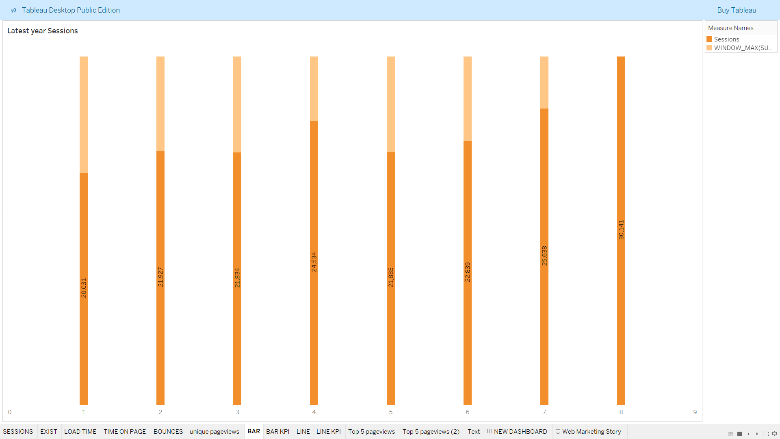

**This chart is a **stacked vertical bar chart** that displays the **Latest Year Sessions** data.**

"This chart helps understand how many people visited the website each month in the latest year, and how many of them left without interacting further."

# **What Insights Get:**

* You can easily **compare session counts month by month**.
* You can **see how much of the traffic is bouncing** (users leaving immediately).
* **Higher bounce height** means **lower engagement**.
* **Growth or drop** in total sessions across months can be quickly spotted.
* You can **identify the best and worst-performing months** by looking at the size of the bars.

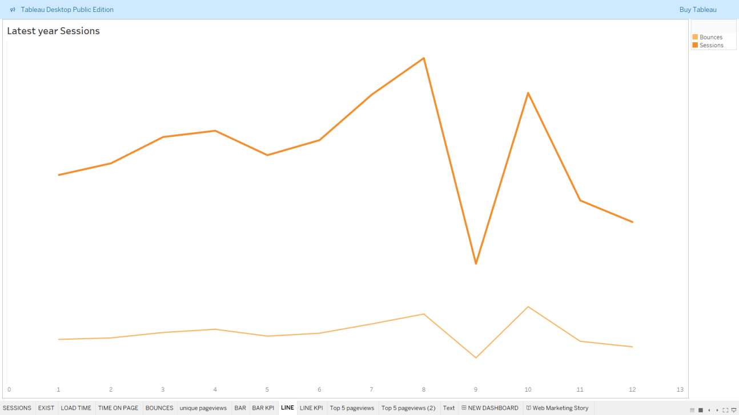

**This chart is a **dual line graph** that shows two metrics across the months of the latest year:**

# **What Insights Get:**

* **Session Trends**: You can observe how website traffic grows or drops during the year.
* **Bounce Trends**: You can track if user engagement (or lack of it) is following or differing from session patterns.
* **Performance Drops**: A sudden drop in sessions around month 9 could mean technical issues, seasonality, or poor campaign results.
* **Performance Recovery**: Sessions sharply increased again in month 10, indicating some corrective action or event might have helped.

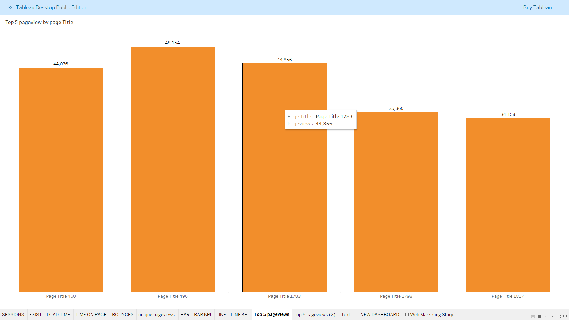

**Top 5 Pageviews by Page Title - Vertical Bar Chart**

* This visualization displays the **Top 5 web pages** based purely on the **total number of views**, regardless of which country the viewers come from.  
  It uses **vertical bars** (upwards-growing bars), making it visually intuitive to **quickly spot** which pages dominate in popularity.
* Unlike the horizontal bar chart with country split, this chart **combines all countries into a single total count** for each page.

**Business Value:**  
This gives a **straightforward, country-independent** view —  
ideal for understanding which content is universally popular across all audiences.

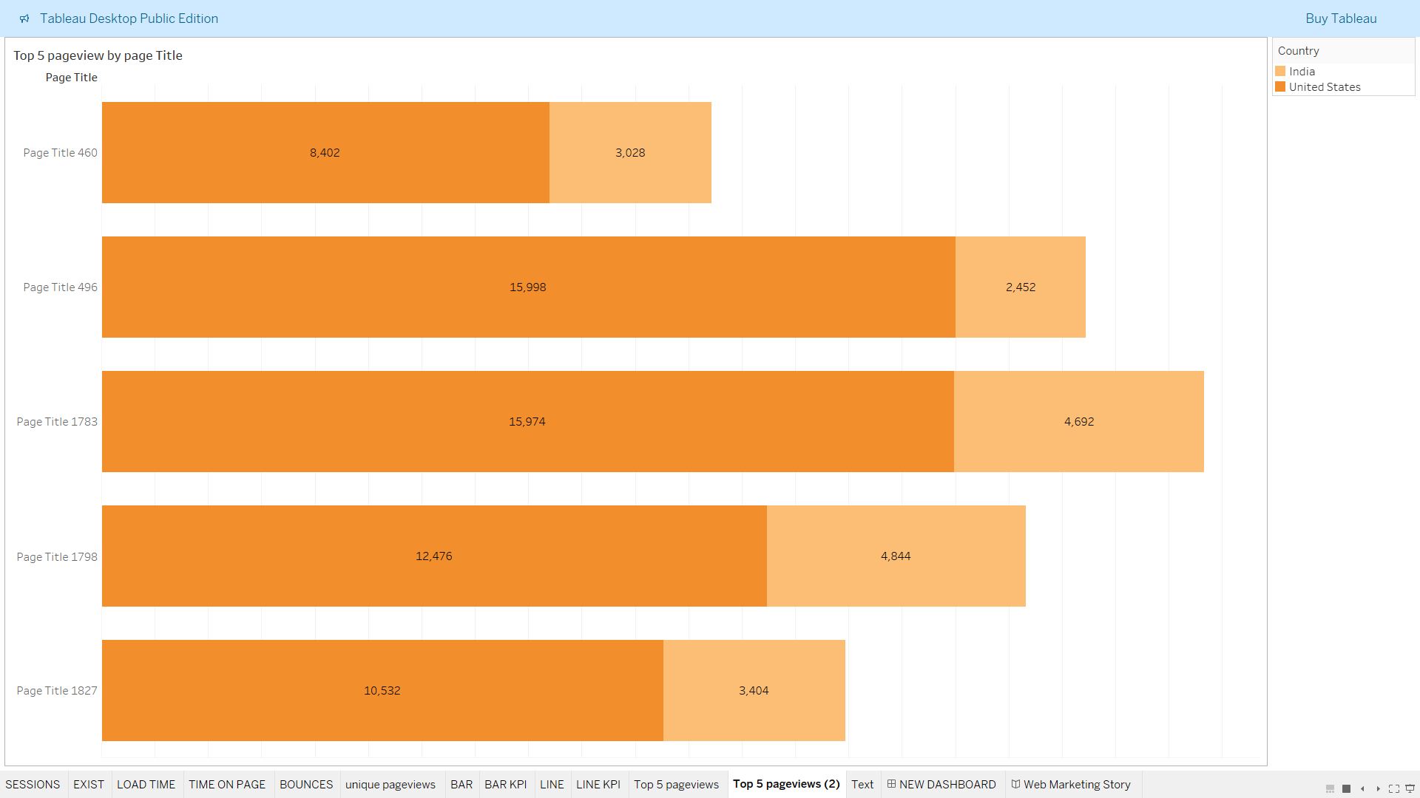

****Behavior** — showing how different countries contribute to the page's popularity.**

**Top 5 Pageviews by Page Title - Horizontal Bar Chart**

* This chart **visually ranks** the **top 5 web pages** based on how many times they were viewed by users.
* The horizontal bars allow you to **easily compare** page performance side-by-side.  
  Additionally, the **country split (India vs United States)** helps in **analyzing geographic**

It gives a **clear view** of:

* Which web content users love the most.
* Whether Indian or US users prefer different pages.

**Business Value:**  
This helps marketing teams **focus their promotions** or **improve specific content** for certain regions.

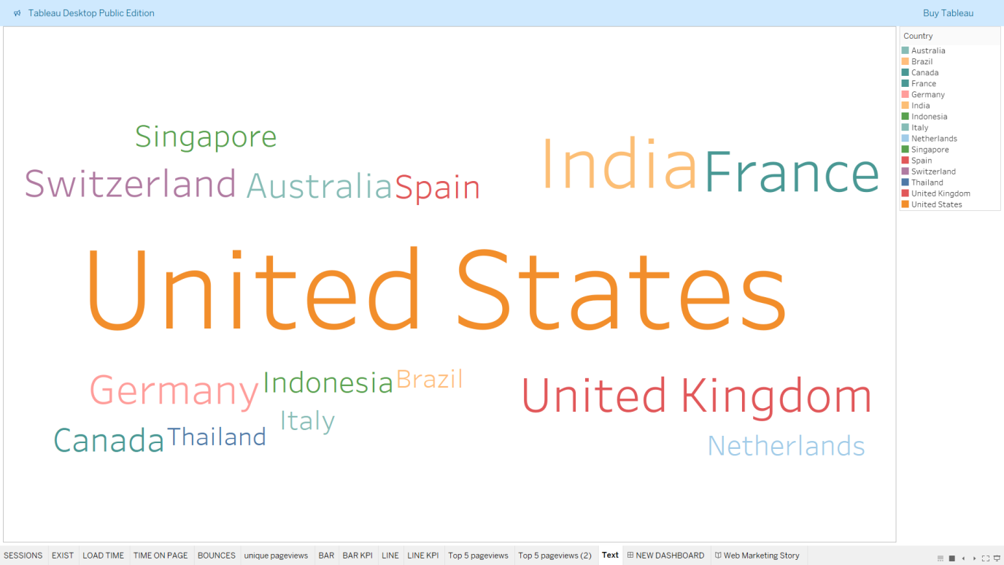

**Geographical User Distribution - Word Cloud**

* This visualization uses a **word cloud** to show the **distribution of website visitors** based on their countries.
* In a word cloud, **the size of the country name** represents **the amount of traffic** —  
  **Bigger names** mean **more visitors**, and **smaller names** mean **fewer visitors**.
* It’s a **quick, visual way** to understand which countries are your **primary audience sources** without having to look at a table of numbers.
* **Business Value:**  
  Instead of reading boring lists, you can **immediately spot the most important markets** and **focus marketing efforts** toward the countries bringing the most traffic.

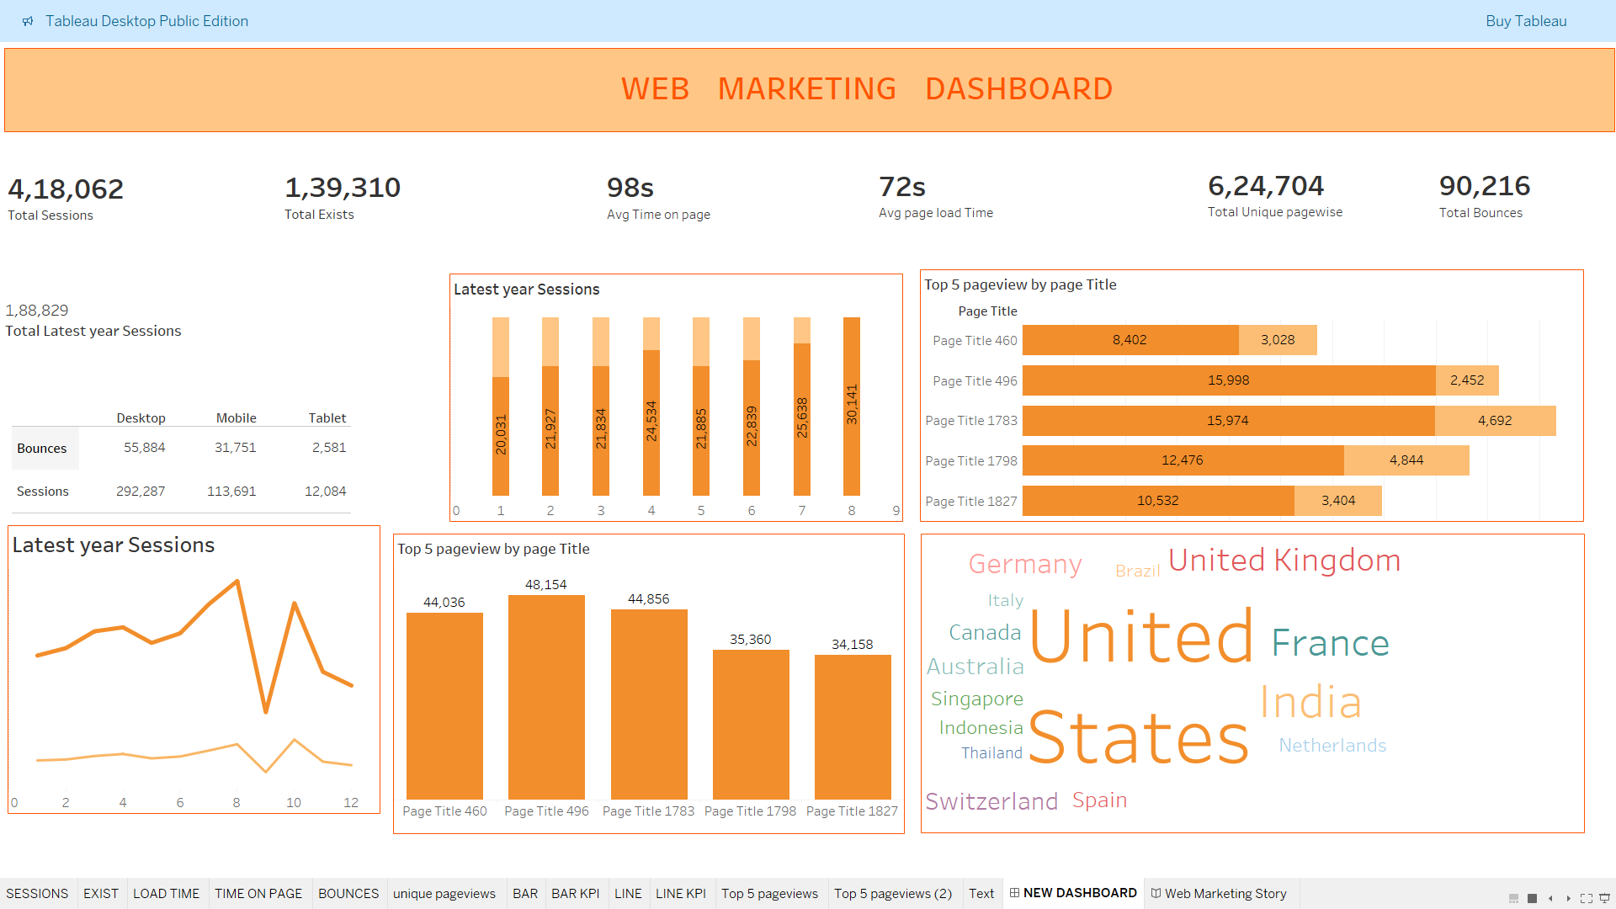

## **KPI Summary (Top Metrics)**

**Total Sessions**:  
Displays the total number of sessions recorded on the website (4,18,062).

**Total Exits**:  
Shows how many times users exited the website after visiting a page (1,39,310).

**Average Time on Page**:  
Indicates the average time users spend on a page (98 seconds).

**Average Page Load Time**:  
Displays how long it takes for pages to load on average (72 seconds).

**Total Unique Page-views**:  
Summarizes the number of unique pages viewed (6,24,704).

# **Conclusion:**

The dashboard provides a clear view of website performance by highlighting top-performing pages, major user countries, traffic sources, device usage, and user engagement patterns. It helps quickly understand where the audience comes from, how they interact, and what content drives the most interest.