DevSphere AI
  - UML and Workflow Handbook
Advanced Intelligent Software Engineering Assistant
Fourteen UML diagram families and the PostgreSQL ER model. Editable PlantUML, SVG and PNG files accompany this handbook.

Diagram index
01 Use case diagram
02 Class diagram
03 Object diagram
04 Component diagram
05 Composite structure diagram
06 Deployment diagram
07 Package diagram
08 Profile diagram
09 Activity diagram
10 State machine diagram
11 Sequence diagram
12 Communication diagram
13 Interaction overview diagram
14 Timing diagram
15 Database ER diagram
Object and timing views are illustrative design examples. Actual runtime evidence is recorded separately in the testing report.

Use case diagram
Shows developer actions and the boundaries of the AI provider and isolated runner.
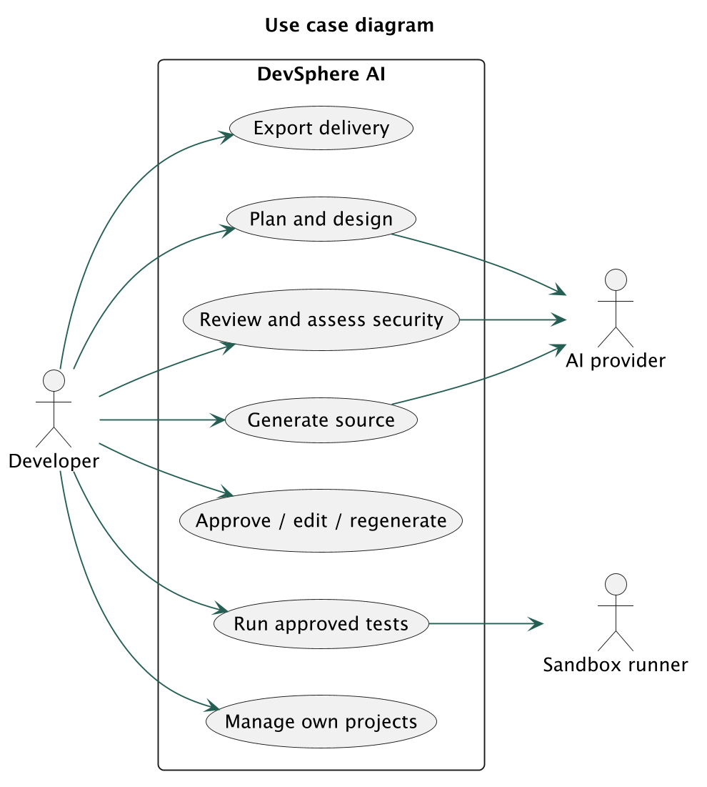
Editable source: docs/diagrams/01-use-case.puml

Class diagram
Core persisted entities and service responsibilities. The complete column dictionary is in the database schema.
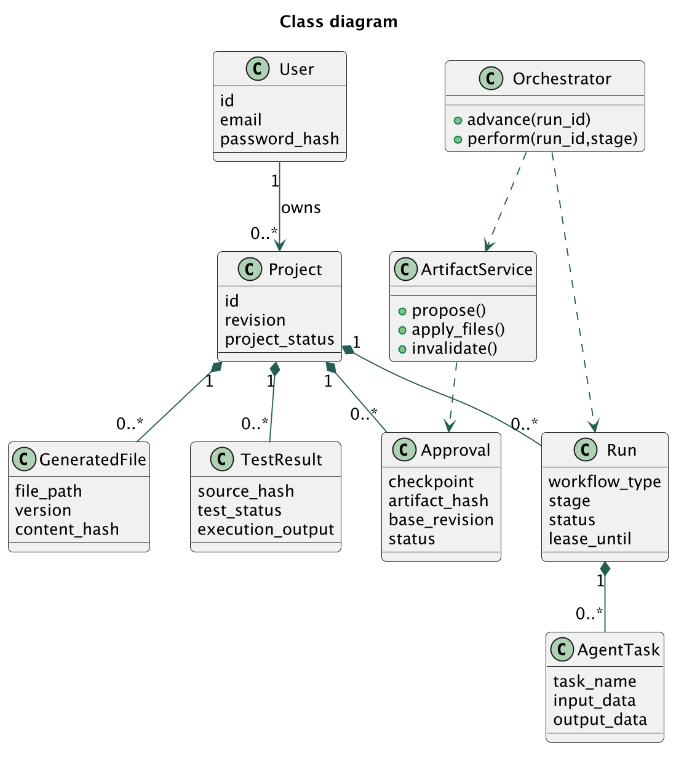
Editable source: docs/diagrams/02-class.puml

Object diagram
Illustrative snapshot of a workflow paused for architecture review; identifiers here are explanatory examples.
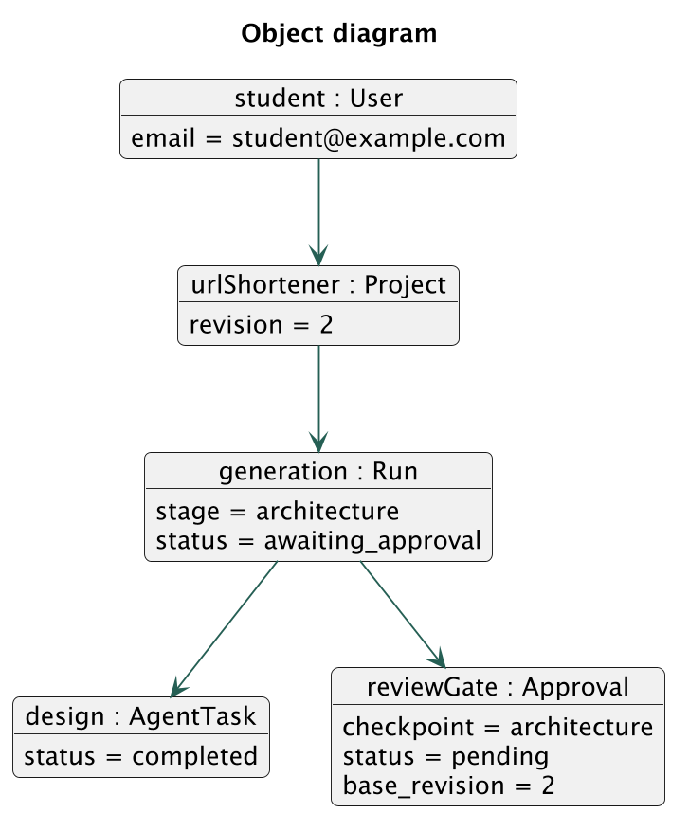
Editable source: docs/diagrams/03-object.puml

Component diagram
One modular application, one relational database and one separate trusted runner. Agent modules are Python functions.
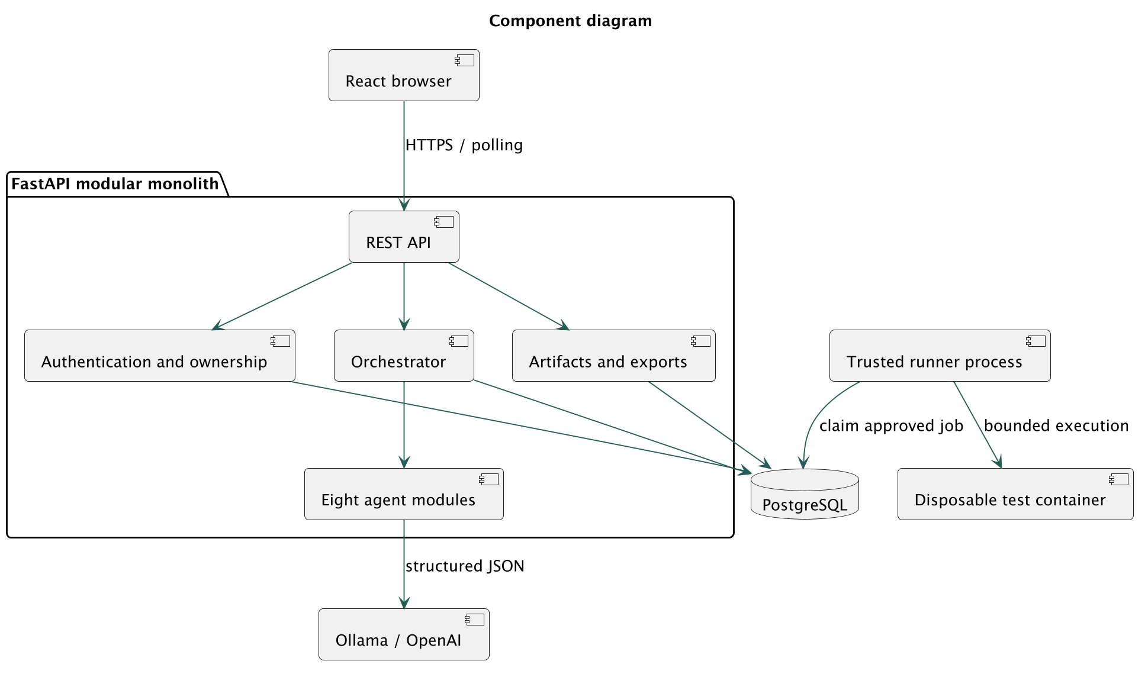
Editable source: docs/diagrams/04-component.puml

Composite structure diagram
Internal collaboration of the orchestrator component; ports are logical interfaces rather than separate network services.
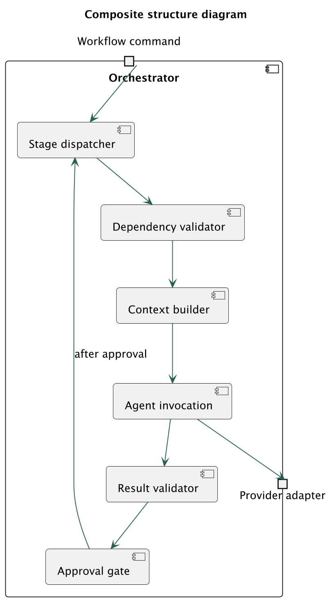
Editable source: docs/diagrams/05-composite-structure.puml

Deployment diagram
Local execution has a VM boundary for generated code. A free temporary tunnel exposes only the authenticated application.
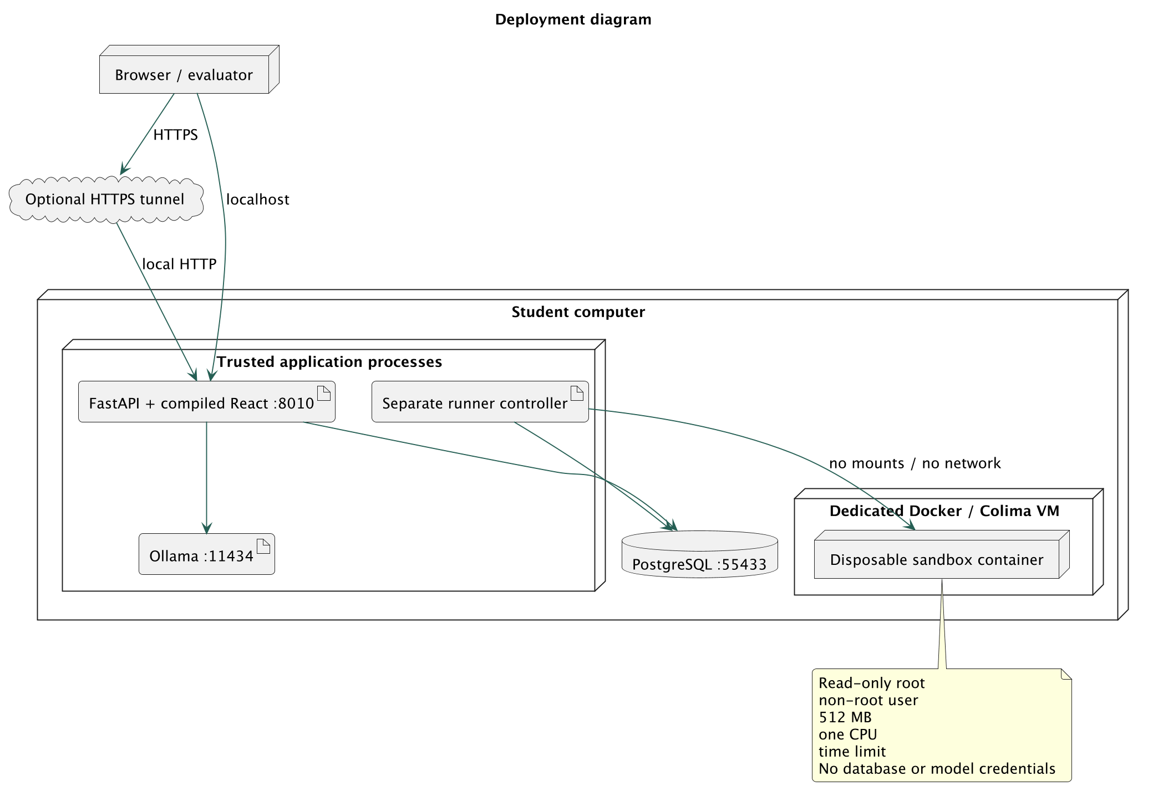
Editable source: docs/diagrams/06-deployment.puml

Package diagram
Source dependencies follow the modular monolith layout. The API never imports the sandbox executor.
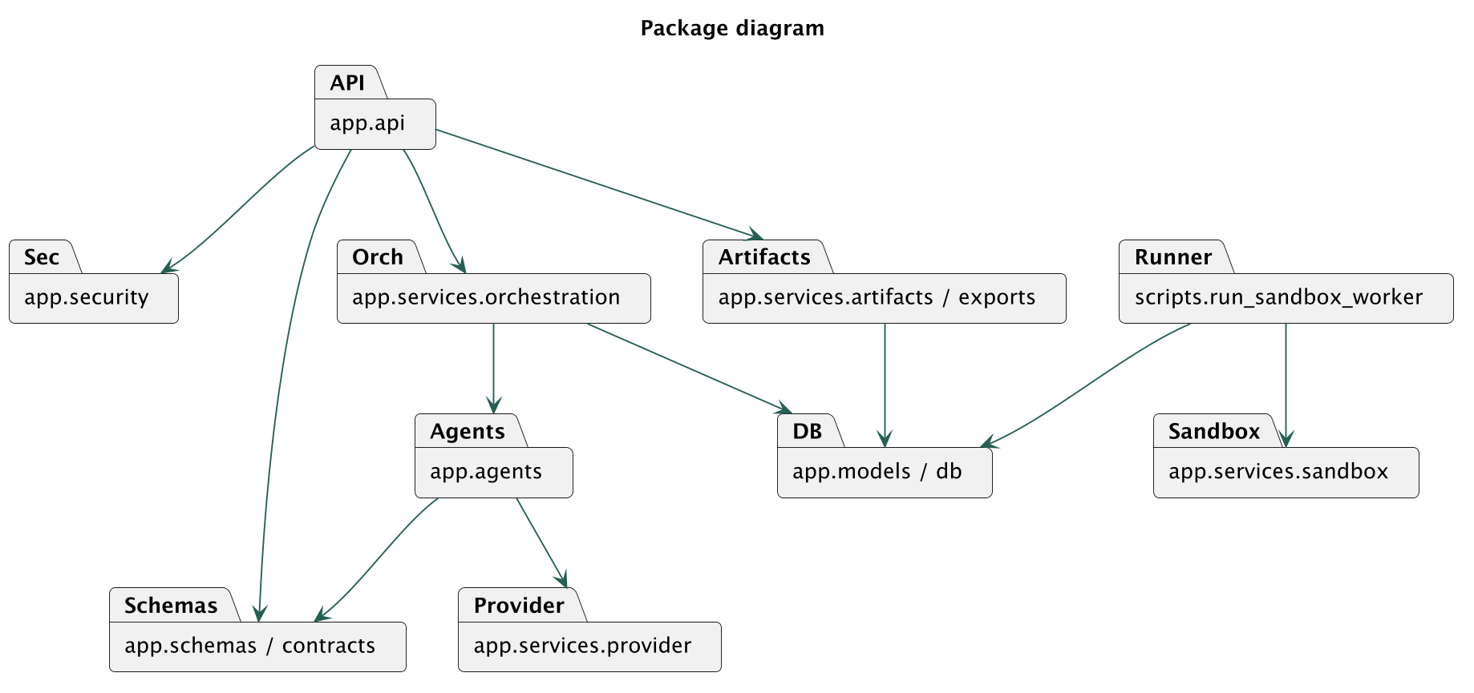
Editable source: docs/diagrams/07-package.puml

Profile diagram
Design vocabulary used in this project. Stereotypes describe responsibilities; enforcement is implemented in validation, transactions and runner constraints.
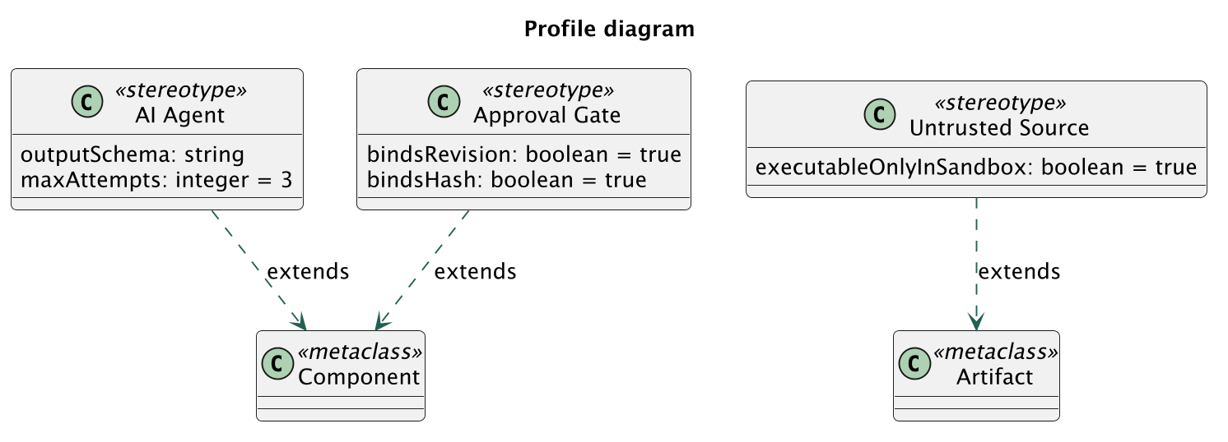
Editable source: docs/diagrams/08-profile.puml

Activity diagram
Full workflow includes explicit human gates and a conditional repair loop. Review-only workflows omit generation stages.
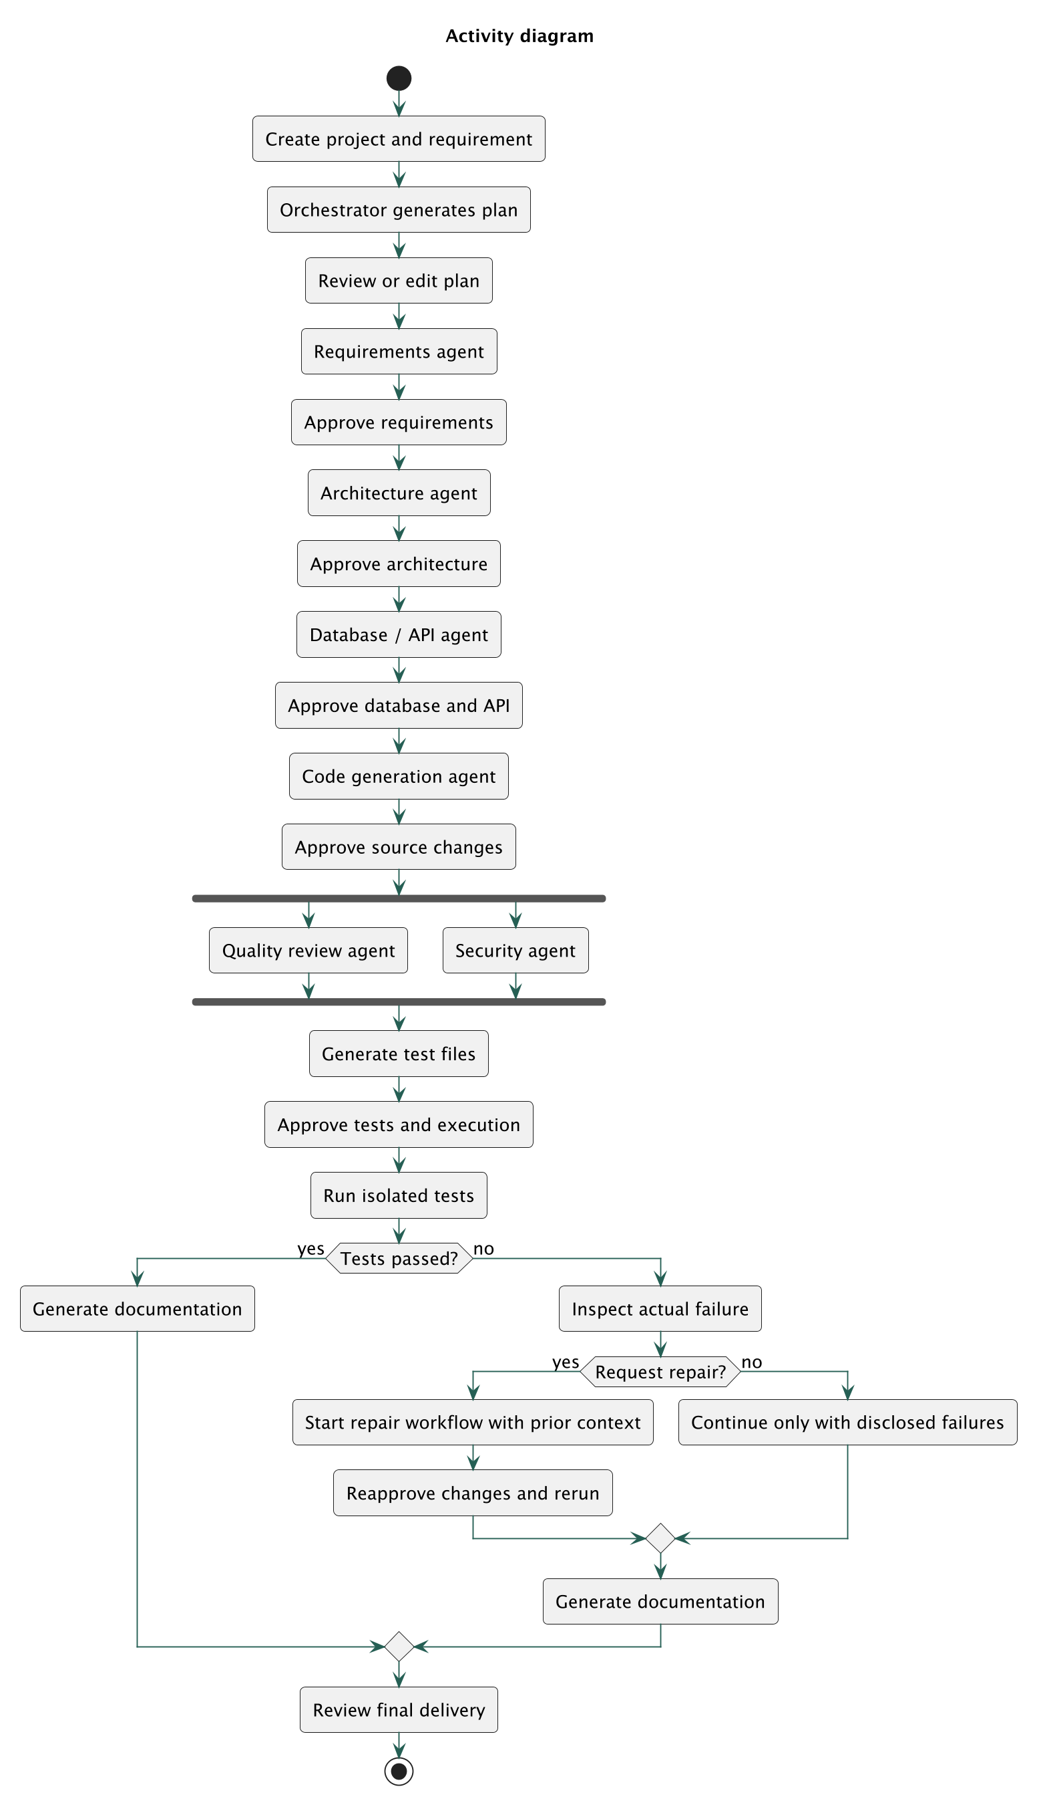
Editable source: docs/diagrams/09-activity.puml

State machine diagram
Persisted workflow status transitions, including a lease-expiry recovery path and cancellation.
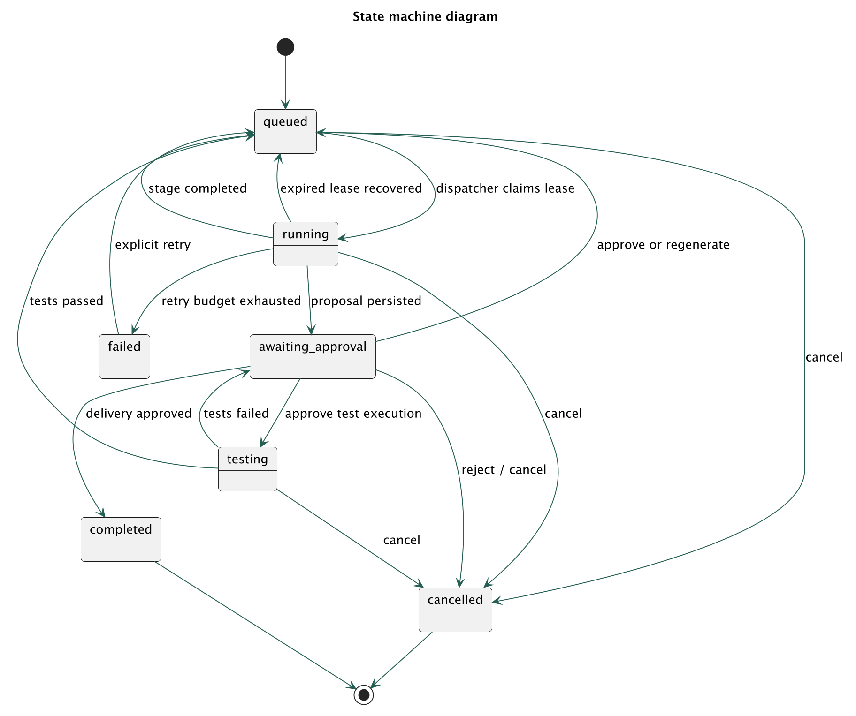
Editable source: docs/diagrams/10-state-machine.puml

Sequence diagram
Optimistic approval binds both artifact content and project revision, preventing a stale browser action from committing different work.
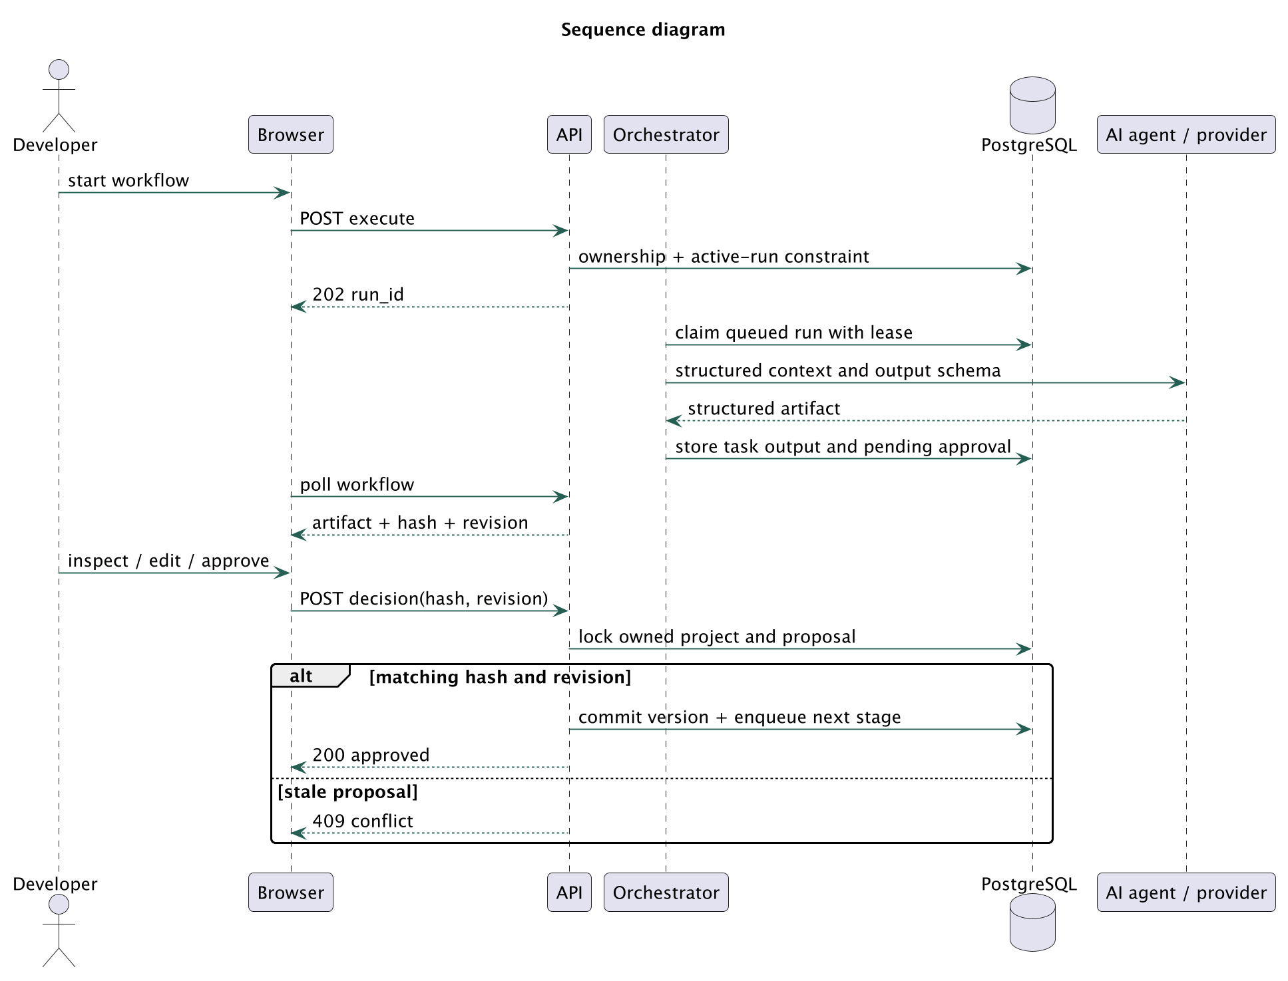
Editable source: docs/diagrams/11-sequence.puml

Communication diagram
Numbered messages express collaboration around an approved test run. This uses object notation for UML communication links.
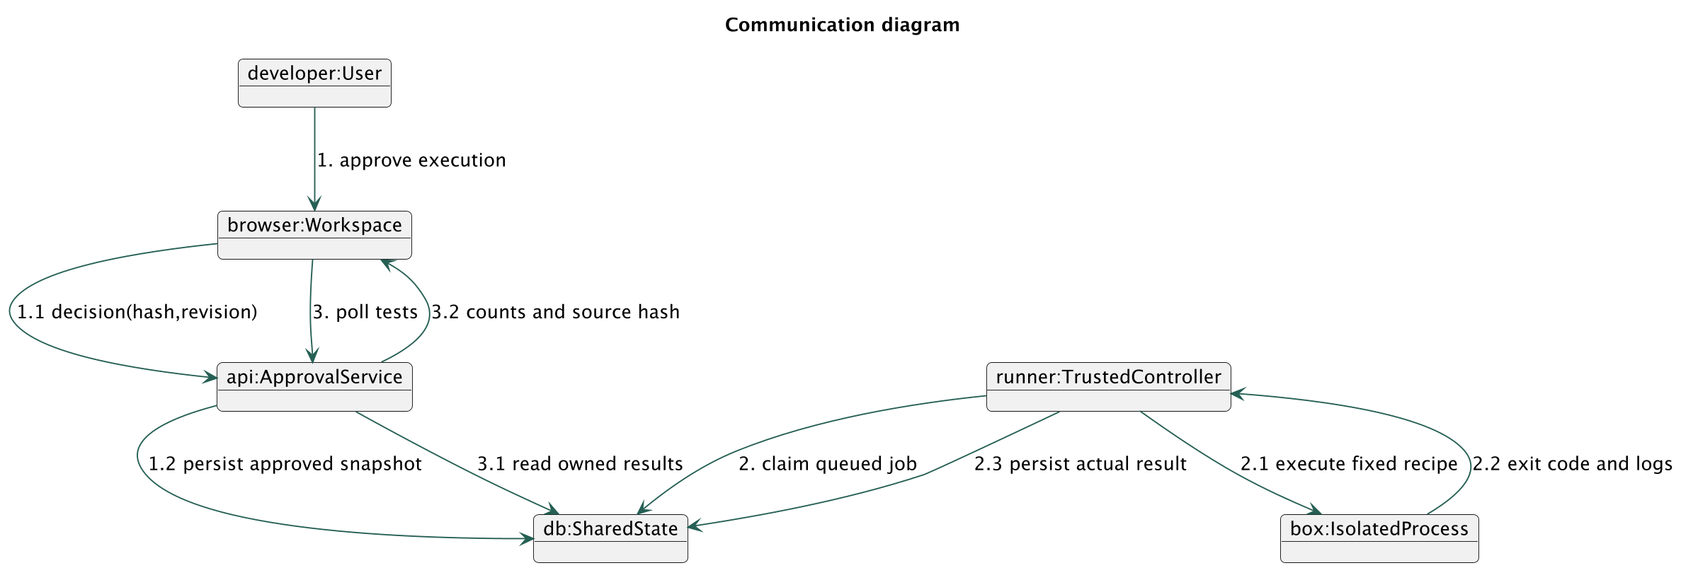
Editable source: docs/diagrams/12-communication.puml

Interaction overview diagram
High-level references to detailed interactions. Decisions route complete generation, review-only or repair without running every agent.
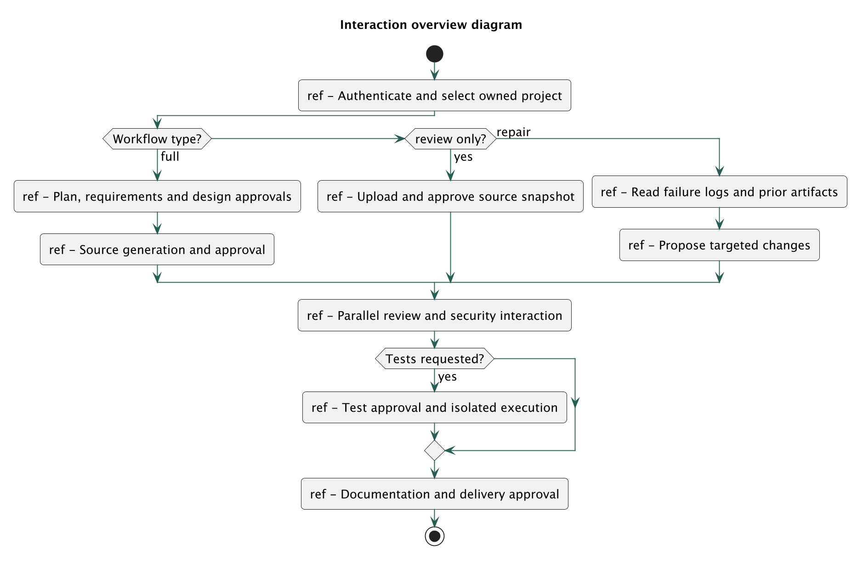
Editable source: docs/diagrams/13-interaction-overview.puml

Timing diagram
Illustrative ordering only; the horizontal units are logical ticks, not measured latency or a performance benchmark.
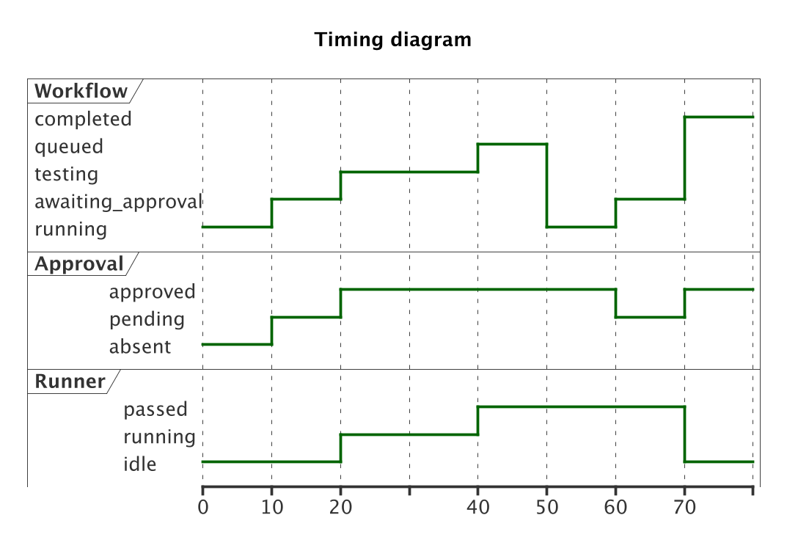
Editable source: docs/diagrams/14-timing.puml

Database ER diagram
All thirteen PostgreSQL tables are included. Project ownership is resolved through users and projects for every API operation.
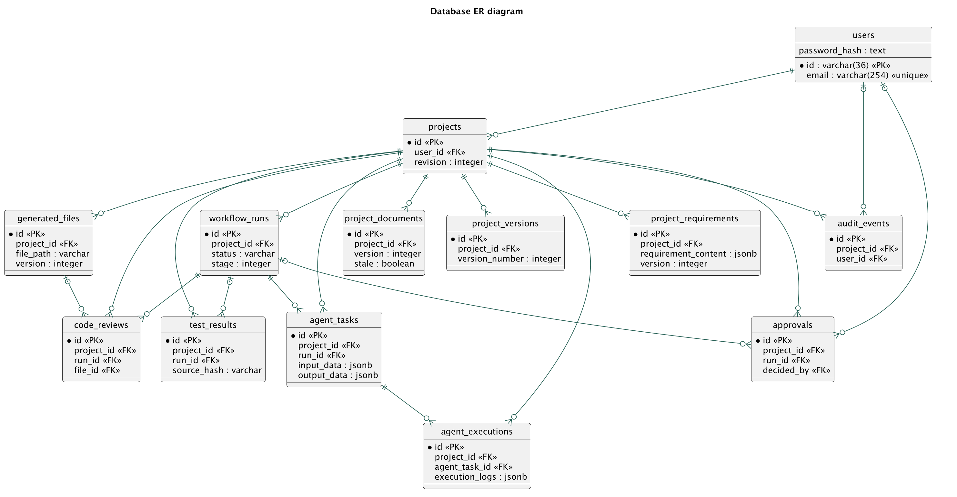
Editable source: docs/diagrams/15-database-er.puml

