PROCESSOR ARCHITECTURE SIMULATION,
ARITHMETIC PROCESSING, PIPELINING AND
PERFORMANCE EVALUATION
Particular | Details
Department | Computer Science and Engineering - AI
Programme | B.E – Computer Science and Engineering - AI
Course Code & Course Name | CSA0707 – Computer Network  LOKESH S - 192572151
Assignment Title | Real-time railway ticket reservation system using java OOP, collections, multithreading, GUI, file handling, serialization and JDBC
Maximum Marks | 100
Course Outcomes | CO4: Create Java applications using event handling, the Delegation Event Model, AWT components, and GUI design principles.  CO5: Apply Java I/O Streams, serialization, collections, exception handling, multithreading, synchronization, and JDBC database connectivity to develop applications that perform reliable and persistent data management and CRUD operations.
Bloom’s Taxonomy Level | K6 – Create; K3 – Apply, K6 – Create; K5 – Evaluate
SDG Mapping | SDG 4, SDG 8, SDG 9, SDG 11
Industry / Societal Relevance | Railway reservation automation, real-time booking management, concurrent transaction processing, database-driven transportation services, passenger data management, system reliability, and scalable digital infrastructure.

Table of Contents
1. Introduction and Problem Statement
2. Project Objectives
3. System Architecture and Design Approach
4. Object-Oriented Design: Classes, Objects, Inheritance and Polymorphism
5. String Handling and Java Collection Framework
6. Exception Handling and Reservation Validation
7. Multithreading, Synchronization and Concurrent Seat Booking
8. Thread Priority and Inter-Thread Communication
9. AWT GUI Design and Event Handling
10. File I/O Streams and Serialization/Deserialization
11. Database Design and JDBC Connectivity
12. SQL Operations and CRUD Implementation
13. System Execution, Testing and Performance Evaluation
14. Data Consistency, Maintainability and Scalability Analysis
15. Conclusion and Future Enhancements

1. INTRODUCTION AND PROBLEM STATEMENT
1.1 Introduction
Railway transportation is one of the most widely used modes of public transportation, serving a large number of passengers every day. Managing railway ticket reservations manually or through inefficient systems can lead to problems such as seat duplication, incorrect passenger information, delayed booking confirmation, and difficulties in maintaining real-time reservation data. A computerized railway reservation system provides an efficient solution by automating train search, seat availability checking, ticket booking, cancellation, passenger management, and payment-related operations.
The Real-Time Railway Ticket Reservation System is a Java-based application designed to demonstrate how various Java programming concepts can be integrated to develop a reliable and maintainable real-world application. The system uses Object-Oriented Programming (OOP), Java Collections, String handling, exception handling, multithreading, synchronization, AWT GUI, event handling, file handling, serialization, and JDBC database connectivity.
The system models railway entities such as Passenger, Train, Coach, Seat, Ticket, and Payment as separate classes. This modular structure improves code organization and allows different components of the application to be developed and maintained independently. Concepts such as encapsulation, inheritance, method overloading, method overriding, runtime polymorphism, packages, and interfaces are incorporated into the design.
1.2 Problem Statement
The objective is to design and implement a Java-based real-time railway ticket reservation system that allows customers to search for trains, check seat availability, book tickets, cancel bookings, and access current booking information.
The system must handle a large number of simultaneous booking requests while ensuring that the same seat is never allocated to multiple passengers. Concurrent access to shared booking and seat information can result in race conditions if proper synchronization is not implemented.

The system must therefore provide:
- Efficient train and seat searching.
- Passenger and booking management.
- Secure and consistent seat allocation.
- Prevention of duplicate bookings.
- Proper cancellation and validation.
- Exception handling for invalid operations.
1.3 Need for the Proposed System
The proposed system is needed to provide a structured digital solution for railway reservation activities. By integrating Java programming concepts into one application, the system demonstrates how real-world reservation software can manage multiple users, shared resources, persistent data, and concurrent transactions reliably.

2. PROJECT OBJECTIVES
The primary objective of the Real-Time Railway Ticket Reservation System is to develop a reliable Java-based application that automates railway reservation activities while demonstrating important Java programming concepts.
2.1 Primary Objectives
- To develop a real-time railway ticket reservation system using Java.
- To allow passengers to search for available trains based on source and destination.
- To provide real-time seat availability information.
- To enable passengers to book and cancel railway tickets efficiently.
- To maintain passenger, train, coach, seat, ticket, and payment information systematically.
- To apply Object-Oriented Programming principles such as encapsulation, inheritance, polymorphism, constructors, method overloading, and method overriding.
- To use ArrayList, HashSet, HashMap, Generics, and Iterators for efficient and type-safe data management.
- To implement built-in and user-defined exceptions for invalid passenger details, unavailable seats, duplicate bookings, invalid cancellations, and booking failures.
- To implement multithreading and synchronization for handling simultaneous booking requests.
2.2 Technical Objective
The technical objective is to integrate the different Java concepts into a single modular application. The system should ensure that simultaneous booking operations are executed safely and that shared resources such as seats remain consistent.
2.3 Expected Outcome
At the end of the project, the system should provide an integrated reservation application in which users can search trains, verify seats, book and cancel tickets, while the backend manages concurrent requests, persistent data, exceptions, and database operations reliably.

3. SYSTEM ARCHITECTURE AND DESIGN APPROACH
3.1 System Architecture
The Real-Time Railway Ticket Reservation System is designed as a modular Java application in which the user interface, application logic, reservation management, file storage, and database connectivity work together.
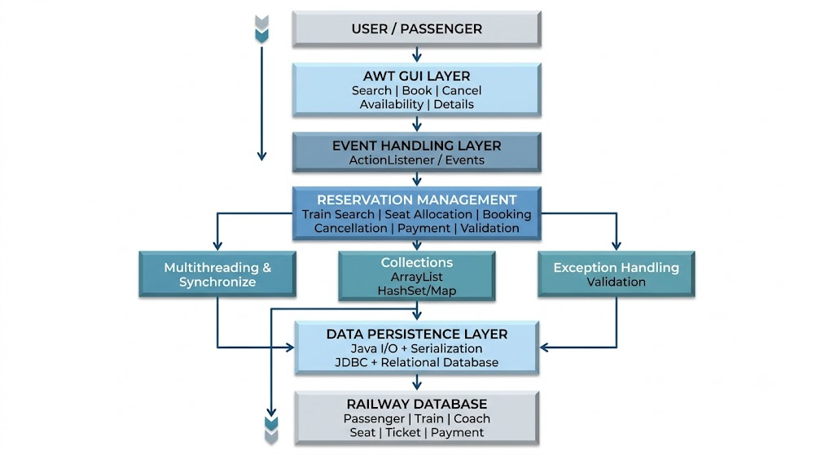
3.2 Major Components
3.2.1 User Interface Layer
The AWT-based GUI provides the interaction between passengers and the reservation system. It contains controls for:
- Train search
- Seat availability
- Ticket booking
- Ticket cancellation
- Booking details
- Clearing input
- Exit
3.2.2 Reservation Management Layer
This is the core processing layer of the application. It manages:
- Passenger details
- Train information
- Coach information
- Seat allocation
- Ticket generation
- Payment details
- Booking cancellation
- Availability checking

3.2.3 Collection Management
Java Collections are used for efficient temporary data management.

