WIRELESS DATA ACQUISITION BY SMARTPHONE

**EKANSH GUPTA L. S. VISHNU SAI RAO**

## CONTENTS

1. **WIRED DATA ACQUISITION TO A LAPTOP**

* **USING 9163 CHASSIS**
* **USING 9191 CHASSIS**

1. **WIRELESS DATA ACQUISITION TO A LAPTOP**

* **USING 9163 CHASSIS**
* **USING 9191 CHASSIS**

1. **WIRELESS DATA ACQUISITION TO AN ANDROID SMARTPHONE**
2. **WIRELESS DATA ACQUISITION TO LAPTOP USING ROUTER AS AN INTERMEDIATE**

* **WIRED CONNECTION BETWEEN ROUTER AND CHASSIS**
* **WIRELESS CONNECTION BETWEEN ROUTER AND CHASSIS**

1. **WIRELESS DATA ACQUISITION TO SMARTPHONE USING ROUTER AS AN INTERMEDIATE**
2. **WIRELESS DATA ACQUISITION TO SMARTPHONE USING LAPTOP AS AN INTERMEDIATE**

**INSTRUMENTS USED**

**Specifications**

**NI WLS- 9163**

**Specifications**

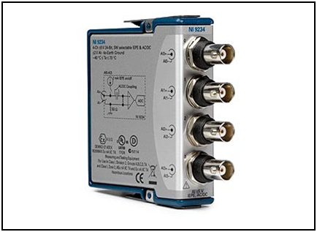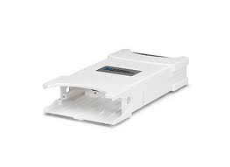

* IEEE 802.11B/G wireless communication interface
* Send data to a host PC over Ethernet or IEEE 802.11 Wi-Fi
* 30 meter indoor, 100 meter line of sight wireless signal range
* Advanced security with 128-bit AES data encryption and IEEE 802.11i (WPA2) support

**Specifications**:

**NI cDAQ - 9234**

* Four-channel dynamic signal acquisition module
* 51.2 kS/s per-channel maximum sampling rate
* 24-bit resolution
* 102 dB dynamic range
* Anti aliasing filter
* Software selectable IEPE signals conditioning
* 802.11 Wi-Fi Data Acquisition
* Send data to a host PC over Ethernet or IEEE 802.11 Wi-Fi
* 30 meter indoor, 100 meter line of sight wireless signal range
* Advanced security with 128-bit AES data encryption and IEEE 802.11i (WPA2) support
* 4 general-purpose 32-bit counter/timers built into the chassis

13

12

**NI WLS- 9191**

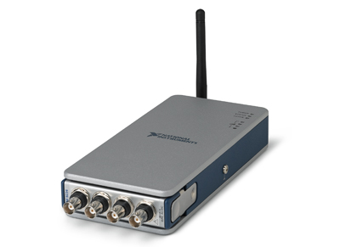

**Wired data acquisition to a laptop**

### USING 9163 CHASSIS

SOFTWARE USED ON THE LAPTOP --- LabVIEW Measurement and automation explorer

Detailed setup procedure is as follows:-

1. Connect the chassis to the laptop using the Ethernet cable and detect the device using LabVIEW MAX

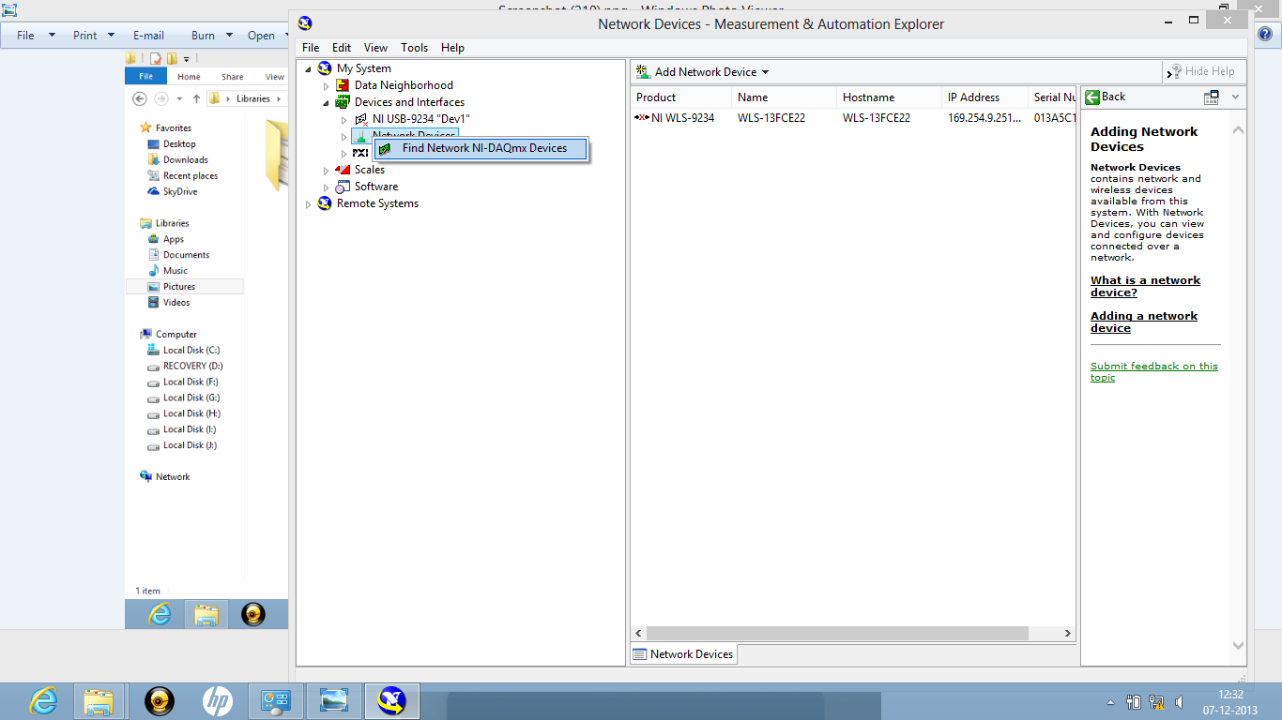

1. The device is now visible also with the connection type to be wired. Select the detected device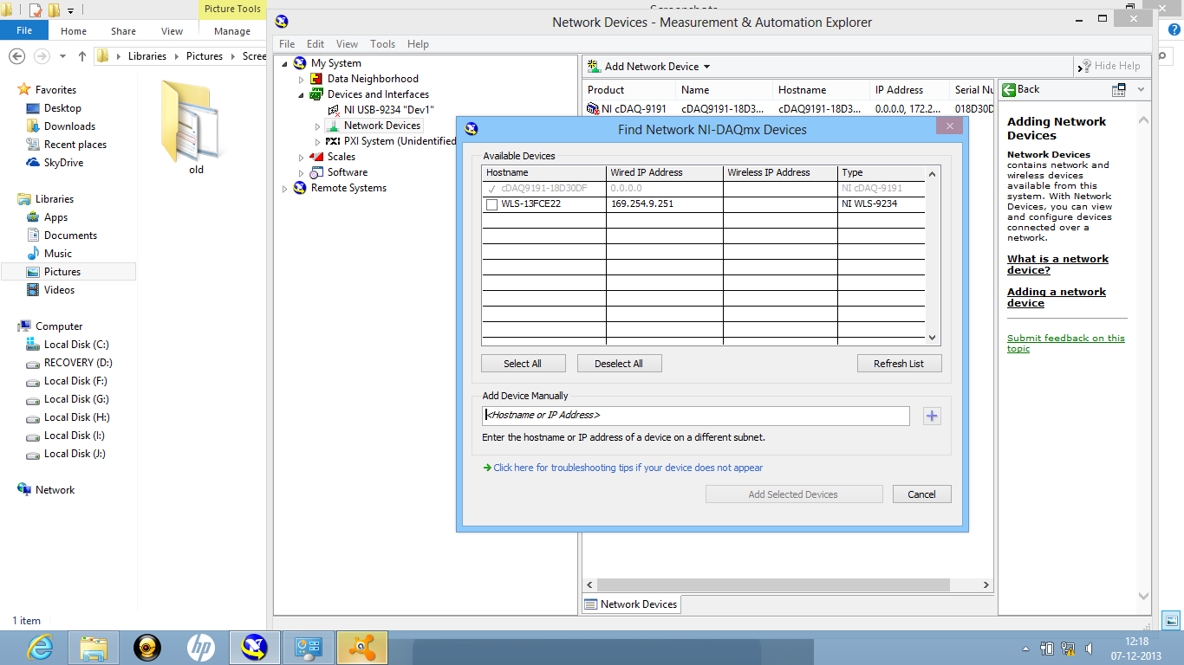
2. The wired configuration settings should be as follows

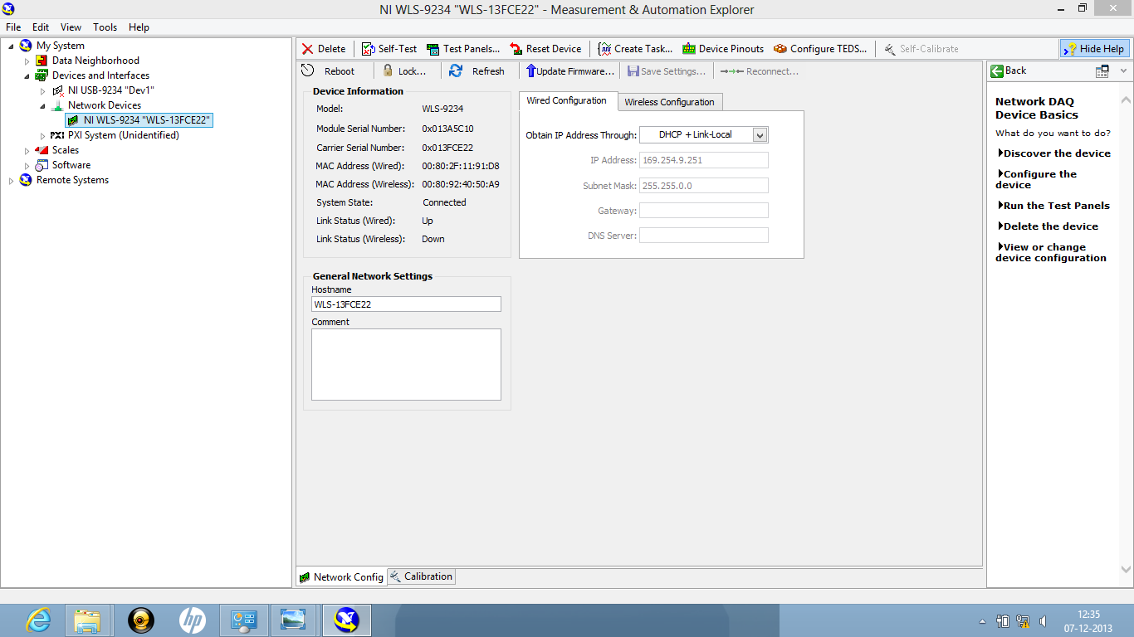

1. Click on the self-test icon to check whether data acquisition is actually happening or not. To see the data, click the test panels tab and a waveform is obtained indicating successful transmission of data from the chassis to the laptop

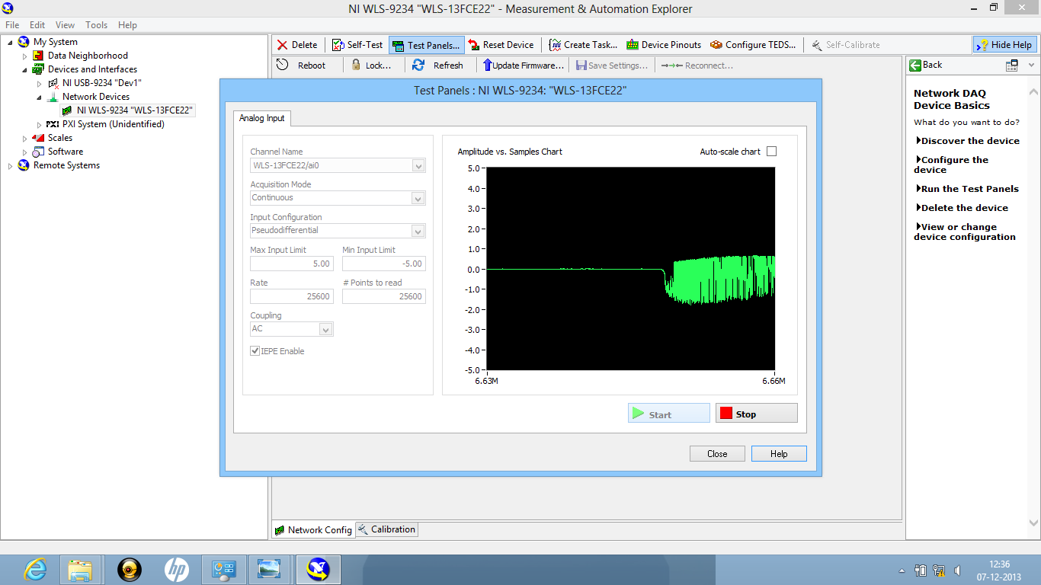

### USING 9191 CHASSIS

CDAQ-9191 has four counters and 5 Watts of power. NI WLS/ENET-9163 has no counters and 4.5 Watts of power. The physical dimensions seem comparable, but do differ slightly.

**Though the two devices differ structurally the functionality of these two devices remains the SAME.**

The set up remains the same as that of 9163.The only difference is that one needs to reserve the chassis in 9191. Such a choice is not available in case of 9163.Here is the screen shot for chassis reservation.

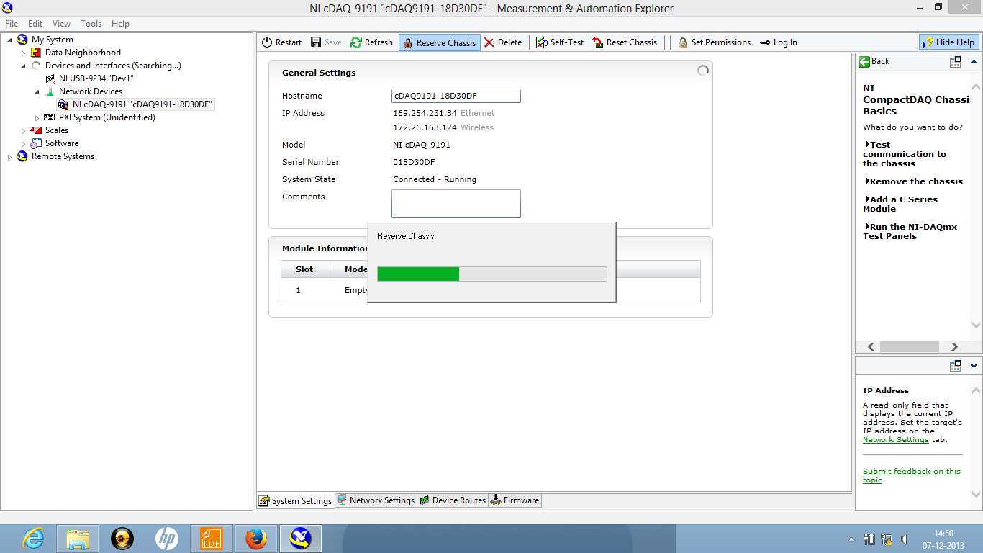

**Since the chassis is reserved for a particular laptop, only one laptop can access the data at one time**.

**Wireless data acquisition to a laptop**

### USING 9163 CHASSIS

Type of wireless data acquisition --- ad hoc network or peer to peer network

On wireless computer networks, **ad-hoc** mode is a method for wireless devices to directly communicate with each other. Operating in ad-hoc mode allows all wireless devices within range of each other to discover and communicate in peer-to-peer fashion without involving central access points (including those built in to broadband wireless [routers](http://compnetworking.about.com/library/glossary/bldef-router.htm)).

In order to wirelessly obtain data one has to configure the chassis, thus connect the chassis to the laptop using Ethernet cable

1. Click on the chassis icon, go to network settings and under the “wireless mode”, select Connect to wireless network”. Select the router’s network in the wireless network menu and let the ipv4 address be “DHPC or Link Local”.

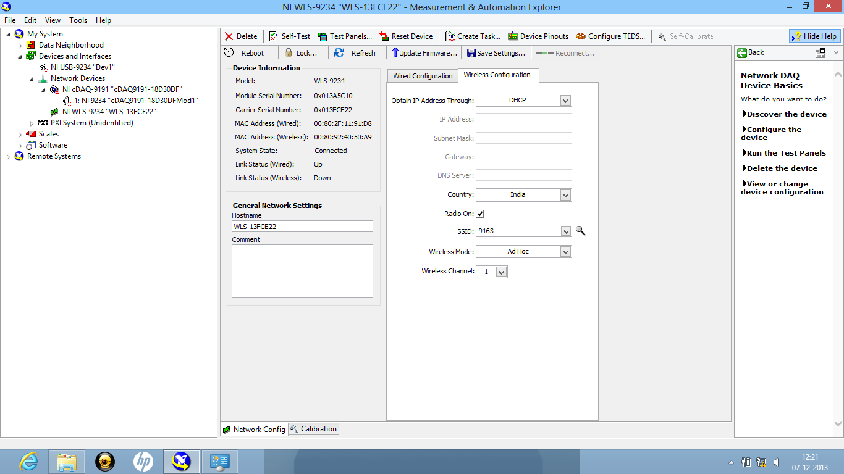

1. IP address must be fed in static mode. Any suitable IP address can be used. This step would create an ad hoc connection between the chassis and the laptop

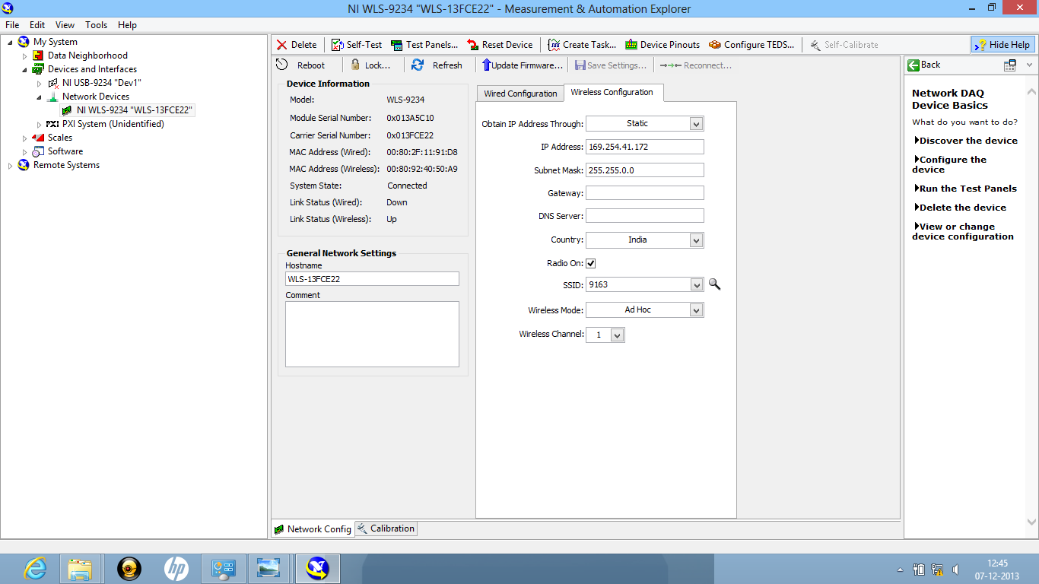

1. Now unplug the Ethernet cable, connect to the router’s network and click “test panels” to take measurements

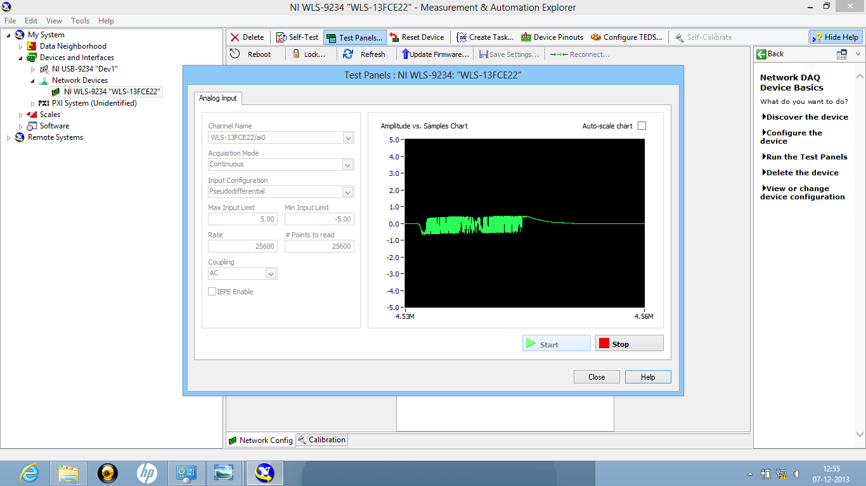

### USING 9191 CHASSIS

Configuration of the chassis for wireless data acquisition is needed again. The chassis shall be wired until its wireless configuration is finished

1. One can see in this screenshot that the chassis has been connected using an Ethernet cable and is ready for configuration.

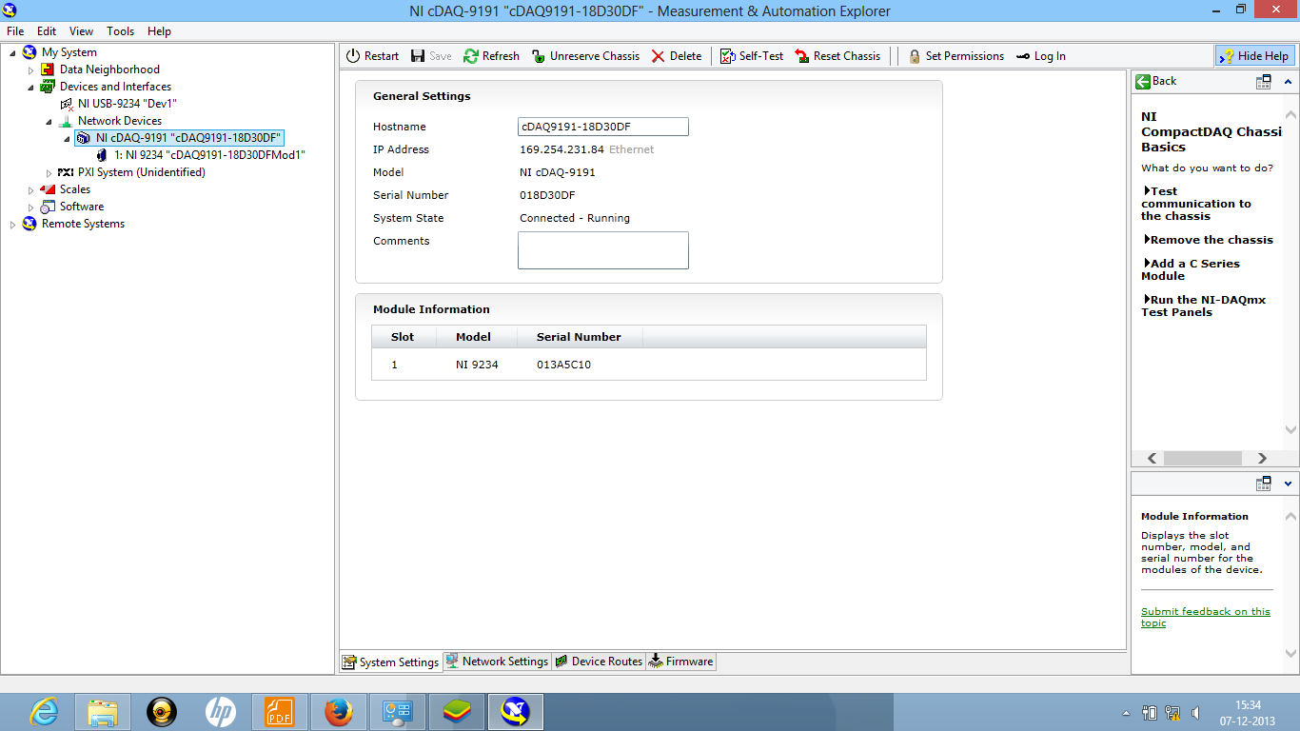

1. Click on the chassis icon, go to network settings. Now we have to change the settings of “wireless adapter wlan0”

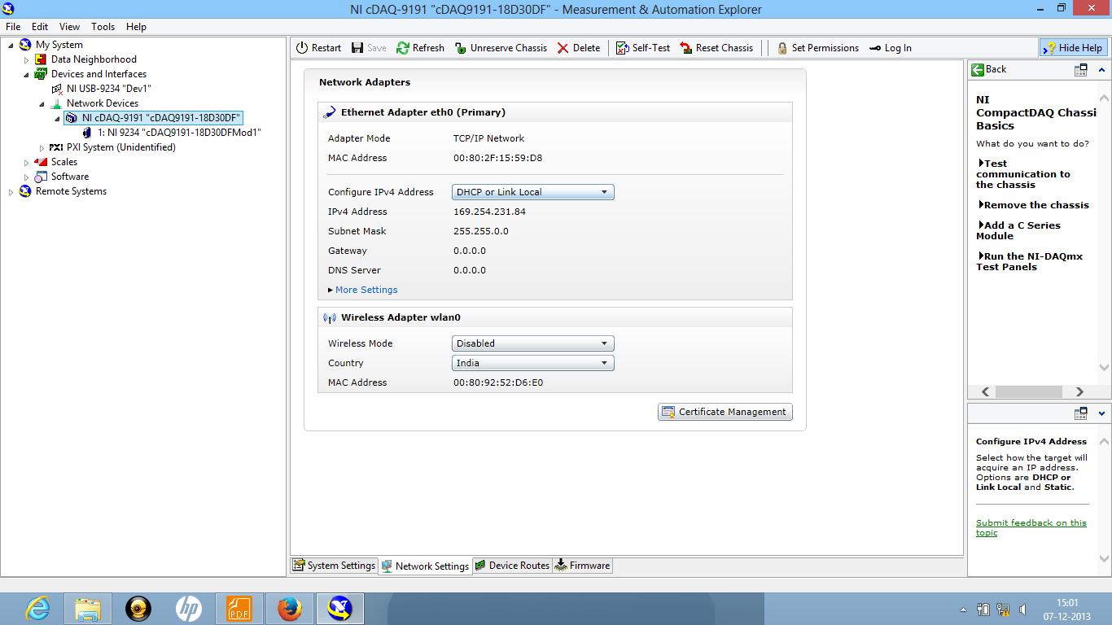

1. The IP addresses get updated automatically. As soon as they do, select static from the Configure IPv4 Address menu.

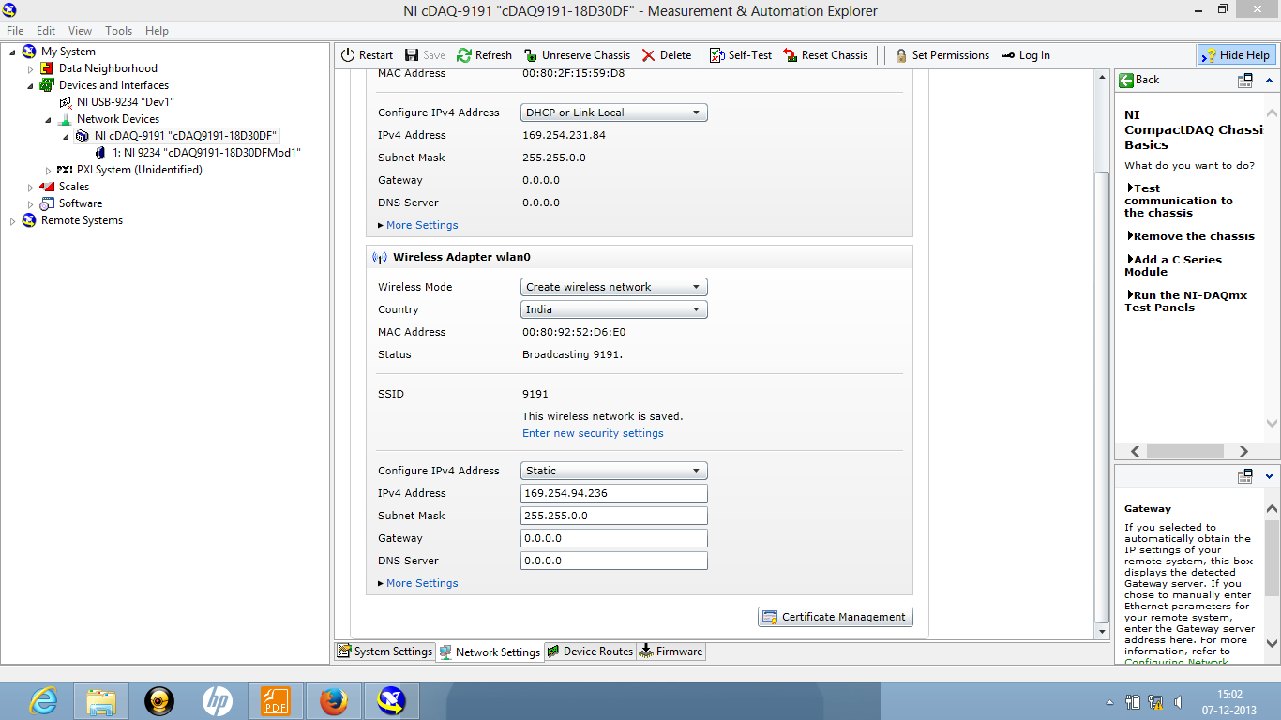

1. The chassis has been configured to broadcast the data. Now one can wirelessly connect to the ad hoc network and receive the data.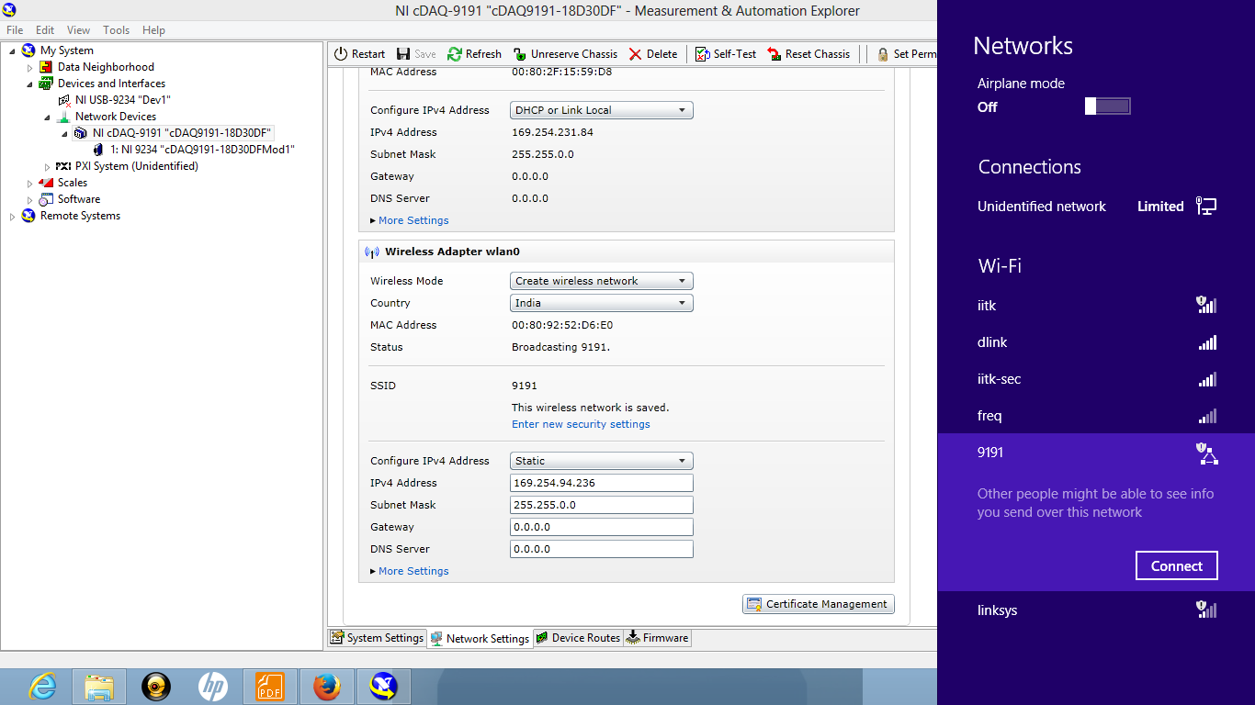
2. One can see the data received in two ways one Ethernet and the other wireless whose IP addresses are also different. In case there are two data receiving ways then it prefers wired over wireless. In order to wirelessly receive the data, unplug the Ethernet cable.

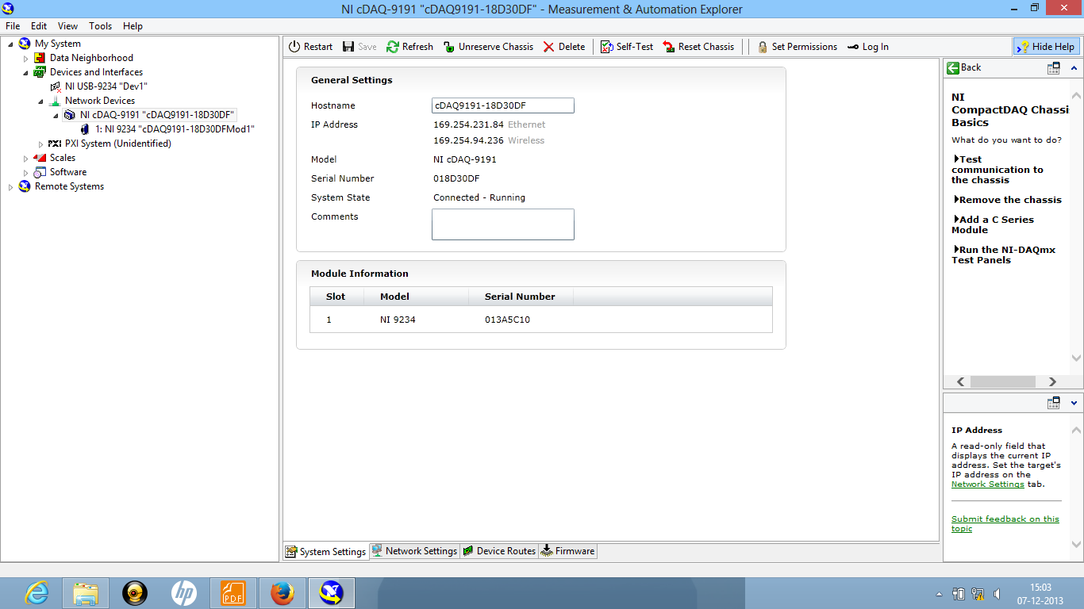

1. Click on test panel to take the measurements

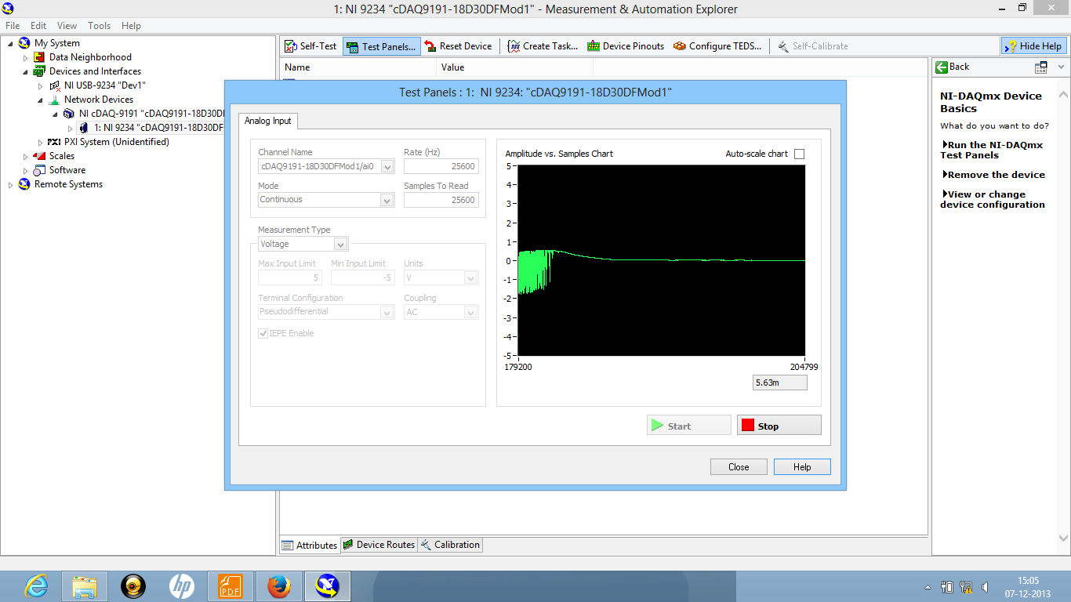

Again over here multiple connections are not possible as the chassis gets reserved to a particular system.

**Wireless DAQ to an android smartphone**

Type of wireless data acquisition --- ad hoc network or peer to peer network

On wireless computer networks, **ad-hoc** mode is a method for wireless devices to directly communicate with each other. Operating in ad-hoc mode allows all wireless devices within range of each other to discover and communicate in peer-to-peer fashion without involving central access points (including those built in to broadband wireless [routers](http://compnetworking.about.com/library/glossary/bldef-router.htm)).

Android app installed on smartphone—NI cDAQ-9191 Data Display

Mobile phone app couldn’t detect the network, as it demanded a firmware upgrade of the chassis.

**Chassis 9191 upgraded from 1.2.0f1 to 1.2.10f2**

Even then Mobile phone app couldn’t detect the network as the upgrade was not designed for

9234 module

## Wireless DAQ to Laptop using an intermediate router.

## Procedure 1:

## Connecting the chassis to the router via an Ethernet cable.

Steps:

Connect the chassis to the router via a LAN cable. In this case the router’s network is called “dlink”.

Now, DAQmx shows that the chassis is not wired to the laptop. Connect to the router’s network and refresh the program.

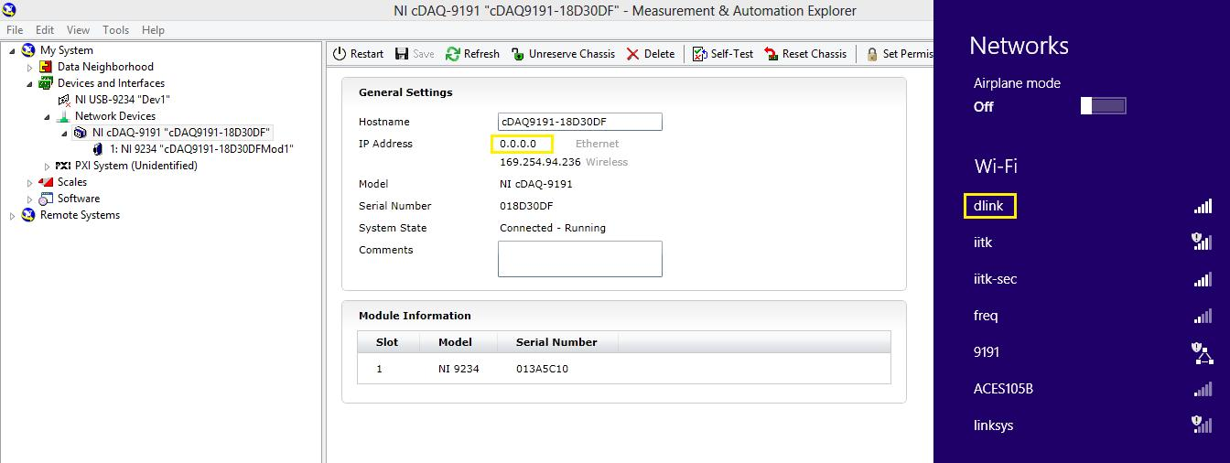

It should now start showing that the chassis is connected via Ethernet with the address being that of the router. This means that the chassis sends data to the router via the cable which we receive from “dlink”.

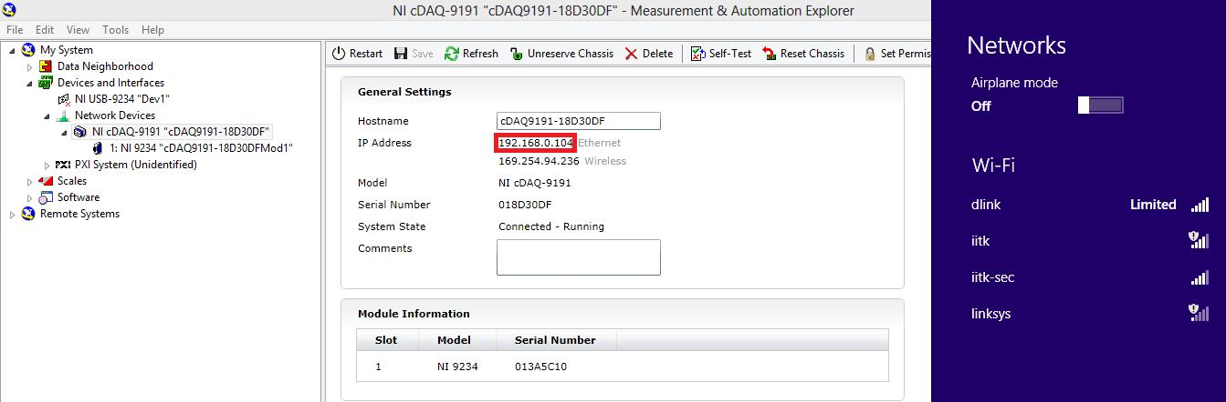

To test the data, click the test panels tab and a waveform is obtained indicating successful transmission of data from the chassis to the laptop.

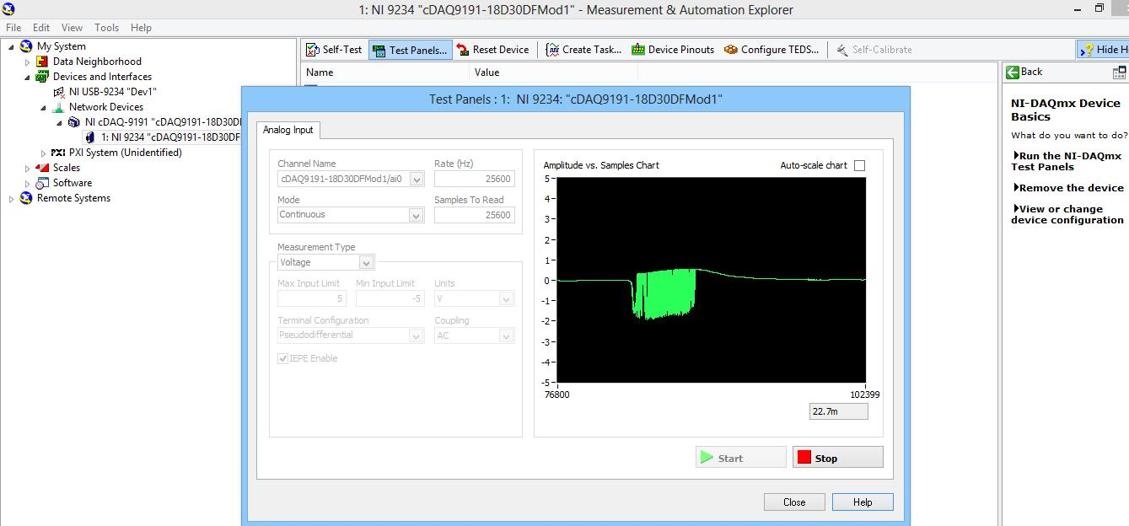

## Procedure 2:

## Connecting the chassis to the router wirelessly.

Steps:

Connect the chassis to the laptop via the Ethernet cable. The chassis shall be wired until its wireless configuration is finished.

Click on the chassis icon, go to network settings and under the “wireless mode”, select Connect to wireless network”. Select the router’s network in the wireless network menu and let the ipv4 address be “DHPC or Link Local”.

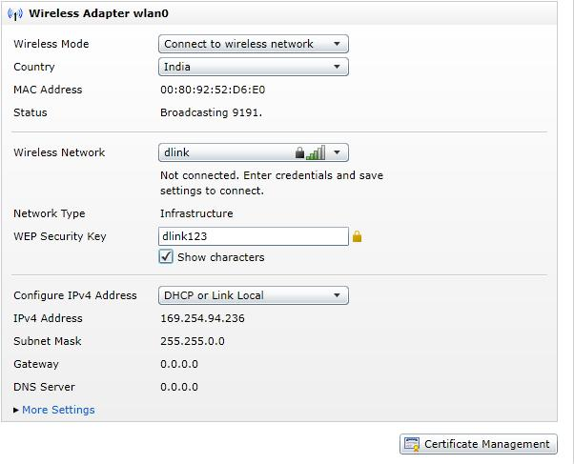

Click save settings.

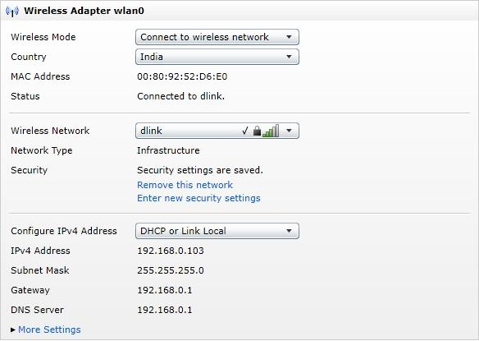

Now the wireless IP address of the chassis would show the router’s address meaning it was successful in connecting to the router.

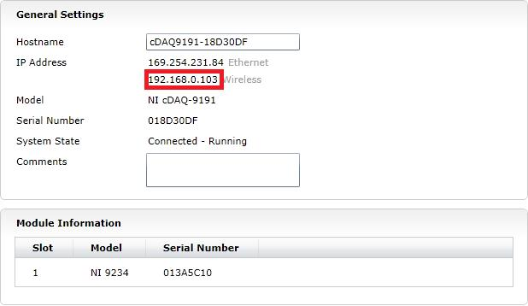

Now unplug the Ethernet cable, connect to the router’s network and click “test panels” to take measurements.

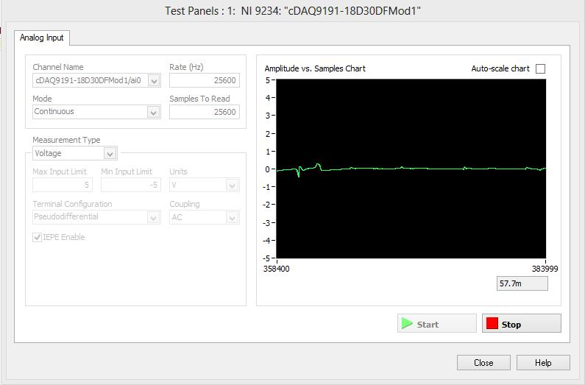

Wireless DAQ to Smartphone using an intermediate router.

Since after the firmware upgrade for cDAQ 9191 chassis, the Smartphone was not able to detect the network, a router was used to make the chassis’ network available to the phone. Its setup was similar as in connecting the chassis wirelessly to the router in the previous example.

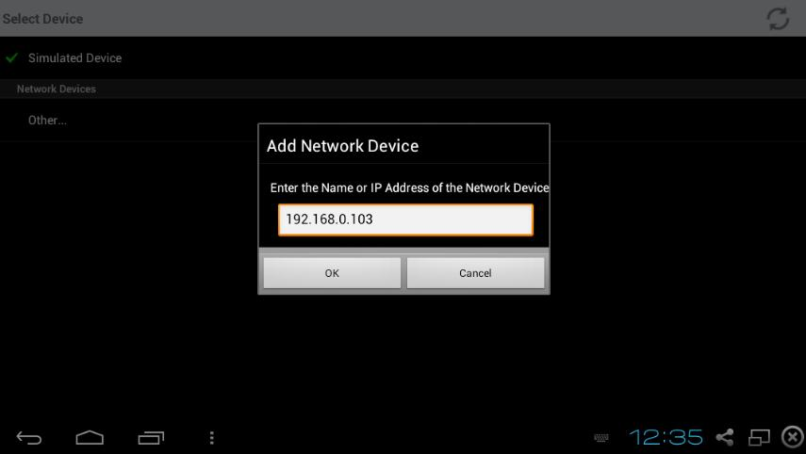

The IP address of the chassis was manually entered in the Data Display App of the Smartphone as shown in the screenshot above. The Smartphone returned the following error.

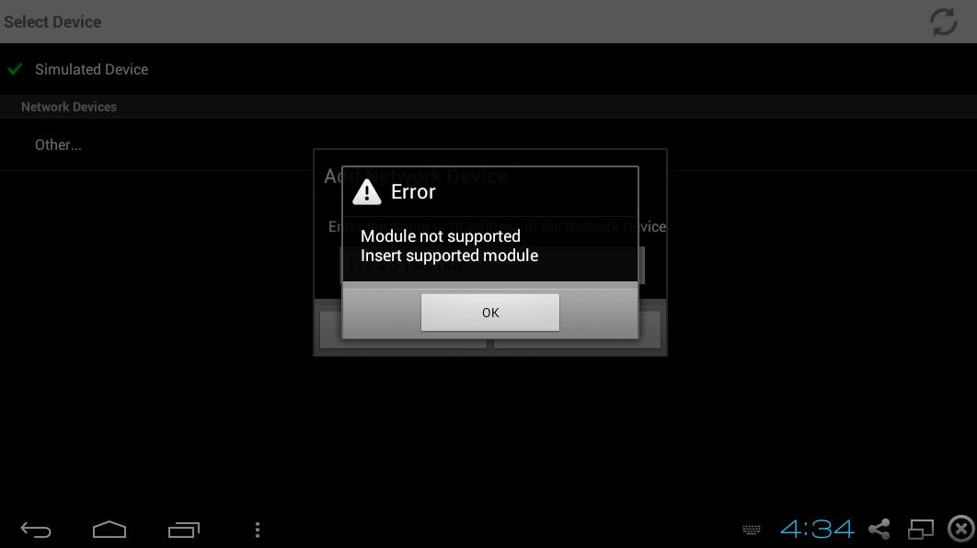

This was because the firmware upgrade was designed for cDAQ 9215 module whereas the one linked to the chassis was cDAQ 9234 which was not compatible with upgrade.

### Wireless DAQ to Smartphone using laptop as an intermediate

This requires the Data Dashboard App to be installed on the Smartphone.

Steps:

Connect the chassis to the laptop using an Ethernet cable.

In the network settings, select “Connect to wireless network” in the Wireless mode menu.

Choose an available network (As in this example “iitk” network). Let the “Configure ipv4 address” be “DHPC or Link Local”.

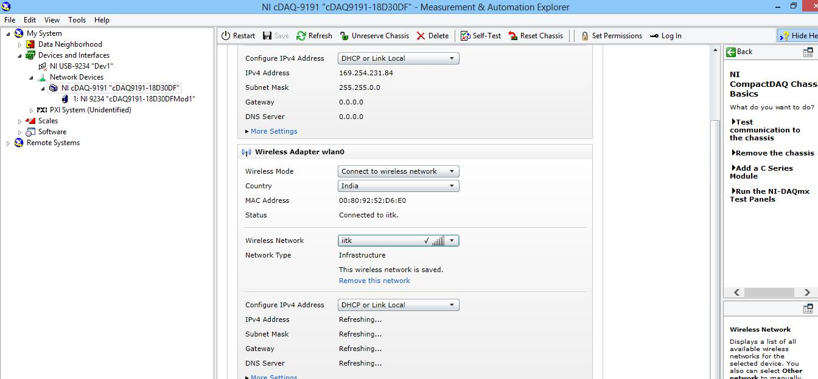

Save the settings to let them take effect and then select “static” from the “Configure ipv4 address”.

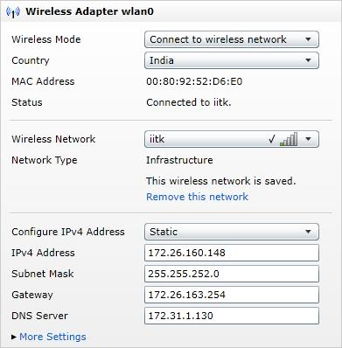

Now, unplug the Ethernet cable and connect the laptop to the same network i.e. “iitk”.

Connect the Smartphone to “iitk” as well.

The process works in the following way:

The chassis sends data to the laptop via “iitk” network. The Laptop takes the data in the form of a waveform and with the help of a LabVIEW program, puts the waveform in a variable. This variable is of “Graph” data type.

**Data Dashboard version 2.0 (iPad)**

The data (which is of graph data type) is put into the shared variable which is again of graph data type. Now, the shared variable is deployed on the network. The Data Dashboard app on the iPad can access the shared variables as it supports graph data type.

**Data Dashboard version 1.0 (Android Smartphone)**

This App does not support graphs so the data (which is of graph data type) is converted (extracted) to yield a scalar data type which is put into the shared variable which is of scalar data type. The shared variable is then deployed on the network. Now the data dashboard app on the android Smartphone can access the shared variables

The waveform is converted to a scalar data type like a “double” using the “Convert from dynamic data” function in LabVIEW.

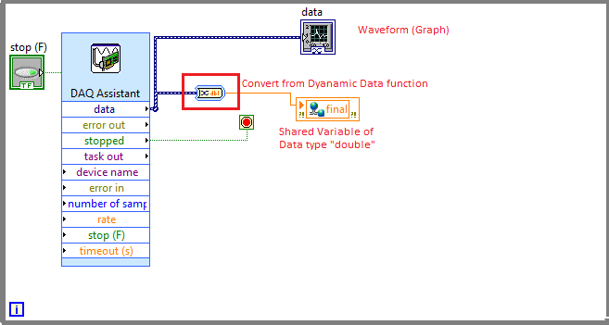

This is put into a shared variable which is then deployed over the network the laptop is connected to (iitk).

Note the IP address from the deployment dialogue box.

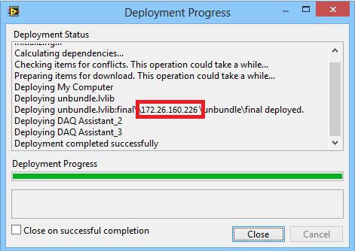

Open the Data Dashboard App in the phone and follow the steps in the screenshots.

Select “Add”

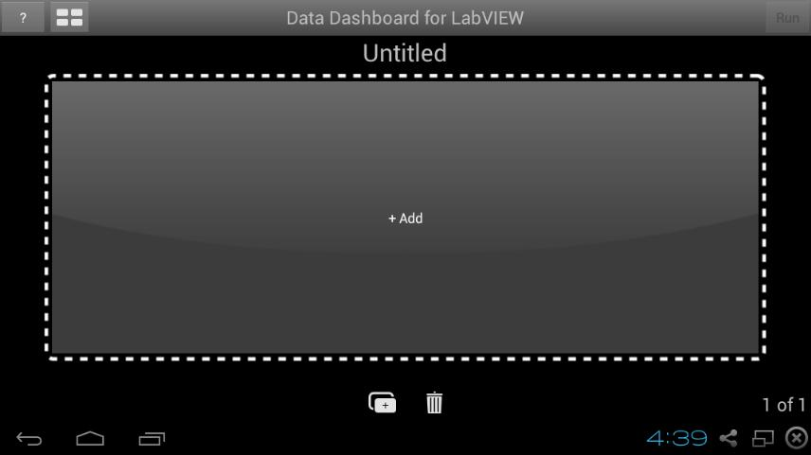

Select “Connect to shared variable”.

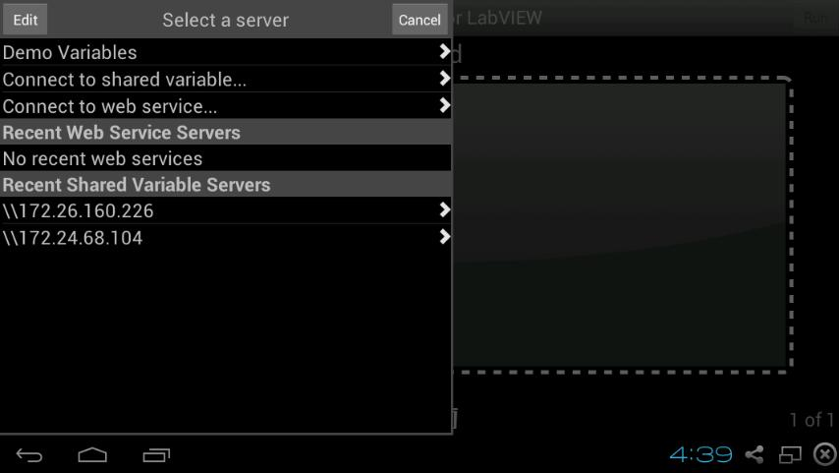

Enter the IP address noted down before. This would give the list of all the deployed libraries on the server.

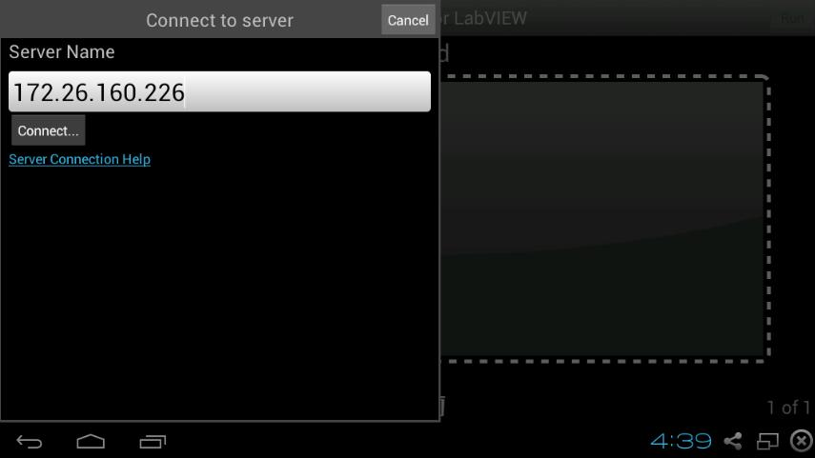

Select the one which has the shared variable and run the simulation.

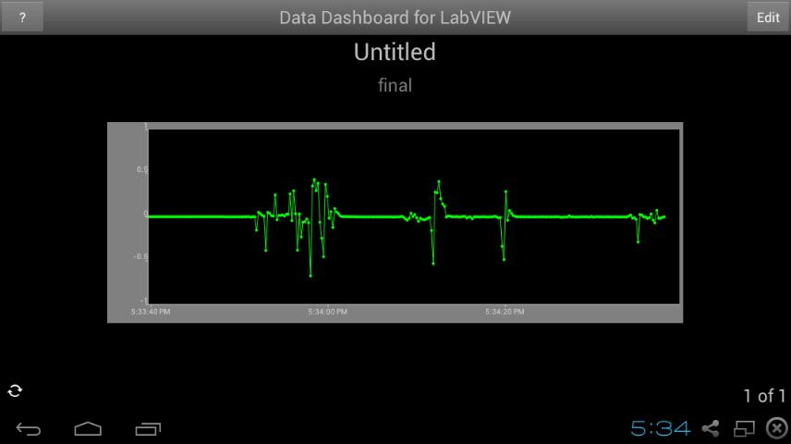

The no of samples read, sampling rate etc. can be configured from the DAQ Assistant in LabVIEW.