BLUE-GREEN DEPLOYMENT ON AWS
Project Objective
The objective of this project is to implement a Blue-Green Deployment strategy on AWS using EC2, VPC, Target Groups and Application Load Balancer. It allows us to deploy a new application version safely and shift traffic gradually from the old environment to the new environment.

1. VPC and Network Setup
A VPC named BG-VPC was created with CIDR 10.0.0.0/16.
Two public subnets were created:
- Public-1: 10.0.1.0/24
- Public-2: 10.0.2.0/24
An Internet Gateway (BG-IGW) and Route Table (BG-RT) were configured to provide internet connectivity.

2. Blue Environment
The Blue environment represents the existing stable version of the application.
- EC2 Instance: Blue-Server
- Subnet: Public-1
- Web Server: Apache
- Application Version: VERSION 1 (BLUE)
The Blue environment initially handled 100% of the traffic.

3. Green Environment
The Green environment represents the new version of the application.
- EC2 Instance: Green-Server
- Subnet: Public-2
- Web Server: Apache
- Application Version: VERSION 2 (GREEN)
The Green environment was prepared separately so that the new version could be tested before receiving all user traffic.

4. Target Groups
Two target groups were created:
- TG-Blue → Blue-Server
- TG-Green → Green-Server
Both target groups use HTTP port 80.

5. Application Load Balancer
An Application Load Balancer named BlueGreen-ALB was created.
Configuration:
- Type: Internet-facing
- VPC: BG-VPC
- Subnets: Public-1 and Public-2
- Security Group: Web-SG
- Listener: HTTP : 80
- Default Target Group: TG-Blue
Initially, the ALB forwarded 100% traffic to TG-Blue.

6. Initial Testing
The ALB DNS name was opened in a browser using:
http://ALB-DNS-NAME
The browser displayed:
VERSION 1 (BLUE)
Refreshing the page repeatedly continued to show the Blue version.

7. Canary Deployment
A Canary deployment was performed to gradually shift traffic from Blue to Green.
The listener rule was changed to:
Target Group | Traffic
TG-Blue | 80%
TG-Green | 20%
After saving the changes, the configuration was allowed to propagate for approximately 30–60 seconds.
Repeated browser refreshes were used to verify that traffic was being distributed between Blue and Green.

8. Blue Environment Screenshot

The screenshot shows:
VERSION 1 (BLUE)
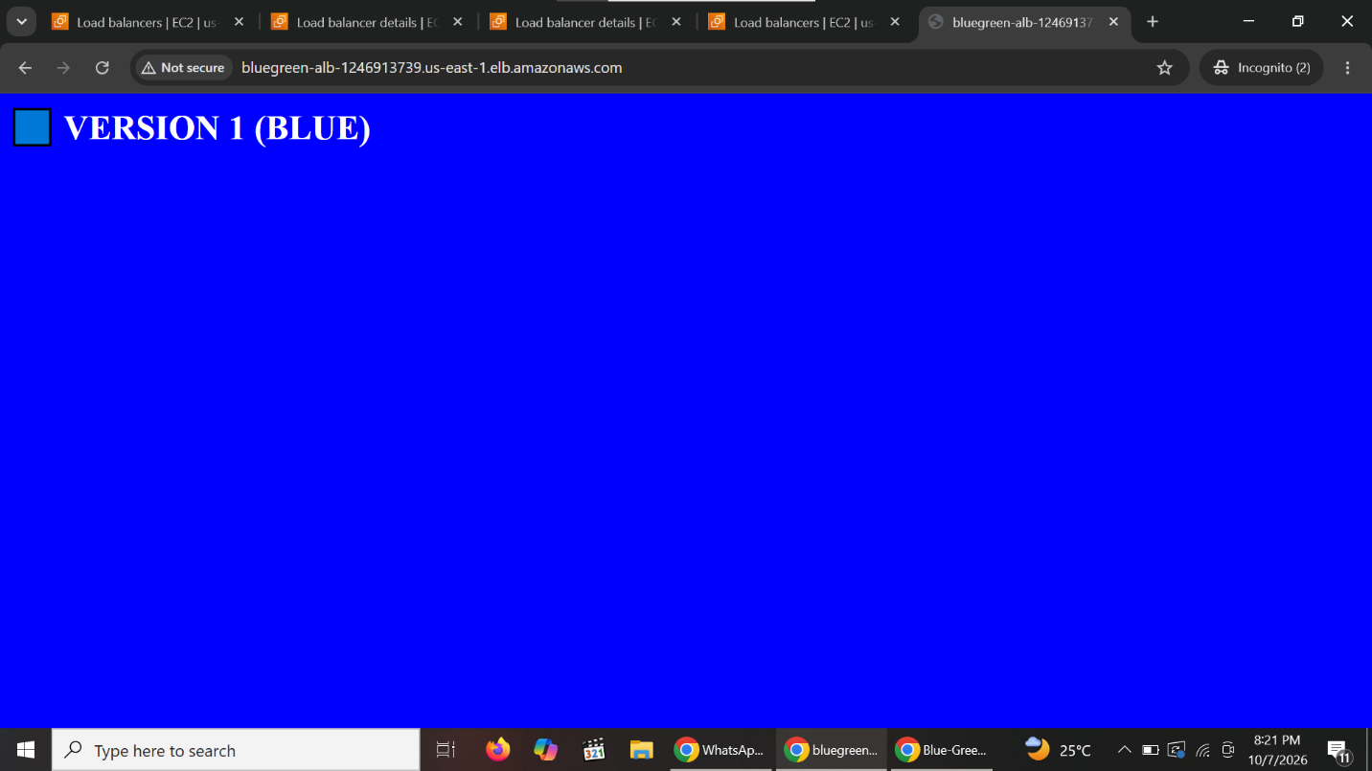

9. Green Environment Screenshot

The screenshot shows:
VERSION 2 (GREEN)
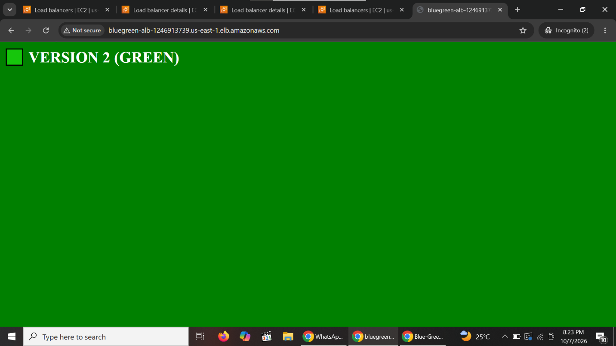s

10. Full Cutover
After successful Canary testing, the deployment was completed by changing the traffic weights to:
Target Group | Final Traffic
TG-Blue | 0%
TG-Green | 100%
Now, the Application Load Balancer routes 100% of the traffic to the Green environment.
The expected result is:
VERSION 2 (GREEN)

11. Result
The Blue-Green deployment was successfully implemented on AWS.
The traffic was initially routed 100% to Blue, then shifted using a Canary deployment of 80% Blue and 20% Green, and finally changed to 0% Blue and 100% Green.

12. Technologies Used
- AWS VPC
- Amazon EC2
- Application Load Balancer (ALB)
- Target Groups
- Security Groups
- Internet Gateway
- Route Table
- Apache HTTP Server
- Blue-Green Deployment
- Canary Deployment

13. Conclusion
Blue-Green deployment provides a safe way to release a new application version. The existing Blue environment continues to serve users while the Green environment is tested. Traffic can then be gradually shifted to Green, reducing deployment risk and minimizing downtime.

