ICS4U Java Level 4 Final Project Proposal

3 TURN KLONDIKE by Lokhin Wu

Screen layout
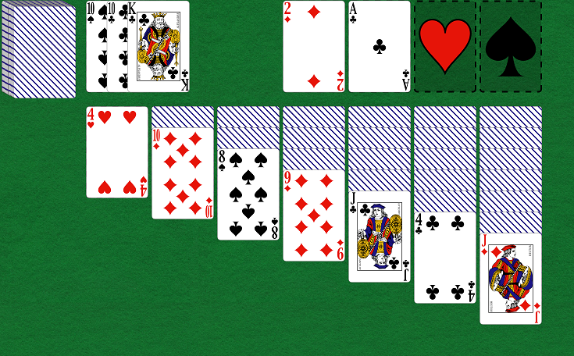

Game Play Description:

OBJECTIVE:

The objective is to collect all cards from the Ace to the King of all four different suits. These cards will be placed in piles called the “foundation.” Once all the foundations have been collected from the Ace to the King, the user wins.

SETUP:

The game is setup with one full deck of 52 cards. The deck is shuffled, and the cards will be dealt in a random order. At the beginning, there are 7 rows of cards (called tableaus). The number of cards in each tableau are determined by their row number (row 1 will have one card at the beginning where row 7 would have 7 cards in the beginning.) The remaining cards go into a “stock” deck, where the user can pick up three cards at a time. There are also 4 piles at the top right called the “foundation.” Each with a corresponding suit, this is where you store the cards from Ace to King.

VALID MOVES:

Moves are valid when a card is dragged on top of another card that is a value higher than the card being dragged and is an opposite color (blacks go on top of reds, and vice versa.) An example of a valid move would be dragging a seven of spades on top of a eight of hearts.

The top four “foundation” piles must start from the Ace and ascend to the King. They must be of the same suit.

SCORING:

Minimum score is 0.

Points are gained or lost through the following 5 types of movements.

Move | Points
Waste to Tableau | 5
Waste to Foundation | 5
Tableau to Foundation | 10
Turn over Tableau Card | 5
Foundation to Tableau | -15

