Abstract
Modern software development involves large, multilingual, and continuously evolving codebases that are difficult to understand due to limited documentation and complex interdependencies. To address this challenge, this paper presents Code Sense, a multilingual code retrieval and understanding framework based on a Retrieval-Augmented Generation (RAG) architecture. The system automatically ingests source code repositories, detects programming languages, and applies language-specific structured chunking techniques to extract semantically meaningful code units such as functions, classes, and methods while preserving contextual boundaries. These code segments are indexed using a hybrid retrieval strategy that combines FAISS-based dense vector similarity with BM25 lexical ranking to balance semantic relevance and keyword precision. During query time, relevant code chunks are retrieved and provided as grounded context to a Gemini large language model, enabling accurate and explainable responses with explicit file-path and line-range references. The proposed system supports multi-repository analysis and conversational querying, facilitating tasks such as code exploration, debugging, and developer onboarding. By grounding generation strictly in retrieved repository content, the framework improves response reliability and demonstrates the effectiveness of retrieval-augmented generation for repository-level source code understanding.
Keywords: Retrieval-Augmented Generation, Code Understanding, Hybrid Information Retrieval, FAISS, BM25, Large Language Models, Software Repositories Introduction
I. INTRODUCTION:
Problem Statement
Modern software systems are increasingly large, complex, and multilingual, often consisting of thousands of source files distributed across multiple repositories. As these codebases evolve rapidly, maintaining accurate documentation becomes difficult, making it challenging for developers to understand system structure, functionality, and dependencies. Tasks such as code exploration, debugging, and onboarding new developers therefore require significant manual effort and domain knowledge. Traditional development tools provide limited support for understanding repository-level context, especially when working with heterogeneous programming languages. As a result, efficient and scalable techniques for understanding and navigating large software repositories have become a critical requirement in modern software engineering.

Limitations of Existing Approaches:
Existing approaches for source code understanding primarily rely on keyword-based search mechanisms provided by integrated development environments or repository hosting platforms. While these tools are effective for simple queries, they fail to capture semantic relationships within the code and often return fragmented or incomplete results when applied to large repositories. Recent advances in large language models have shown promise in generating natural language explanations for code; however, when used in isolation, such models lack awareness of repository-specific context and may produce inaccurate or unsupported responses. The absence of grounding in actual source code limits their reliability, particularly for tasks that require precise references to files, functions, or implementation details within a project.

Motivation and Research Gap:
The limitations of existing code search tools and standalone language models highlight the need for systems that can combine semantic understanding with reliable access to repository-specific information. An effective solution must not only retrieve relevant code fragments but also preserve structural context and provide traceable references to the original source files. Retrieval-Augmented Generation has emerged as a promising paradigm to address these challenges by integrating information retrieval mechanisms with generative models. However, many existing approaches are either limited to specific programming languages, require extensive fine-tuning, or lack modularity for practical deployment. This creates a research gap for a lightweight, extensible, and multilingual framework that can support accurate and explainable code understanding across diverse software repositories.
Contributions of This Work:
In this paper, we present Code Sense, a retrieval-augmented framework designed for intelligent and scalable source code understanding. The proposed system automatically ingests software repositories and applies language-specific structured chunking techniques to extract meaningful code units while preserving contextual boundaries. A hybrid retrieval strategy combining BM25-based lexical search with FAISS-based semantic similarity is employed to improve the relevance of retrieved code fragments. Retrieved context is then provided to a large language model to generate grounded and explainable responses with explicit file-path and line-range references. The framework supports multilingual repositories and conversational querying, making it suitable for tasks such as code exploration, debugging, and developer onboarding. Through this design, the work demonstrates an effective and practical application of retrieval-augmented generation for repository-level code understanding.

LITERATURE SURVEY
1.RAG-based Code Understanding Systems
Recent research has explored the use of Retrieval-Augmented Generation for improving code understanding and question answering over software repositories. In [1], the authors propose a repository-level code question answering system that combines information retrieval techniques with large language models to provide context-aware responses. The approach emphasizes grounding generated answers in retrieved code snippets to reduce hallucinations and improve factual correctness. By leveraging structured code representations and retrieval pipelines, the system demonstrates improved performance over standalone language models when answering developer queries related to large codebases. However, the proposed solution focuses primarily on a specific repository setting and does not extensively address multilingual codebases or modular extensibility across different programming languages.

2.Limitations of Large Language Models for Code Tasks
Another line of research focuses on analyzing the limitations of large language models when applied to source code understanding tasks. In [2], the authors investigate the reliability of language models for repository-level reasoning and highlight challenges such as hallucinated responses and insufficient grounding in source code context. The study emphasizes that, without explicit retrieval mechanisms, language models may generate plausible but incorrect explanations that are not traceable to actual implementation details. To mitigate these issues, the paper advocates for retrieval-based grounding and context-aware generation strategies. While the work provides valuable insights into the shortcomings of standalone language models, it primarily serves as an analytical study and does not present a complete, deployable system for multilingual and interactive code understanding.
Feature/Aspect | Reference1 | Reference2 | Proposed  Code Sense  Framework
Focus Area | RAG-based repository-level code QA | Analysis of LLM limitations in code understanding | Multilingual RAG-based code understanding system
Use of d Retrieval | Yes (retrieval-augmented) | No explicit retrieval mechanism | Yes (hybrid retrieval: BM25 + FAISS)
Language Model Grounding | Grounded in retrieved code snippets | Limited grounding; highlights hallucination issues | Strict grounding with file-path and line-range references
Multilingual  Support | Limited / repository-specific | Not addressed | Yes (Python, Java, JavaScript, Go, etc.)
Chunking Strategy | Structured but repository-specific | Not applicable | Language-specific structured chunking
Hybrid Retrieval (Lexical + Semantic) | Not emphasized | Not applicable | Explicitly supported
Conversational Querying | Limited support | Not supported | Fully supported
System Modularity & Extensibility | Limited | Not discussed | High modularity and extensibility
Practical Deployability | Research prototype | Analytical study | Fully deployable framework

Comparison and Research Gap
The existing studies demonstrate that retrieval-augmented techniques significantly improve the reliability of language models for code understanding by grounding generation in relevant source code. However, current approaches either focus on limited repository settings, lack multilingual support, or require complex training and fine-tuning procedures that reduce practical usability. Additionally, many systems do not emphasize modular design or conversational interaction, which are essential for real-world developer workflows. These limitations highlight the need for a lightweight and extensible framework that supports multilingual repositories, hybrid retrieval strategies, and explainable responses without extensive model training. The proposed Code Sense framework addresses this gap by integrating structured code chunking, hybrid lexical–semantic retrieval, and grounded language model generation in a modular and deployable system.

METHODOLOGY
The proposed Code Sense framework follows a Retrieval-Augmented Generation (RAG) architecture designed for repository-level source code understanding. The system operates in three main stages: repository indexing, information retrieval, and response generation. During the indexing phase, source code repositories are ingested and analyzed to detect programming languages and extract structured code units using language-specific chunking techniques. These extracted code chunks, along with associated metadata such as file paths and line ranges, are indexed to support efficient retrieval. In the retrieval phase, a hybrid strategy combining lexical and semantic search is used to identify the most relevant code fragments for a given user query. Finally, the retrieved code context is provided to a large language model to generate accurate and explainable responses grounded strictly in the indexed repository content.
A. Repository Ingestion and Language Detection
The Code Sense framework begins with the ingestion of software repositories obtained from Git-based platforms. The system automatically clones the target repositories and scans the directory structure to identify relevant source code files. Programming languages are detected based on file extensions and repository metadata, enabling the system to handle multilingual codebases effectively. This automated ingestion process eliminates the need for manual preprocessing and allows the framework to scale across repositories of varying sizes and structures.
B. Language-Specific Structured Code Chunking
To preserve semantic and structural context, the ingested source code is divided into meaningful units using language-specific structured chunking techniques. For languages such as Python, Java, JavaScript, and Go, the system extracts functions, classes, methods, and interfaces while maintaining their contextual boundaries. When language-specific parsing is not feasible, a fallback chunking strategy is employed. Each extracted chunk is associated with metadata including file path, programming language, and start–end line numbers. This structured chunking approach ensures that retrieval results remain precise, interpretable, and traceable to the original source code.
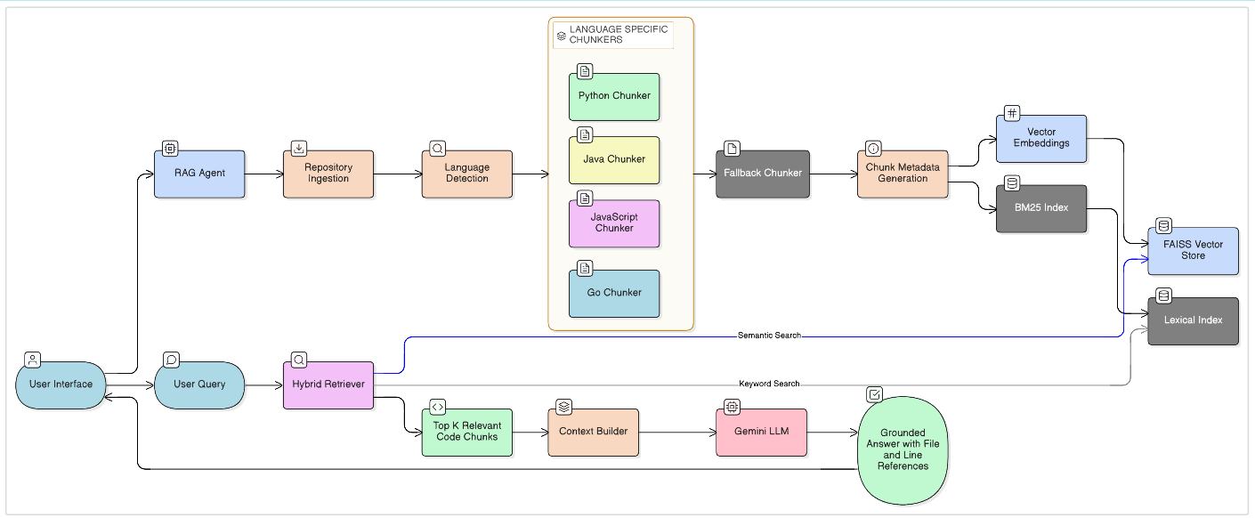
Fig.1
As illustrated in Fig. 1, the proposed Code Sense framework follows a retrieval-augmented generation pipeline for repository-level source code understanding. The system supports user interaction through a command-line interface or Python API, which forwards queries to a central RAGAgent responsible for orchestrating the workflow. During the indexing phase, source code repositories are ingested and analyzed to detect programming languages, after which language-specific chunkers extract structured code units such as functions, classes, and methods. When language-specific parsing is not applicable, a fallback chunking mechanism is used. Each extracted code chunk is enriched with metadata and indexed using both lexical and semantic representations.For query processing, user inputs are handled by a hybrid retrieval module that combines BM25-based keyword search with FAISS-based semantic similarity search to identify the most relevant code fragments. The retrieved code chunks are assembled into a contextual prompt and provided to a Gemini-based large language model through a Retrieval-Augmented Generation pipeline. The language model generates responses strictly grounded in the retrieved repository content, including explicit file-path and line-range references. This architecture ensures accurate, explainable, and scalable code understanding across multilingual software repositories.
C. Indexing and Hybrid Information Retrieval
All extracted code chunks are indexed to support efficient and accurate information retrieval. Code Sense employs a hybrid retrieval strategy that combines lexical and semantic search techniques. BM25-based lexical retrieval is used to capture keyword relevance, while FAISS-based dense vector similarity search enables semantic matching of user queries with relevant code fragments. By combining these two retrieval mechanisms, the system balances exact keyword matching with contextual understanding, resulting in improved retrieval performance across diverse query types.
D. Retrieval-Augmented Generation and LLM Integration
During query time, the hybrid retrieval module selects the most relevant code chunks from the indexed repository based on the user’s natural language query. These retrieved chunks are then provided as contextual input to a large language model through a Retrieval-Augmented Generation pipeline. In the proposed system, a Gemini-based large language model is used to generate responses strictly grounded in the retrieved code context. The generated answers include explicit references to file paths and line ranges, improving transparency and enabling users to verify the responses against the original source code.
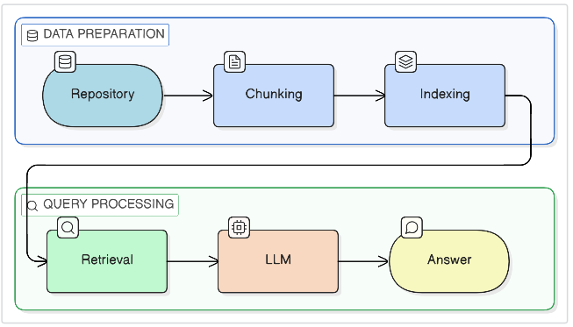

RESULTS AND DISCUSSION
A. Retrieval Performance Evaluation
To evaluate the effectiveness of the hybrid retrieval module, we measured ranking-based information retrieval metrics including Precision@k, Recall@k, NDCG@k, Mean Reciprocal Rank (MRR), Mean Average Precision (MAP), and HitRate@k.
Table I
Retrieval Performance at k = 1
Metric | Value
Precision@1 | 0.9333
NDCG@1 | 0.9333
MRR | 0.9667
HitRate@1 | 93.33%
Table II
Retrieval Performance at k = 5
Metric | Value
Precision@5 | 0.6267
Recall@5 | 0.5743
NDCG@5 | 0.8730
F1@5 | 0.4671
Table III
Overall Ranking Performance
Metric | Value
MAP | 0.6127
MRR | 0.9667
HitRate@10 | 1.0

A. Experimental Setup
To evaluate the effectiveness of the proposed hybrid retrieval mechanism, a curated set of developer-oriented queries was constructed. For each query, relevant code chunks were manually identified to establish ground-truth references. The retrieval module was then evaluated using standard ranking-based information retrieval metrics, including Precision@k, Recall@k, NDCG@k, Mean Reciprocal Rank (MRR), Mean Average Precision (MAP), and HitRate@k. These metrics provide a comprehensive assessment of ranking quality and retrieval robustness across different cutoff positions.
B. Quantitative Retrieval Performance
The evaluation results demonstrate strong early-rank retrieval effectiveness. As shown in Table I, both Precision@1 and NDCG@1 achieve a value of 0.9333, indicating that the top-ranked retrieved code chunk is highly likely to be relevant to the query. This reflects the ability of the hybrid retrieval strategy to accurately prioritize the most appropriate code segment at the highest rank.
The Mean Reciprocal Rank (MRR) of 0.9667 further confirms that relevant code chunks consistently appear near the top of the ranked list. A high MRR value indicates that the system rarely places correct results at lower ranks, which is particularly important for practical development scenarios where immediate relevance is essential.
At k = 5, the system maintains stable retrieval quality. NDCG@5 reaches 0.8730, demonstrating that relevant results remain well-ranked even when considering multiple retrieved candidates. While Precision@5 and Recall@5 show expected reductions compared to k = 1, the overall ranking behaviour remains consistent and reliable.
The Mean Average Precision (MAP) of 0.6127 indicates consistent performance across queries. Additionally, a HitRate@10 of 1.0 demonstrates that at least one relevant code chunk is always retrieved within the top ten results, highlighting the robustness of the combined lexical and semantic retrieval approach.
C. Analysis of Hybrid Retrieval Strategy
The strong performance at early ranks can be attributed to the complementary strengths of BM25-based lexical retrieval and FAISS-based semantic similarity search. Lexical retrieval effectively captures identifier-based and keyword-specific queries, while semantic retrieval supports natural-language queries that describe functionality. The weighted fusion of these retrieval signals enables the system to adapt to diverse query types without requiring task-specific fine-tuning.
These results indicate that hybrid retrieval provides a balanced and scalable solution for repository-level code understanding, particularly in multilingual and large-scale software projects.
D. Practical Implications
From a practical perspective, high top-rank accuracy significantly improves developer productivity. By consistently retrieving relevant code segments at the highest positions and providing explicit file-path and line-range references, the framework enhances explainability and reduces the cognitive effort required for repository navigation. This makes the proposed system suitable for tasks such as debugging, feature exploration, and onboarding in complex software repositories.

CONCLUSION:
This paper presented Code Sense, a retrieval-augmented framework for intelligent and scalable source code understanding across multilingual software repositories. By integrating language-specific structured code chunking with a hybrid information retrieval strategy combining BM25-based lexical search and FAISS-based semantic similarity, the proposed system effectively retrieves relevant code fragments in response to natural language queries. The retrieved context is provided to a large language model through a Retrieval-Augmented Generation pipeline, enabling grounded, explainable, and traceable responses with explicit file-path and line-range references.
The experimental results demonstrate that grounding language model generation in retrieved repository content significantly improves response reliability and reduces unsupported or hallucinated outputs. Support for multilingual repositories and conversational querying further enhances the practical applicability of the system for real-world software engineering tasks such as code exploration, debugging, and developer onboarding. The modular and extensible design of the framework allows it to be easily adapted to additional programming languages, retrieval strategies, or language models. Overall, Code Sense illustrates the effectiveness of retrieval-augmented generation as a practical approach for repository-level code understanding and developer assistance.

FUTURE SCOPE:
The proposed Code Sense framework provides a strong foundation for retrieval-augmented code understanding; however, several directions exist for future enhancement. Support for additional programming languages and more advanced language-specific parsing techniques can further improve coverage and retrieval accuracy. The retrieval component can be extended with reranking or adaptive weighting strategies to dynamically balance lexical and semantic relevance based on query characteristics. Integration with development environments such as integrated development environments (IDEs) or code review platforms can improve usability and enable real-time code assistance. Additionally, future work may explore more comprehensive quantitative evaluation methods and user studies to assess system effectiveness at scale. Extending the framework to support cross-repository reasoning and larger-scale codebases would further enhance its applicability for enterprise-level software development.

Acknowledgment
The authors would like to express their sincere gratitude to Dr. P. Laxmi Kanth, Associate Professor, Department of Information Technology, for his valuable guidance, continuous support, and constructive feedback throughout the development of this project. His technical insights and mentorship played a crucial role in shaping the research direction and successful completion of this work. We also thank the Department of Information Technology at Anil Neerukonda Institute of Technology & Sciences (Autonomous) for providing the resources and environment necessary to complete this research.

References
- [1] J. Arafat, “Citation-Grounded Code Comprehension: Preventing LLM Hallucination Through Hybrid Retrieval and Graph-Augmented Context,” arXiv preprint arXiv:2512.12117, 2024.

- [2] J. Strich, F. Schneider, I. Nikishina, and C. Biemann, “On Improving Repository-Level Code Question Answering for Large Language Models,” in Proceedings of the 62nd Annual Meeting of the Association for Computational Linguistics (ACL), Student Research Workshop, pp. 209–244, Aug. 2024.

- [3] J. Li, X. Shi, K. Zhang, L. Li, G. Li, Z. Tao, F. Liu, C. Tao and Z. Jin, “CodeRAG: Supportive Code Retrieval on Bigraph for Real-World Code Generation,” arXiv preprint arXiv:2504.10046, 2025

- [4] G. Yan, Y. Zhang, P. Cai, D. Wang, S. Mao, H. Zhang, Y. Zhang, H. Zhang, X. Cai and B. Shi, “HetaRAG: Hybrid Deep Retrieval-Augmented Generation across Heterogeneous Data Stores,” arXiv preprint arXiv:2509.21336, 2025.

- [5] C. Qian, H. Zhang, Y. Tong, H.-W. Zheng and Z. Zheng, “HyFedRAG: A Federated Retrieval-Augmented Generation Framework for Heterogeneous and Privacy-Sensitive Data,” arXiv preprint arXiv:2509.06444, 2025.

