**DBMS LAB ASSIGNMENT – 7**

**NAME: K LOKESH**

**REG.NO:19bcs056**

Q1) Write two stored Procedures relevant to your database.

**OUTPUT :**

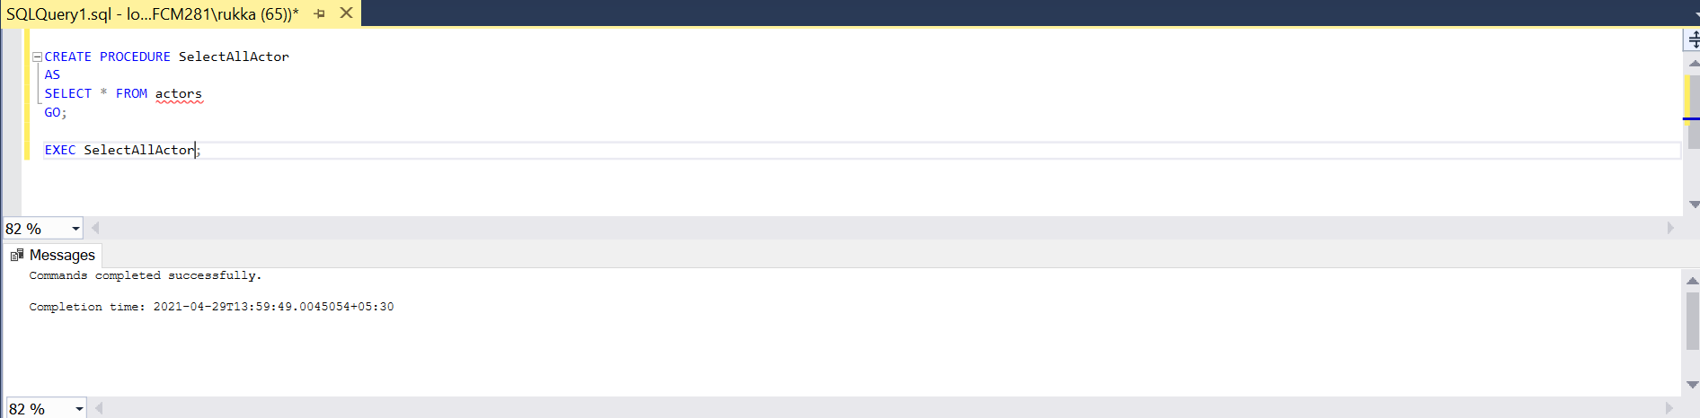

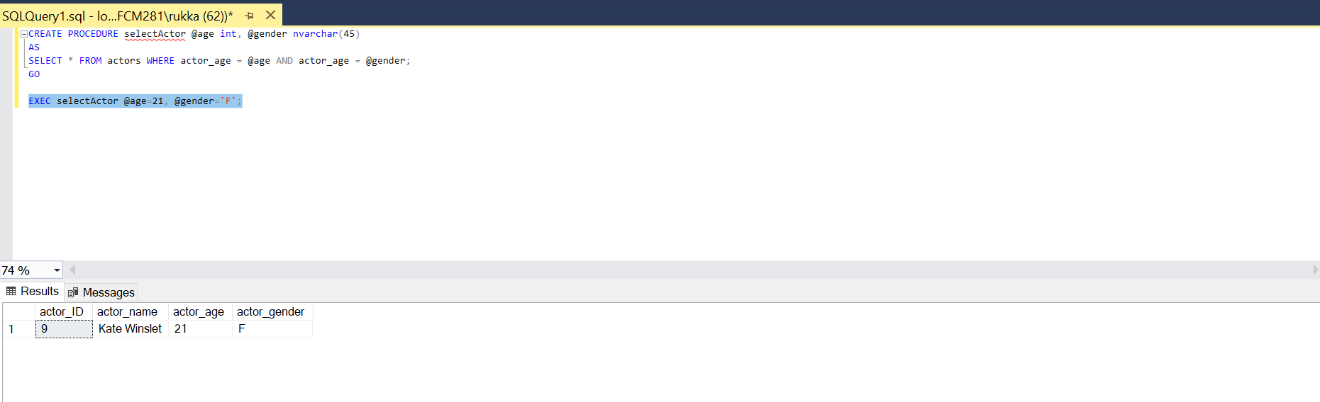

Q2) Write a transaction to illustrate atomicity (related to your database)

**OUTPUT** after transaction is successful

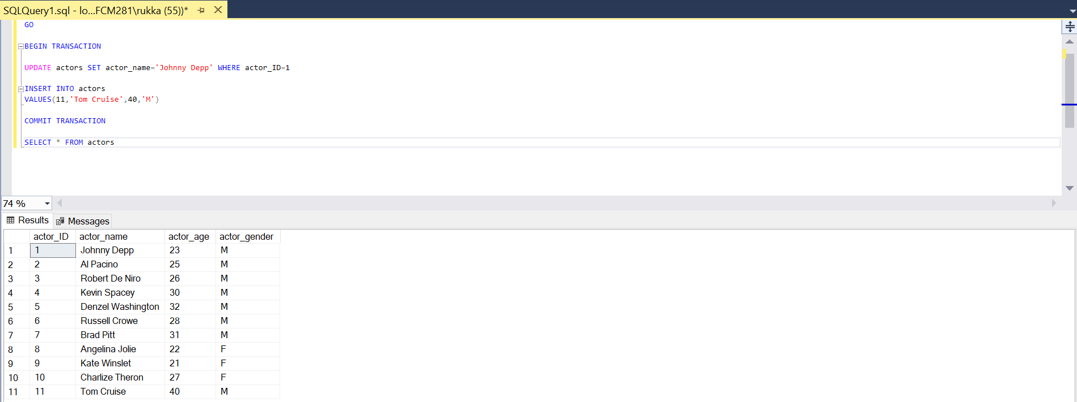

This time we will insert wrong information in the Customers table to fail the

insertion deliberately.

**OUTPUT** after transaction:

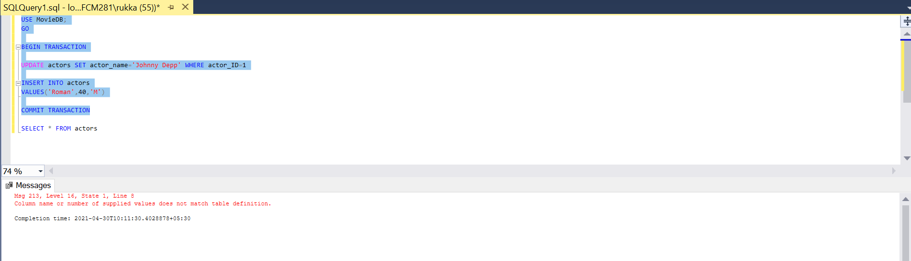

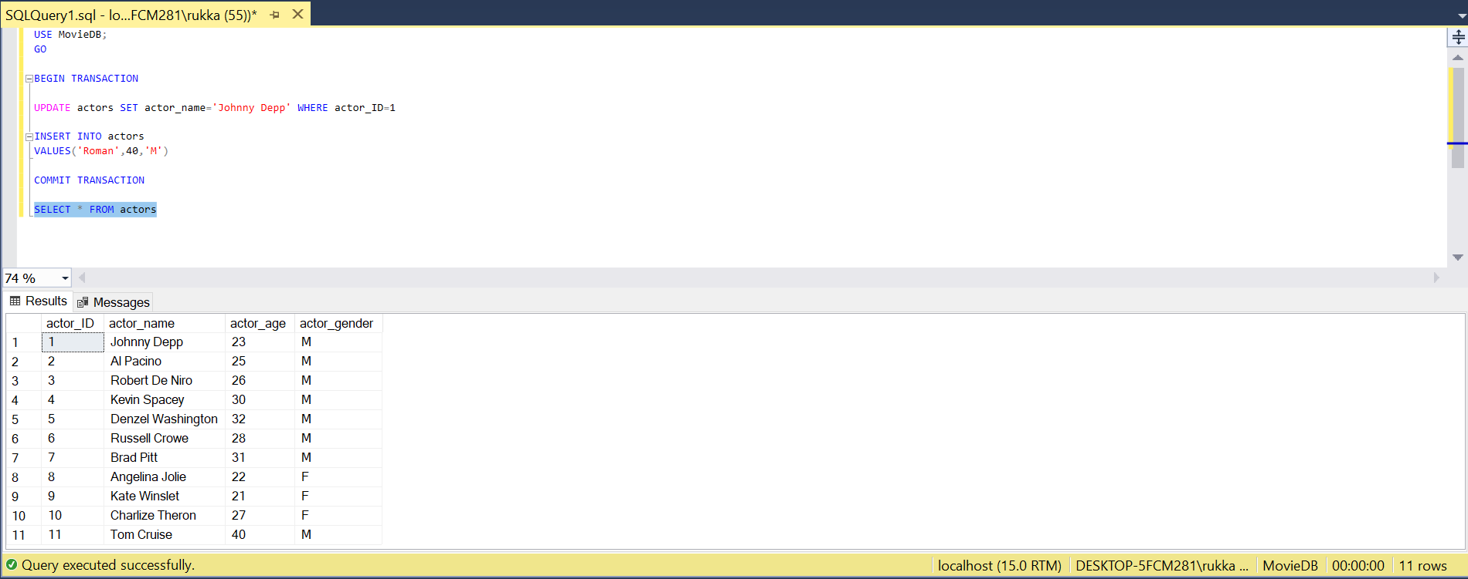

As we could see here when error occurs in the transaction it got rolled back so

the table has its previous values and didn’t get updated.

It means all the statements inside a transaction should either succeed or fail as a

unit. So this is the atomicity property.

Q3) Write a transaction to illustrate isolation level. It can be on commit or

uncommitted (related to your database) ?

