Aspect-Based Sentiment Analysis for Automated Product Review Analysis Using Natural Language Processing
Generated by python -m training.report. The text is maintained in backend/training/report.py; every number is read from the evaluation outputs.
Evaluation date: 2026-10-10T05:00:39+00:00. Test data: SemEval-2014 Task 4 gold test set (laptops, restaurants).

Abstract
Traditional sentiment analysis assigns one label to a whole review, although a review usually praises some features of a product and criticises others. This project builds a system that extracts the product aspects mentioned in a review and classifies the sentiment towards each one. Two fine-tuned BERT models do this: a token classifier that tags aspect terms and a sentence-pair classifier that judges one aspect at a time. A third model gives the traditional single label for comparison. On the SemEval-2014 test sets (laptops, restaurants) the system reaches an aspect-extraction F1 of 0.8462, an aspect-sentiment accuracy of 0.8151 (macro-F1 0.7456) and an end-to-end F1 of 0.6977. A rule-and-lexicon baseline scored on the same data reaches an aspect-extraction F1 of 0.3765 and an end-to-end F1 of 0.2530. The models are served by a REST API with a web interface for single reviews, CSV batches, a review history and an aggregate dashboard.

1. Introduction
Online reviews are a main source of feedback for sellers, but there are too many to read. Automatic sentiment analysis helps, yet a single positive or negative label answers the wrong question. The sentence "The screen is gorgeous but the battery life is terrible" is neither positive nor negative: it is positive about the screen and negative about the battery. A seller needs exactly that breakdown.
Aspect-based sentiment analysis (ABSA) produces it. The task has two parts:
- Aspect term extraction: find the words that name a feature of the product.
- Aspect sentiment classification: decide the sentiment expressed towards each one.
The objectives of the project were to build both parts with learnt models and no hard-coded aspect list, to measure them on a standard benchmark, to compare them with a method that uses no neural model, and to deliver a working application around them.

2. Dataset
SemEval-2014 Task 4 (Pontiki et al., 2014): review sentences from two domains, laptops and restaurants, annotated by people with aspect terms, their character offsets and their polarity. The official training data was split 90/10 into training and validation; the official gold test set is used unchanged.
Domain | Training sentences | Validation sentences | Test sentences | Test aspect terms
laptops | 2723 | 303 | 800 | 654
restaurants | 2726 | 303 | 800 | 1134

The preparation script validates the annotations and removes training sentences that are duplicates or that also occur in the test set, so that no sentence is shared between splits. Aspects annotated as conflict (both praised and criticised) are kept for extraction and left out of sentiment classification, the usual three-class setting. Details: methodology.md, section 2.

3. Method
All models start from bert-base-uncased and are fine-tuned end to end.
Preprocessing. Text is cleaned (HTML, Unicode, whitespace), split into sentences and tokenised into words with character offsets. Stop words are not removed and nothing is stemmed, because BERT depends on words such as "not" and "but". The same code prepares text for training and for the running application.
Aspect extraction. A token classifier labels every word B-ASPECT, I-ASPECT or O (BIO scheme), so multi-word aspects such as "battery life" are found as one unit. When BERT splits a word into several pieces, the first piece carries the label.
Aspect sentiment. A sentence-pair classifier receives [CLS] sentence [SEP] aspect [SEP] and outputs positive, negative or neutral. Because the aspect is part of the input, one sentence can receive different labels for different aspects.
Overall sentiment. A third classifier reads the sentence alone. It represents the traditional approach and is shown next to the aspect-based result. SemEval-2014 has no sentence-level labels, so it is trained on labels derived from the aspect polarities; its scores are indicative only.
Baseline. To measure what the neural models add, the same tasks are solved without them: aspects are runs of nouns found by a part-of-speech tagger, and sentiment is a count of opinion words from the Hu and Liu (2004) lexicon in the aspect's clause, with a simple negation rule.

4. System
review -> preprocessing -> aspect extraction -> aspect sentiment + overall sentiment
-> REST API (FastAPI) -> database (SQLite) -> web interface (React)
The backend exposes endpoints to analyse one review or a batch, to list, read and delete stored reviews, and to return aggregate statistics, service health and the evaluation report. The web interface has five pages: an introduction, the analyzer (highlighted aspects, a table with sentiment and confidence, and the overall label), batch analysis of CSV files with export, the review history, and a dashboard with charts and the models' test metrics. Architecture: architecture.md. Endpoints: API.md.
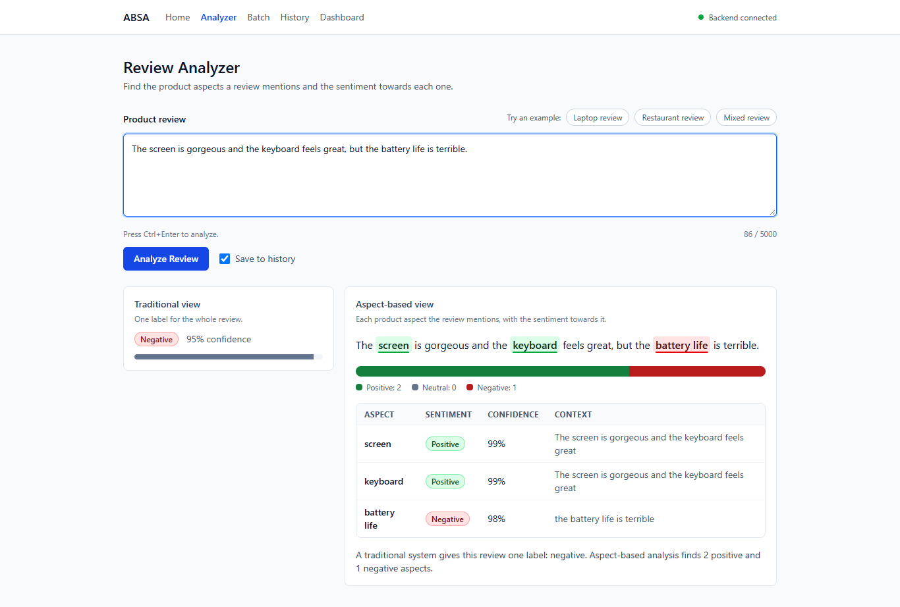
The analyzer: overall label, highlighted aspects and the aspect table
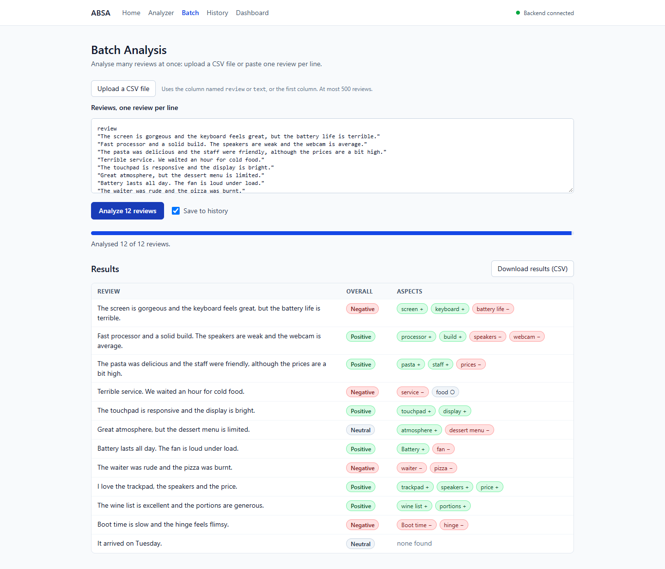
Batch analysis of a CSV file
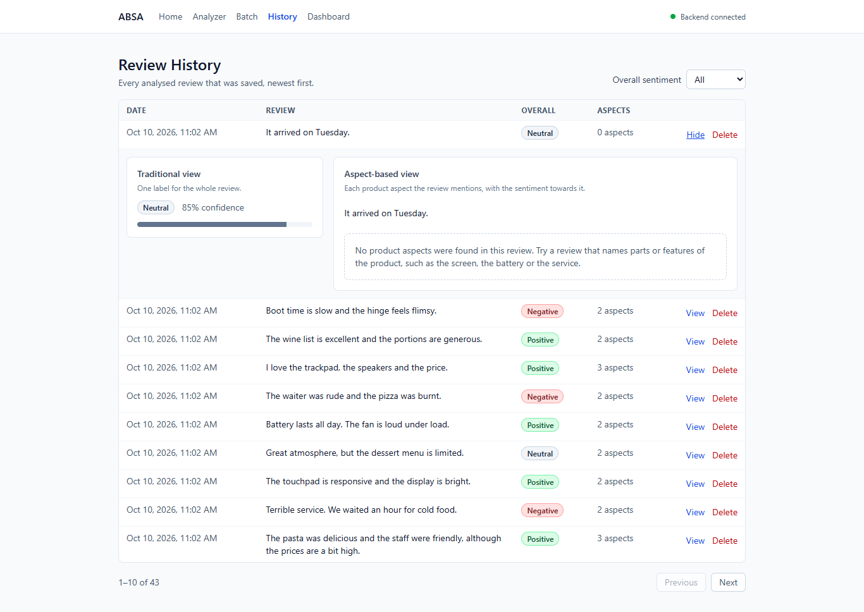
Review history with one analysis opened
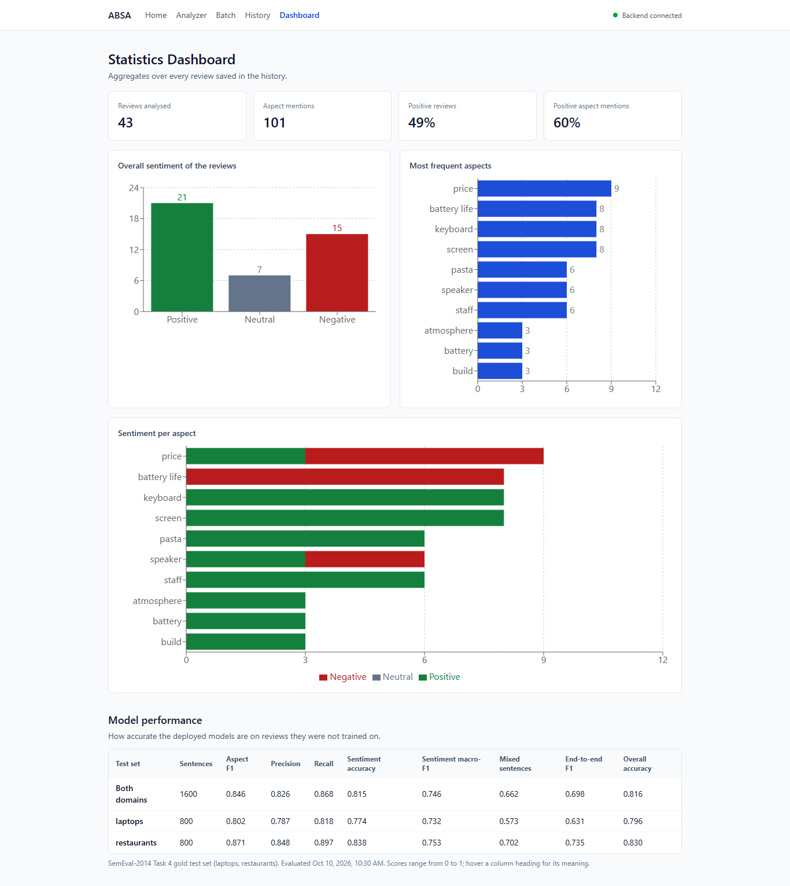
Dashboard: aggregate charts and the models' test metrics

5. Experimental setup
 | Aspect extraction | Aspect sentiment | Overall sentiment
Training domains | laptops, restaurants | laptops, restaurants | laptops, restaurants
Epochs | 3 | 4 | 4
Batch size | 16 | 16 | 16
Learning rate | 3e-05 | 2e-05 | 2e-05
Maximum sequence length | 128 | 128 | 128
Random seed | 42 | 42 | 42
Best epoch on validation | 3 | 3 | 4
Training time (minutes) | 78.62 | 94.96 | 37.33
Device | cpu | cpu | cpu

Optimiser AdamW with weight decay 0.01, linear warm-up over 10% of the steps followed by linear decay, gradient clipping at 1.0. After every epoch the model is scored on the validation split and only the best checkpoint is kept; the test set plays no part in training. Aspect extraction is scored by exact span match (both boundaries must equal the annotation). End-to-end scoring starts from raw text and counts an (aspect, sentiment) pair only if span and sentiment are both right.

6. Results

6.1 The deployed models
Metric | Both domains | Laptops | Restaurants
Aspect extraction precision | 0.8255 | 0.7868 | 0.8475
Aspect extraction recall | 0.8680 | 0.8180 | 0.8968
Aspect extraction F1 | 0.8462 | 0.8021 | 0.8715
Aspect sentiment accuracy | 0.8151 | 0.7743 | 0.8384
Aspect sentiment macro-F1 | 0.7456 | 0.7322 | 0.7528
Overall sentiment accuracy | 0.8160 | 0.7956 | 0.8300
Overall sentiment macro-F1 | 0.7202 | 0.7310 | 0.7074
End-to-end F1 | 0.6977 | 0.6308 | 0.7355

Per-class results for aspect sentiment (both domains):
Class | Precision | Recall | F1 | Test aspects
negative | 0.6651 | 0.8580 | 0.7493 | 324
neutral | 0.6973 | 0.4986 | 0.5815 | 365
positive | 0.9018 | 0.9102 | 0.9060 | 1069

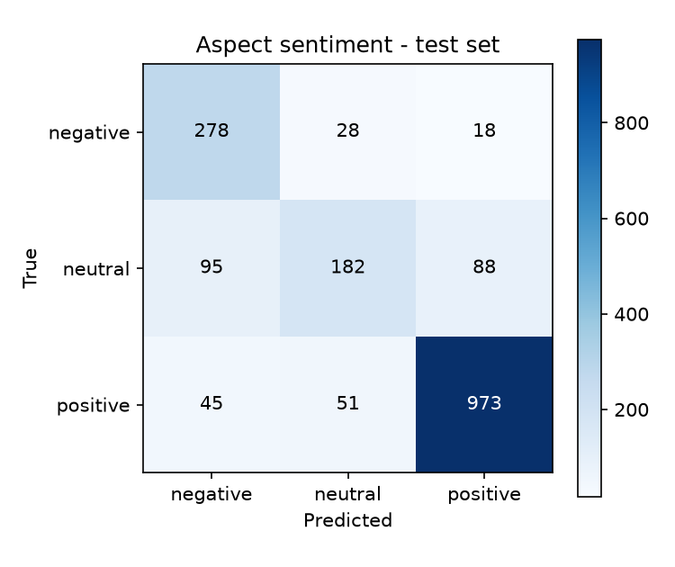
Aspect-sentiment confusion matrix
Full tables per domain: results.md.

6.2 Sentences that mix sentiments
In a sentence whose aspects all share one sentiment, a classifier can be right without looking at the aspect. Only sentences with differing aspects test whether predictions are aspect-specific.
Sentence type | Test aspects | Accuracy | Macro-F1
uniform | 1427 | 0.8507 | 0.7695
mixed | 331 | 0.6616 | 0.6540

6.3 Comparison with the rule-and-lexicon baseline
Both domains
Metric | Baseline | BERT (deployed) | Difference
Aspect extraction precision | 0.2736 | 0.8255 | +0.5520
Aspect extraction recall | 0.6035 | 0.8680 | +0.2645
Aspect extraction F1 | 0.3765 | 0.8462 | +0.4698
Aspect sentiment accuracy | 0.6633 | 0.8151 | +0.1519
Aspect sentiment macro-F1 | 0.6159 | 0.7456 | +0.1297
Overall sentiment accuracy | 0.7201 | 0.8160 | +0.0959
Overall sentiment macro-F1 | 0.6475 | 0.7202 | +0.0727
End-to-end F1 | 0.2530 | 0.6977 | +0.4447

Laptops
Metric | Baseline | BERT (deployed) | Difference
Aspect extraction precision | 0.1755 | 0.7868 | +0.6112
Aspect extraction recall | 0.4740 | 0.8180 | +0.3440
Aspect extraction F1 | 0.2562 | 0.8021 | +0.5459
Aspect sentiment accuracy | 0.6724 | 0.7743 | +0.1019
Aspect sentiment macro-F1 | 0.6471 | 0.7322 | +0.0850
Overall sentiment accuracy | 0.7032 | 0.7956 | +0.0925
Overall sentiment macro-F1 | 0.6623 | 0.7310 | +0.0687
End-to-end F1 | 0.1590 | 0.6308 | +0.4718

Restaurants
Metric | Baseline | BERT (deployed) | Difference
Aspect extraction precision | 0.3531 | 0.8475 | +0.4944
Aspect extraction recall | 0.6781 | 0.8968 | +0.2187
Aspect extraction F1 | 0.4644 | 0.8715 | +0.4071
Aspect sentiment accuracy | 0.6580 | 0.8384 | +0.1804
Aspect sentiment macro-F1 | 0.5939 | 0.7528 | +0.1589
Overall sentiment accuracy | 0.7317 | 0.8300 | +0.0983
Overall sentiment macro-F1 | 0.6301 | 0.7074 | +0.0773
End-to-end F1 | 0.3215 | 0.7355 | +0.4140

Details: baseline.md.

6.4 Transfer to an unseen domain
The first aspect-extraction model of the project was trained on laptop reviews only, with the same settings as the deployed one. Its scores on the restaurant test set measure transfer to a product category absent from training. Sentiment scores are not compared: the earlier laptops-only sentiment model has no training record, so a difference could not be attributed to the training domains.
Restaurants test set
Metric | Trained on laptops only | BERT (deployed) | Difference
Aspect extraction precision | 0.8923 | 0.8475 | -0.0448
Aspect extraction recall | 0.2337 | 0.8968 | +0.6631
Aspect extraction F1 | 0.3704 | 0.8715 | +0.5011

Laptops test set
Metric | Trained on laptops only | BERT (deployed) | Difference
Aspect extraction precision | 0.7864 | 0.7868 | +0.0004
Aspect extraction recall | 0.7936 | 0.8180 | +0.0245
Aspect extraction F1 | 0.7900 | 0.8021 | +0.0121

Details and examples from other product categories: transfer.md.

7. Error analysis
error_analysis.md breaks the errors down per domain: aspects missed, found with wrong boundaries or invented; the aspect terms missed most often; which sentiments are confused with which; accuracy by reported confidence; and a sample of misclassified sentences. The per-class table in 6.1 and the mixed-sentence table in 6.2 show where the classifier is weakest.

8. Limitations
- The training data is laptop and restaurant reviews from 2014. Other product categories work only as far as the models generalise; section 6.4 quantifies one such case.
- Only explicit aspects are found. "It dies after two hours" implies the battery but names no aspect.
- The sentiment classifier identifies an aspect by its text. The same term occurring twice in one sentence with different sentiments gets one prediction.
- Overall-sentiment labels are derived from aspect labels, not annotated.
- Every number comes from one training run with one random seed; there are no confidence intervals. The deployed models were chosen over the earlier ones by comparing test scores, which makes the reported scores slightly optimistic.
- Confidence values are softmax probabilities and are not calibrated.
- The Docker setup in the repository has not been run on the development machine.

9. Conclusion
The project delivers a complete aspect-based sentiment analysis system: a reproducible data pipeline, three fine-tuned BERT models, an evaluation that is regenerated by script, a tested REST API and a web application. Against a rule-and-lexicon baseline on the same test data, aspect-extraction F1 changes from 0.3765 to 0.8462 and end-to-end F1 from 0.2530 to 0.6977. Sentiment accuracy is 0.8507 on aspects in uniform sentences and 0.6616 in mixed ones, so sentences that mix sentiments remain the main open problem, together with the neutral class.
Future work: more training data with contrasting aspects, marking the aspect's position in the classifier input, several training runs to report variance, implicit aspects, and annotated data from further product categories.

References
- Devlin, J., Chang, M.-W., Lee, K., Toutanova, K. (2019). BERT: Pre-training of Deep Bidirectional Transformers for Language Understanding. NAACL 2019.
- Hu, M., Liu, B. (2004). Mining and Summarizing Customer Reviews. KDD 2004.
- Pontiki, M., Galanis, D., Pavlopoulos, J., Papageorgiou, H., Androutsopoulos, I., Manandhar, S. (2014). SemEval-2014 Task 4: Aspect Based Sentiment Analysis. Proceedings of SemEval 2014.

Appendix A: Full evaluation results
Generated by python -m training.evaluate. Do not edit by hand: rerun the script after retraining and this file is rewritten from the new predictions.
- Generated: 2026-10-10T05:00:39+00:00
- Test data: SemEval-2014 Task 4 gold test set, domains: laptops, restaurants
- Test sentences: 1600

Training setup
 | Aspect extraction | Aspect sentiment | Overall sentiment
Base model | bert-base-uncased | bert-base-uncased | bert-base-uncased
Training domains | laptops, restaurants | laptops, restaurants | laptops, restaurants
Epochs | 3 | 4 | 4
Batch size | 16 | 16 | 16
Learning rate | 3e-05 | 2e-05 | 2e-05
Max sequence length | 128 | 128 | 128
Seed | 42 | 42 | 42
Best epoch (validation) | 3 | 3 | 4
Model-selection metric | f1 | macro_f1 | macro_f1
Best validation score | 0.8312 | 0.7574 | 0.7363
Training time (minutes) | 78.62 | 94.96 | 37.33
Device | cpu | cpu | cpu
Training examples | 5449 sentences | 5327 (sentence, aspect) pairs | 3088 sentences

All evaluated domains
Test sentences: 1600

Aspect extraction and end-to-end ABSA
Exact match: a predicted aspect counts only if both of its boundaries equal the annotation. End-to-end additionally requires the predicted sentiment to be correct.
Task | Precision | Recall | F1-score
Aspect extraction | 0.8255 | 0.8680 | 0.8462
End-to-end (aspect + sentiment) | 0.6807 | 0.7156 | 0.6977

Gold aspects: 1788, predicted: 1880, correct: 1552.

Aspect sentiment classification (gold aspects given)
Examples: 1758
Metric | Value
Accuracy | 0.8151
Precision (macro) | 0.7547
Recall (macro) | 0.7556
F1-score (macro) | 0.7456
F1-score (weighted) | 0.8097

Class | Precision | Recall | F1-score | Support
negative | 0.6651 | 0.8580 | 0.7493 | 324
neutral | 0.6973 | 0.4986 | 0.5815 | 365
positive | 0.9018 | 0.9102 | 0.9060 | 1069

Confusion matrix (rows = true class, columns = predicted class):
true \ predicted | negative | neutral | positive
negative | 278 | 28 | 18
neutral | 95 | 182 | 88
positive | 45 | 51 | 973

Confusion matrix
Accuracy by sentence type. In a uniform sentence every aspect has the same sentiment; in a mixed sentence the aspects differ, so the model must be aspect-specific to be right:
Sentence type | Aspects | Accuracy | F1-score (macro)
uniform | 1427 | 0.8507 | 0.7695
mixed | 331 | 0.6616 | 0.6540

Overall (sentence-level) sentiment - weak labels
Examples: 1011
Metric | Value
Accuracy | 0.8160
Precision (macro) | 0.7235
Recall (macro) | 0.7227
F1-score (macro) | 0.7202
F1-score (weighted) | 0.8109

Class | Precision | Recall | F1-score | Support
negative | 0.7273 | 0.8251 | 0.7731 | 223
neutral | 0.5299 | 0.4251 | 0.4718 | 167
positive | 0.9135 | 0.9179 | 0.9157 | 621

Confusion matrix (rows = true class, columns = predicted class):
true \ predicted | negative | neutral | positive
negative | 184 | 27 | 12
neutral | 54 | 71 | 42
positive | 15 | 36 | 570

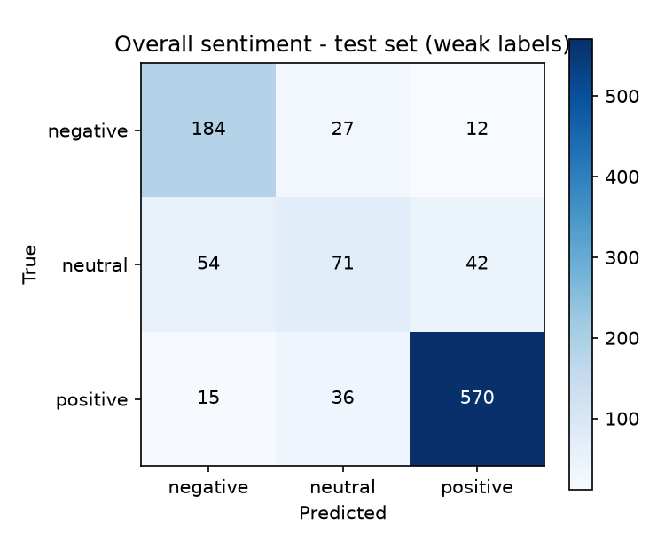
Overall-sentiment confusion matrix

Domain: laptops
Test sentences: 800

Aspect extraction and end-to-end ABSA
Exact match: a predicted aspect counts only if both of its boundaries equal the annotation. End-to-end additionally requires the predicted sentiment to be correct.
Task | Precision | Recall | F1-score
Aspect extraction | 0.7868 | 0.8180 | 0.8021
End-to-end (aspect + sentiment) | 0.6193 | 0.6426 | 0.6308

Gold aspects: 654, predicted: 680, correct: 535.

Aspect sentiment classification (gold aspects given)
Examples: 638
Metric | Value
Accuracy | 0.7743
Precision (macro) | 0.7433
Recall (macro) | 0.7627
F1-score (macro) | 0.7322
F1-score (weighted) | 0.7718

Class | Precision | Recall | F1-score | Support
negative | 0.5882 | 0.9375 | 0.7229 | 128
neutral | 0.7328 | 0.5030 | 0.5965 | 169
positive | 0.9088 | 0.8475 | 0.8771 | 341

Confusion matrix (rows = true class, columns = predicted class):
true \ predicted | negative | neutral | positive
negative | 120 | 5 | 3
neutral | 58 | 85 | 26
positive | 26 | 26 | 289

Accuracy by sentence type. In a uniform sentence every aspect has the same sentiment; in a mixed sentence the aspects differ, so the model must be aspect-specific to be right:
Sentence type | Aspects | Accuracy | F1-score (macro)
uniform | 535 | 0.8131 | 0.7619
mixed | 103 | 0.5728 | 0.5750

Overall (sentence-level) sentiment - weak labels
Examples: 411
Metric | Value
Accuracy | 0.7956
Precision (macro) | 0.7415
Recall (macro) | 0.7418
F1-score (macro) | 0.7310
F1-score (weighted) | 0.7897

Class | Precision | Recall | F1-score | Support
negative | 0.6615 | 0.8776 | 0.7544 | 98
neutral | 0.6452 | 0.4545 | 0.5333 | 88
positive | 0.9178 | 0.8933 | 0.9054 | 225

Confusion matrix (rows = true class, columns = predicted class):
true \ predicted | negative | neutral | positive
negative | 86 | 7 | 5
neutral | 35 | 40 | 13
positive | 9 | 15 | 201

Domain: restaurants
Test sentences: 800

Aspect extraction and end-to-end ABSA
Exact match: a predicted aspect counts only if both of its boundaries equal the annotation. End-to-end additionally requires the predicted sentiment to be correct.
Task | Precision | Recall | F1-score
Aspect extraction | 0.8475 | 0.8968 | 0.8715
End-to-end (aspect + sentiment) | 0.7150 | 0.7571 | 0.7355

Gold aspects: 1134, predicted: 1200, correct: 1017.

Aspect sentiment classification (gold aspects given)
Examples: 1120
Metric | Value
Accuracy | 0.8384
Precision (macro) | 0.7687
Recall (macro) | 0.7469
F1-score (macro) | 0.7528
F1-score (weighted) | 0.8316

Class | Precision | Recall | F1-score | Support
negative | 0.7383 | 0.8061 | 0.7707 | 196
neutral | 0.6690 | 0.4949 | 0.5689 | 196
positive | 0.8988 | 0.9396 | 0.9187 | 728

Confusion matrix (rows = true class, columns = predicted class):
true \ predicted | negative | neutral | positive
negative | 158 | 23 | 15
neutral | 37 | 97 | 62
positive | 19 | 25 | 684

Accuracy by sentence type. In a uniform sentence every aspect has the same sentiment; in a mixed sentence the aspects differ, so the model must be aspect-specific to be right:
Sentence type | Aspects | Accuracy | F1-score (macro)
uniform | 892 | 0.8733 | 0.7727
mixed | 228 | 0.7018 | 0.6870

Overall (sentence-level) sentiment - weak labels
Examples: 600
Metric | Value
Accuracy | 0.8300
Precision (macro) | 0.7128
Recall (macro) | 0.7027
F1-score (macro) | 0.7074
F1-score (weighted) | 0.8268

Class | Precision | Recall | F1-score | Support
negative | 0.7967 | 0.7840 | 0.7903 | 125
neutral | 0.4306 | 0.3924 | 0.4106 | 79
positive | 0.9111 | 0.9318 | 0.9213 | 396

Confusion matrix (rows = true class, columns = predicted class):
true \ predicted | negative | neutral | positive
negative | 98 | 20 | 7
neutral | 19 | 31 | 29
positive | 6 | 21 | 369

Notes for interpreting these numbers
- 'conflict' aspects are excluded from sentiment evaluation (3-class setting).
- Overall-sentiment labels are not human annotations: they are derived from the aspect polarities of each sentence (majority of positive vs. negative, neutral on a tie). Treat that table as indicative only.
- All numbers come from a single training run (one seed).
- Models trained by training.run_all are selected over the previously deployed models by comparing test-set scores (training.promote: span F1 for aspect extraction, macro-F1 for sentiment). Choosing between two models on the test set makes these numbers slightly optimistic as an estimate for unseen reviews.

Appendix B: Baseline comparison
Generated by python -m training.baseline. Do not edit by hand.
- Generated: 2026-10-10T05:02:25+00:00
- Test data: SemEval-2014 Task 4 gold test set, domains: laptops, restaurants
The baseline uses no trained model. Aspects are runs of nouns found by a part-of-speech tagger; sentiment is a count of opinion words from the Hu and Liu (2004) lexicon in the aspect's clause, with a simple negation rule. Both systems are scored by the same functions on the same sentences, so the difference column is what the fine-tuned BERT models add.

All evaluated domains
Test sentences: 1600
Metric | Baseline | BERT | Difference
Aspect extraction precision | 0.2736 | 0.8255 | +0.5520
Aspect extraction recall | 0.6035 | 0.8680 | +0.2645
Aspect extraction F1 | 0.3765 | 0.8462 | +0.4698
Aspect sentiment accuracy | 0.6633 | 0.8151 | +0.1519
Aspect sentiment macro-F1 | 0.6159 | 0.7456 | +0.1297
Overall sentiment accuracy | 0.7201 | 0.8160 | +0.0959
Overall sentiment macro-F1 | 0.6475 | 0.7202 | +0.0727
End-to-end F1 | 0.2530 | 0.6977 | +0.4447

Domain: laptops
Test sentences: 800
Metric | Baseline | BERT | Difference
Aspect extraction precision | 0.1755 | 0.7868 | +0.6112
Aspect extraction recall | 0.4740 | 0.8180 | +0.3440
Aspect extraction F1 | 0.2562 | 0.8021 | +0.5459
Aspect sentiment accuracy | 0.6724 | 0.7743 | +0.1019
Aspect sentiment macro-F1 | 0.6471 | 0.7322 | +0.0850
Overall sentiment accuracy | 0.7032 | 0.7956 | +0.0925
Overall sentiment macro-F1 | 0.6623 | 0.7310 | +0.0687
End-to-end F1 | 0.1590 | 0.6308 | +0.4718

Domain: restaurants
Test sentences: 800
Metric | Baseline | BERT | Difference
Aspect extraction precision | 0.3531 | 0.8475 | +0.4944
Aspect extraction recall | 0.6781 | 0.8968 | +0.2187
Aspect extraction F1 | 0.4644 | 0.8715 | +0.4071
Aspect sentiment accuracy | 0.6580 | 0.8384 | +0.1804
Aspect sentiment macro-F1 | 0.5939 | 0.7528 | +0.1589
Overall sentiment accuracy | 0.7317 | 0.8300 | +0.0983
Overall sentiment macro-F1 | 0.6301 | 0.7074 | +0.0773
End-to-end F1 | 0.3215 | 0.7355 | +0.4140

Reading the table
- A noun run is a generous guess: most nouns are not aspects, so the baseline's precision is low even where its recall is reasonable.
- The lexicon has no entry for domain phrases such as "runs hot" or "long wait", and predicts neutral whenever it finds no opinion word.
- Overall-sentiment labels are derived from aspect polarities, not annotated (see methodology, section 4.3).
Reference: Hu, M. and Liu, B. (2004). Mining and Summarizing Customer Reviews. KDD 2004.

Appendix C: Error analysis
Generated by python -m training.error_analysis. Do not edit by hand.
- Generated: 2026-10-10T06:22:29+00:00
- Models: the deployed models; data: SemEval-2014 Task 4 gold test set.
- Headline metrics are in results.md; this file looks at the errors behind them.

Domain: laptops

Aspect extraction
Outcome | Aspects | Share of gold aspects
Found with exact boundaries | 535 | 81.8%
Found with wrong boundaries | 62 | 9.5%
Missed entirely | 57 | 8.7%

Predictions that match no gold aspect (spurious): 51.
Aspect length | Gold aspects | Found exactly
one word | 362 | 89.5%
several words | 292 | 72.3%

Aspect terms most often missed or cut short:
- starts up (2)
- aluminum (2)
- graphic design (2)
- working (2)
- function (2)
- slot (2)
- installation disk ( dvd ) (1)
- works (1)
- mountain lion (1)
- configure (1)
- portable computing (1)
- ms office 2011 for mac (1)
- look (1)
- lit up keys (1)
- squaretrade 3 - year computer accidental protection warranty (1)

Aspect sentiment (gold aspects given)
144 of 638 aspects are misclassified (22.6%).
Gold sentiment | Predicted as | Errors | Share of all errors
neutral | negative | 58 | 40.3%
positive | negative | 26 | 18.1%
positive | neutral | 26 | 18.1%
neutral | positive | 26 | 18.1%
negative | neutral | 5 | 3.5%
negative | positive | 3 | 2.1%

Accuracy by the confidence the model reports. If confidence carries information, accuracy rises from the first row to the last:
Confidence | Predictions | Accuracy
below 0.60 | 37 | 43.2%
0.60 to 0.80 | 90 | 53.3%
0.80 and above | 511 | 84.1%

A random sample of misclassified aspects (seed fixed, at most 20):
Sentence | Aspect | Gold | Predicted | Confidence
I needed a laptop with big storage, a nice screen and fast so I can photoshop without any problem. | storage | neutral | positive | 95%
A veryimportant feature is Firewire 800 which in my experience works better then USB3 (in PC enabled with USB3)I was not originally sold on the MAC OS I felt it was inferior in many ways To Windows 7. | Firewire 800 | positive | negative | 73%
I switched to this because I wanted something different, even though I miss windows. | windows | positive | negative | 55%
The Mac mini is about 8x smaller than my old computer which is a huge bonus and runs very quiet, actually the fans aren't audible unlike my old pc | fans | positive | negative | 88%
12.44 seconds to boot. | boot | neutral | positive | 76%
I've had it for about 2 months now and found no issues with software or updates. | updates | neutral | positive | 66%
WiFi capability, disk drive and multiple USB ports to connect scale and printers was all that was required. | USB ports | positive | neutral | 96%
Within a few hours I was using the gestures unconsciously. | gestures | positive | neutral | 51%
I had to buy a wireless mouse to go with it, as I am old school and hate the pad, but knew that before I bought it, now it works great, need to get adjusted to the key board, as I am used to a bigger one and pounding. | key board | neutral | negative | 65%
And as for all the fancy finger swipes -- I just gave up and attached a mouse. | finger swipes | negative | positive | 83%
I was a little worry at first because I don't have a lot of experience with os.x and windows has always been second nature to me after many years of using windows. | windows | neutral | negative | 58%
This newer netbook has no hard drive or network lights. | hard drive | neutral | negative | 92%
This newer netbook has no hard drive or network lights. | network lights | neutral | negative | 92%
I needed a laptop with big storage, a nice screen and fast so I can photoshop without any problem. | screen | neutral | positive | 99%
So happy with this purchase, I just wish it came with Microsoft Word. | Microsoft Word | neutral | negative | 73%
It shouldn't happen like that, I don't have any design app open or anything. | design app | neutral | negative | 77%
I know some people complained about HDMI issues but they released a firmware patch to address that issue. | HDMI | neutral | negative | 85%
I like the Mini Mac it was easy to setup and install, but I am learning as I go and could use a tutorial to learn how to use some of the features I was use to on the PC especially the right mouse click menu. | tutorial | neutral | positive | 61%
Fan only comes on when you are playing a game. | Fan | neutral | negative | 73%
After fumbling around with the OS I started searching the internet for a fix and found a number of forums on fixing the issue. | OS | negative | neutral | 50%

Domain: restaurants

Aspect extraction
Outcome | Aspects | Share of gold aspects
Found with exact boundaries | 1017 | 89.7%
Found with wrong boundaries | 78 | 6.9%
Missed entirely | 39 | 3.4%

Predictions that match no gold aspect (spurious): 74.
Aspect length | Gold aspects | Found exactly
one word | 812 | 94.8%
several words | 322 | 76.7%

Aspect terms most often missed or cut short:
- place (6)
- waiting (3)
- dining experience (3)
- flavor (2)
- lychee martini (1)
- portions of the food (1)
- waitress ' s (1)
- tart of the day (1)
- portion size (1)
- portobello / gorgonzola / sausage appetizer (1)
- lemon - dressed cobb (1)
- hot dog (1)
- creme brulee (1)
- chili signed food items (1)
- beef (1)

Aspect sentiment (gold aspects given)
181 of 1120 aspects are misclassified (16.2%).
Gold sentiment | Predicted as | Errors | Share of all errors
neutral | positive | 62 | 34.3%
neutral | negative | 37 | 20.4%
positive | neutral | 25 | 13.8%
negative | neutral | 23 | 12.7%
positive | negative | 19 | 10.5%
negative | positive | 15 | 8.3%

Accuracy by the confidence the model reports. If confidence carries information, accuracy rises from the first row to the last:
Confidence | Predictions | Accuracy
below 0.60 | 72 | 50.0%
0.60 to 0.80 | 124 | 46.8%
0.80 and above | 924 | 91.5%

A random sample of misclassified aspects (seed fixed, at most 20):
Sentence | Aspect | Gold | Predicted | Confidence
don't get me wrong - sushi was good, just not fantastic. | sushi | positive | neutral | 63%
How can hope to stay in business with service like this? | service | negative | positive | 47%
Service is known for bending over backwards to make everyone happy. | Service | positive | negative | 60%
I HAVE NEVER HAD A BAD MEAL(OR BAD SERVICE )@ PIGALLE. | MEAL | positive | negative | 58%
The sushi is cut in blocks bigger than my cell phone. | sushi | negative | neutral | 70%
Build a meal with side orders like Amazin' Greens salads, Buffalo Chicken Kickers and Cinna Stix. | meal | neutral | positive | 58%
i have eaten here on a different occasion - the food is mediocre for the prices. | prices | negative | positive | 85%
Thick fries, meaty chili and stuffed baked potatoes round out a menu that includes a cool, ultra-thick chocolate Frosty. | stuffed baked potatoes | neutral | positive | 99%
Would you ever believe that when you complain about over an hour wait, when they tell you it will be 20-30 minutes, the manager tells the bartender to spill the drinks you just paid for? | drinks | neutral | negative | 67%
There was only one waiter for the whole restaurant upstairs. | waiter | neutral | negative | 67%
Average cake thats been courted by a LOT of hype. | cake | negative | positive | 76%
The decor is designed in a contemporary Japanese style restaurant. | decor | neutral | positive | 83%
No green beans, no egg, no anchovy dressing, no nicoise olives, no red onion. | egg | neutral | negative | 84%
How pretentious and inappropriate for MJ Grill to claim that it provides power lunch and dinners! | lunch | negative | positive | 72%
No green beans, no egg, no anchovy dressing, no nicoise olives, no red onion. | green beans | neutral | negative | 84%
Build a meal with side orders like Amazin' Greens salads, Buffalo Chicken Kickers and Cinna Stix. | Cinna Stix | neutral | positive | 91%
The closest that I got was the Cherry Marscapone, but they were out of it that day. | Cherry Marscapone | neutral | negative | 74%
The room is a gorgeous, bi-level space and the long bar perfect for a drink. | drink | neutral | positive | 97%
" The menu includes pub fare--burgers, steaks and shepherds pie--and even a portabella lasagna for those black sheep known as "vegetarians. | menu | neutral | positive | 58%
i have eaten here on a different occasion - the food is mediocre for the prices. | food | neutral | positive | 65%

Appendix D: Cross-domain transfer
Generated by python -m training.error_analysis. Do not edit by hand.
- Generated: 2026-10-10T06:22:29+00:00

Measured: a laptop-trained aspect extractor on restaurant reviews
The first aspect-extraction model of this project was trained on laptop reviews only, with the same settings as the deployed one. Evaluating it on the restaurant test set shows what happens on a product category the model never saw. The second column is the deployed model, trained on both domains, on the same sentences.
Sentiment and end-to-end scores are not compared here. The earlier laptops-only sentiment model is a checkpoint from an interrupted training run and has no training record, so a difference in its scores could not be attributed to the training domains.

Restaurant test set (unseen domain for the laptops-only model)
Metric | Trained on laptops only | Trained on both domains | Difference
Aspect extraction precision | 0.8923 | 0.8475 | -0.0448
Aspect extraction recall | 0.2337 | 0.8968 | +0.6631
Aspect extraction F1 | 0.3704 | 0.8715 | +0.5011

Laptop test set (seen by both)
Metric | Trained on laptops only | Trained on both domains | Difference
Aspect extraction precision | 0.7864 | 0.7868 | +0.0004
Aspect extraction recall | 0.7936 | 0.8180 | +0.0245
Aspect extraction F1 | 0.7900 | 0.8021 | +0.0121

Illustration: reviews of other product categories
There is no annotated test data for other categories, so this is an illustration, not a measurement. The reviews in data/samples/other_domains.csv were written by hand; the table shows what the deployed pipeline returns for each. Read the aspect column and judge: an aspect that a person would not name, or a sentiment a person would not agree with, is an error.
Category | Review | Overall | Aspects found
phones | The camera takes sharp photos in daylight, but the battery barely lasts until the evening. | negative | battery (negative, 97%)
phones | Call quality is clear and the fingerprint sensor is fast. | positive | Call quality (positive, 99%), fingerprint sensor (positive, 99%)
phones | The speaker is tinny and the charger stopped working after a month. | negative | speaker (negative, 98%), charger (negative, 98%)
phones | I bought it for my mother and she uses it every day. | neutral | none
hotels | The room was spotless and the bed was comfortable, although the wifi kept dropping. | positive | room (negative, 61%), bed (positive, 99%), wifi (negative, 98%)
hotels | Breakfast was disappointing and the staff at the reception were rude. | negative | Breakfast (negative, 98%), staff (negative, 98%), reception (negative, 97%)
hotels | Great location, a short walk from the station, and the pool is lovely. | positive | location (positive, 99%), pool (positive, 99%)
hotels | The air conditioning was noisy, so we hardly slept. | negative | air conditioning (negative, 98%)
headphones | The noise cancellation is impressive and the ear cushions are soft. | positive | noise cancellation (positive, 99%), ear cushions (positive, 97%)
headphones | Bass is muddy and the bluetooth connection drops every few minutes. | negative | Bass (negative, 98%), bluetooth connection (negative, 98%)
headphones | The carrying case feels cheap, but the sound quality is excellent for the price. | positive | carrying case (positive, 97%), sound quality (positive, 95%), price (positive, 90%)
headphones | The microphone is fine for calls. | positive | microphone (positive, 96%)

