CUSTOMER CHURN PREDICTION & LTV ENGINE
Exploratory Data Analysis Report — Telco Customer Churn Dataset
7,043 customers · 21 attributes · Prepared July 2, 2026

Headline Metrics
26.5%  Overall Churn Rate | $139,131  Monthly Revenue at Risk | 18 mo vs 38 mo  Avg. Tenure (Churned)

1. Executive Summary
This report summarizes exploratory analysis of the IBM/Kaggle Telco Customer Churn dataset (7,043 customers). The goal is to surface the strongest churn drivers ahead of model development, so the classification and LTV models in Weeks 2-3 are built around the factors that matter most.
Roughly 1 in 4 customers (26.5%) has churned historically, representing about $139,131 in monthly recurring revenue at risk — 30.5% of total monthly billings. Churn is heavily concentrated among new, month-to-month, fiber-optic customers paying by electronic check with no add-on services. These segments should be the initial focus of both the predictive model's feature set and the retention team's early-warning playbook.

2. Key Findings

2.1 Contract type is the single strongest driver
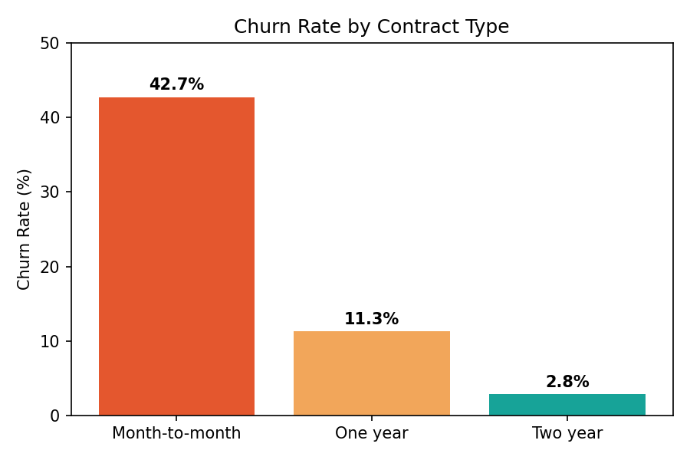
Figure 1: Churn rate by contract type
Month-to-month customers churn at 42.7%, roughly 4x the rate of one-year contracts (11.3%) and 15x two-year contracts (2.8%). Contract type alone explains a large share of churn variance and should be a top feature in the classification model.

2.2 Tenure: risk is front-loaded in the first year
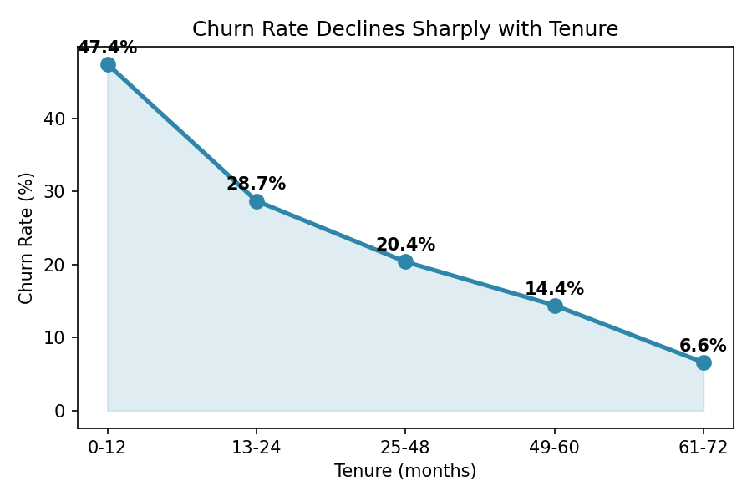
Figure 2: Churn rate by tenure bucket (months)
Customers in their first 12 months churn at 47.4%, falling steadily to 6.6% for customers past 5 years. Churned customers have a median tenure of just 10 months vs. 38 months for retained customers. New customers are the highest-priority segment for early intervention.

2.3 Fiber optic customers churn at more than double the DSL rate
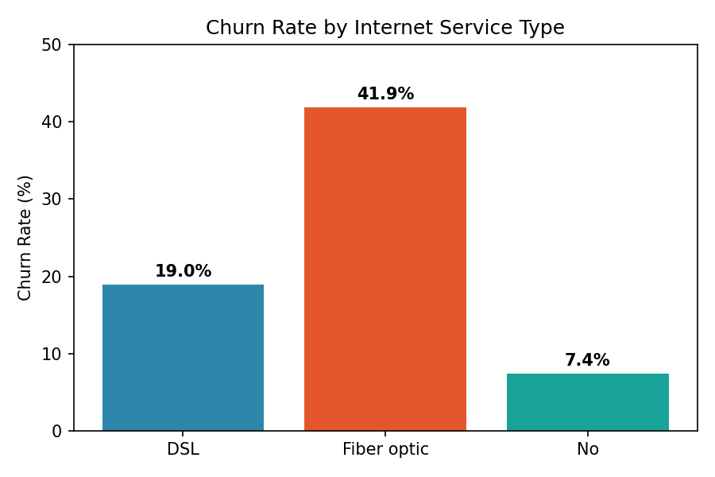
Figure 3: Churn rate by internet service type
Fiber optic subscribers churn at 41.9% versus 19.0% for DSL and 7.4% for customers with no internet service. Combined with the finding below on monthly charges, this suggests fiber pricing or service-quality perception may be a factor worth investigating with the product team.

2.4 Electronic check payers are the highest-risk payment segment
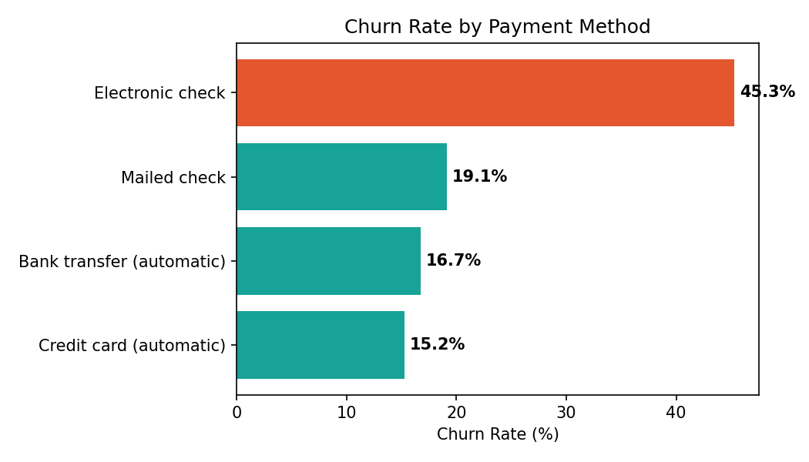
Figure 4: Churn rate by payment method
Electronic check users churn at 45.3%, roughly 3x the rate of automatic bank transfer (16.7%) or credit card (15.2%) payers. Because this is correlated with lack of payment automation rather than being causal on its own, it is still a useful, low-cost signal for the model and for prompting customers to switch to autopay.

2.5 Higher bills correlate with higher churn
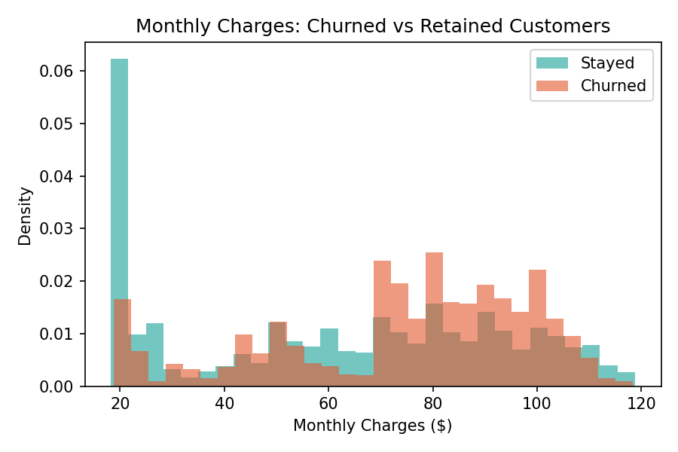
Figure 5: Monthly charges distribution — churned vs. retained
Churned customers pay a median of $79.65/month vs. $64.43 for retained customers. Churn risk rises noticeably above roughly $70/month, reinforcing the fiber-optic finding since fiber plans carry the highest price points.

2.6 Add-on services act as a retention anchor
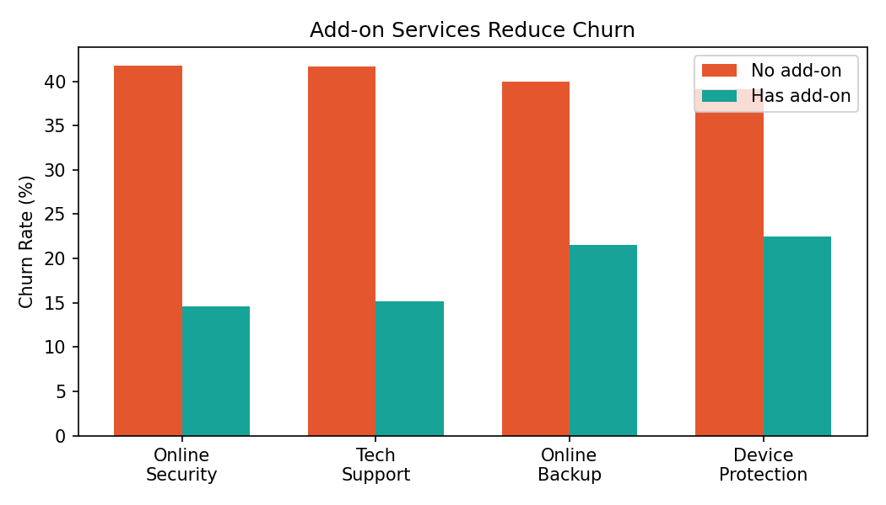
Figure 6: Churn rate with vs. without support/security add-ons
Customers without Online Security or Tech Support churn at roughly 42%, compared to 15% for those who have subscribed to these add-ons. This is one of the largest effect sizes in the dataset and points to a concrete retention lever: bundling or promoting these services to at-risk segments.

3. Churn Rate by Segment (Reference Table)
Segment | Group | Churn Rate | Customers
Contract | Month-to-month | 42.7% | 3,875
Contract | One year | 11.3% | 1,473
Contract | Two year | 2.8% | 1,695
Internet Service | Fiber optic | 41.9% | 3,096
Internet Service | DSL | 19.0% | 2,421
Internet Service | None | 7.4% | 1,526
Payment Method | Electronic check | 45.3% | 2,365
Payment Method | Mailed check | 19.1% | 1,612
Payment Method | Bank transfer (auto) | 16.7% | 1,544
Payment Method | Credit card (auto) | 15.2% | 1,522
Senior Citizen | Yes | 41.7% | 1,142
Senior Citizen | No | 23.6% | 5,901
Has Partner | No | 33.0% | 3,641
Has Partner | Yes | 19.7% | 3,402
Has Dependents | No | 31.3% | 4,933
Has Dependents | Yes | 15.5% | 2,110

4. Data Quality Notes
- 11 rows (0.16%) have a blank TotalCharges value; all correspond to customers with tenure = 0 (brand-new sign-ups). These should be imputed as $0 or excluded before model training, not dropped as generic missing data.
- TotalCharges is stored as text in the raw export in some distributions and must be coerced to numeric — already handled in this analysis.
- No duplicate customerID values were found; all 7,043 rows are unique customers.
- Categorical fields (e.g., OnlineSecurity, TechSupport) include a 'No internet service' category that is functionally different from 'No' — these were kept distinct rather than collapsed, since it changes the churn rate materially (7.4% vs ~40%).

5. Recommendations for Weeks 2–4
- Feature engineering: prioritize contract type, tenure, internet service type, payment method, and add-on service flags — these show the largest churn effect sizes and should anchor the feature set.
- Consider an engineered 'digital engagement score' combining OnlineSecurity, TechSupport, OnlineBackup, and DeviceProtection into a single 0-4 count, since they behave similarly and may be collinear individually.
- Given the tenure effect, a 'new customer' flag (tenure ≤ 3 months) may help the model catch the highest-risk cohort early — a natural trigger for the LTV engine's retention prioritization.
- For the LTV model, note that TotalCharges is nearly deterministic from tenure × MonthlyCharges (with small variation from historical price changes/promos) — use it as a sanity check rather than a primary LTV input, since forecasted LTV should be forward-looking, not backward-looking.
- Recommend the retention/marketing team pilot autopay-conversion incentives for electronic-check customers and security/support add-on promotions for fiber customers — both are the largest, most actionable churn levers identified.

