AI/ML Role in IntelliTrace GPS Project
Project Title: IntelliTrace GPS – Authenticated Wearable Tracking & Tamper-Proof System
This document explains the complete role of Artificial Intelligence and Machine Learning (AI/ML) in the IntelliTrace GPS project. It is prepared for team understanding and project presentation purposes.

1. Introduction to the Project
IntelliTrace GPS is an advanced wearable security and monitoring system designed to track a person's location, health condition, and identity authenticity in real time. Unlike normal GPS trackers, this system verifies whether the authorized person is actually wearing the device.
The system combines:
- GPS Tracking
- Health Monitoring
- Tamper Detection
- AI/ML-based Identity Verification
- Real-time Alerts

2. Main Role of AI/ML in This Project
AI/ML acts as the intelligence engine of the entire system. The main purpose of AI/ML is not only to track location but also to analyze user behavior, verify identity, and detect unusual activities.
The major AI/ML responsibilities are:
• Behavioral Biometric Authentication:
AI analyzes:Heartbeat patterns ,Walking style ,Movement behavior ,Activity habits
• Anomaly Detection:
AI Check for: Sudden heart rate increase, Device removal, No body contact, Unusual movement, Identity mismatch, Falls or accidents
• Health Condition Monitoring
• Motion Pattern Recognition
• Tamper Detection
• Emergency Alert Generation

3. Why AI/ML is Needed
Traditional GPS trackers only provide location coordinates. They cannot identify whether the actual person is wearing the device. A user can remove the tracker and leave it somewhere else.
AI/ML solves this issue by continuously checking:
- Heart rate patterns
- Body contact
- Movement behavior
- Physical activity patterns
This ensures 'Person-to-Device Integrity'.

4. How AI/ML Works in the Project

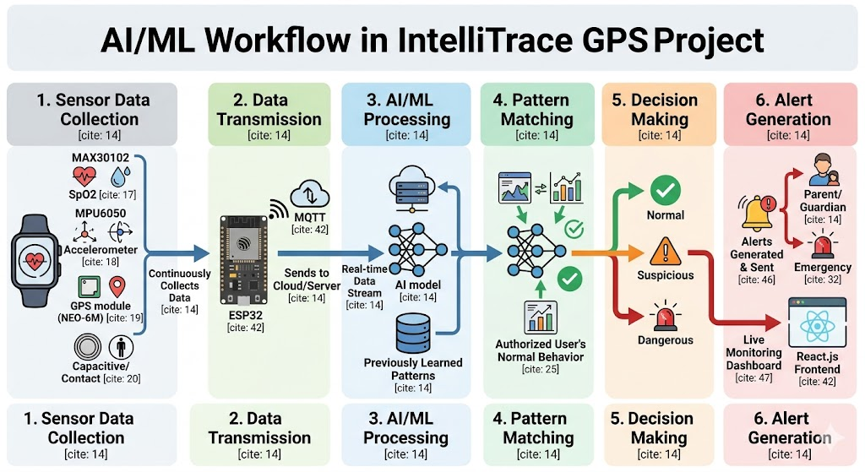
sStep 1: Sensor Data Collection
The wearable device continuously collects data using sensors.
Step 2: Data Transmission
The ESP32 microcontroller sends sensor data to the cloud/server.
Step 3: AI/ML Processing
The AI model analyzes incoming data and compares it with previously learned patterns.
Step 4: Pattern Matching
The system checks whether the behavior matches the authorized user.
Step 5: Decision Making
The AI decides whether the situation is:
- Normal
- Suspicious
- Dangerous
Step 6: Alert Generation
If abnormalities are detected, alerts are sent to parents/guardians.

5. Where AI/ML Gets Data
The AI/ML system gets real-time data directly from hardware sensors.
Sensors used in the project:
1. MAX30102 Sensor
- Measures Heart Rate
- Measures SpO2 (oxygen levels)
- Used for biometric verification
2. MPU6050 Sensor
- Accelerometer + Gyroscope
- Detects movement and motion patterns
- Used for activity recognition and fall detection
3. GPS Module (NEO-6M)
- Provides live location coordinates
- Used for tracking and route monitoring
4. Capacitive/Contact Sensor
- Detects whether the wearable is still attached to the body
- Used for tamper detection

6. Types of Data Collected
The following data is continuously collected:
- Heart Rate (BPM)
- SpO2 Levels
- Acceleration Values
- Rotation/Gyroscope Values
- GPS Coordinates
- Body Contact Status
- Motion and Activity Patterns

7. Behavioral Biometrics
Behavioral biometrics means identifying a person based on their natural body behavior.
In this project, AI studies:
- Pulse patterns
- Heartbeat rhythm
- Walking style
- Movement characteristics
Every person has slightly different biological and movement patterns. AI learns these patterns and stores them as the user's normal behavior.
If another person wears the device, the AI detects a mismatch and sends an alert.

8. Anomaly Detection
Anomaly detection means identifying abnormal or unusual behavior.
Examples of anomalies in this project:
- Sudden heart rate spike
- Device removal
- No body contact
- Unusual movement
- Identity mismatch
- Fall or accident detection
AI continuously compares current sensor data with normal learned behavior. If the difference becomes large, the system flags it as an anomaly.

9. Motion Pattern Recognition
Using MPU6050 sensor data, AI recognizes user activities such as:
- Walking
- Running
- Sitting
- Falling
- Sudden impact
This helps in detecting emergencies, accidents, or suspicious activities.

10. Health Monitoring Intelligence
AI monitors the user's physical condition continuously.
The system checks:
- Heart rate stability
- Oxygen levels
- Stress indicators
- Abnormal health conditions
If dangerous changes are detected, emergency alerts are generated automatically.

11. Machine Learning Models Used
Different ML models can be used for different tasks.
1. K-Nearest Neighbors (KNN)
- Used for identity classification
- Compares current behavior with stored user patterns
- Simple and effective for biometric matching
2. Support Vector Machine (SVM)
- Used for classification tasks
- Helps distinguish between authorized and unauthorized users
- Works well with sensor data
3. Random Forest
- Used for activity classification
- Detects user activities based on motion data
- Provides high accuracy
4. Isolation Forest
- Used for anomaly detection
- Detects unusual behaviors or suspicious activities
5. LSTM/CNN (Advanced Option)
- Used for time-series and sequential sensor data
- Useful for advanced activity recognition

12. Why These Models Are Used
KNN:
- Easy to train
- Good for biometric similarity matching
SVM:
- High accuracy for classification
- Works efficiently with small and medium datasets
Random Forest:
- Handles sensor data well
- Reduces overfitting
Isolation Forest:
- Specialized for anomaly detection
- Fast detection of unusual behavior
LSTM:
- Excellent for continuous sensor data analysis
- Learns time-based patterns

13. Technologies Used
Hardware Technologies:
- ESP32 Microcontroller
- MAX30102 Sensor
- MPU6050 Sensor
- NEO-6M GPS Module
Programming Languages:
- Python
- C++
AI/ML Libraries:
- Scikit-learn
- TensorFlow
- PyTorch
- NumPy
- Pandas
Cloud & Communication:
- MQTT Protocol
- Firebase / AWS
Frontend Dashboard:
- React.js
- HTML/CSS/JavaScript

14. Complete AI/ML Workflow
1. Sensors collect live data.
2. ESP32 processes sensor values.
3. Data is transmitted to the cloud.
4. AI/ML model analyzes the incoming data.
5. The model compares current behavior with trained patterns.
6. The system decides whether behavior is normal or abnormal.
7. Alerts are generated if suspicious activities are detected.
8. Live monitoring dashboard updates in real time.

15. Final Conclusion
The AI/ML module is used to intelligence systems behind IntelliTrace GPS. It transforms a normal GPS tracker into a smart security system capable of:
- Identity verification
- Health monitoring
- Behavioral analysis
- Anomaly detection
- Emergency response
- Tamper detection
By combining wearable sensors, AI/ML models, cloud communication, and real-time monitoring, the project provides a highly secure and intelligent tracking solution.

