Initial View of DB Table

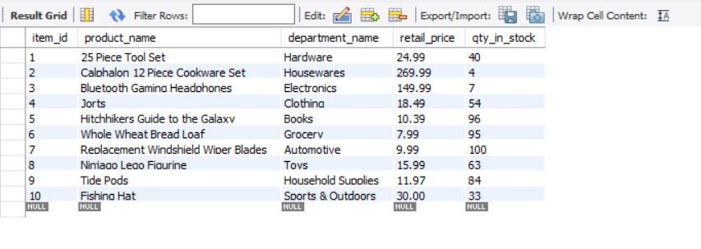

Execute javascript code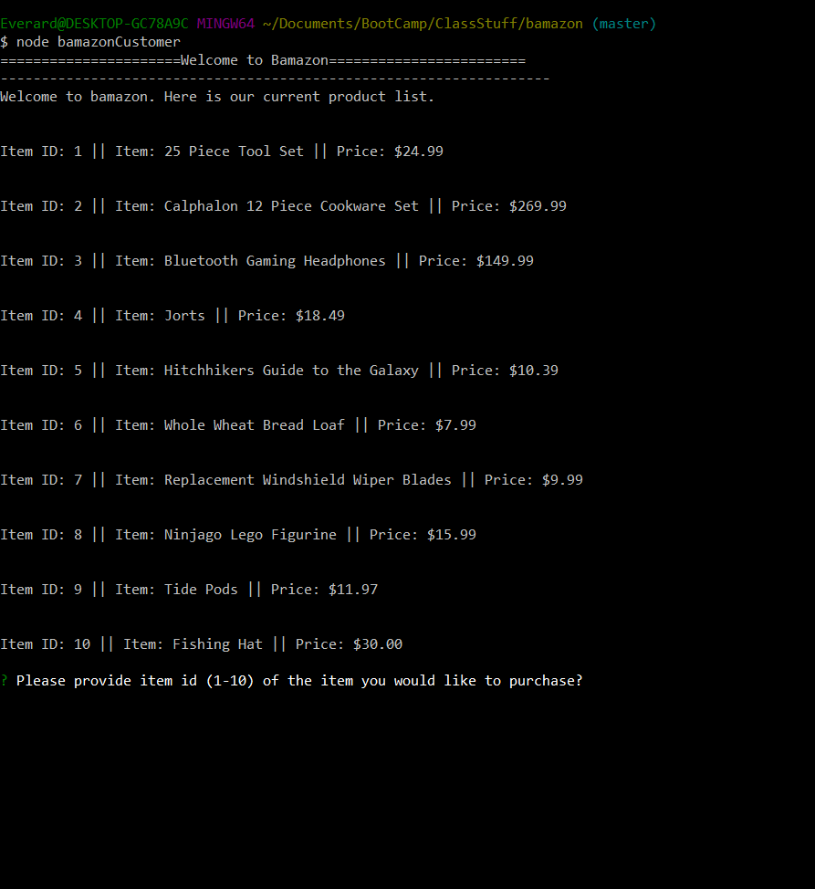

After inputting item and qty

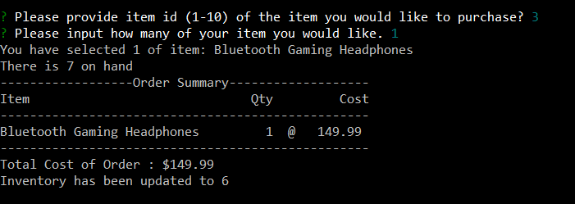

Note, the last version does not update inventory in database (it did, but that broke when polishing up the code.