State Equations:
$$\ddot{y}= - \dot{ψ}\dot{x}+\frac{2C_{α}}{m}\left(\cos{δ}\left(δ-\frac{\dot{y}+l_{f}\dot{ψ}}{\dot{x}}\right)-\frac{\dot{y}-l_{r}\dot{ψ}}{\dot{x}}\right)$$
$$\ddot{x}=\dot{ψ}\dot{y}+\frac{1}{m}\left(F-fg\right)$$
$$\ddot{ψ}=\frac{2l_{f}C_{α}}{I_{z}}\left(δ-\frac{\dot{y}+l_{f}\dot{ψ}}{\dot{x}}\right)-\frac{2l_{r}C_{α} }{I_{z}}\left(-\frac{\dot{y}-l_{r}\dot{ψ}}{\dot{x}}\right)$$
$$\dot{X}=\dot{x}\cos{ψ}-\dot{y}\sin{ψ}$$
$$\dot{Y}=\dot{x}\sin{ψ}+\dot{y}\cos{ψ}$$
Measurements:
$$y=\left[\begin{matrix}\dot{x} \\ \dot{y} \\ \dot{ψ} \\ X \\ Y \\ ψ\end{matrix}\right]$$
Model Parameters:
$$δ≤\frac{π}{6} rad$$
$$F≥0 and F≤15367 N$$
$$\dot{x≥{10}^{-5} m/s}$$
Name | Description | Unit | Value
$$(\dot{x},\dot{y})$$ | Vehicle’s velocity along the direction of  vehicle frame | $$m/s$$ | State
$$\left(X,Y\right)$$ | Vehicle’s coordinates in the world  frame | $$m$$ | State
$$ψ,\dot{ψ}$$ | Body yaw angle, angular speed | $$rad,rad/s$$ | State
$$δ, δ_{f}$$ | Front wheel angle | $$rad$$ | Input
$$F$$ | Total input force | $$N$$ | Input
$$m$$ | Vehicle mass | $$kg$$ | 1888.6
$$l_{r}$$ | Length from rear tire to the center of  mass | $$m$$ | 1.39
$$l_{f}$$ | Length from front tire to the center of  mass | $$m$$ | 1.55
$$C_{α}$$ | Cornering stiffness of each tire | $$N$$ | 20000
$$I_{z}$$ | Yaw inertia | $$kg m^{2}$$ | 25854
$$F_{pq}$$ | Tire Force, $p ∈\{x,y\}$, $q ∈\{f,r\}$ | $$N$$ | Depends on input force
$$f$$ | Rolling resistance coefficient | $$N/A$$ | 0.019
$$delT$$ | Simulation timestep | $$sec$$ | 0.032

- Linearization
Lateral Linearization
$$u=\left[\begin{aligned}δ \\ F\end{aligned}\right], s_{1}=\left[\begin{aligned}y \\ \dot{y} \\ ψ \\ \dot{ψ}\end{aligned}\right]$$
Assume $x, \dot{x}$ are constant in the lateral system.
$$Let \dot{x}=v_{x}$$
Non-linearized System:
$$\dot{\dot{s_{1}}=\left[\begin{aligned}\dot{y} \\ \ddot{y} \\ \dot{ψ} \\ \ddot{ψ}\end{aligned}\right]}=\left[\begin{aligned}\dot{y} \\ - \dot{ψ}v_{x}+\frac{2C_{α}}{m}\left(\cos{δ}\left(δ-\frac{\dot{y}+l_{f}\dot{ψ}}{v_{x}}\right)-\frac{\dot{y}-l_{r}\dot{ψ}}{v_{x}}\right) \\ \dot{ψ} \\ \frac{2l_{f}C_{α}}{I_{z}}\left(δ-\frac{\dot{y}+l_{f}\dot{ψ}}{v_{x}}\right)-\frac{2l_{r}C_{α} }{I_{z}}\left(-\frac{\dot{y}-l_{r}\dot{ψ}}{v_{x}}\right)\end{aligned}\right]=f(s_{1},u)$$
$$A_{1}= ∇f_{s_{1}}, B_{1}=∇f_{u}$$
$$A_{1}=\left[\begin{matrix}0 & 1 & 0 & 0 \\ 0 & -\frac{2C_{α}}{mv_{x}}\left(\cos{δ}+1\right) & 0 & {-v}_{x}+\frac{2C_{α}}{mv_{x}}\left(-l_{f}cos{δ}+l_{r}\right) \\ 0 & 0 & 1 & 0 \\ 0 & \frac{2C_{α}}{I_{z}v_{x}}\left(l_{r}-l_{f}\right) & 0 & \frac{2C_{α}}{I_{z}v_{x}}\left(-l_{f}^{2}-l_{r}^{2}\right)\end{matrix}\right]$$

$$B_{1}=\left[\begin{matrix}0 & 0 \\ \frac{2C_{α}}{m}\left(-\sin{δ}\left(δ-\frac{\dot{y}+l_{f}\dot{ψ}}{v_{x}}\right)+\cos{δ}\right) & 0 \\ 0 & 0 \\ \frac{2l_{f}C_{α}}{I_{z}} & 0\end{matrix}\right]$$

Apply small angle Approximations $→cos\left(δ\right)≈1, \sin\left(δ\right)≈0$
$$A_{1}=\left[\begin{matrix}0 & 1 & 0 & 0 \\ 0 & -\frac{4C_{α}}{mv_{x}} & 0 & {-v}_{x}-\frac{2C_{α}}{mv_{x}}\left(l_{f}-l_{r}\right) \\ 0 & 0 & 1 & 0 \\ 0 & \frac{2C_{α}}{I_{z}v_{x}}\left(l_{r}-l_{f}\right) & 0 & -\frac{2C_{α}}{I_{z}v_{x}}\left(l_{f}^{2}+l_{r}^{2}\right)\end{matrix}\right]$$
$$B_{1}=\left[\begin{matrix}0 & 0 \\ \frac{2C_{α}}{m} & 0 \\ 0 & 0 \\ \frac{2l_{f}C_{α}}{I_{z}} & 0\end{matrix}\right]$$
Longitudinal Linearization
$$u=\left[\begin{aligned}δ \\ F\end{aligned}\right], s_{2}=\left[\begin{aligned}x \\ \dot{x}\end{aligned}\right]$$
Assume $y, \dot{y, } ψ, \dot{ψ, }$ are constant in the longitudinal linearization
Non-linearized System:
$$\dot{\dot{s_{2}}=\left[\begin{matrix}\dot{x} \\ \ddot{x}\end{matrix}\right] }=\left[\begin{matrix}\dot{x} \\ \dot{ψ}\dot{y}+\frac{1}{m}\left(F-fg\right)\end{matrix}\right]$$
$$A_{2}= ∇f_{s_{2}}, B_{1}=∇f_{2}$$
$$A_{2}=\left[\begin{matrix}0 & 1 \\ 0 & 0\end{matrix}\right]$$
$$B_{2}=\left[\begin{matrix}0 & 0 \\ 0 & \frac{1}{m}\end{matrix}\right]$$
Dynamics of rolling accommodate for using a disturbance term
$$d\left(t\right)=\left[\begin{aligned}0 \\ \dot{ψ}\dot{y}+\frac{fg}{m}\end{aligned}\right]$$

PID Results:
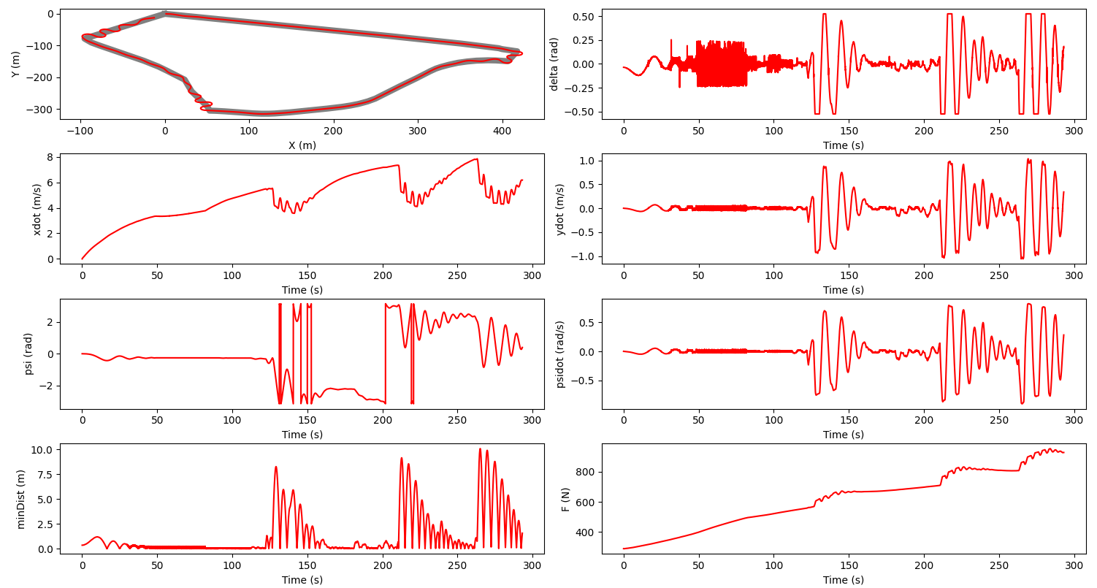
Fig.1 Simulation Plot

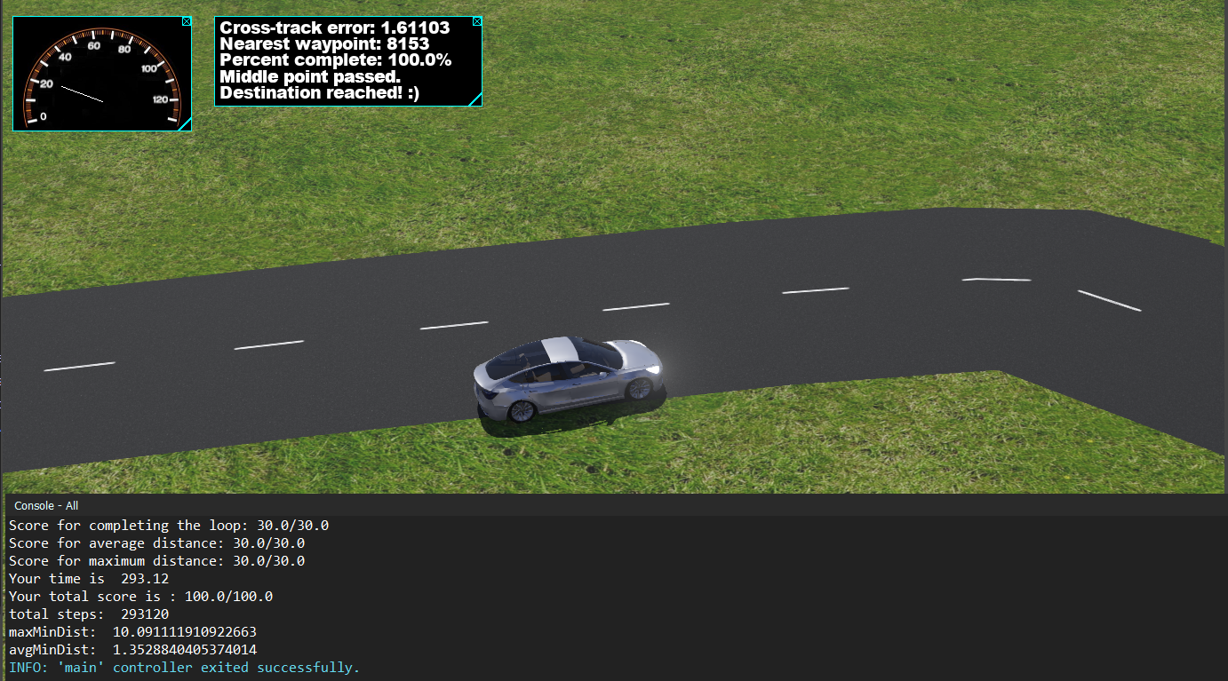
Fig.2 Simulation Result

Twiddle Algorithm for PID tuning
import numpy as np
from util import getTrajectory, closestNode, clamp

default_dt = 0.032

class PID:
def __init__(self, Kp, Ki, Kd, dt=default_dt):
self.Kp = Kp
self.Ki = Ki
self.Kd = Kd
self.dt = dt
self.integral = 0
self.prev_error = 0

def reset(self):
self.integral = 0
self.prev_error = 0

def update(self, setpoint, measurement):
error = setpoint - measurement
self.integral += error * self.dt
derivative = (error - self.prev_error) / self.dt
output = self.Kp * error + self.Ki * self.integral + self.Kd * derivative
self.prev_error = error
return output

# Load trajectory using util.py
trajectory = getTrajectory('buggyTrace.csv')

# Simulate lateral controller (returns total squared cross-track error)
def lateral_error(pid_gains, trajectory, dt=default_dt):
Kp, Ki, Kd = pid_gains
pid = PID(Kp, Ki, Kd, dt)
X, Y = trajectory[0, 0], trajectory[0, 1] # start at first waypoint
total_error = 0
for i in range(1, len(trajectory)):
cross_track_error, idx = closestNode(X, Y, trajectory)
control = pid.update(0, cross_track_error) # setpoint is 0
# Simulate: move towards next waypoint, apply steering
direction = trajectory[i] - np.array([X, Y])
speed = 11 #
max_steer = np.radians(30)
control = clamp(control, -max_steer, max_steer)
X += direction[0] * dt + control * dt
Y += direction[1] * dt + control * dt
total_error += cross_track_error ** 2
return total_error

# Simulate longitudinal controller (returns total squared speed error)
def longitudinal_error(pid_gains, trajectory, desired_speed=11.0, dt=default_dt):
Kp, Ki, Kd = pid_gains
pid = PID(Kp, Ki, Kd, dt)
speed = 0.0
total_error = 0
for i in range(1, len(trajectory)):
speed_error = desired_speed - speed
control = pid.update(desired_speed, speed)
# Simulate: update speed
speed += control * dt
speed = clamp(speed, 0, 50) # clamp to reasonable speed range
total_error += speed_error ** 2
return total_error

# Twiddle algorithm for PID tuning
def twiddle(error_func, trajectory, tol=0.01, initial_p=[0.00, 0.0, 0.0], initial_dp=[0.01, 0.01, 0.01]):
p = initial_p.copy()
dp = initial_dp.copy()
best_err = error_func(p, trajectory)
it = 0
prev_err = None
while sum(dp) > tol:
for i in range(len(p)):
p[i] += dp[i]
err = error_func(p, trajectory)
if err < best_err:
best_err = err
dp[i] *= 1.1
else:
p[i] -= 2 * dp[i]
err = error_func(p, trajectory)
if err < best_err:
best_err = err
dp[i] *= 1.05
else:
p[i] += dp[i]
dp[i] *= 0.95
it += 1
print(f"Iteration {it}, PID: {p}, Error: {best_err}")
# Stop if error does not change
if prev_err is not None and abs(best_err - prev_err) < 1e-8:
print("Error did not change, stopping Twiddle.")
break
prev_err = best_err
return p

if __name__ == "__main__":
print("Tuning lateral PID...")
best_pid_lateral = twiddle(lateral_error, trajectory)
print("Best lateral PID gains:", best_pid_lateral)
# dp's set to 0.1 - Best lateral PID gains: [0.1, 0.0, 0.0]
# dp s set to 0.01 - Best lateral PID gains: [0.11435888100000004, 0.0, 0.0178966525]
print("Tuning longitudinal PID...")
best_pid_longitudinal = twiddle(longitudinal_error, trajectory)
print("Best longitudinal PID gains:", best_pid_longitudinal)
# dp's set to 0.1- Best longitudinal PID gains: [29.91268053287073, 1.3640345468017792, 0.02870992997411423]
# dp's set to 0.01 -Best longitudinal PID gains: [27.580149049219923, 0.4822354299071474, 0.0734521331616762]

Tuned PID Controller:

# Import libraries
import numpy as np
from base_controller import BaseController
from scipy import signal, linalg
from util import *

class PID:
def __init__(self, Kp, Ki, Kd, dt):
self.Kp = Kp
self.Ki = Ki
self.Kd = Kd
self.dt = dt
self.integral = 0
self.prev_error = 0

def reset(self):
self.integral = 0
self.prev_error = 0

def update(self, setpoint, measurement):
error = setpoint - measurement
self.integral += error * self.dt
derivative = (error - self.prev_error) / self.dt
output = self.Kp * error + self.Ki * self.integral + self.Kd * derivative
self.prev_error = error
return output

# CustomController class (inherits from BaseController)
class CustomController(BaseController):

def __init__(self, trajectory):

super().__init__(trajectory)

# Define constants
self.lr = 1.39
self.lf = 1.55
self.Ca = 20000
self.Iz = 25854
self.m = 1888.6
self.g = 9.81

# Iter 1: 0.1, 0.0, 0.0
# Iter 2: 0.11435888100000004, 0.0, 0.0178966525
# Iter 3: reducing Kp a bit to reduce oscillations
self.lateral_pid = PID(Kp=0.1, Ki=0.0, Kd=0.0178966525, dt=0.032)

# Iter 1: 29.91, 1.36, 0.03
# Iter 2: 27.580149049219923, 0.4822354299071474, 0.0734521331616762
self.longitudinal_pid = PID(27.580149049219923, 0.4822354299071474, 0.0734521331616762, 0.032)

def update(self, timestep):

trajectory = self.trajectory

lr = self.lr
lf = self.lf
Ca = self.Ca
Iz = self.Iz
m = self.m
g = self.g

# Fetch the states from the BaseController method
delT, X, Y, xdot, ydot, psi, psidot = super().getStates(timestep)

# ---------------|Lateral Controller|-------------------------
# closest node
cross_track_error, idx = closestNode(X, Y, trajectory)
closest_node = trajectory[idx]
next_node = trajectory[(idx + 1) % len(trajectory)] # safe wrap-around

# Path tangent vector
t_dx = next_node[0] - closest_node[0]
t_dy = next_node[1] - closest_node[1]

# Vector from path to car
v_dx = X - closest_node[0]
v_dy = Y - closest_node[1]

# Signed cross-track error
signed_cte = np.sign(t_dx * v_dy - t_dy * v_dx) * cross_track_error

# PID control
delta = self.lateral_pid.update(0, signed_cte)
delta = clamp(delta, -np.pi/6, np.pi/6)

# ---------------|Longitudinal Controller|-------------------------
# Many of the attempt changes were made by adjusting speed
desired_speed = 10.5
current_speed = np.sqrt(xdot**2 + ydot**2)
F = self.longitudinal_pid.update(desired_speed, current_speed)
F = clamp(F, 0, 15736)

# Return all states and calculated control inputs (F, delta)
return X, Y, xdot, ydot, psi, psidot, F, delta

