# **Introduction:**

$1/f$ or “Flicker” noise is one of the intrinsic noises – a disturbance that cannot be avoided through improved engineering. The phenomenon’s cause is yet to be determined but it is present in all systems. As indicated by the name, the noise is prevalent in lower frequencies

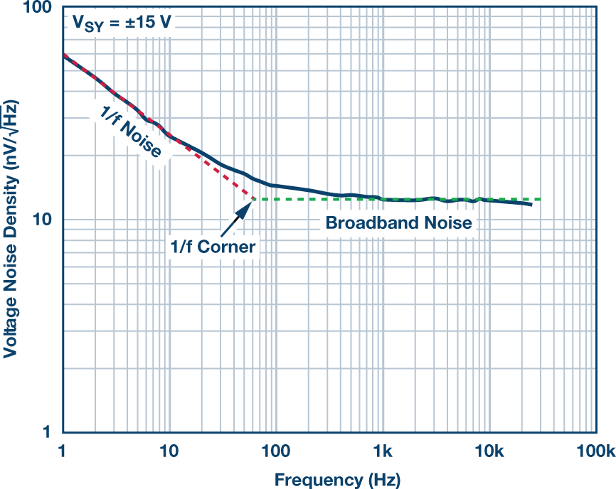

***Fig x****. Flicker-noise example in bode plot* *(Analog Devices, n.d.)*

Due to its low frequency characteristics, flicker noise is more influential in Direct Current (DC) systems. While it may seem small in magnitude, it is important to consider due to most of our systems being built on DC infrastructure. In electronics, flicker noise is especially significant in semiconductors, resistors, and operational amplifiers, affecting the performance of precision analog circuits and sensors.

This report aims to demonstrate flicker noise present in audio signals captured by a microphone sensor module. By analyzing the sensor’s output under different configurations—varying impedance via a resistor and environmental conditions via the box lid position—it highlights how flicker noise manifests in practical audio measurements and its impact on sensing applications. The configurations, which will be referenced throughout the report, are as follows:

* Configuration 1: Open lid, no impedance matching
* Configuration 2: Open lid, impedance matching
* Configuration 3: Closed lid, impedance matching

# **Method:**

**Equipment:**

* Raspberry Pi 4B (RPi 4B)
* RPi 4B wall power source
* MicroSD card (for data collection)
* ADS1115 (Analog to Digital Converter)
* MAX4466 Microphone
* Resistors (10 $Ω$)
* Breadboard
* Jumper wires
* Closable box

**Wiring Schematic:**

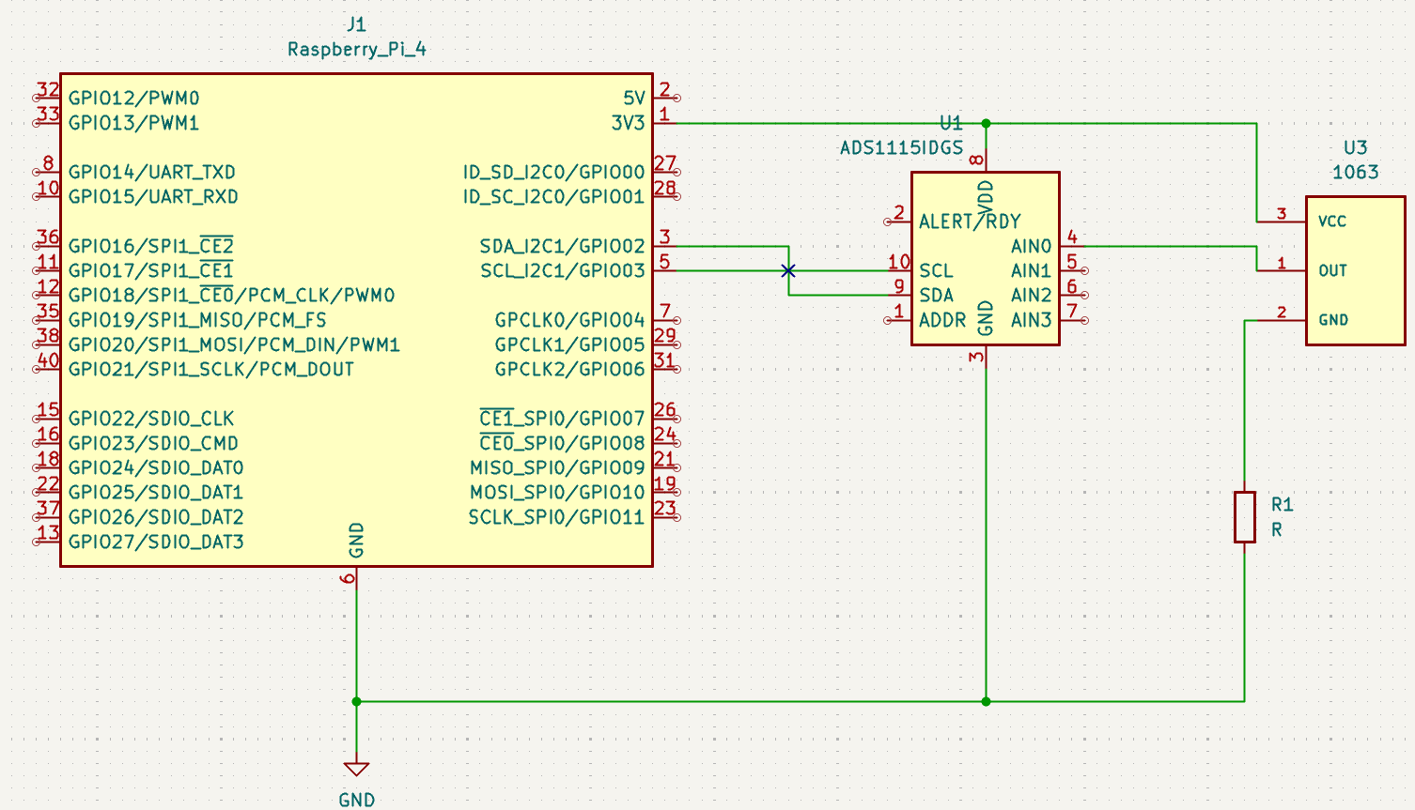

***Fig x****. Wiring schematic for experiment (KiCad)*

**Experimental Setup:**

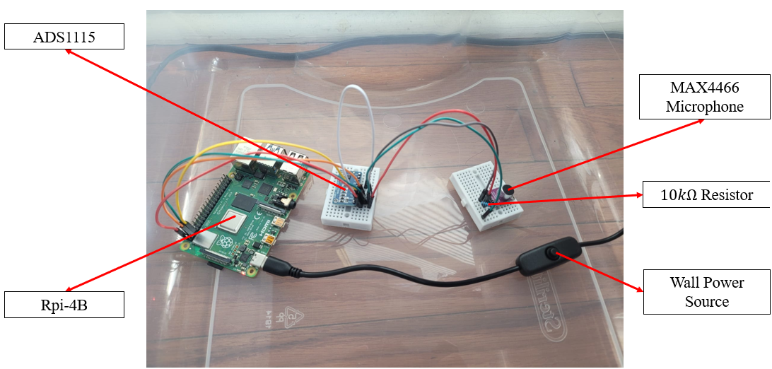

***Fig x.*** *Circuit Setup (Note: the resistor is only there in the Configuration 2 and 3) (Engineering Projects, 2021)*

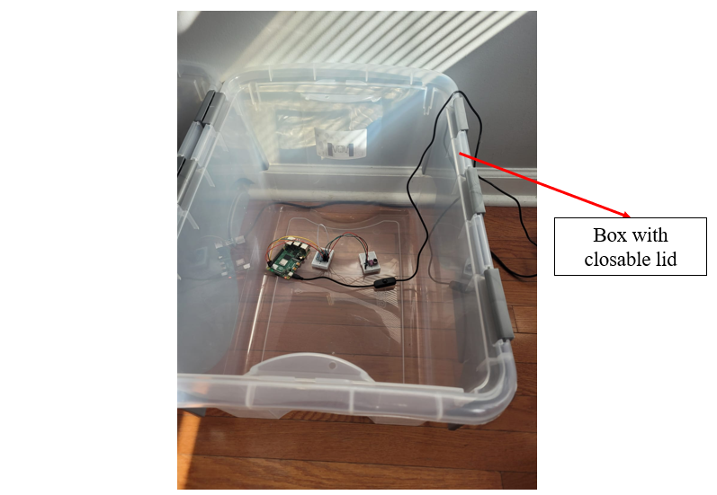

***Fig x.*** *Box in which circuit is placed (closed only in Configuration 3)*

**Data Acquisition:**

Microphone data was sampled at 1 Hz using the ADS1115 connected to the Raspberry Pi 4B, collecting a total of 86,400 samples over a 24-hour period. The MAX4466 microphone output was connected directly to ADC channel A0, with the onboard gain potentiometer at its default setting. Data collection was performed on the Raspberry Pi 4B using Python 3.9 running on Raspberry Pi OS, with the Adafruit_ADS1x15 library for ADC readings. The collected data was saved as CSV files and later transferred to a desktop computer for processing and analysis

**Data Analysis:**

On the desktop, Python libraries including *numpy*, *matplotlib*, and *scipy* were used. Power Spectral Density (PSD) was computed using Welch’s method (scipy.signal.welch), and frequency (Bode) plots were generated to analyze the noise characteristics.

**Procedure:**

1. Setup experimental setup following the schematic above in the box with the lid open and no resistor (R1) between the sensor and ground *(Configuration 1)*
2. Collect microphone data for 24 hours.
3. Save and import data to Desktop
4. Plot Power Spectral Density (PSD) plot for the data collected for data set using python
5. Run the previous steps in the following configurations **(EXTRA)**
   1. Open lid but with resistor between ground and sensor *(Configuration 2)*
   2. Closed lid and resistor between ground and sensor *(Configuration 3)*

# **Results:**

**Configuration 1:**

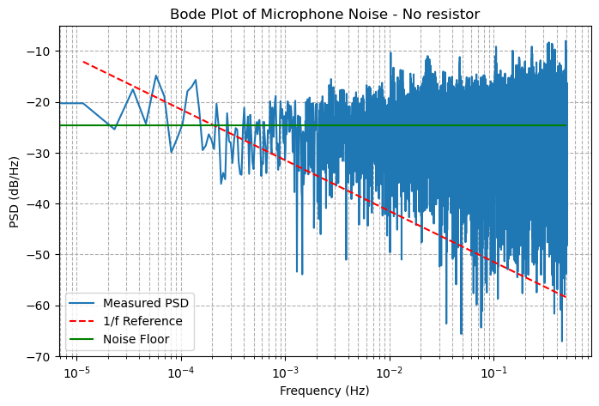

***Fig x.*** *Frequency (Hz) vs PSD (dB/Hz) plot for Configuration 1*

**Configuration 2: (EXTRA)**

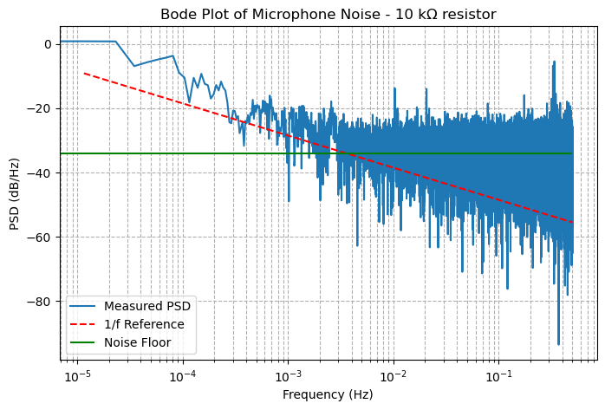

***Fig x.*** *Frequency (Hz) vs PSD (dB/Hz) plot for Configuration 2*

**Configuration 3: (EXTRA)**

***Fig x.*** *Frequency (Hz) vs PSD (dB/Hz) plot for Configuration 1*

# **Discussion:**

**Configuration 1**

**Configuration 2**

**Configuration 3**

# **References:**

1. *Analog Devices. (n.d.). Understanding and eliminating 1/f noise. Analog Dialogue.* [*https://www.analog.com/en/resources/analog-dialogue/articles/understanding-and-eliminating-1-f-noise.html*](https://www.analog.com/en/resources/analog-dialogue/articles/understanding-and-eliminating-1-f-noise.html)
2. Engineering Projects. (2021, March). What is Raspberry Pi 4? Pinout, specs, projects & datasheet. The Engineering Projects. [https://www.theengineeringprojects.com/2021/03/what-is-raspberry-pi-4-pinout-specs-projects-datasheet.html](vscode-file://vscode-app/c:/Users/HP/AppData/Local/Programs/Microsoft%20VS%20Code/resources/app/out/vs/code/electron-browser/workbench/workbench.html)
3. SciPy Developers. (2024). scipy.signal.welch — Power spectral density using Welch’s method. SciPy v1.XX documentation. <https://docs.scipy.org/doc/scipy/reference/generated/scipy.signal.welch.html>
4. DiCola, T. (2016, February 9). *ADS1015 / ADS1115 | Raspberry Pi analog to digital converters*. Adafruit Learning System. Retrieved from [https://learn.adafruit.com/raspberry-pi-analog-to-digital-converters/ads1015-slash-ads1115](https://learn.adafruit.com/raspberry-pi-analog-to-digital-converters/ads1015-slash-ads1115?utm_source=chatgpt.com)

# **Appendices:**