**Exploring 1/f Noise in Microphone Sensors: The Impact of Impedance Matching and Environmental Shielding**

By: Lokesh Sriram

# **Introduction:**

or “Flicker” noise is one of the intrinsic noises – a disturbance that cannot be avoided through improved engineering. The phenomenon’s cause is yet to be determined but it is present in all systems. As indicated by the name, the noise is prevalent in lower frequencies

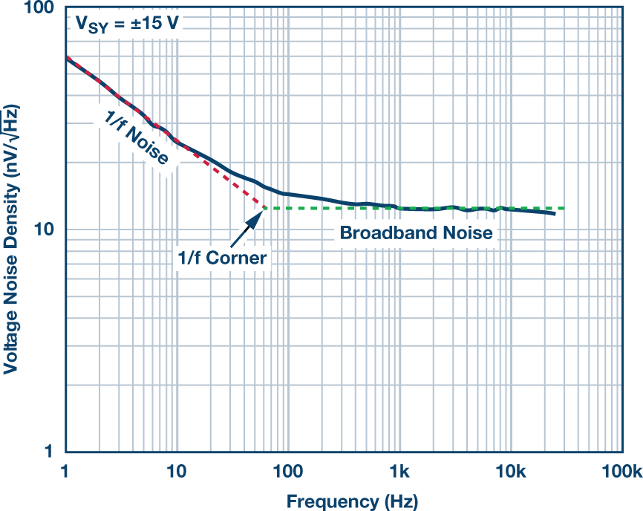

***Fig 1****. Flicker-noise example in bode plot* *(Analog Devices, n.d.)*

Due to its low frequency characteristics, flicker noise is more influential in Direct Current (DC) systems. While it may seem small in magnitude, it is important to consider due to most of our systems being built on DC infrastructure. In electronics, flicker noise is especially significant in semiconductors, resistors, and operational amplifiers, affecting the performance of precision analog circuits and sensors.

This report aims to demonstrate flicker noise present in audio signals captured by a microphone sensor module. By analyzing the sensor’s output under different configurations—varying impedance via a resistor and environmental conditions via the box lid position—it highlights how flicker noise manifests in practical audio measurements and its impact on sensing applications. The configurations, which will be referenced throughout the report, are as follows:

* Configuration 1: Open lid, no impedance matching
* Configuration 2: Open lid, impedance matching
* Configuration 3: Closed lid, impedance matching

# **Method:**

**Equipment:**

* Raspberry Pi 4B (RPi 4B)
* RPi 4B wall power source
* MicroSD card (for data collection)
* ADS1115 (Analog to Digital Converter)
* MAX4466 Microphone
* Resistors (10)
* Breadboard
* Jumper wires
* Closable box

**Wiring Schematic:**

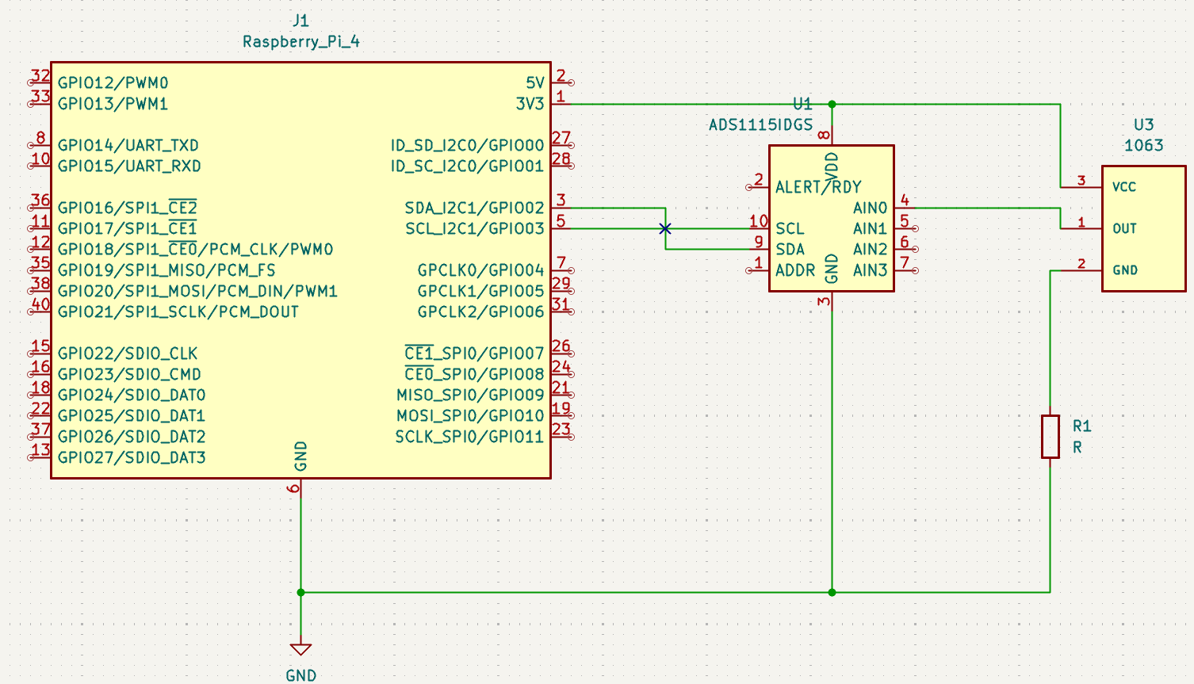

***Fig 2****. Wiring schematic for experiment (KiCad)*

**Experimental Setup:**

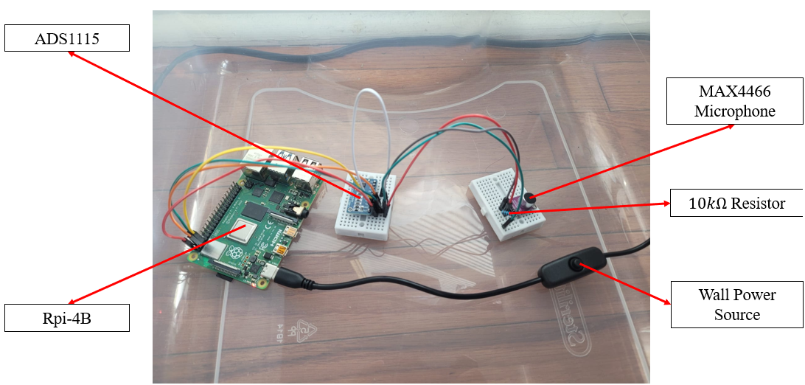

***Fig 3.*** *Circuit Setup (Note: the resistor is only there in the Configuration 2 and 3) (Engineering Projects, 2021)*

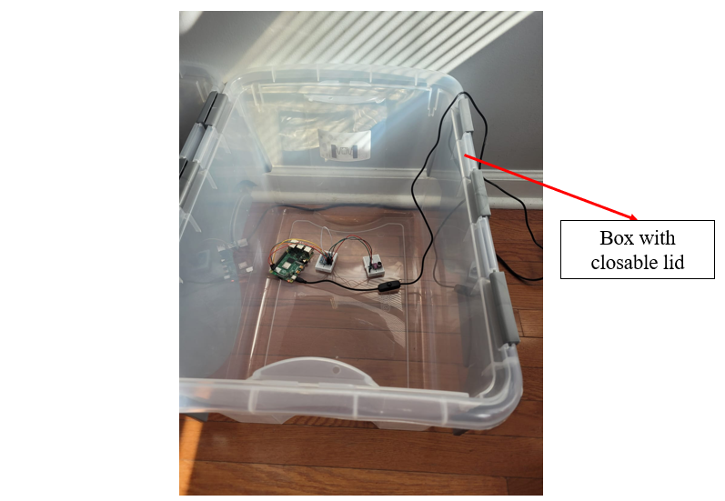

***Fig 4.*** *Box in which circuit is placed (closed only in Configuration 3)*

**Data Acquisition:**

Microphone data was sampled at 1 Hz using the ADS1115 connected to the Raspberry Pi 4B, collecting a total of 86,400 samples over a 24-hour period. The MAX4466 microphone output was connected directly to ADC channel A0, with the onboard gain potentiometer at its default setting. Data collection was performed on the Raspberry Pi 4B using Python 3.9 running on Raspberry Pi OS, with the Adafruit_ADS1x15 library for ADC readings. The collected data was saved as CSV files and later transferred to a desktop computer for processing and analysis

**Data Analysis:**

On the desktop, Python libraries including *numpy*, *matplotlib*, and *scipy* were used. Power Spectral Density (PSD) was computed using Welch’s method (scipy.signal.welch), and frequency (Bode) plots were generated to analyze the noise characteristics.

**Procedure:**

1. Setup experimental setup following the schematic above in the box with the lid open and no resistor (R1) between the sensor and ground *(Configuration 1)*
2. Collect microphone data for 24 hours.
3. Save and import data to Desktop
4. Plot Power Spectral Density (PSD) plot for the data collected for data set using python
5. Run the previous steps in the following configurations **(EXTRA)**
   1. Open lid but with resistor between ground and sensor *(Configuration 2)*
   2. Closed lid and resistor between ground and sensor *(Configuration 3)*

# **Results:**

**Configuration 1:**

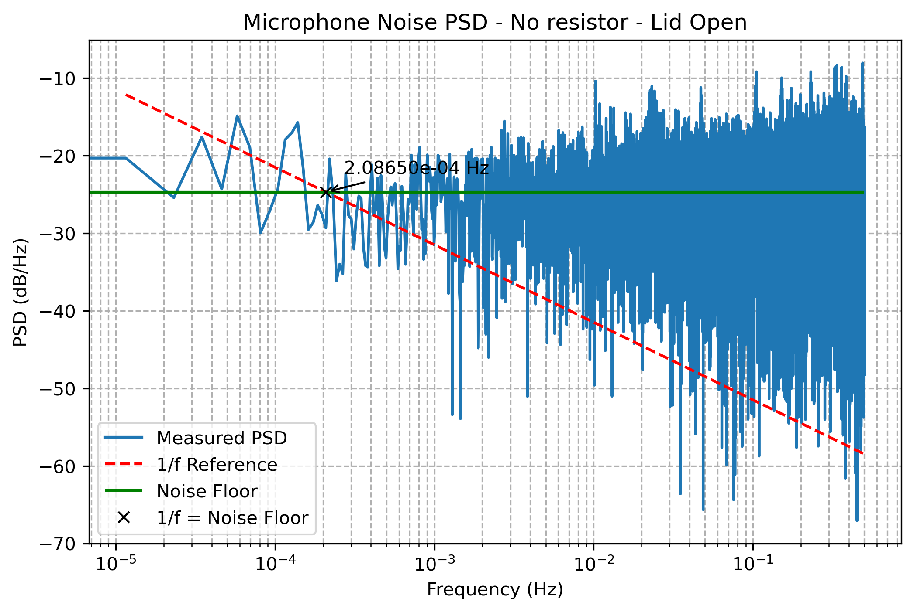

***Fig 5.*** *Frequency (Hz) vs PSD (dB/Hz) plot for Configuration 1*

**Configuration 2: (EXTRA)**

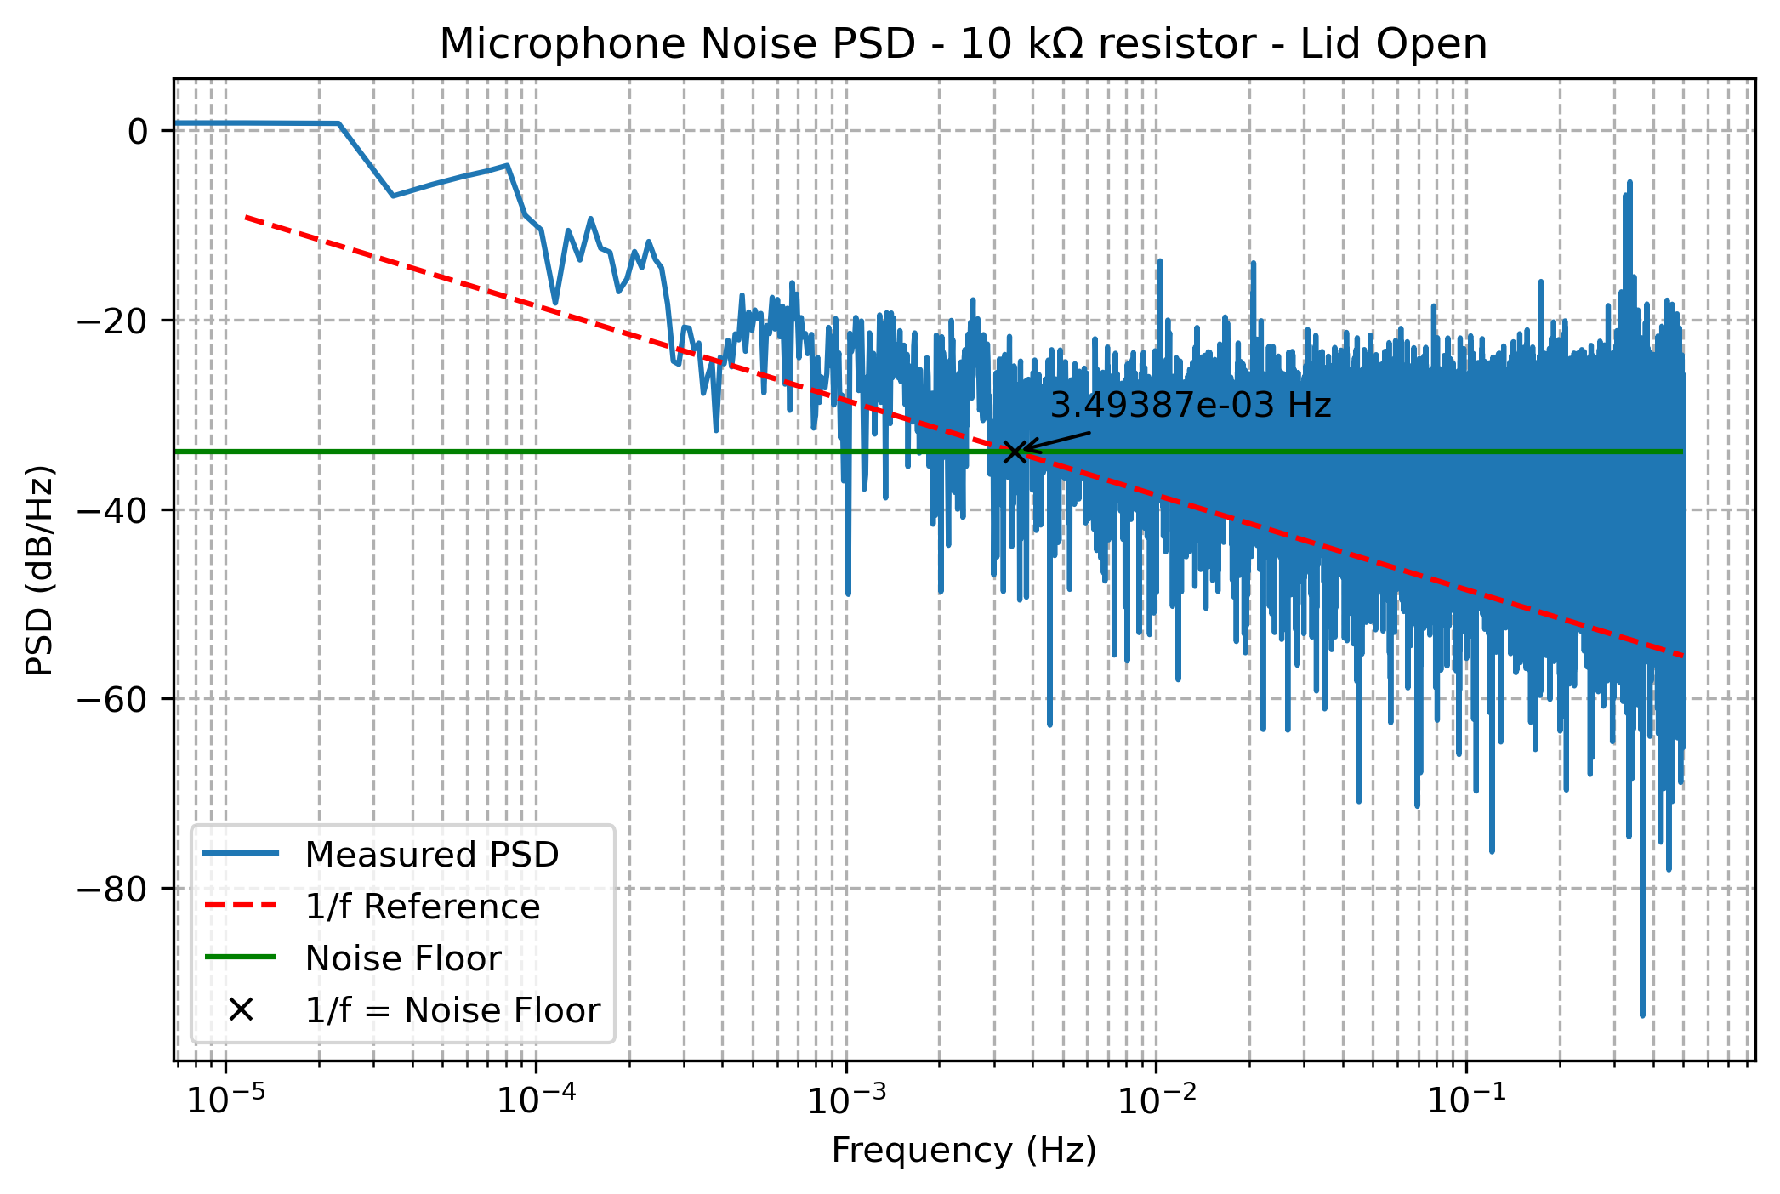

***Fig 6.*** *Frequency (Hz) vs PSD (dB/Hz) plot for Configuration 2*

**Configuration 3: (EXTRA)**

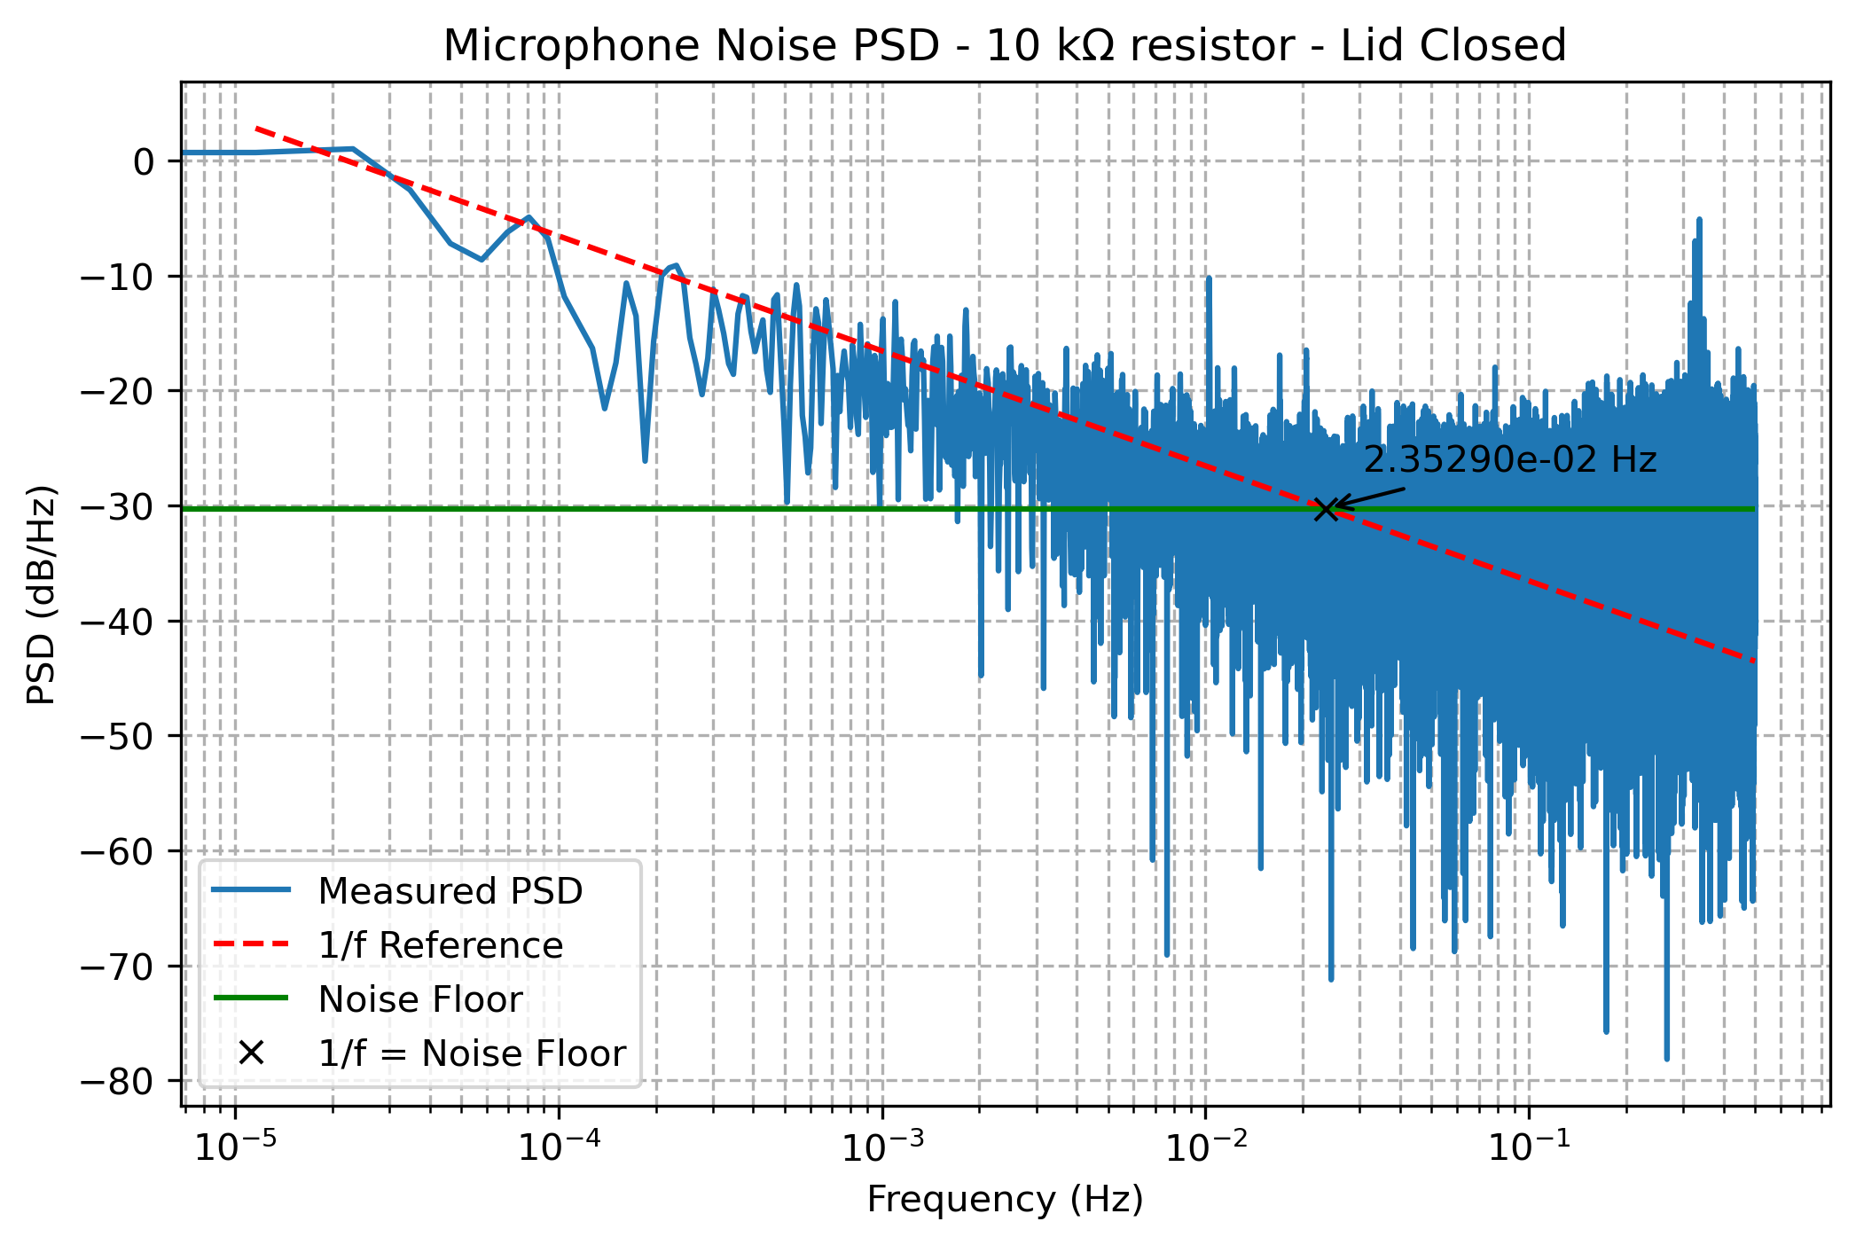

***Fig 7.*** *Frequency (Hz) vs PSD (dB/Hz) plot for Configuration 3*

# **Discussion:**

The three plots compare the power spectral density (PSD) of microphone noise under different experimental configurations: (1) no resistor with lid open, (2) 10 resistor with lid open, and (3) 10 resistor with lid closed. Each plot displays the measured PSD, a theoretical 1/f reference, the broadband noise floor, and the intersection ("corner") where 1/f noise transitions to white noise.

**Configuration 1**

In the setup without a resistor and with the lid open, the broadband noise floor is highest, and the 1/f corner occurs at the lowest frequency (2.09e-4 Hz). The measured PSD only follows the 1/f slope at the very lowest frequencies before quickly flattening out, indicating that white noise dominates most of the spectrum. This configuration is least effective for observing 1/f noise, as the flicker noise is largely masked by broadband and environmental noise.

**Configuration 2 (Impedance Matching)**

Adding a resistor with the lid open lowers the broadband noise floor and shifts the 1/f corner to a higher frequency (3.49e-3 Hz) compared to the no-resistor case. The measured PSD demonstrates a clearer 1/f region, following the theoretical slope over a wider frequency range before flattening out. While impedance matching improves the visibility of flicker noise, the absence of environmental shielding allows more external noise to enter, limiting the clarity of the 1/f region.

**Configuration 3 (Enclosure + Impedance Matching)**

With the lid closed and a resistor in place, this configuration produces the clearest and most extended region of 1/f noise. The measured PSD closely follows the theoretical 1/f slope over several decades of frequency, and the transition to white noise occurs at the highest corner frequency (2.35e-2 Hz) among all setups. The environmental shielding provided by the closed lid further reduces the overall noise floor, likely due to improved acoustic isolation and reduced external interference. As a result, 1/f noise is visible over a broader frequency range, making this configuration the most effective for observing flicker noise in the sensor output.

**Comparison**

The three experimental configurations reveal how impedance matching and environmental shielding affect the visibility of 1/f noise in microphone sensor measurements. Without a resistor, the system is dominated by broadband white noise, and 1/f noise is only observable at the lowest frequencies, making it difficult to distinguish the flicker noise region. Introducing a resistor significantly lowers the broadband noise floor and allows the measured PSD to follow the theoretical 1/f slope over a much wider frequency range, with a clear and distinct transition to white noise. This demonstrates that impedance matching is crucial for exposing intrinsic low-frequency noise. Further enclosing the setup by closing the lid provides additional shielding, which reduces external interference and extends the frequency range where 1/f noise is visible even more. Overall, the combination of impedance matching and environmental control produces the clearest and most extended region of 1/f noise, highlighting the importance of both factors in accurate sensor noise characterization.

# **Conclusion:**

In conclusion, the results clearly show that both impedance matching and environmental shielding are essential for revealing and accurately characterizing 1/f noise in microphone sensor measurements. The addition of a resistor lowers the broadband noise floor and exposes a broad frequency range where the PSD follows the expected 1/f slope, while enclosing the setup further enhances the clarity and extent of the flicker noise region by reducing external interference. These findings highlight the importance of careful experimental design in low-frequency noise studies and demonstrate that the combination of proper impedance and environmental control provides the most reliable evidence of intrinsic 1/f noise in practical sensing applications.

# **References:**

1. *Analog Devices. (n.d.). Understanding and eliminating 1/f noise. Analog Dialogue.* [*https://www.analog.com/en/resources/analog-dialogue/articles/understanding-and-eliminating-1-f-noise.html*](https://www.analog.com/en/resources/analog-dialogue/articles/understanding-and-eliminating-1-f-noise.html)
2. Engineering Projects. (2021, March). What is Raspberry Pi 4? Pinout, specs, projects & datasheet. The Engineering Projects. [https://www.theengineeringprojects.com/2021/03/what-is-raspberry-pi-4-pinout-specs-projects-datasheet.html](vscode-file://vscode-app/c:/Users/HP/AppData/Local/Programs/Microsoft%20VS%20Code/resources/app/out/vs/code/electron-browser/workbench/workbench.html)
3. SciPy Developers. (2024). scipy.signal.welch — Power spectral density using Welch’s method. SciPy v1.XX documentation. <https://docs.scipy.org/doc/scipy/reference/generated/scipy.signal.welch.html>
4. DiCola, T. (2016, February 9). *ADS1015 / ADS1115 | Raspberry Pi analog to digital converters*. Adafruit Learning System. Retrieved from [https://learn.adafruit.com/raspberry-pi-analog-to-digital-converters/ads1015-slash-ads1115](https://learn.adafruit.com/raspberry-pi-analog-to-digital-converters/ads1015-slash-ads1115?utm_source=chatgpt.com)

# **Appendices:**

# All code and data can be found at the following github repo: <https://github.com/lokichubs/Flicker-noise-project>