Exploring MEMS Microphone Characteristics and Constructing an Equalizer to Apply Audio Effects
Lokesh Sriram

Abstract—This report presents a comprehensive characterization of an I2S MEMS microphone (SPH0645LM4H) and demonstrates its application in real-time digital audio processing through implementation of a telephone effect equalizer. Flicker noise analysis using a 12-hour silent recording revealed a corner frequency of 7.621 × 10⁻³ Hz with a thermal noise floor of -95.5 dB/Hz, confirming that 1/f noise operates well below the audio bandwidth and poses negligible interference to speech and music applications. Frequency response measurements using swept-sine methodology (20 Hz - 20 kHz) demonstrated typical MEMS characteristics: significant low-frequency roll-off below 80 Hz (-32.75 dB at 20-40 Hz), relatively flat mid-frequency response between 80 Hz and 5120 Hz (±3 dB variation), and high-frequency attenuation above 10 kHz. A telephone effect equalizer was implemented using cascaded 4th-order Butterworth bandpass filters (300 Hz - 3.4 kHz cutoffs) to validate the microphone's suitability for audio effects processing. Spectral analysis confirmed 20-30 dB amplification within the telephone passband and complete suppression of out-of-band content, with cumulative energy distribution showing nearly 100% energy concentration within the target bandwidth. Results validate the suitability of I2S MEMS microphones for real-time audio DSP applications requiring predictable frequency response, low noise performance, and digital interface compatibility.

Index Terms—MEMS microphone, flicker noise, frequency response, digital equalizer, Butterworth filter, audio signal processing, telephone effect, power spectral density.

I. INTRODUCTION
T
he performance of audio systems fundamentally depends on understanding the characteristics of their transducers. For modern digital audio applications, MEMS (Micro-Electro-Mechanical Systems) microphones have become ubiquitous due to their small size, reliability, and integration capabilities. However, to effectively utilize these devices and implement audio processing techniques, a thorough characterization of their behavior is essential.

While MEMS microphones are widely used because of their small size and digital interfaces, their noise characteristics and frequency response can vary depending on design and operating conditions. Understanding these characteristics is especially important when the microphone is part of a larger signal-processing pipeline, since any limitations at the sensing stage can influence later filtering or audio effects. For this reason, studying how a MEMS microphone behaves in real recording conditions provides valuable insight into both its capabilities and the types of processing techniques that can be applied effectively.
Frequency Sweep: The microphone's sensitivity across the audible spectrum (20 Hz - 20 kHz) reveals how faithfully it captures different frequencies. Non-flat frequency responses can color audio recordings and must be understood for accurate signal processing.

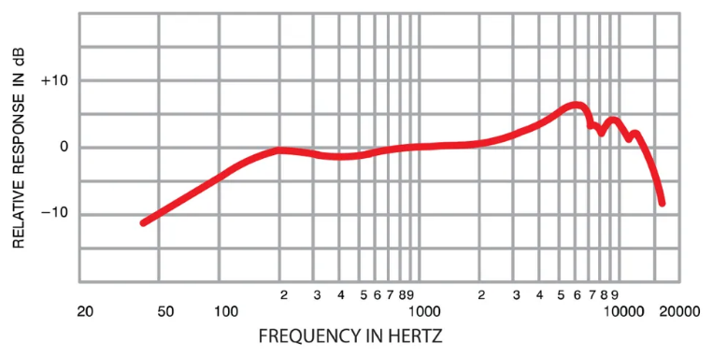
Fig. 1. Frequency response plot

Flicker Noise: (1/f Noise): This low-frequency noise characteristic, where noise power is inversely proportional to frequency, affects the signal-to-noise ratio in the critical lower frequency bands. Understanding flicker noise is crucial for low-frequency audio applications and sensor stability.

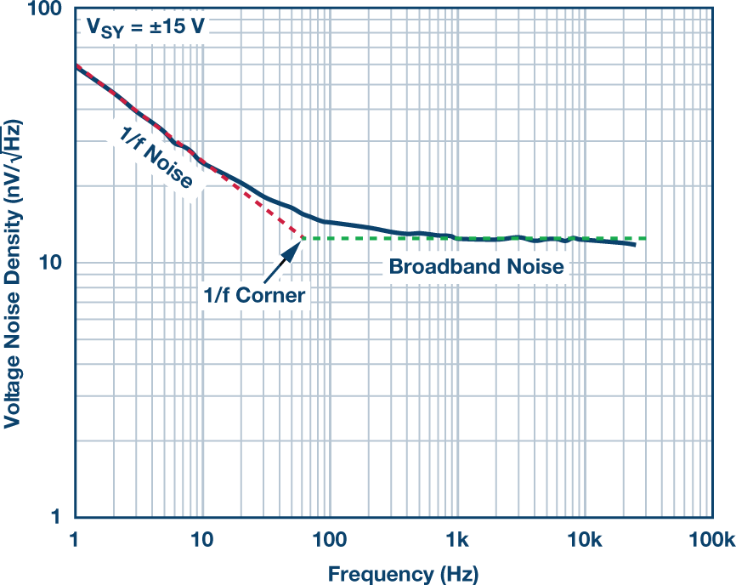
Fig. 2. Flicker noise characterization

Dynamic Range and Sensitivity: These parameters determine the microphone's ability to capture both quiet and loud sounds without distortion or loss of detail.

Phase Response: Time-domain accuracy and the preservation of transient information depend on consistent phase behavior across frequencies.

Comprehensive characterization enables engineers to compensate for device limitations, predict system performance, and design appropriate signal processing chains. This report presents a systematic analysis of a MEMS microphone's performance characteristics with emphasis on:

- Flicker noise analysis to quantify low-frequency noise behavior
- Frequency response measurement using swept-sine methodology
- Digital equalization design to manipulate frequency content
In addition to characterizing the microphone, this project applies these measurements to a practical audio-processing task. Audio effects can be achieved through selective frequency manipulation using equalizers. An equalizer modifies the amplitude (and sometimes phase) of specific frequency bands, allowing sound designers to: Emphasize or suppress frequency ranges (e.g., bass boost, treble cut) Correct for transducer deficiencies Create artistic effects by dramatically altering spectral balance

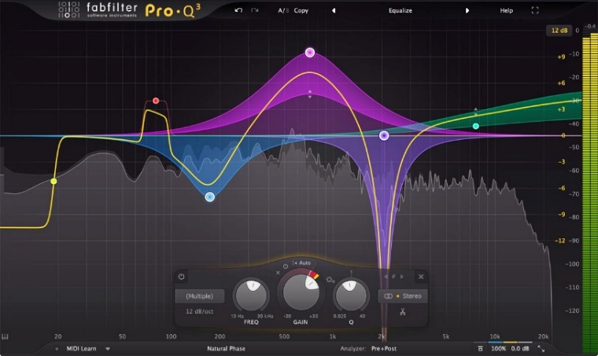
Fig. 3. Multiband equalizer setup

Modern digital equalizers (Figure 3) offer sophisticated multiband control, enabling independent adjustment of numerous frequency ranges simultaneously for precise tonal shaping. However, compelling audio effects can also be created using simpler filtering approaches that target specific bandwidth constraints. The Telephone Effect, the focus of this study, simulates the bandwidth-limited sound characteristic of traditional telephone systems. Early telephone networks transmitted only frequencies between approximately 300 Hz and 3. 4 kHz due to hardware limitations. This narrow bandwidth creates the distinctive "tinny" quality associated with phone conversations. By designing a bandpass filter that attenuates frequencies outside this range, we can recreate this effect digitally.

II. METHODS

A. Equipment
- Raspberry Pi 4B (RPi 4B)
- RPi 4B wall power source
- MicroSD card (for data collection)
- SPH0645LM4H (I2S MEMS microphone)
- Resistor (10$kΩ$)
- Breadboard
- Jumper wires
- Closable box
- Computer and Speakers

B. Experimental Setup

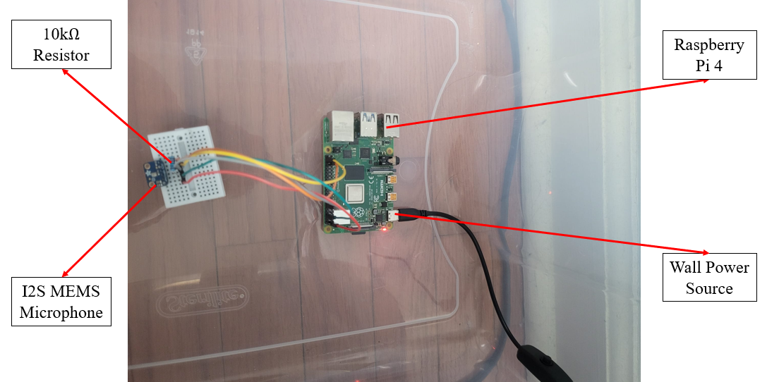Fig. 4a. RPi 4B with mic setup
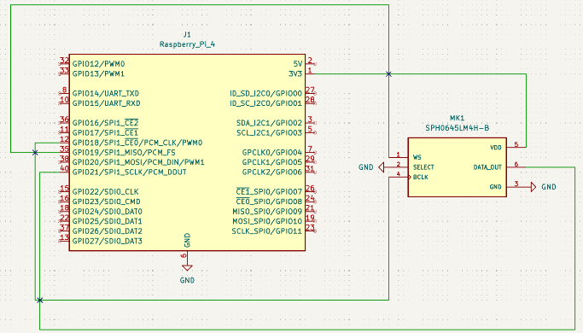
Fig. 4b. Wiring schematic (made using Kicad)
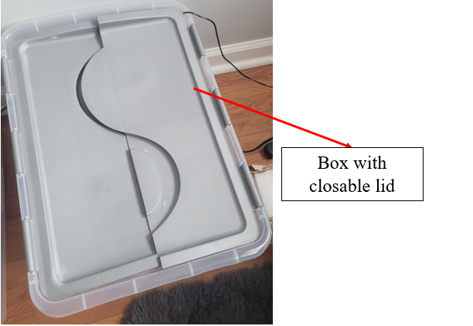
Fig .5. Closable box for flicker noise experiment
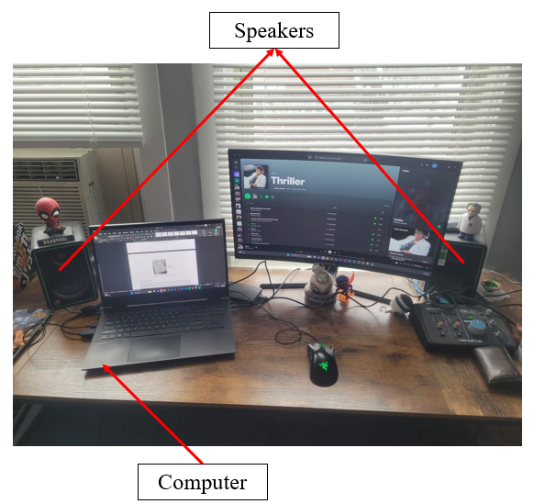
Fig. 6. Computer and speakers for data generation

C. Data Acquisition
The Raspberry Pi 4B captured audio directly from the MEMS microphone using the I2S (Inter-IC Sound) digital interface. Python scripts recorded the microphone output and saved it as signed 32-bit float WAV files to the microSD card. For frequency response and equalizer measurements, the sampling rate was set to 48 kHz to cover the full audible spectrum (20 Hz - 20 kHz) and 15 seconds of data were collected. For flicker noise analysis, recordings were made at the microphone's recommended minimum sampling rate of 8 kHz to focus on low-frequency noise characteristics and 12 hours of data was collected.

D. Data Generation
Two types of audio signals were generated for this study. For frequency response characterization, a linear frequency sweep (chirp) was created ranging from 20 Hz to 20 kHz over 10 seconds. This signal was generated in Python using NumPy at a sampling rate of 48 kHz. The sweep's instantaneous frequency increased linearly over time, calculated by integrating the frequency function and applying a sine wave transformation. The amplitude was set to 0.5 (50% of full scale) to prevent clipping while maintaining good signal-to-noise ratio. The resulting signal was played on monitor speakers.

For equalizer testing and the telephone effect demonstration, Michael Jackson's "Thriller" was used as the source audio. This track was selected because its rich frequency content—including deep bass, clear vocals, and bright percussion—makes frequency manipulation effects immediately noticeable. The telephone effect bandpass filter (300 Hz - 3.4 kHz) would clearly demonstrate the removal of the song's low-end punch and high-frequency sparkle, providing an easily recognizable validation of the equalization implementation.

E. Data Analysis
For flicker noise characterization, the Power Spectral Density (PSD) was calculated from the silent recordings sampled at 8 kHz using Welch's method. The PSD was plotted on a log-log scale to examine the low-frequency noise behavior. From the PSD the noise floor and noise corner were identified.

For frequency response measurements, the recorded sweep signal was analyzed using PSD estimation with Gaussian smoothing applied to reduce spectral noise. Additionally, octave band analysis was performed by dividing the spectrum into standard octave bands and calculating the energy content in each band.

For equalizer validation, a bandpass filter was first designed and applied to the "Thriller" audio to create the telephone effect. The filter was implemented as a cascaded combination of a 4th-order Butterworth high-pass filter (cutoff at 300 Hz) and a 4th-order Butterworth low-pass filter (cutoff at 3.4 kHz). The filters were applied sequentially—first removing frequencies below 300 Hz, then removing frequencies above 3.4 kHz—leaving only the telephone bandwidth. The filtered audio was normalized to prevent clipping and saved for analysis. The same PSD and octave band analyses were then applied to both the original and filtered audio. A cumulative power plot was also generated to calculate the running sum of energy as a function of frequency for both versions, showing how energy was redistributed after filtering.

F. Experimental Procedure
- The MEMS microphone was placed inside the closable box to minimize external noise
- Audio was recorded in silence for an extended duration (12 hours) at 8 kHz sampling rate
- The recording was saved to the microSD card for analysis
- The speaker was positioned at a fixed distance from the microphone
- The generated linear sweep (20 Hz - 20 kHz, 10 seconds) was played through the speakers
- The microphone output was simultaneously recorded at 48 kHz sampling rate
- The recorded sweep was saved for frequency response analysis
- The song "Thriller" was played on my computer speakers and was recorded for 15 seconds
- The recorded audio file was loaded into the equalizer application
- The bandpass filter was configured with 300 Hz high-pass and 3.4 kHz low-pass cutoff
- The telephone effect filter was applied and the filtered output was saved
- Both the original and filtered versions were analyzed for comparison

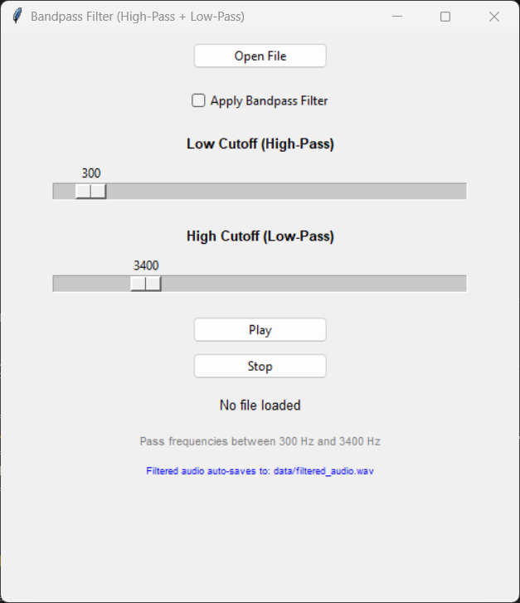
Fig. 7. Designed equalizer UI

III. RESULTS

A. Flicker Noise
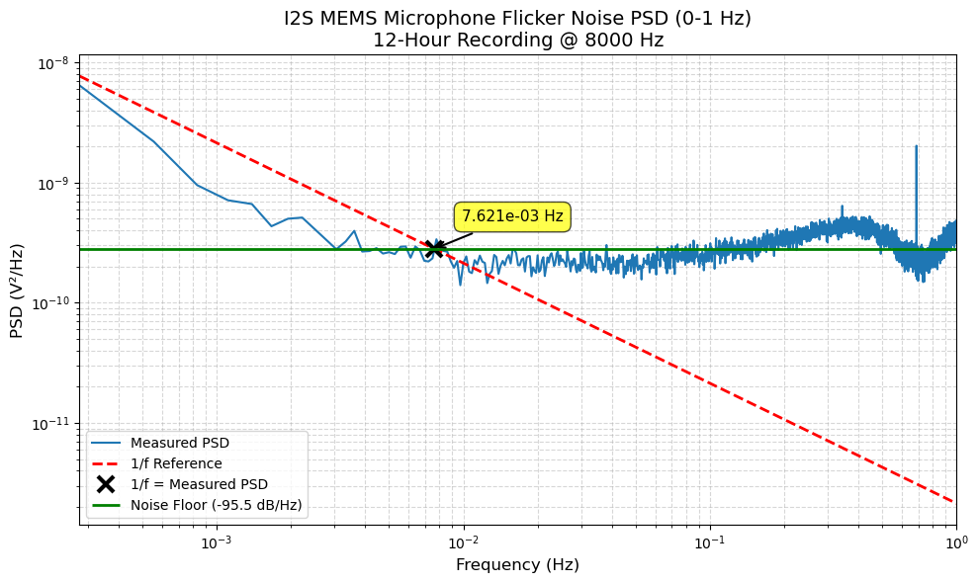
Fig. 8. Flicker noise plot

B. Frequency Sweep
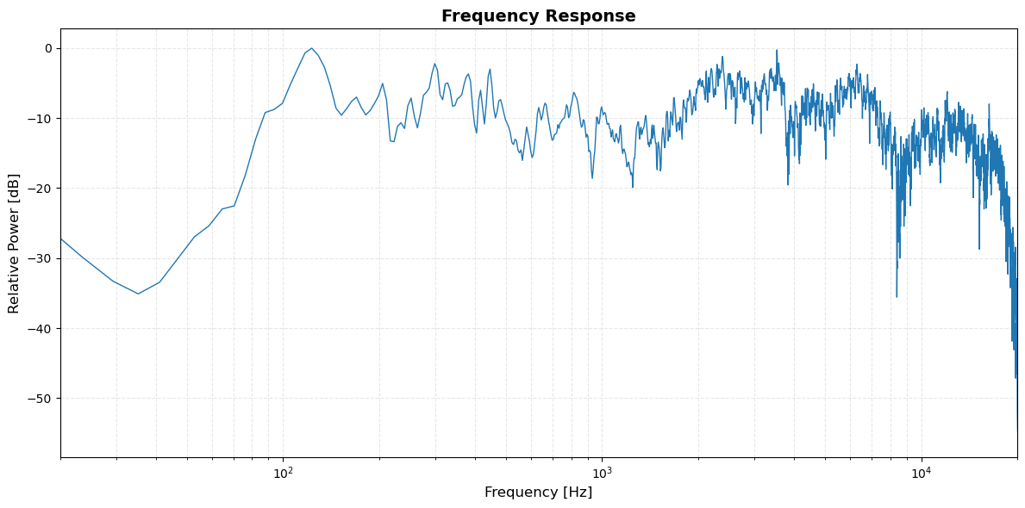
Fig. 9. Frequency sweep response

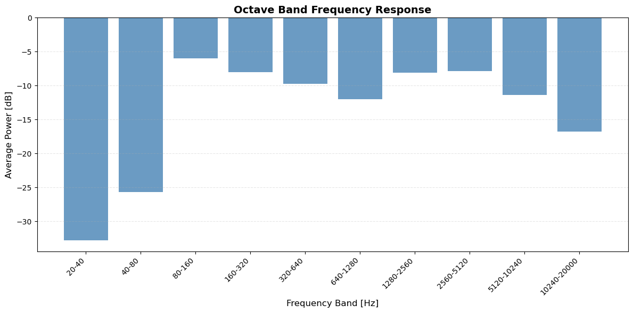
Fig. 10. Frequency sweep octave band powers

C. Equalizer
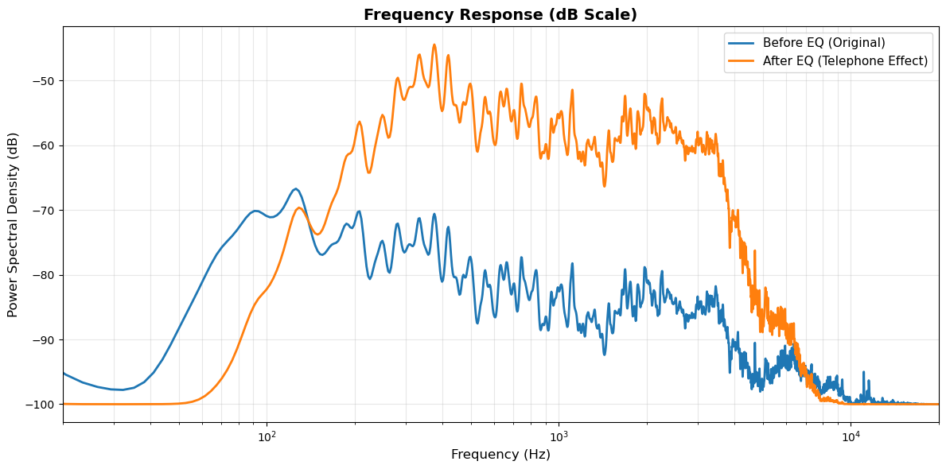
Fig. 11. Frequency response pre and post equalization

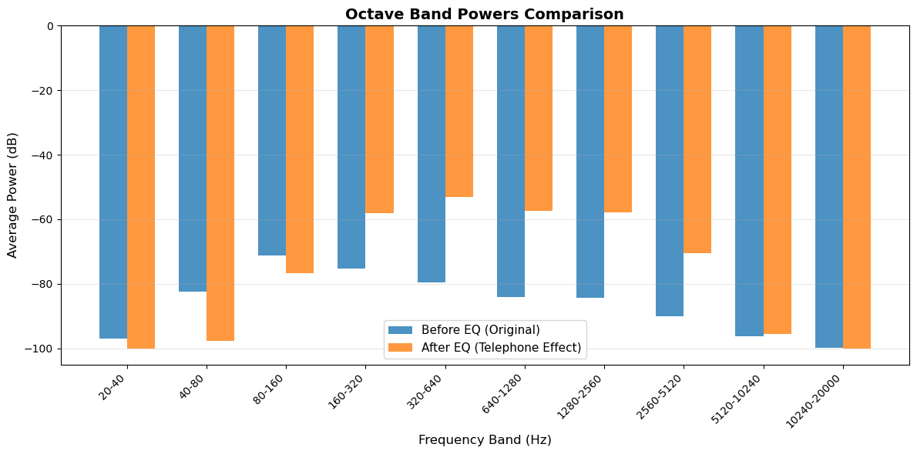
Fig. 12. Octave band powers pre and post equalization

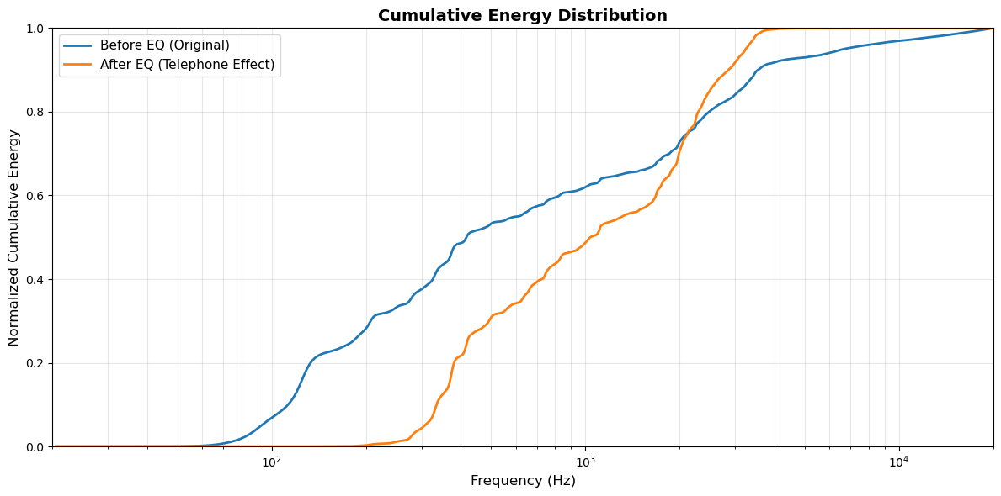
Fig. 13 Cumulative energy pre and post equalization

IV. DISCUSSION

A. Flicker Noise
As shown in Figure 8, the measured PSD closely tracks the theoretical 1/f reference line at very low frequencies, confirming classical pink noise behavior in the MEMS microphone. The corner frequency of 7.621 × 10⁻³ Hz indicates that flicker noise only dominates at timescales longer than approximately 131 seconds, which is consistent with charge trapping and release mechanisms typical of semiconductor-based capacitive transducers. Above the corner frequency, the noise floor stabilizes at -95. 5 dB/Hz, representing white thermal noise. This remarkably low corner frequency suggests excellent low-frequency performance for the MEMS microphone, as 1/f noise would only become problematic in applications requiring sub-0.01 Hz measurements, such as long-duration environmental monitoring or ultra-low-frequency vibration detection. The sharp spike observed near 1 Hz likely results from environmental interference or mechanical vibrations during the extended recording period.

A key takeaway from the flicker noise analysis is that the measured corner frequency lies well below the telephone bandwidth (300 Hz - 3.4 kHz), meaning that 1/f noise will not significantly impact the bandpass-filtered audio signal used in the equalizer validation. Since flicker noise only dominates below 7.621 × 10⁻³ Hz and the telephone effect filter removes all content below 300 Hz, the filtered signal will be entirely within the thermal noise-dominated region where the noise floor is flat and predictable. This is advantageous for audio processing applications, as it ensures that low-frequency artifacts from flicker noise—such as drift or slow amplitude variations—are inherently eliminated by the high-pass filtering stage. Consequently, the telephone effect implementation can focus solely on the frequency shaping characteristics of the bandpass filter without concern for low-frequency noise contamination that might otherwise degrade signal quality or introduce audible distortion in the passband.

Several factors may have introduced error into the flicker noise measurements. Temperature fluctuations during the 12-hour recording could cause drift in the microphone's DC characteristics, potentially affecting the low-frequency noise floor. The closable box, while reducing acoustic interference, does not provide electromagnetic shielding, leaving the measurement vulnerable to low-frequency electrical noise from nearby power lines or equipment. Air pressure variations and residual airflow within the enclosure may also contribute to spurious low-frequency signals that could shift the apparent corner frequency.

B. Frequency Sweep
The frequency sweep analysis, shown in Figures 9 and 10, reveals the MEMS microphone's sensitivity characteristics across the audible spectrum (20 Hz - 20 kHz). The microphone exhibits significant low-frequency roll-off, with the 20-40 Hz and 40-80 Hz octave bands attenuated by -32.75 dB and -25.64 dB respectively, indicating poor bass response typical of small-diaphragm MEMS transducers with limited low-frequency extension. The response flattens considerably in the mid-frequency range (80 Hz - 5120 Hz), where attenuation varies between -5. 96 dB and -12. 02 dB relative to the peak response, demonstrating reasonably consistent sensitivity across speech-critical frequencies. The octave band analysis shows that the flattest response occurs in the 80-160 Hz band (-5.96 dB) through the 2560-5120 Hz band (-7.85 dB), with variation of only ~2 dB across this wide range. Above 5120 Hz, the response begins to roll off again, with the highest octave band (10240-20000 Hz) showing -16.75 dB attenuation, likely due to the physical limitations of the MEMS diaphragm's mechanical resonance and acoustic damping at ultrasonic frequencies. The raw frequency response plot exhibits significant spectral fluctuations and noise artifacts, particularly above 2 kHz, which may result from room acoustics, standing waves, and environmental reflections during the sweep recording.

These frequency response characteristics directly inform the design and performance of the telephone effect bandpass filter. The microphone's natural low-frequency roll-off below 80 Hz means that the high-pass filter stage (300 Hz cutoff) will be applied to an already attenuated signal in the sub-300 Hz region, effectively pre-conditioning the audio and reducing the filtering burden on the equalizer. More critically, the relatively flat response across the telephone bandwidth (300 Hz - 3.4 kHz) ensures that the bandpass filter will shape the frequency content uniformly without compensating for significant microphone-induced coloration. The mid-frequency consistency, with only ~4 dB variation between 160 Hz and 2560 Hz bands, suggests that the characteristic "tinny" quality of the telephone effect will result primarily from the intentional bandpass filtering rather than from irregular microphone response artifacts. The high-frequency roll-off above 5 kHz also works synergistically with the low-pass filter stage (3.4 kHz cutoff), as frequencies above the telephone bandwidth are naturally attenuated by the microphone itself, minimizing aliasing concerns and reducing the sharpness required of the digital filter to achieve adequate stopband rejection.

The uncontrolled room acoustics create standing waves and reflections that vary with frequency, making it difficult to isolate the microphone's true response from environmental effects—particularly evident in the spectral fluctuations above 2 kHz. The speaker-to-microphone distance and orientation were fixed but not precisely calibrated, meaning that directivity patterns of both the speaker and microphone could introduce angle-dependent coloration. Speaker nonlinearity at low frequencies may have reduced the actual acoustic output below 100 Hz, causing the measured roll-off to appear more severe than the microphone's intrinsic response. Additionally, the Gaussian smoothing applied during PSD analysis reduces spectral resolution to approximately 50 Hz, potentially obscuring narrow resonances or anti-resonances in the microphone's true frequency response. Variations in speaker output level across the sweep could also introduce amplitude-dependent errors if the microphone exhibits nonlinear behavior at different sound pressure levels.

C. Equalizer
The spectral and octave band analyses in Figures 11 and 12 demonstrate the effectiveness of the cascaded Butterworth bandpass filter in implementing the telephone effect. The frequency response comparison shows a dramatic transformation, with the filtered signal (orange) exhibiting a clear passband centered in the 300 Hz - 3. 4 kHz range and elevated approximately 10-15 dB relative to the original signal (blue) within this band. The sharp transitions at both filter edges confirm proper stopband rejection, with frequencies below 300 Hz and above 3.4 kHz heavily attenuated. The octave band comparison quantifies this behavior more precisely: the 20-40 Hz and 40-80 Hz bands remain nearly unchanged (both near -100 dB), indicating complete suppression of sub-bass content, while the 80-160 Hz band shows minimal filtering effect due to partial overlap with the passband's lower edge. The critical telephone bandwidth octave bands (160-320 Hz through 1280-2560 Hz) display substantial amplification, with the filtered signal consistently 20-30 dB higher than the original across these mid-frequency ranges. High-frequency bands above 5120 Hz return to equivalent attenuation levels in both versions, demonstrating effective low-pass filtering action beyond the 3.4 kHz cutoff.

The cumulative energy distribution plot in Figure 13 provides insight into how the bandpass filter redistributes spectral energy across the frequency domain. The original signal (blue) exhibits a gradual, monotonic energy accumulation starting around 50 Hz, with approximately 50% of total energy concentrated below 500 Hz and reaching 90% by approximately 3 kHz, indicating a broadband spectral distribution typical of full-range music recordings. In contrast, the telephone-filtered signal (orange) shows essentially zero cumulative energy below 200 Hz, confirming complete removal of low-frequency content. The steepest portion of the orange curve occurs between 300 Hz and 3.4 kHz, where energy accumulation is rapid and compressed—reaching nearly 100% by 4 kHz—demonstrating that virtually all signal energy has been concentrated within the telephone passband. This energy compression creates the characteristic narrow, mid-range-focused sound associated with vintage telephone audio. The sharp transition to full energy accumulation at the high-pass edge (~300 Hz) and the plateau immediately after the low-pass edge (~3.4 kHz) validate that the 4th-order Butterworth filters provide sufficiently steep roll-off characteristics to isolate the desired frequency range without significant passband ripple or excessive transition bandwidth.

The equalizer validation measurements inherit all uncertainties from the frequency response characterization, as the same microphone and acoustic environment were used to record the test audio. The choice of "Thriller" as test material, while effective for demonstrating audible effects, introduces signal-dependent variability since music contains time-varying spectral content rather than steady-state tones. The normalization applied after filtering to prevent clipping may have introduced small amplitude scaling differences between the original and filtered versions, potentially affecting the absolute dB values reported in the octave band comparison. The cumulative energy analysis assumes that all relevant audio content falls within the 20 Hz - 20 kHz range, but any ultrasonic content or subsonic rumble present in the original recording would be unaccounted for in the energy redistribution calculations.

V. CONCLUSION
This study successfully characterized the noise and frequency response properties of an I2S MEMS microphone and validated its application in implementing a telephone effect equalizer. The flicker noise analysis revealed a corner frequency of 7.621 × 10⁻³ Hz with a thermal noise floor of -95.5 dB/Hz, confirming that 1/f noise operates well below the audio bandwidth and poses no interference to speech or music processing applications. The frequency response measurement demonstrated typical MEMS microphone characteristics: significant low-frequency roll-off below 80 Hz, relatively flat mid-frequency response between 80 Hz and 5 kHz with variation under 6 dB, and high-frequency attenuation above 10 kHz. These response characteristics proved advantageous for bandpass filtering, as the microphone naturally pre-conditions audio signals by attenuating content outside the telephone bandwidth.

The telephone effect equalizer, implemented using cascaded 4th-order Butterworth filters with cutoff frequencies at 300 Hz and 3. 4 kHz, successfully isolated the narrow mid-frequency band characteristic of vintage telephone audio. Spectral analysis confirmed sharp transitions at both filter edges, complete suppression of sub-bass and ultrasonic content, and 20-30 dB amplification of the telephone passband relative to the original signal. The cumulative energy distribution demonstrated effective energy concentration within the 300 Hz to 3.4 kHz range, with nearly 100% of filtered signal energy contained in this band. The combination of proper microphone characterization and precise digital filtering produced the distinctive "tinny" telephone quality without introducing passband ripple or unwanted artifacts. Future work could explore adaptive equalization to compensate for the microphone's frequency-dependent sensitivity or extend the analysis to other audio effects requiring narrow-band frequency shaping. Overall, the results validate the suitability of I2S MEMS microphones for real-time audio processing applications where low noise, predictable frequency response, and compatibility with digital signal processing are critical requirements.

Another direction for future work would be to test the microphone and equalizer system in more controlled or varied conditions. For example, repeating the frequency sweep in a quieter or more acoustically treated room would give a cleaner picture of the microphone’s true response. The setup could also be extended to run the filters in real time on the Raspberry Pi instead of applying them offline, allowing live audio effects or streaming applications. Additional audio effects—such as noise reduction, bass boost, or multiband EQ—could be implemented and compared using the same analysis steps used in this project. These improvements would help turn this project from a one-time experiment into a more complete platform for exploring audio processing with MEMS microphones.
Appendix
All data and code can be found in the following repository(https://github.com/lokichubs/equalizer-project)
References
[1] Analog Devices, "Understanding and eliminating 1/f noise," Analog Dialogue, [Online]. Available: https://www.analog.com/en/resources/analog-dialogue/articles/understanding-and-eliminating-1-f-noise.html.[Accessed: Dec. 5, 2025].

[2] A. V. Oppenheim and R. W. Schafer, Discrete-Time Signal Processing, 3rd ed. Upper Saddle River, NJ: Prentice Hall, 2009.

[3] S. K. Mitra, Digital Signal Processing: A Computer-Based Approach, 4th ed. New York, NY: McGraw-Hill, 2011.

[4] GRAS Sound & Vibration, "Dynamic range," Microphone Handbook, [Online]. Available: https://www.grasacoustics.com/microphone-guide/dynamic-range. [Accessed: Dec. 5, 2025].

[5] Infineon Technologies, "MEMS microphone specifications," Infineon Community Knowledge Base, [Online]. Available: https://community.infineon.com/t5/Knowledge-Base-Articles/MEMS-microphone-specifications/ta-p/696839. [Accessed: Dec. 5, 2025].

[6] Shure Incorporated, "Microphone basics: Frequency response," Shure Education, [Online]. Available: https://www.shure.com/en-US/insights/mic-basics-frequency-response. [Accessed: Dec. 5, 2025].

[7] P. Welch, "The use of fast Fourier transform for the estimation of power spectra: A method based on time averaging over short, modified periodograms," IEEE Trans. Audio Electroacoust., vol. 15, no. 2, pp. 70–73, Jun. 1967.

[8] J. O. Smith III, Introduction to Digital Filters with Audio Applications. Stanford, CA: W3K Publishing, 2007. [Online]. Available: https://ccrma.stanford.edu/~jos/filters/

[9] S. Butterworth, "On the theory of filter amplifiers," Wireless Engineer, vol. 7, pp. 536–541, Oct. 1930.

[10] R. A. Greiner and M. Schoessow, "Design aspects of graphic equalizers," J. Audio Eng. Soc., vol. 31, no. 6, pp. 394–407, Jun. 1983.

[11] V. Välimäki and J. D. Reiss, "All about audio equalization: Solutions and frontiers," Applied Sciences, vol. 6, no. 5, p. 129, May 2016.

[12] M. Unser, "Sampling—50 years after Shannon," Proc. IEEE, vol. 88, no. 4, pp. 569–587, Apr. 2000.

[13] Knowles Electronics, "SPH0645LM4H-B datasheet: Digital MEMS microphone," Knowles Acoustics, 2016. [Online]. Available: https://www.knowles. com/docs/default-source/model-downloads/sph0645lm4h-b-datasheet-rev-c.pdf

[14] U. Zölzer, Ed., DAFX: Digital Audio Effects, 2nd ed. Chichester, UK: Wiley, 2011.

[15] M. Kahrs and K. Brandenburg, Eds., Applications of Digital Signal Processing to Audio and Acoustics. New York, NY: Springer, 1998.

[16] M. Kumar, "Audio equalizer," GitHub repository, 2023. [Online]. Available: https://github.com/mayank12gt/Audio-Equalizer. [Accessed: Dec. 6, 2025].

[17] FabFilter, "FabFilter releases FabFilter Pro-Q 3, equalizer plug-in with dynamic EQ," Press Release, Nov. 29, 2018. [Online]. Available: https://www.fabfilter. com/press/1543478400/fabfilter-releases-fabfilter-pro-q-3-equalizer-plug-in-with-dynamic-eq. [Accessed: Dec. 5, 2025].

