Application of Phase Sensitive Detection Using a Microphone
By: Lokesh Sriram

Introduction:
In real-world measurement systems, weak signals of interest are frequently obscured by multiple sources of noise, including thermal noise, environmental interference, and intrinsic low-frequency disturbances.
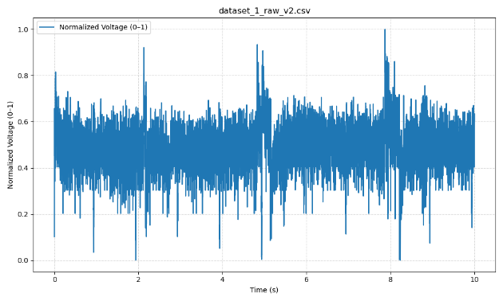
Fig 1. Plot of microphone data for raw data
When the magnitude of the noise component significantly exceeds that of the desired signal, conventional filtering techniques are insufficient for reliable recovery. This fundamental challenge is overcome by employing the principle of Phase-Sensitive Detection (PSD)(University of California, Berkeley, n.d.)
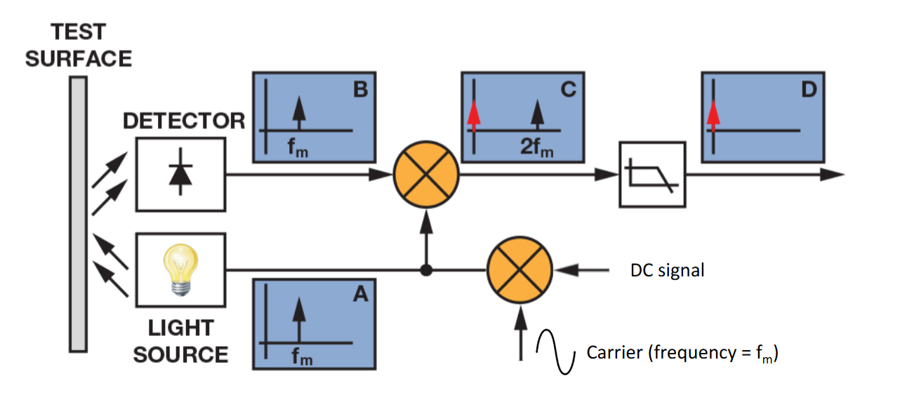
Fig 2. General PSD detection schematic
The PSD technique leverages a known, fixed-frequency carrier to encode the low-frequency information of interest. By multiplying the noisy input signal by a synchronized reference signal and subsequently applying a narrow Low-Pass Filter (LPF), PSD effectively shifts the signal information to Direct Current (DC), while shifting the high-frequency carrier and most noise components out of the filter's passband. This frequency translation allows for an arbitrarily narrow detection bandwidth, enabling high signal-to-noise ratios (SNR). (
This report aims to demonstrate the efficacy of techniques in recovering the information modulation from a heavily noisy environment. By implementing the PSD – and studying the frequency domain results – this study highlights the versatility and precision of lock-in principles in experimental physics and engineering.

Method:
Equipment:
- Raspberry Pi 4B (RPi 4B)
- RPi 4B wall power source
- MicroSD card (for data collection)
- ADS1115 (Analog to Digital Converter)
- MAX4466 Microphone
- Resistors (10$kΩ$)
- Breadboard
- Jumper wires
- Passive Buzzer Module
- My voice and Fan (as source of external noise)
Wiring Schematic:
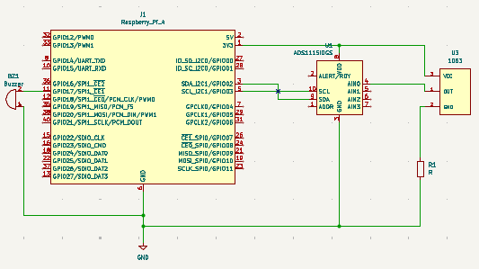
Fig 3. Wiring schematic for experiment (KiCad)
Experimental Setup:
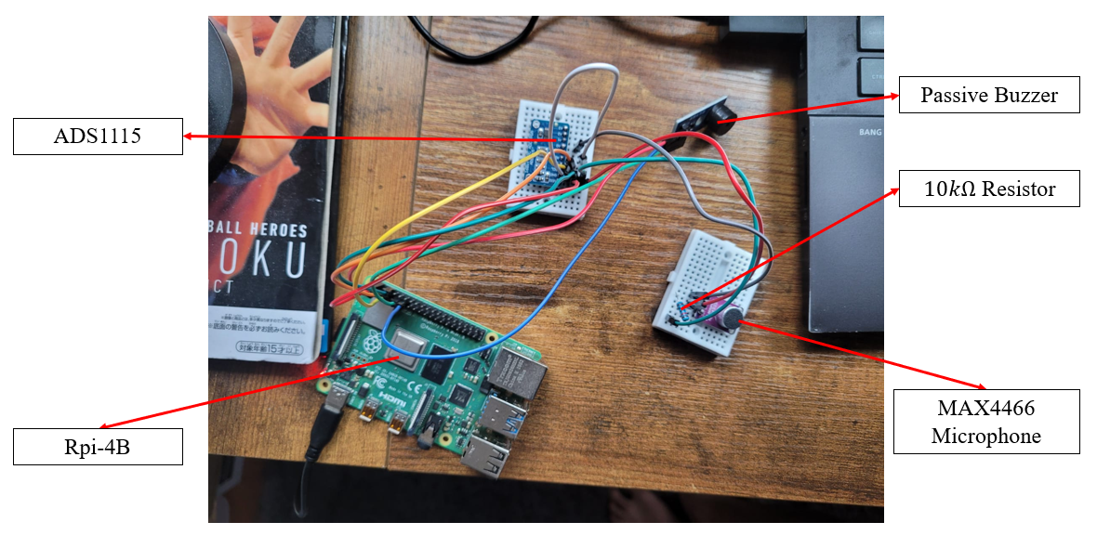
Fig 4. Circuit Setup
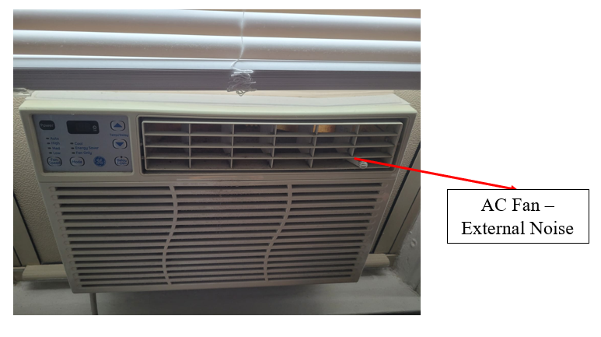
Fig 5. External Noise Source (Along with voice)
Data Acquisition:
Microphone data was sampled at the max ADS1115 sampling rate (860 Hz according to Texas Instruments) connected to the Raspberry Pi 4B. The MAX4466 microphone output was connected directly to ADC channel A0, with the onboard gain potentiometer at its default setting. Data collection was performed on the Raspberry Pi 4B using Python 3.9 running on Raspberry Pi OS, with the Adafruit_ADS1x15 library for ADC readings. The collected data was saved as CSV files and later transferred to a desktop computer for processing and analysis
Signal and Carrier Creation:
The signal of interest was created using Amplitude Modulation (AM), encoding a 2 Hz square wave (the low-frequency information) onto a 430 Hz square wave carrier. A square wave was chosen as it is easy to replicate with digital instruments
The selection of the 430 Hz carrier frequency was strategic: it is high enough to be well above the 1/f noise corner frequency and the dominant low-frequency disturbances present in the environment (as identified in preliminary noise analysis), but low enough to be generated by the buzzer and captured given the ADS1115’s 860 Hz sampling limit. Notice the carrier frequency was set to 0.5x the sampling frequency (while this oscillates in practice) to meet the Nyquist criterion and avoid data aliasing
Critically, the 2 Hz modulation frequency was chosen to show how well the PSD design works with low frequencies. Since flicker noise dominates below 10 Hz and noise magnitude is inversely proportional to frequency, recovering a signal at this low from a high-noise environment demonstrates the full capability of the Phase-Sensitive Detection technique to reject noise in the most challenging spectral region.

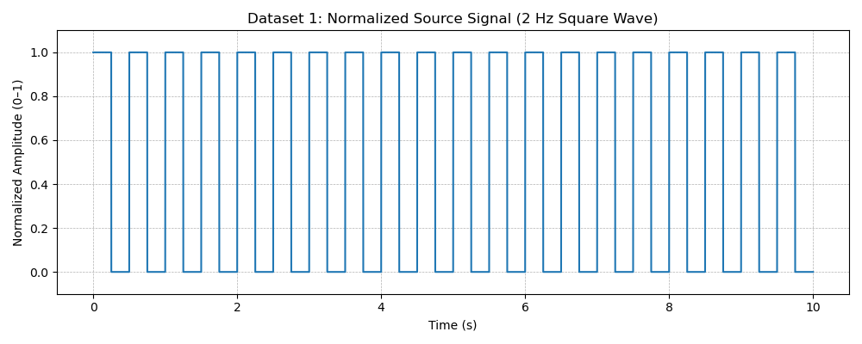
Fig 6. Ideal Source Signal
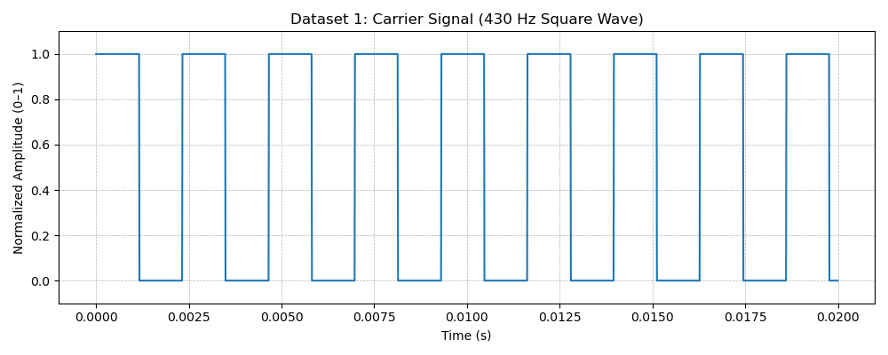
Fig 7. Carrier Signal
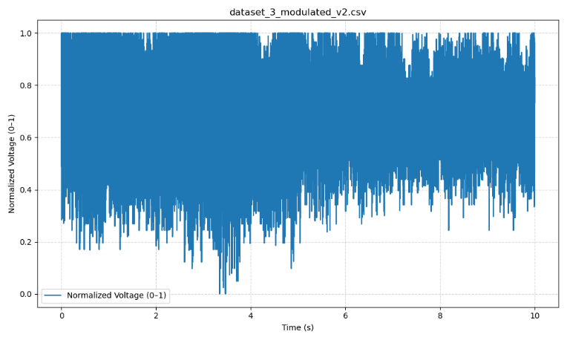
Fig 8. Modulated Signal alongside external noise
Data Analysis:
Phase-Sensitive Detection (PSD) Implementation:
Primary signal recovery was performed using the Phase-Sensitive Detection (PSD) lock-in technique. The core processing steps were implemented digitally on the noisy input data. First, a precisely synchronized square-wave reference signal was constructed at the 2 Hz modulation frequency. This reference was then multiplied by the raw input signal (the “mixing” stage), effectively heterodyning the 2 Hz information to Direct Current (DC). The resulting signal was passed through a 2nd-order Low-Pass Filter (LPF) with a 10 Hz cutoff frequency (five times the modulation frequency) to isolate the recovered modulation component. This cutoff choice balances effective noise suppression with minimal signal distortion.
Frequency-Domain Analysis:
In addition to the PSD-based recovery, a frequency-domain approach was applied to extract complementary information not captured by the lock-in output. This method involved two main stages. First, a narrow Bandpass Filter (BPF) centered at the 430 Hz carrier frequency was applied to the noisy input signal to isolate spectral components near the carrier and suppress broadband noise. Next, the filtered signal was rectified (envelope detection) and passed through a 10 Hz LPF to obtain the low-frequency envelope, which contained the 2 Hz modulation. This frequency-domain analysis provided insight into residual amplitude and noise characteristics outside the PSD bandwidth.
Procedure:
- Setup experimental setup following the schematic above
- Provide buzzer modulated input utilizing RPi 4
- Collect data for 10 seconds using microphone
- Run PSD algorithm on collected data to extract original 2Hz
- Run BPF and LF algorithm on collected data to extract original signal in the frequency domain

Results:
PSD:
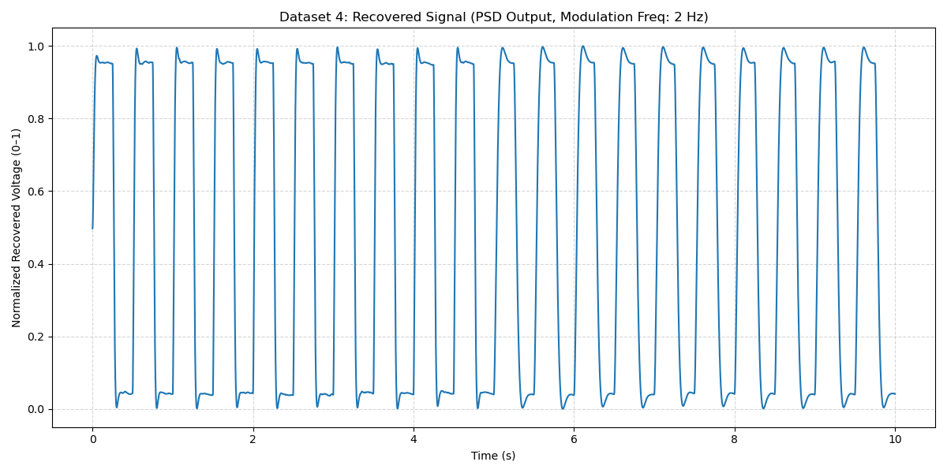
Fig 9. Phase sensitive detection results
Frequency Domain Analysis:
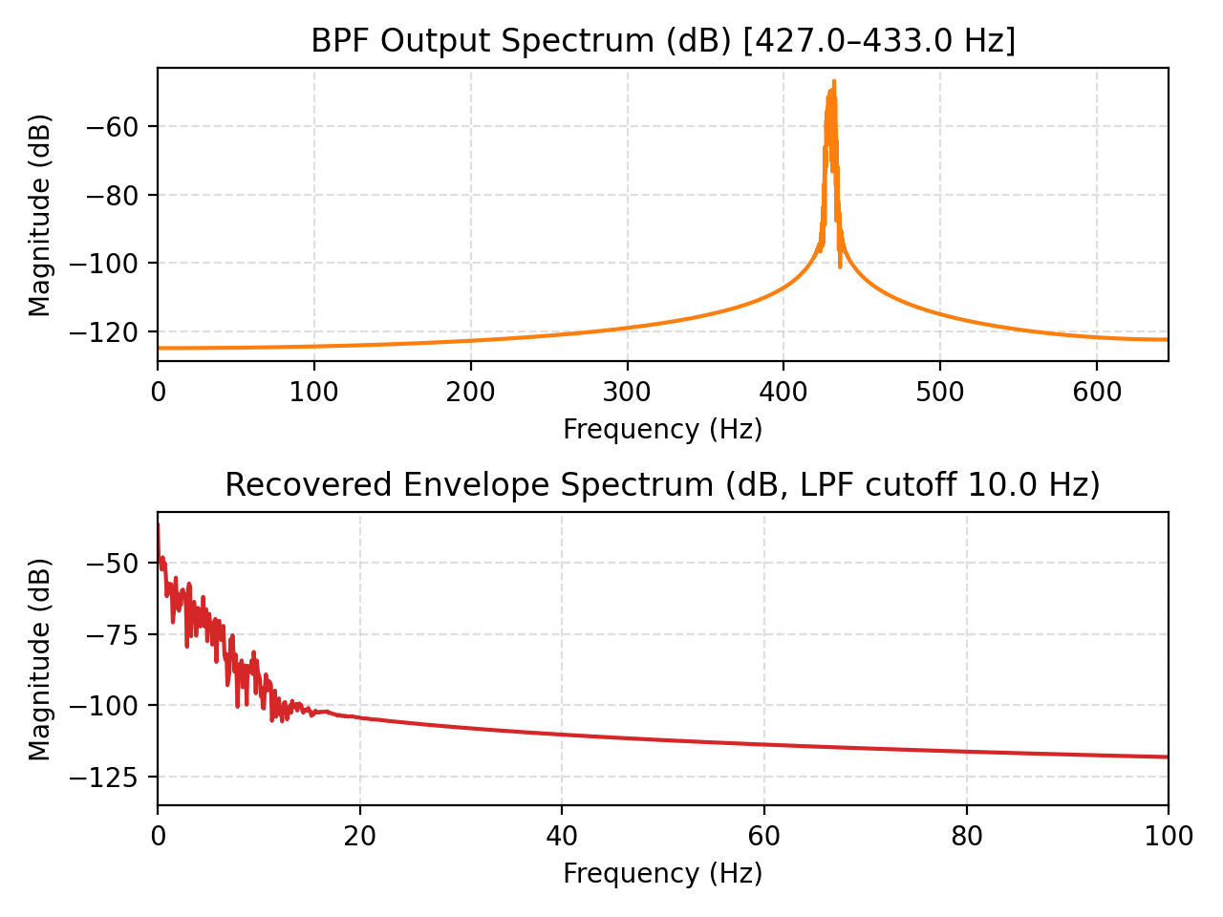
Fig 10. Frequency domain result of PSD with BPF and LPF

Discussion:
The PSD output (Figure 9) clearly demonstrates effective recovery of the 2 Hz source signal from the noisy input. The resulting signal exhibits a clean, periodic waveform with well-defined transitions, indicating that the digital lock-in process successfully isolated the modulated component and rejected broadband noise. The square-wave reference ensured coherent demodulation, and the subsequent 10 Hz low-pass filtering effectively suppressed higher-frequency artifacts while retaining the modulation dynamics. The normalized recovered voltage remains stable and consistent over time, confirming both the accuracy and the phase stability of the PSD approach. This time-domain recovery highlights the lock-in amplifier’s strength in extracting weak, coherent signals buried in noise.
The frequency-domain analysis (Figure 1) provided complementary insight into the spectral content around the carrier and within the recovered envelope. The bandpass-filtered spectrum shows strong confinement of energy around 430 Hz, verifying that the modulation was well centered on the carrier. Following envelope detection and low-pass filtering, the recovered spectrum displays a distinct 2 Hz component, consistent with the modulation frequency. However, compared with the PSD output, the envelope recovery exhibits a higher noise floor and reduced selectivity, as expected from its non-phase-sensitive nature. Nevertheless, this frequency-domain method offers valuable spectral information—particularly regarding residual sidebands and amplitude noise—that the PSD alone cannot reveal. Together, the two analyses confirm successful demodulation while providing both time-domain and frequency-domain perspectives on signal integrity and noise performance.

Conclusion:
The implementation of digital Phase-Sensitive Detection (PSD) proved highly effective for recovering the 2 Hz modulation from a noisy carrier. By synchronizing the reference signal and applying precise low-pass filtering, the PSD method successfully extracted the desired modulation while minimizing broadband and phase-incoherent noise. The resulting output exhibited excellent signal stability and fidelity, validating the lock-in amplifier’s ability to isolate weak periodic signals in challenging noise environments.
Complementary frequency-domain analysis further reinforced these findings by revealing the spectral structure around the 430 Hz carrier and confirming the presence of the 2 Hz modulation component. While less selective than PSD, the bandpass and envelope detection approach provided valuable insight into residual sidebands and amplitude noise characteristics. Overall, the combination of time-domain PSD recovery and frequency-domain analysis offered a comprehensive understanding of the signal’s behavior, demonstrating both the precision of the lock-in technique and the diagnostic value of spectral examination.

References:
- University of California, Berkeley. (n.d.). Phase sensitive detection and lock-in amplifiers. Experimentation Lab. Retrieved November 9, 2025, from https://experimentationlab.berkeley.edu/node/99

- Engineering Projects. (2021, March). What is Raspberry Pi 4? Pinout, specs, projects & datasheet. The Engineering Projects. https://www.theengineeringprojects.com/2021/03/what-is-raspberry-pi-4-pinout-specs-projects-datasheet.html

- SciPy Developers. (2024). scipy.signal.welch — Power spectral density using Welch’s method. SciPy v1.XX documentation. https://docs.scipy.org/doc/scipy/reference/generated/scipy.signal.welch.html

- DiCola, T. (2016, February 9). ADS1015 / ADS1115 | Raspberry Pi analog to digital converters. Adafruit Learning System. Retrieved from https://learn.adafruit.com/raspberry-pi-analog-to-digital-converters/ads1015-slash-ads1115

Appendices:

All code and data can be found at the following github repo: https://github.com/lokichubs/Flicker-noise-project

