**Lokman Baturay Efe**

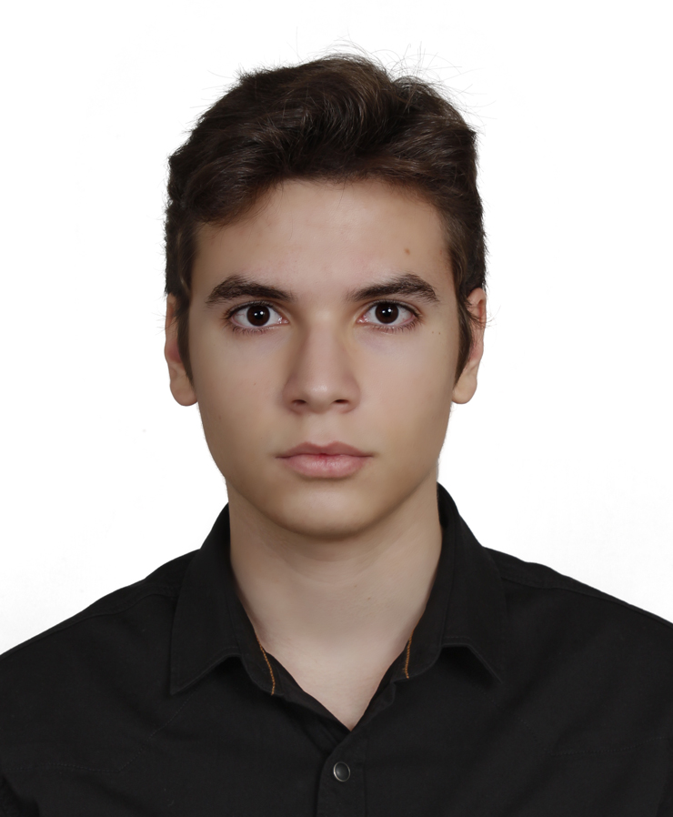

**Contact Information**

E-mail: lokman@lokmanefe.com

Github: <https://github.com/lokicik/>

Linkedin: <https://www.linkedin.com/in/lokmanefe/>

**Personal Information**

I was a lonely kid and my computer was my only friend. After several thousand hours with him, I decided to continue our friendship and build my career on top of it. I am a willing student who just doesn't wanna stop learning. I don’t have any working experience yet. My career goal is to become the CEO of a big tech company.

**Hobbies**

Fitness

Streetcleaning

Singing

**Characteristics**

Joyfulness: I always have a big smile on my face, so you don't hesitate to approach me.

Stubbornness: I just don’t know how to quit.

**Language Skills**

Turkish – Native

English – Advanced Mid

**Education**

Trakya University Computer Engineering(2022-Present)