**Interactive Sudoku Solver**

**A Game of Logic Using Backtracking**

**A PROJECT REPORT**

*Submitted by*

**RAJEEV M (AP24122040003)**

**LOKESH V (AP24122040005)**



**AML 500**

**Advanced Algorithms and Analysis**

**SRM University*–*AP Neerukonda, Mangalagiri, Guntur**

**Andhra Pradesh *–* 522 240**

**Nov 2024**

# **Table of Contents**

|  |  |
| --- | --- |
| **Section** | **Page Number** |
| **1. Introduction** | **1** |
| **2. Objectives** | **3** |
| **3. Problem Statement** | **4** |
| **4. Methodology** | **5** |
| **5. Implementation** | **8** |
| **6. Results and Discussion** | **19** |
| **7. Time Complexity and Space Complexity** | **25** |
| **8. References** | **27** |

**1. INTRODUCTION**

Sudoku is a popular logic-based number puzzle that challenges players to fill a 9x9 grid so that each row, each column, and each of the nine 3x3 subgrids contains all the digits from 1 to 9 exactly once. Originating in the late 18th century as a variation of Latin squares, Sudoku gained global recognition in the 1980s and has since become a widely loved mental exercise. It is a classic example of a problem that blends simplicity in rules with complexity in execution, requiring players to employ logic, deduction, and occasionally trial and error.

At its core, Sudoku involves two fundamental tasks: **solving** a puzzle and **generating** new puzzles. Solving Sudoku often requires recognizing patterns and constraints while testing various possibilities. This process lends itself well to computational techniques, particularly the **backtracking algorithm**, which is a systematic method of exploring all possible configurations to identify a solution. The same logic can be extended to generate valid Sudoku puzzles by first creating a completed grid and then removing numbers to provide varying levels of challenge to the player.

This project addresses both solving and generating Sudoku puzzles programmatically, offering two primary modes of interaction for users:

1. **Mode 1:** The program generates a Sudoku puzzle based on the user’s selected difficulty level (easy, medium, or hard). The user is then presented with the challenge of solving the puzzle, providing an interactive experience.
2. **Mode 2:** Users can input a Sudoku puzzle of their choice. The program will analyze the puzzle, validate its correctness, and determine whether a solution exists using the backtracking algorithm.

The significance of this project lies in the elegance of its approach and the versatility of its applications. From recreational use to educational tools that teach algorithmic problem-solving, this implementation of Sudoku serves multiple purposes. It demonstrates the power of backtracking algorithms to navigate constrained search spaces efficiently. Furthermore, it underscores the importance of ensuring validity and uniqueness in generated puzzles—a critical feature to maintain the integrity of the Sudoku experience.

The proposed solution is implemented in Python, leveraging its flexibility and ease of use. The backtracking algorithm systematically explores possible configurations for solving puzzles, while a carefully designed grid generation algorithm ensures that the puzzles produced are solvable and have a unique solution. By integrating user-friendly features, such as puzzle validation and solution feedback, the program caters to Sudoku enthusiasts of varying skill levels.

In conclusion, this project exemplifies the fusion of computer science and recreational problem-solving. It not only offers a robust tool for solving and generating Sudoku puzzles but also showcases the broader application of algorithms to real-world challenges. Through the structured approach and logical rigor of the backtracking algorithm, users can engage with Sudoku puzzles while gaining insights into the underlying computational principles.

**2. OBJECTIVES**

The objective of this project is to design and implement an interactive Sudoku game with two modes: a pre-defined game mode and a user-input mode. The game should provide a visually appealing and user-friendly interface using Pygame, where users can:

1. **Play the game with varying difficulty levels:**
   * Easy
   * Medium
   * Hard  
     The difficulty levels determine the number of pre-filled cells, adding variety to the game.
2. **Manually input numbers to create custom Sudoku puzzles:**
   * Users can place their numbers onto a blank Sudoku grid.
   * The game provides a mechanism to validate the grid and check for solvability.
3. **Solve Sudoku puzzles using a backtracking algorithm:**
   * The implemented algorithm can solve even complex Sudoku grids.
   * The solution is visually displayed, enabling users to understand the logic.
4. **Ensure an intuitive user experience through:**
   * Color-coded cells for easier interaction.
   * Interactive number selection using draggable elements.
   * Feedback for invalid moves.

By achieving these objectives, the project combines logical problem-solving and interactive software development, making it engaging for both casual users and Sudoku enthusiasts.

**3. PROBLEM STATEMENT**

Sudoku is a popular puzzle game that requires logical reasoning to fill a 9x9 grid with numbers such that each row, column, and 3x3 subgrid contains unique values from 1 to 9. Traditional Sudoku puzzles are often limited to paper formats, which lack interactivity and customization.

The main problems this project addresses include:

1. **Accessibility and Engagement**:
   * Traditional Sudoku lacks an engaging, interactive interface.
   * Users cannot dynamically change the difficulty or input custom puzzles in most applications.
2. **Validation and Assistance**:
   * Users need a mechanism to validate their custom inputs.
   * Automated solutions to assist when users are stuck are often unavailable or poorly integrated.
3. **Programming Challenge**:
   * Implementing a robust algorithm to validate and solve puzzles in real time.
   * Handling user interactions, such as drag-and-drop for number placement.

This project solves these issues by developing an interactive, customizable Sudoku game with features that enhance user experience and provide logical assistance, making it both entertaining and educational.

**4. METHODOLOGY**

The project follows a systematic development approach, divided into the following stages:

**4.1 Requirement Analysis**

Understanding the user requirements for an interactive Sudoku game:

* A clear and appealing graphical interface.
* Support for difficulty levels.
* Ability to create custom puzzles.

**4.2 Design and Planning**

1. **Graphical Interface**:
   * Using **Pygame** for the GUI to create a scalable and interactive game board.
   * Designing menus for game modes and difficulty selection.
2. **Game Logic**:
   * Implementing Sudoku rules (unique numbers in rows, columns, and subgrids).
   * Developing a backtracking algorithm for puzzle-solving.

**4.3 Development**

1. **Menu System**:
   * Creating a main menu with options for starting the game, selecting difficulty, and exiting.
   * Developing a separate menu for user-input mode.
2. **Gameplay Features**:
   * Implementing drag-and-drop functionality for number placement.
   * Providing real-time feedback for invalid moves.
   * Highlighting cells and enabling an intuitive experience.
3. **Validation and Solving**:
   * Coding a Sudoku validator to check the solvability of the board.
   * Implementing the backtracking algorithm to solve puzzles programmatically.

**4.4 Testing and Validation**

* Testing each feature (e.g., menu navigation, drag-and-drop interaction).
* Validating the correctness of the solving algorithm with multiple puzzles.

**4.5 Deployment**

Packaging the game for distribution and ensuring cross-platform compatibility.

**Algorithm to Solve the Problem:**

The algorithm combines Depth-First Search (DFS) with constraint checking, gradually building up possible solutions. It explores each possible solution path, and whenever a constraint is violated (i.e., a solution doesn't meet the Sudoku rules), it backtracks and tries a different path. This method efficiently narrows down the search space, eliminating invalid solutions early.

**Algorithm**

The core algorithm used to solve Sudoku combines **Depth-First Search (DFS)** with **constraint checking**. It builds potential solutions incrementally while ensuring that any invalid paths are abandoned early through backtracking. This ensures computational efficiency and adherence to Sudoku's rules.

**Steps/Algorithm to Solve the Problem**

The following steps outline the logic used to solve the Sudoku puzzle:

1. **Check for Valid Placement (Constraint Checking):**
   * Before placing a number in an empty cell, validate that the placement adheres to Sudoku rules:
     + The number should not exist in the same row.
     + The number should not exist in the same column.
     + The number should not exist in the same 3x3 subgrid.
   * If any constraint is violated, discard this number as a potential solution for the current cell.
2. **Depth-First Search (DFS) with Backtracking:**
   * The algorithm utilizes DFS to explore all potential configurations for the grid.
   * Each number from 1 to 9 is checked for validity in the current cell. If valid, the number is placed temporarily.
   * The algorithm then moves to the next empty cell, recursively repeating this process.
3. **Recursive Backtracking Function:**
   * **Base Case:**
     + If no unassigned cells are left in the grid, the puzzle is solved, and the function returns true.
   * **Recursive Case:**
     + Identify the first unassigned (empty) cell.
     + Try numbers from 1 to 9 for this cell:
       1. Validate the placement using the constraint-checking function.
       2. If valid, place the number in the cell and recursively attempt to solve the remaining grid.
       3. If the recursive attempt succeeds, return true.
       4. If unsuccessful, undo the placement (backtrack) and try the next number.
   * If no numbers from 1 to 9 lead to a valid solution, return false (indicating no solution exists for the current configuration).

**5. IMPLEMENTATION**

**Pseudocode**

Here is the pseudocode for the backtracking algorithm:

def solve_sudoku(grid):

# Find the first unassigned cell

row, col = find_empty_cell(grid)

if not row: # Base Case: No unassigned cells

return True

for num in range(1, 10): # Try numbers 1 through 9

if is_valid(grid, row, col, num): # Check if placement is valid

grid[row][col] = num # Place the number

if solve_sudoku(grid): # Recursive call

return True

grid[row][col] = 0 # Backtrack: Remove the number

return False # No solution found for current configuration

def is_valid(grid, row, col, num):

# Check row, column, and 3x3 subgrid for validity

return not (

num in grid[row] or

num in [grid[i][col] for i in range(9)] or

num in get_subgrid(grid, row, col)

)

**Program Code (Python):**

**Sudoku Menu Page**

import pygame  
import sys  
import sudoku_game  
import sudoku_user_mode  
*#from sudoku_user_mode import start_game # Import the user mode script  
  
# Initialize Pygame*pygame.init()  
  
*# Screen setup*screen_width, screen_height = 700, 500  
screen = pygame.display.set_mode((screen_width, screen_height))  
pygame.display.set_caption("Sudoku Game")  
  
*# Colors*WHITE = (255, 255, 255)  
BLACK = (0, 0, 0)  
RED = (255, 0, 0)  
  
*# Fonts*font = pygame.font.Font(None, 36)  
  
*# Game variables*mode = "menu"  
difficulty_blanks = 2 *# Default difficulty (Easy)  
  
# Function to display the main menu*def display_main_menu():  
 screen.fill(WHITE)  
 title_text = font.render("Sudoku Game", True, BLACK)  
 mode1_text = font.render("1. Start Game", True, BLACK)  
 mode2_text = font.render("2. User Mode", True, BLACK)  
 exit_text = font.render("3. Exit", True, BLACK)  
  
 screen.blit(title_text, (screen_width // 2 - title_text.get_width() // 2, 50))  
 screen.blit(mode1_text, (screen_width // 2 - mode1_text.get_width() // 2, 150))  
 screen.blit(mode2_text, (screen_width // 2 - mode2_text.get_width() // 2, 200))  
 screen.blit(exit_text, (screen_width // 2 - exit_text.get_width() // 2, 250))  
  
*# Function to display the difficulty menu*def display_difficulty_menu():  
 screen.fill(WHITE)  
 title_text = font.render("Select Difficulty", True, BLACK)  
 easy_text = font.render("1. Easy", True, BLACK)  
 medium_text = font.render("2. Medium", True, BLACK)  
 hard_text = font.render("3. Hard", True, BLACK)  
 back_text = font.render("4. Back to Main Menu", True, BLACK)  
  
 screen.blit(title_text, (screen_width // 2 - title_text.get_width() // 2, 50))  
 screen.blit(easy_text, (screen_width // 2 - easy_text.get_width() // 2, 150))  
 screen.blit(medium_text, (screen_width // 2 - medium_text.get_width() // 2, 200))  
 screen.blit(hard_text, (screen_width // 2 - hard_text.get_width() // 2, 250))  
 screen.blit(back_text, (screen_width // 2 - back_text.get_width() // 2, 300))  
  
*# Function to exit the game after a delay*def exit_game_with_delay(message, delay=500):  
 print(message) *# Print the selected difficulty  
  
 # Display the goodbye message* screen.fill(WHITE)  
 goodbye_text = font.render("Goodbye!", True, BLACK)  
 screen.blit(goodbye_text, (screen_width // 2 - goodbye_text.get_width() // 2, screen_height // 2 - goodbye_text.get_height() // 2))  
 pygame.display.flip() *# Update the display* pygame.time.delay(2000) *# Show goodbye message for 2 seconds* pygame.quit() *# Clean up and close the window* sys.exit() *# Exit the program  
  
# Game loop*running = True  
while running:  
 if mode == "menu": *# Main menu* display_main_menu()  
 elif mode == "difficulty": *# Difficulty selection* display_difficulty_menu()  
 elif mode == "user_mode": *# User mode* print("User mode is selected")  
 sudoku_user_mode.start_game() *# Call the function from the us.py file* pygame.display.flip() *# Update the display* for event in pygame.event.get():  
 if event.type == pygame.QUIT:  
 running = False  
 elif event.type == pygame.MOUSEBUTTONDOWN:  
 mouse_x, mouse_y = pygame.mouse.get_pos()  
 if mode == "menu": *# Main menu interaction* if 150 < mouse_y < 180: *# Start Game* mode = "difficulty"  
 elif 200 < mouse_y < 230: *# User Mode* mode = "user_mode" *# Switch to user mode* elif 250 < mouse_y < 280: *# Exit* running = False  
 elif mode == "difficulty": *# Difficulty selection* if 150 < mouse_y < 180:  
 *# Easy* sudoku_game.start_game("Easy")  
 exit_game_with_delay("Selected Difficulty: Easy") *# Print and exit* elif 200 < mouse_y < 230:  
  
 sudoku_game.start_game("Medium")  
 exit_game_with_delay("Selected Difficulty: Medium") *# Print and exit* elif 250 < mouse_y < 280:  
  
 sudoku_game.start_game("Hard")  
 exit_game_with_delay("Selected Difficulty: Hard") *# Print and exit* elif 300 < mouse_y < 330: *# Back to Main Menu* mode = "menu"  
  
pygame.quit()

**Sudoku User Mode**

import pygame  
import numpy as np  
from copy import deepcopy  
  
*# Initialize pygame*pygame.init()  
  
*# Screen setup for 700x500*screen_width, screen_height = 700, 500  
screen = pygame.display.set_mode((screen_width, screen_height))  
pygame.display.set_caption("Sudoku Game - User Mode")  
  
*# Colors*WHITE = (255, 255, 255)  
BLACK = (0, 0, 0)  
GRAY = (200, 200, 200)  
GREEN = (99, 200, 167)  
RED = (255, 0, 0)  
LIGHT_BLUE = (173, 216, 230)  
HOVER_COLOR = (220, 220, 220)  
  
*# Fonts*font = pygame.font.Font(None, 30)  
  
*# Size variables*cell_size = 50  
offset_x, offset_y = 20, 20 *# Offset to center board in 700x500  
  
  
# Function to check if the board is valid*def is_valid_board(board):  
 for row in range(9):  
 for col in range(9):  
 num = board[row][col]  
 if num != 0:  
 board[row][col] = 0  
 if not is_valid(board, row, col, num):  
 board[row][col] = num *# Restore the value before returning* return False  
 board[row][col] = num  
 return True  
  
  
*# Function to check if placing a number is valid*def is_valid(board, row, col, num):  
 for i in range(9):  
 if board[row][i] == num or board[i][col] == num:  
 return False  
 box_x, box_y = row // 3 * 3, col // 3 * 3  
 for i in range(3):  
 for j in range(3):  
 if board[box_x + i][box_y + j] == num:  
 return False  
 return True  
  
  
*# Function to solve Sudoku using backtracking*def solve_sudoku(board):  
 for row in range(9):  
 for col in range(9):  
 if board[row][col] == 0:  
 for num in range(1, 10):  
 if is_valid(board, row, col, num):  
 board[row][col] = num  
 if solve_sudoku(board):  
 return True  
 board[row][col] = 0  
 return False  
 return True  
  
  
*# Main menu function*def main_menu():  
 menu_running = True  
  
 while menu_running:  
 screen.fill(WHITE)  
  
 *# Display the title* title_text = font.render("Sudoku Game", True, BLACK)  
 screen.blit(title_text, (screen_width // 2 - title_text.get_width() // 2, screen_height // 4))  
  
 *# Create Start Game button* start_button = pygame.Rect(screen_width // 2 - 75, screen_height // 2, 150, 50)  
 pygame.draw.rect(screen, GREEN, start_button)  
 start_text = font.render("Start Game", True, BLACK)  
 text_rect_start = start_text.get_rect(center=start_button.center)  
 screen.blit(start_text, text_rect_start)  
  
 for event in pygame.event.get():  
 if event.type == pygame.QUIT:  
 menu_running = False  
 elif event.type == pygame.MOUSEBUTTONDOWN:  
 mouse_x, mouse_y = event.pos  
 if start_button.collidepoint(mouse_x, mouse_y):  
 menu_running = False *# Exit menu and start the game* pygame.display.flip()  
  
 start_game()  
  
  
*# Start the game with a new board*def start_game():  
 initial_board = [[0] * 9 for _ in range(9)]  
 solved_board = deepcopy(initial_board)  
  
 *# Game loop* running = True  
 dragging = False  
 selected_num = None  
 mouse_x, mouse_y = 0, 0  
 solution_found = False  
 invalid_board = False  
  
 while running:  
 screen.fill(WHITE)  
  
 *# Draw Sudoku grid with empty cells clearly visible* for row in range(9):  
 for col in range(9):  
 rect = pygame.Rect(offset_x + col * cell_size, offset_y + row * cell_size, cell_size, cell_size)  
 pygame.draw.rect(screen, LIGHT_BLUE if (row // 3 + col // 3) % 2 == 0 else WHITE, rect)  
 pygame.draw.rect(screen, BLACK, rect, 1)  
  
 if initial_board[row][col] != 0:  
 num_text = font.render(str(initial_board[row][col]), True, BLACK)  
 screen.blit(num_text, (offset_x + col * cell_size + 15, offset_y + row * cell_size + 10))  
  
 *# Display draggable number buttons from 1 to 9 in a 2x5 grid format* for i in range(1, 10):  
 row = (i - 1) // 2  
 col = (i - 1) % 2  
 x_pos = screen_width - 160 + col * 60  
 y_pos = offset_y + 30 + row * 50 *# Adjusted y position for buttons* num_text = font.render(str(i), True, BLACK)  
 num_rect = pygame.Rect(x_pos - 15, y_pos - 15, 50, 50)  
  
 *# Highlight the button if hovered over* if num_rect.collidepoint(pygame.mouse.get_pos()):  
 pygame.draw.rect(screen, HOVER_COLOR, num_rect)  
 else:  
 pygame.draw.rect(screen, GRAY, num_rect)  
  
 pygame.draw.rect(screen, BLACK, num_rect, 2) *# Border for each button  
 # Center the text* text_rect = num_text.get_rect(center=num_rect.center)  
 screen.blit(num_text, text_rect)  
  
 *# Draw Find Solution button below number buttons* find_solution_button = pygame.Rect(screen_width - 190, offset_y + 300, 155, 40)  
 pygame.draw.rect(screen, GREEN if is_valid_board(initial_board) else RED, find_solution_button)  
 solution_text = font.render(" Find Solution", True, BLACK)  
 text_rect_solution = solution_text.get_rect(center=find_solution_button.center)  
 screen.blit(solution_text, text_rect_solution)  
  
 *# Draw Exit button below Find Solution button* exit_button = pygame.Rect(screen_width - 170, offset_y + 350, 120, 40)  
 pygame.draw.rect(screen, GRAY, exit_button)  
 exit_text = font.render("Exit", True, BLACK)  
 text_rect_exit = exit_text.get_rect(center=exit_button.center)  
 screen.blit(exit_text, text_rect_exit)  
  
 *# Handle dragging and dropping numbers into empty cells* for event in pygame.event.get():  
 if event.type == pygame.QUIT:  
 running = False  
 elif event.type == pygame.MOUSEBUTTONDOWN:  
 mouse_x, mouse_y = event.pos  
 *# Check if a number button is clicked to start dragging* for i in range(1, 10):  
 row = (i - 1) // 2 *# Adjusted to match button layout* col = (i - 1) % 2  
 x_pos = screen_width - 160 + col * 60  
 y_pos = offset_y + 30 + row * 50  
 num_rect = pygame.Rect(x_pos - 15, y_pos - 15, 50, 50)  
 if num_rect.collidepoint(mouse_x, mouse_y):  
 dragging = True  
 selected_num = i  
 break  
 *# Check if Find Solution button is clicked* if find_solution_button.collidepoint(mouse_x, mouse_y):  
 if is_valid_board(initial_board):  
 solution_board = deepcopy(initial_board)  
 solution_found = solve_sudoku(solution_board)  
 if solution_found:  
 solved_board = solution_board  
 else:  
 print("No solution exists")  
 else:  
 invalid_board = True  
 *# Check if Exit button is clicked* if exit_button.collidepoint(mouse_x, mouse_y):  
 running = False  
 elif event.type == pygame.MOUSEBUTTONUP:  
 if dragging and selected_num is not None:  
 dragging = False  
 grid_x = (mouse_x - offset_x) // cell_size  
 grid_y = (mouse_y - offset_y) // cell_size  
 if 0 <= grid_x < 9 and 0 <= grid_y < 9:  
 *# Update the board with the selected number, replacing any existing value* initial_board[grid_y][grid_x] = selected_num  
 selected_num = None  
 elif event.type == pygame.MOUSEMOTION:  
 mouse_x, mouse_y = pygame.mouse.get_pos()  
  
 *# Display solution if found* if solution_found:  
 for row in range(9):  
 for col in range(9):  
 if solved_board[row][col] != 0:  
 *# Use the same font and color as user-entered numbers* num_text = font.render(str(solved_board[row][col]), True, BLACK)  
 screen.blit(num_text, (offset_x + col * cell_size + 15, offset_y + row * cell_size + 10))  
 elif invalid_board:  
 invalid_text = font.render("Invalid Board!", True, RED)  
 screen.blit(invalid_text, (screen_width // 2 - invalid_text.get_width() // 2, screen_height // 2))  
  
 pygame.display.flip()  
  
 pygame.quit()  
  
  
*# Start the application*if __name__ == "__main__":  
 main_menu()

**Sudoku Game**

*# sudoku_game.py*import pygame  
from random import sample  
from copy import deepcopy  
  
*# Initialize pygame*pygame.init()  
  
*# Screen setup*screen_width, screen_height = 700, 500  
screen = pygame.display.set_mode((screen_width, screen_height))  
pygame.display.set_caption("Sudoku Game")  
  
*# Colors*WHITE = (255, 255, 255)  
BLACK = (0, 0, 0)  
GRAY = (200, 200, 200)  
GREEN = (99, 200,167)  
RED = (255, 0, 0)  
LIGHT_BLUE = (173, 216, 230)  
HOVER_COLOR = (220, 220, 220) *# Color for hover effect on buttons  
  
# Fonts*font = pygame.font.Font(None, 30)  
win_font = pygame.font.Font(None, 60)  
  
*# Size variables*cell_size = 50  
offset_x, offset_y = 30, 30  
  
*# Generate a random 9x9 Sudoku grid*def generate_sudoku():  
 base = 3  
 side = base * base  
  
 def pattern(r, c): return (base * (r % base) + r // base + c) % side  
  
 def shuffle(s): return sample(s, len(s))  
  
 r_base = range(base)  
 rows = [g * base + r for g in shuffle(r_base) for r in shuffle(r_base)]  
 cols = [g * base + c for g in shuffle(r_base) for c in shuffle(r_base)]  
 nums = shuffle(range(1, side + 1))  
 board = [[nums[pattern(r, c)] for c in cols] for r in rows]  
 return board  
  
*# Create a partial board with some cells set to 0 (blank)*def make_partial_board(board, blanks):  
 partial_board = deepcopy(board)  
 for _ in range(blanks):  
 x, y = sample(range(9), 2)  
 partial_board[x][y] = 0  
 return partial_board  
  
*# Start the game with the selected difficulty level*def start_game(selected_difficulty):  
 *# Set the number of blanks based on difficulty level* if selected_difficulty == 'Easy':  
 blanks = 2  
 elif selected_difficulty == 'Medium':  
 blanks = 50  
 else: *# Hard* blanks = 65  
  
 full_board = generate_sudoku() *# Generate the full solved board* initial_board = make_partial_board(deepcopy(full_board), blanks) *# Create a playable board with blanks* solved_board = deepcopy(initial_board) *# Initialize the player’s board  
  
 # Helper functions* def draw_grid():  
 for row in range(9):  
 for col in range(9):  
 rect = pygame.Rect(offset_x + col * cell_size, offset_y + row * cell_size, cell_size, cell_size)  
 pygame.draw.rect(screen, LIGHT_BLUE if (row // 3 + col // 3) % 2 == 0 else WHITE, rect)  
 pygame.draw.rect(screen, BLACK, rect, 1)  
 if initial_board[row][col] != 0:  
 num_text = font.render(str(initial_board[row][col]), True, BLACK)  
 screen.blit(num_text, (offset_x + col * cell_size + 15, offset_y + row * cell_size + 10))  
 elif solved_board[row][col] != 0:  
 color = GREEN if solved_board[row][col] == full_board[row][col] else RED  
 num_text = font.render(str(solved_board[row][col]), True, color)  
 screen.blit(num_text, (offset_x + col * cell_size + 15, offset_y + row * cell_size + 10))  
  
 *# Draw thicker lines for 3x3 subgrids* for i in range(0, 10, 3):  
 pygame.draw.line(screen, BLACK, (offset_x, offset_y + i * cell_size),  
 (offset_x + 9 * cell_size, offset_y + i * cell_size), 2)  
 pygame.draw.line(screen, BLACK, (offset_x + i * cell_size, offset_y),  
 (offset_x + i * cell_size, offset_y + 9 * cell_size), 2)  
  
 def draw_buttons():  
 *# Display draggable number buttons from 1 to 9 in a 2x5 grid format* for i in range(1, 10):  
 row = (i - 1) // 2  
 col = (i - 1) % 2  
 x_pos = 540 + col * 60  
 y_pos = 40 + row * 60  
 num_text = font.render(str(i), True, BLACK)  
 num_rect = pygame.Rect(x_pos - 15, y_pos - 15, 50, 50)  
  
 *# Highlight the button if hovered over* if num_rect.collidepoint(pygame.mouse.get_pos()):  
 pygame.draw.rect(screen, HOVER_COLOR, num_rect)  
 else:  
 pygame.draw.rect(screen, GRAY, num_rect)  
  
 pygame.draw.rect(screen, BLACK, num_rect, 2) *# Border for each button  
 # Center the text* text_rect = num_text.get_rect(center=num_rect.center)  
 screen.blit(num_text, text_rect)  
  
 def check_win():  
 for i in range(9):  
 for j in range(9):  
 if solved_board[i][j] != full_board[i][j]:  
 return False  
 return True  
  
 *# Game loop* running = True  
 dragging = False  
 selected_num = None  
 mouse_x, mouse_y = 0, 0  
  
 while running:  
 screen.fill(WHITE)  
 draw_grid()  
 draw_buttons()  
  
 *# Display the dragged number if dragging* if dragging and selected_num is not None:  
 num_text = font.render(str(selected_num), True, RED)  
 screen.blit(num_text, (mouse_x - 15, mouse_y - 15))  
  
 for event in pygame.event.get():  
 if event.type == pygame.QUIT:  
 running = False  
 elif event.type == pygame.MOUSEBUTTONDOWN:  
 mouse_x, mouse_y = pygame.mouse.get_pos()  
 *# Check if a number button is clicked to start dragging* for i in range(1, 10):  
 row = (i - 1) // 2  
 col = (i - 1) % 2  
 x_pos = 540 + col * 60  
 y_pos = 40 + row * 60  
 num_rect = pygame.Rect(x_pos - 15, y_pos - 15, 50, 50)  
 if num_rect.collidepoint(mouse_x, mouse_y):  
 dragging = True  
 selected_num = i  
 break  
 elif event.type == pygame.MOUSEBUTTONUP:  
 if dragging:  
 dragging = False  
 if selected_num is not None:  
 *# Calculate the grid cell where the number is dropped* grid_x = (mouse_x - offset_x) // cell_size  
 grid_y = (mouse_y - offset_y) // cell_size  
 *# Place the number if in a valid cell* if 0 <= grid_x < 9 and 0 <= grid_y < 9 and initial_board[grid_y][grid_x] == 0:  
 solved_board[grid_y][grid_x] = selected_num  
 if check_win():  
 win_text = win_font.render("You Win!", True, GREEN)  
 screen.blit(win_text, (200, 220))  
 pygame.display.flip()  
 pygame.time.delay(5000)  
 running = False  
 selected_num = None  
 elif event.type == pygame.MOUSEMOTION:  
 mouse_x, mouse_y = pygame.mouse.get_pos()  
  
 pygame.display.flip()  
  
 pygame.quit()

**6. RESULTS AND DISCUSSION**

**6.1. Solving Puzzles**

* Mode 1: Users appreciate the range of difficulty levels and clear grid presentation.
* Mode 2: Users find the validation and solving feedback useful for understanding their puzzles.

**Output:**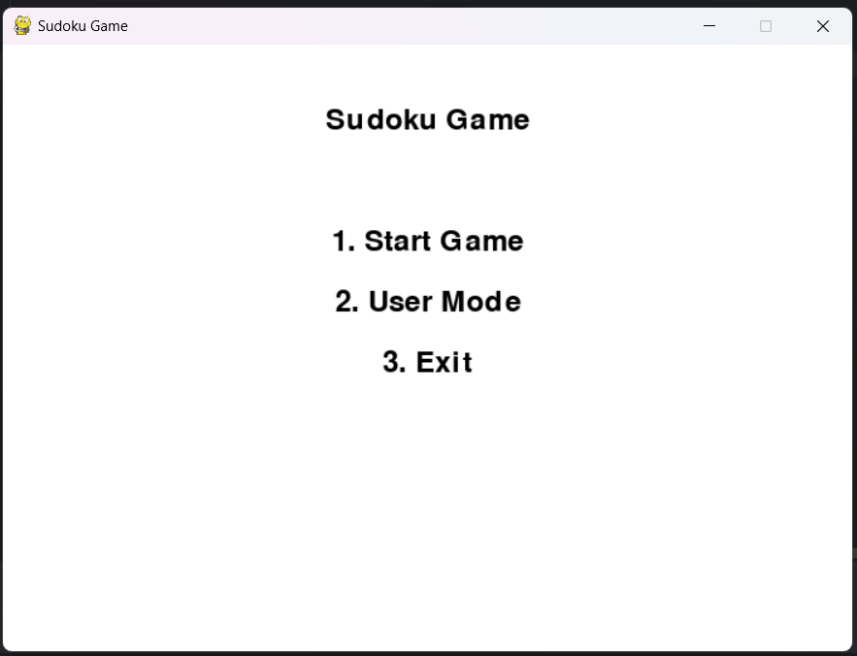

The above output is the sudoku main page in which user can select the start game,user mode and the exit.

**6.2. Generating Puzzles**

The generated puzzles are tested to ensure:

* They adhere to Sudoku rules.
* They have unique solutions.
* The difficulty levels align with the expected complexity for users.

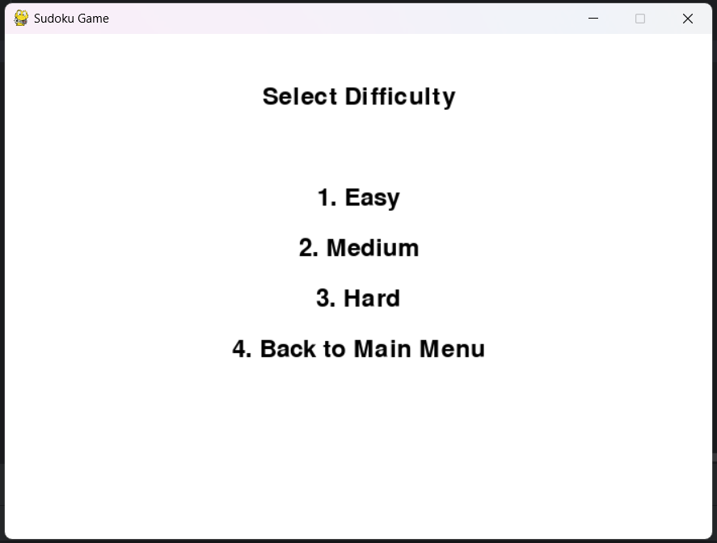

When the user selects the start game it displays the different difficulty levels in the game like Easy,Medium,Hard as shown above.

**Playing:**

Based on the difficulty mode the sudoku game will be displayed and user can start playing the game.

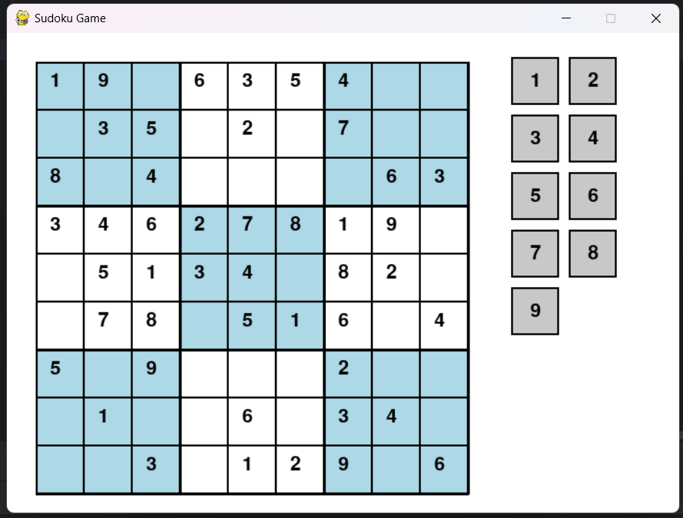

**WIN:**

**If Output obey all condition ...**

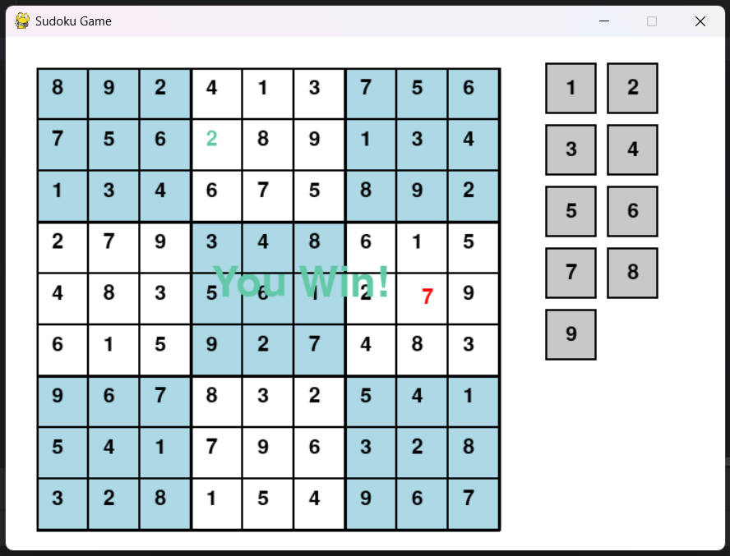

If the number entered by the user is correct, then it will display in green color, else in red color. Once the user finishes the game, then it will display “You Win!”

**User Mode**

The Below image is the User mode where user can create their own Sudoku game.

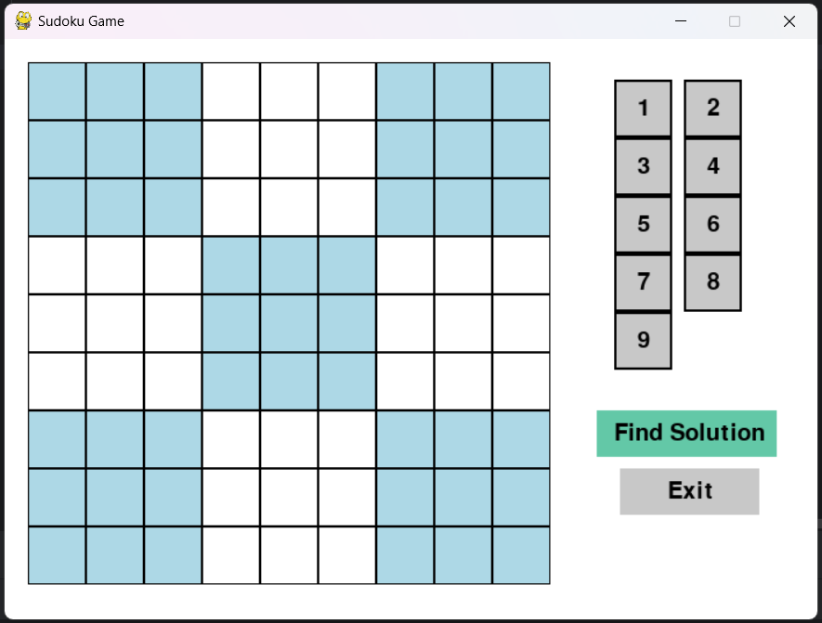

Based on the numbers placed by the user in the cells, it will find the solution, if the solution exists.

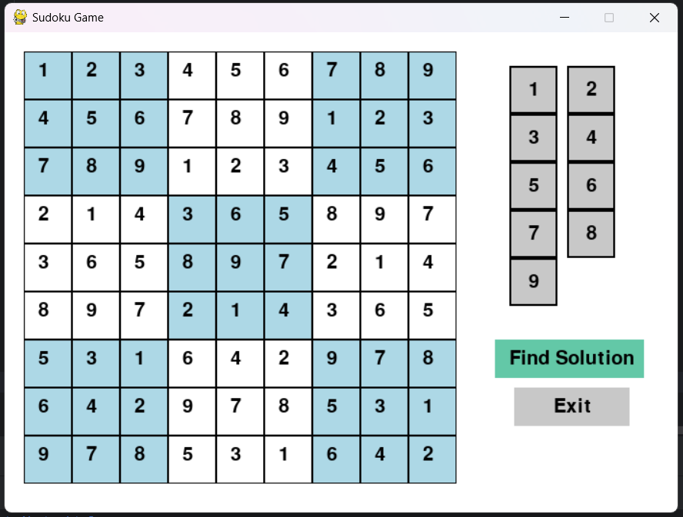

**7. TIME COMPLEXITY AND SPACE COMPLEXITY**

**Time Complexity**:

The time complexity of solving a Sudoku puzzle using backtracking is determined by the number of recursive calls made and the operations performed at each step. Here's the detailed derivation:

1. **Recursive Exploration:**  
   At every step, the algorithm attempts to fill an empty cell with a number from 1 to 9.
   * If there are nnn empty cells, the worst-case scenario involves trying 9n9^n9n combinations.
   * However, due to constraint checking (validating the row, column, and 3x3 subgrid), invalid combinations are pruned early. This significantly reduces the search space but does not eliminate the exponential growth in the worst case.
2. **Constraint Checking:**  
   For each placement attempt, the algorithm validates the number against the row, column, and subgrid constraints.
   * Checking all constraints for a single cell takes O(9)O(9)O(9), as each row, column, and subgrid contains a maximum of 9 cells.
   * Therefore, the complexity per placement attempt is constant, O(1)O(1)O(1).
3. **Overall Time Complexity:**  
   Combining the above, the **worst-case time complexity** is:

O(9n)where n is the number of empty cells.O(9^n) \quad \text{where } n \text{ is the number of empty cells.}O(9n)where n is the number of empty cells.

* + In practice, the complexity is much lower due to pruning from constraint checks and early termination when a solution is found.

**Space Complexity**

The space complexity is determined by the storage used during the execution of the algorithm.

1. **Recursive Stack Space:**  
   The backtracking approach uses recursion to explore all possible solutions.
   * In the worst case, the recursion depth is equal to the number of empty cells, nnn, as each recursive call fills one cell.
   * Hence, the space required for the stack is O(n)O(n)O(n).
2. **Grid Storage:**  
   The Sudoku grid is stored in memory and requires constant space, O(81)O(81)O(81), as the grid size is fixed at 9x9. For larger grids, the storage requirement is O(k2)O(k^2)O(k2), where kkk is the grid dimension.
3. **Auxiliary Space:**  
   No additional data structures are used beyond the grid and the stack. Thus, auxiliary space usage is minimal.
4. **Overall Space Complexity:**  
   Combining the stack space and grid storage:

O(n)+O(81) ≈ O(n) for a standard 9x9 grid.

**8. REFERENCES**

[1] Maji A K, Pal R K. Sudoku solver using mini grid based backtracking [C]. 2014 IEEE

International Advance Computing Conference (IACC), Gurgaon, India, 2014, pp. 36-44, doi:

10.1109/IAdCC.2014.6779291.

[2] Wang, C. et al. A Novel Evolutionary Algorithm with Column and Sub-Block Local Search for Sudoku

Puzzles [J]. IEEE Transactions on Games, 2023, 1–11, doi: 10.1109/TG.2023.3236490.

[3] Gupta K, Khatri S, Khan M H. A Novel Automated Solver for Sudoku Images [C]. 2019 IEEE 5th

International Conference for Convergence in Technology (I2CT), Bombay, India, 2019, pp. 1-6, doi:

10.1109/I2CT45611.2019.9033860.

[4] Nwulu E, Bisandu D, Dunka B. A hybrid backtracking and pencil and paper sudoku solver [J].

International Journal of Computer Applications, 2019, 181, 975-8887. 10.5120/ijca2019918642.

[5] Dheeraj G S, Lakshmi K B V, Krishna K A. Computer Vision based Sudoku Solving with Augmented

Reality [J]. International Research Journal of Engineering and Technology (IRJET), 2020, 7(10):

1489–1493.

[6] Syed A, Merugu S, Kumar V. Augmented Reality on Sudoku Puzzle Using Computer Vision and Deep Learning [J]. Augmented Reality on Sudoku Puzzle Using Computer Vision and Deep Learning,

[7] Sudoku solving using patterns and graph theory [J]. International Journal of Emerging

Technologies and Innovative Research, 2021, 8(3): 2219-2226.

[8] Iyer R, Jhaveri A, Parab K. A Review of Sudoku Solving using Patterns [J]. International Journal of

Scientific and Research Publications, 2013, 3(5).

[9] Musliu N, Winter F. A Hybrid Approach for the Sudoku Problem: Using Constraint Programming in

Iterated Local Search [J]. IEEE Intelligent Systems, 2017, 32(2): 52-62, doi: 10.1109/MIS.2017.29

[10] Singh V, Sharma V, Bachchas V. Sudoku Solving Using Quantum Computer [J]. Ijraset Journal for

Research in Applied Science and Engineering Technology, 2023, 128: 8.

[11] Herimanto P, Sitorus P, Zamzami E M. An Implementation of Backtracking Algorithm for Solving a

Sudoku-Puzzle Based on Android [J]. J. Phys.: Conf. Ser., 2020, 1566: 012038.

[12] A Survey on Sudoku Solver Using Various Algorithms [J]. International Journal of Emerging Trends

Technology in Computer Science (IJETTCS), 2017, 6(4): 123-129.

[13] Norvig P, Russel S. Artificial Intelligence: A Modern Approach. Third Edition [D]. Harlow: Pearson

Education, 2016.

[14] Knuth, D. Dancing links [J]. arXiv Preprint, 2000.

[15] Harrysson M, Laestander H. Solving Sudoku efficiently with Dancing Links. (Degree Project in

Computer Science, DD143X) [D]. Stockholm, Sweden: Stockholm University, 2014.