**A Project Report on**

**AI-DRIVEN DRONE DETECTION AND TRACKING**

***Submitted by***

**Lokesh V – AP24122040005**

**Ismail Suleiman – AP24122040020**

**Phaneendra – AP24122040022**

**Rajeev M – AP24122040003**

**Koushik G – AP24122040006**

**Venkatesh N P S – AP24122040013**



**SEC 502**

**Design Thinking**

**SRM University – AP**

**Neerukonda, Mangalagiri, Guntur**

**Andhra Pradesh – 522240**

**Nov 2024**

**Abstract**

The increasing prevalence of low-cost drones has introduced significant security challenges for military operations, such as unauthorized surveillance, the delivery of explosives, and the disruption of communications. Current countermeasures, which often involve costly missile-based systems, are unsustainable and impractical for widespread deployment against such low-cost threats. This project aims to develop an AI-driven drone detection and tracking system capable of addressing these challenges efficiently and cost-effectively.

Through advanced AI technologies like object detection algorithms (e.g., YOLO, CNNs), the proposed system enables real-time identification, classification, and tracking of enemy drones. The design thinking process employed emphasizes empathy for the end-users, understanding their pain points, and iteratively developing innovative solutions. The system’s adaptability to different terrains, scalability for detecting multiple drones simultaneously, and integration with existing defense mechanisms form its core strengths.

By incorporating edge computing and refining AI models for faster and more accurate detections, this system aspires to provide robust solutions for real-world defense scenarios. The project explores low-fidelity, mid-fidelity, and high-fidelity prototypes to validate the system’s functionality. Experimental results showcase the system's real-time capabilities, including drone speed estimation and instant notifications through messaging platforms like Telegram. This innovation holds promise for revolutionizing military drone countermeasures by ensuring security with enhanced efficiency and reduced costs.

**Table of Contents:**

|  |  |  |
| --- | --- | --- |
| **S. NO** | **SECTION / CHAPTER** | **PAGE NO** |
| **1** | **Introduction** | **4** |
| **2** | **Empathy** | **5** |
| **3** | **Define** | **11** |
| **4** | **Ideation** | **14** |
| **5** | **Prototype** | **16** |
| **6** | **Conclusion** | **22** |
| **7** | **Future Scope** | **23** |
| **8** | **References** | **25** |

**1. Introduction**

Drones have emerged as a transformative technology in modern warfare, surveillance, and logistics. However, their accessibility and affordability have created new security challenges, particularly for military operations. Enemy forces increasingly deploy low-cost drones for reconnaissance, delivering explosives, and disrupting communication systems, posing significant threats to both personnel and critical infrastructure. Traditional countermeasures, such as expensive missile systems, are unsustainable and impractical for addressing these low-cost threats, necessitating the development of cost-effective and scalable solutions.

* 1. **Objectives**

The primary objective of this project is to design and develop an AI-driven system for real-time detection, classification, and tracking of enemy drones. By leveraging advanced AI algorithms and sensor integration, the system aims to automate threat identification and reduce response times, ensuring accurate and efficient counter-drone measures. Additionally, the project seeks to enhance adaptability across different terrains and weather conditions while maintaining low implementation costs.

* 1. **Scope**

This project envisions a scalable and robust solution to counter the evolving threats posed by enemy drones. The system will focus on:

1. **Real-time detection and tracking:** Using AI technologies like object detection algorithms to identify drones efficiently.
2. **Cost-effective implementation:** Incorporating low-cost components and algorithms to ensure affordability for widespread adoption.
3. **Environmental adaptability:** Designing the system to perform reliably in diverse terrains and under varying weather conditions.
4. **Integration potential:** Ensuring compatibility with existing military defense systems for seamless deployment.
5. **Future scalability:** Building a system that can be expanded to handle swarms of drones or autonomous neutralization tasks.

**2. Empathy**

Empathy forms the cornerstone of the design thinking process, as it involves understanding the users' challenges, experiences, and requirements. For this project, empathy focuses on military personnel and security teams tasked with defending against enemy drones. By observing their pain points and simulating their experiences, the development of an AI-driven drone detection and tracking system aligns more closely with their real-world needs.

**1. Observation**

Military personnel face a multitude of challenges when tasked with identifying and neutralizing drones.

1. The **speed and agility** of drones make them difficult to track and monitor, particularly in real-time scenarios.
2. Smaller drones often evade detection by traditional systems due to their size and low-altitude flight paths.
3. Countermeasures employed today, such as using expensive missiles for neutralization, are **not scalable** and lead to resource wastage.
4. Operational inefficiencies are exacerbated by systems that cannot reliably distinguish between drones and other airborne objects, such as birds or debris.
5. Weather conditions and environmental obstacles (like buildings or trees) further hinder the accuracy of existing detection technologies.

**2. Engagement**

Direct interactions and discussions with military personnel provide valuable insights:

1. **Interviews** revealed a pressing need for **automated real-time systems** to reduce their workload and response times.
2. Personnel expressed dissatisfaction with **outdated technologies**, which lack the capabilities to address modern drone threats effectively.
3. Many pointed out the need for systems that can **reduce false alarms**, which otherwise create distractions and waste critical resources in high-pressure situations.
4. Feedback emphasized the importance of **user-friendly interfaces** that can be operated with minimal training, particularly in fast-paced military operations.

**3. User Experiences**

Military personnel often have to work with systems that do not match the pace or complexity of modern threats:

1. Outdated systems result in **delays** and inefficiencies, leading to a **high level of manual effort** to monitor and analyze drone activities.
2. Budgetary constraints restrict access to cutting-edge technologies, necessitating affordable and efficient solutions.
3. Personnel frequently experience **stress and fatigue** due to the manual nature of the tasks involved, such as prolonged scanning and monitoring of aerial zones.
4. The **uncertainty in identifying real threats** increases the cognitive load and affects the overall effectiveness of defense strategies.

**Shadowing:**

Shadowing involves closely observing military personnel during their drone detection and neutralization processes to identify their pain points, understand their workflows, and discover opportunities for improvement. This hands-on approach offers deeper insights into the challenges faced on the ground and helps refine the design of an AI-driven drone detection and tracking system.

**Observe**

1. **Challenges in Workflow**:
   * Military personnel face delays in threat identification due to the limitations of current systems.
   * Manual scanning for drones is time-consuming and often prone to human error.
2. **Equipment Inefficiency**:
   * Existing tools for drone detection, such as radar and infrared systems, often lack accuracy and adaptability to handle smaller, low-altitude drones.
   * The inability to integrate existing systems with real-time response mechanisms further reduces efficiency.
3. **Operational Hurdles**:
   * Terrain and weather variations significantly impact detection accuracy, making operations unreliable in certain environments.
   * Personnel often require significant training to use existing systems effectively, creating additional logistical challenges.

**Experience**

1. **Simulation of Drone Detection Systems**:
   * Testing basic drone detection setups highlights technical limitations, such as delays in detection and poor classification capabilities.
   * Simulated exercises reveal how stress levels increase during prolonged monitoring sessions, especially when systems fail to differentiate between threats and harmless objects.
2. **Real-World Constraints**:
   * Simulations also emphasize the critical need for affordability, as high-cost systems are unsustainable for long-term operations.
   * Observations show that personnel must compensate for these inefficiencies by increasing manual interventions, which are not always accurate or scalable.

**Reflect**

1. **Identifying Gaps**:
   * Current systems do not meet the needs of modern drone defense strategies, particularly in terms of real-time response and accuracy.
   * The excessive manual workload highlights the need for automation and AI integration to improve operational efficiency.
2. **Opportunities for Improvement**:
   * Developing a low-cost, AI-driven solution that can adapt to diverse environments will address key pain points.
   * An automated system that minimizes false alarms and integrates seamlessly with existing military workflows can significantly enhance defense capabilities.

**What/Why/How Method:**

It allows for a structured exploration of the core challenges (What), their underlying causes (Why), and potential solutions (How). In the context of this project, it enables a clear understanding of the issues military personnel face with drone detection and tracking, why current systems fall short, and how advanced technologies like AI can bridge these gaps. This approach ensures the solution aligns with real-world needs, paving the way for effective and scalable implementations.

**What is the Problem?**

Enemy drones are increasingly being used for unauthorized surveillance, delivery of explosives, and communication disruption, posing severe threats to military personnel and infrastructure. Detecting and tracking these drones effectively is a significant challenge, as current systems are often inadequate for identifying drones in real time or in diverse operational environments.

**Why Does this Problem Exist?**

1. **Technological Gaps**: Traditional systems, such as radar and infrared detectors, are not optimized for detecting and tracking fast-moving or small drones.
2. **Inaccuracy in Detection**: Existing technologies struggle to distinguish between drones and non-threatening objects, leading to operational inefficiencies.
3. **Evolving Drone Strategies**: Enemy drones are becoming increasingly sophisticated, utilizing stealth technologies, varying speeds, and unpredictable flight patterns, making detection and tracking more complex.
4. **Operational Limitations**: Current solutions lack adaptability for deployment in varied terrains, such as urban, desert, or forested areas, and under different weather conditions.

**How Can We Solve It?**

1. **AI-Driven Detection and Tracking**:
   * Implement advanced AI algorithms, such as object detection and classification models, to enable real-time identification of drones.
   * Incorporate tracking technologies that can monitor the drone’s position and movement accurately, even in challenging conditions.
2. **Improved System Accuracy**:
   * Integrate multi-sensor systems (e.g., radar, cameras, and infrared) to improve detection reliability and reduce false positives.
   * Train AI models to distinguish drones from non-threatening objects more effectively.
3. **Adaptability and Scalability**:
   * Design the system to function seamlessly in various terrains and weather conditions.
   * Ensure the ability to track multiple drones simultaneously to enhance operational efficiency.

By focusing on these solutions, the project aims to build a robust, real-time drone detection and tracking system that enhances military preparedness and operational efficiency. This foundation paves the way for future advancements, such as autonomous drone neutralization or cost optimization, making it a critical step in modernizing defense systems.

**Empathy Map**

An Empathy Map is a visual tool used in the design thinking process to better understand the needs, experiences, and challenges of users. For this project, the empathy map focuses on military personnel, providing insights into their thoughts, emotions, and actions when addressing drone threats.

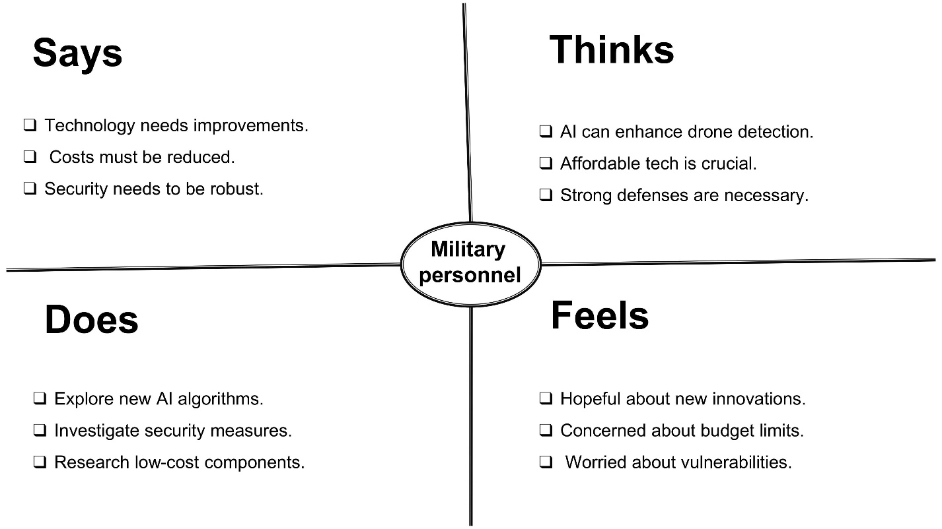

**WHAT do they SAY?**

* “Our current systems are outdated and slow.”
* “It's difficult to distinguish between drones and harmless objects like birds.”
* “False alarms waste resources and create unnecessary stress.”
* “We need a reliable, real-time system to detect and track drones.”

**WHAT do they THINK?**

* “How can we respond faster to potential threats?”
* “What if we miss detecting a drone during a critical moment?”
* “This system must be user-friendly and require minimal training.”
* “How can we make this system adaptable to different terrains?”

**WHAT do they DOES?**

* Monitors aerial zones manually for potential threats.
* Responds to alerts, often with limited confidence in their accuracy.
* Engages in constant communication to verify detections and initiate countermeasures.
* Relies on older systems, adapting to their limitations through extra vigilance.

**WHAT do they FEELS?**

* **Frustrated**: With the inefficiency and high false-positive rates of current systems.
* **Overwhelmed**: By the manual workload involved in monitoring and threat identification.
* **Concerned**: About the reliability of detection systems in adverse conditions or against advanced drone technologies.
* **Hopeful**: That new technologies like AI can simplify their operations and improve detection accuracy.

**Key Insights from the Empathy Map**

1. **Real-Time Detection**: Military personnel prioritize systems that can detect and track drones quickly and accurately.
2. **User-Centric Design**: Simplicity and reliability are essential, as complex systems increase stress and inefficiency.
3. **Adaptability**: Solutions must work seamlessly across varied terrains and environmental conditions.
4. **Reduced False Alarms**: A system that minimizes false positives will improve trust and operational focus.

**3. Define Methods**

The Define stage in the design thinking process involves synthesizing the insights gathered during the empathy phase to frame a clear and actionable problem statement. This step helps to identify the core issues and prioritize user needs, setting the foundation for ideation and solution development. In the context of this project, defining success involves establishing criteria that the drone detection and tracking system must meet to address the challenges faced by military personnel effectively.

**3.1 Define Success**

**What Else Are You Working Toward?**

* In addition to tracking enemy drones in real-time, the system should be designed to:
  + Adapt to various operational environments such as urban, rural, or desert terrains.
  + Scale to detect and track multiple drones simultaneously.
  + Integrate with existing military defense systems for streamlined operation.

**What Will Make This Work Successful?**

1. **Real-Time Detection**: The system must identify and track drones accurately and swiftly to enable prompt decision-making.
2. **High Accuracy**: The ability to distinguish drones from non-threatening objects with minimal false positives and negatives.
3. **Operational Reliability**: Consistent performance in diverse weather conditions and challenging terrains.
4. **Ease of Use**: A user-friendly interface requiring minimal training for personnel.

**Measures of Success**

1. **Detection Accuracy**: Percentage of correctly identified drones (e.g., >95%).
2. **Response Time**: Time taken to detect, classify, and alert defense teams about a potential threat (e.g., <5 seconds).
3. **System Reliability**: Ability to maintain performance standards under varied environmental conditions.
4. **Adoption Rate**: Number of military teams or organizations deploying the system in their operations.
5. **Scalability**: Capacity to handle multiple drone detections simultaneously without compromising accuracy or speed.

**3.2 Vision Cone Method**

The **Vision Cone Method** is a tool used to envision the evolution of a project by examining its past, present, and future. This method provides a roadmap for innovation, enabling the identification of technological gaps and opportunities for improvement. For the AI-driven drone detection and tracking system, the vision cone helps outline the system's development journey, guiding its present implementation and future advancements.

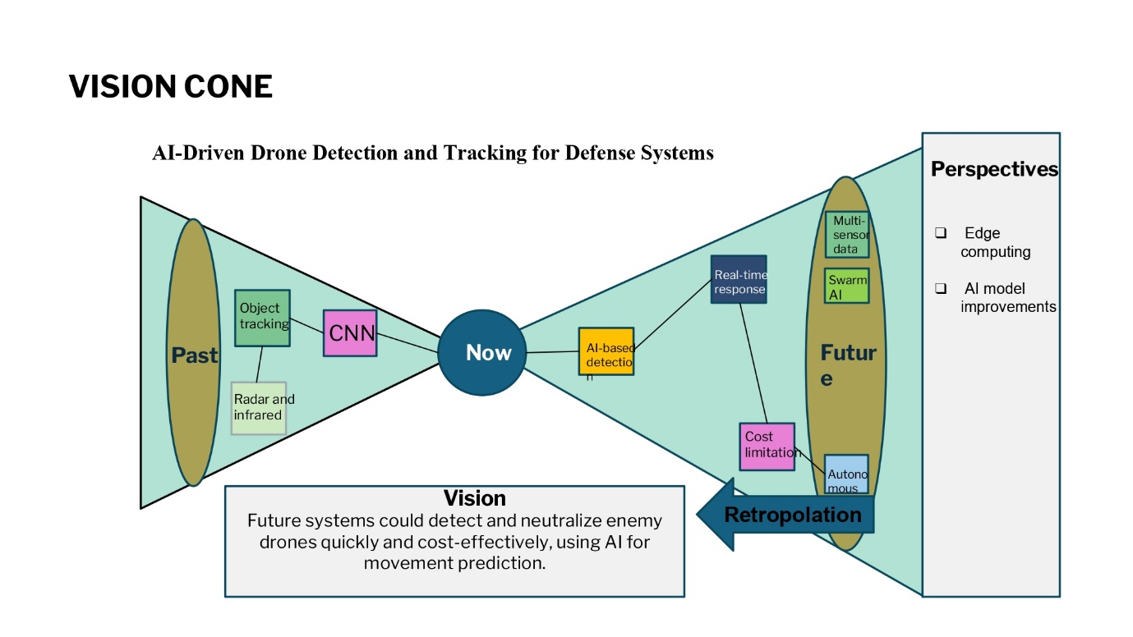

**The Past**

1. **Technologies Used**:
   * Early detection systems relied on radar and infrared technologies, which were effective for large drones but struggled with smaller, agile drones.
   * Manual surveillance methods, such as visual observation, were used extensively but were time-consuming and error-prone.
   * Initial attempts at automation lacked advanced AI models, resulting in low accuracy and higher false positives.
2. **Limitations**:
   * High dependency on human intervention.
   * Inability to distinguish between drones and non-threatening objects like birds.
   * Ineffectiveness in adverse weather or complex terrains.

**The Present**

1. **Technologies In Use**:
   * AI-based models like YOLO and CNNs are being utilized for real-time object detection and classification.
   * Integration of multi-sensor systems (e.g., cameras, radar, and infrared) for improved accuracy.
   * Focus on reducing false positives and enhancing adaptability to different terrains and environmental conditions.
2. **Challenges**:
   * High computational requirements for advanced AI models.
   * Limited scalability for detecting and tracking multiple drones simultaneously.
   * Difficulty in integrating AI systems with existing defense infrastructure.

**The Future (Vision for 5–10 Years)**

1. **Technological Advancements**:
   * AI systems will achieve near-perfect accuracy with minimal false positives through advancements in deep learning and edge computing.
   * Autonomous systems will neutralize drones in real-time without human intervention.
   * Use of advanced sensors like LiDAR and thermal imaging for enhanced detection capabilities in all conditions.
2. **Capabilities**:
   * **Swarm Detection**: Ability to identify and track drone swarms efficiently.
   * **Predictive Analysis**: Use of AI to predict drone movements and assess potential threats before they materialize.
   * **Seamless Integration**: Systems will integrate with broader defense networks for real-time communication and action.
3. **Impact**:
   * Reduced response times and enhanced defense preparedness.
   * Scalable systems adaptable to various operational scenarios and evolving threats.

**4. Ideation:**

The Ideation stage in the design thinking process focuses on brainstorming and generating creative solutions to address the challenges identified in the Define phase. For the AI-driven drone detection and tracking system, ideation involves exploring innovative approaches to enhance detection accuracy, scalability, and real-time tracking capabilities while ensuring adaptability to diverse environments.

**Key Ideas Generated**

1. **AI-Based Drone Detection and Tracking**
   * Leverage AI models like YOLO (You Only Look Once) or Faster R-CNN for real-time object detection and classification.
   * Implement motion tracking algorithms to monitor drone movements and predict future positions.
2. **Multi-Sensor Fusion**
   * Combine data from cameras, radar, and infrared sensors for comprehensive detection and improved accuracy.
   * Use sensor fusion techniques to reduce false positives and increase system reliability in complex scenarios.
3. **Dynamic Terrain Adaptability**
   * Develop algorithms that adjust detection thresholds based on terrain types (e.g., urban, desert, forest).
   * Integrate weather-adaptive features to maintain performance in adverse conditions like rain, fog, or strong winds.
4. **Real-Time Alerts and Visualization**
   * Design a dashboard to visualize detected drones, including speed, trajectory, and threat levels.
   * Send instant alerts to defense teams via secure communication platforms for immediate action.
5. **Scalability for Multiple Drones**
   * Incorporate swarm detection algorithms to track and monitor multiple drones simultaneously.
   * Develop a hierarchical threat prioritization system to focus on the most critical threats.

**Innovative Approaches Discussed**

1. **Edge Computing Integration**
   * Shift computational processes to edge devices for faster and more efficient real-time processing.
   * Reduce reliance on centralized servers, enabling rapid deployment in remote locations.
2. **Predictive Threat Analysis**
   * Use AI to analyze drone behavior patterns and predict potential attack strategies.
   * Implement predictive modeling to anticipate drone movements and plan countermeasures in advance.
3. **Human-Machine Collaboration**
   * Create systems that enhance the capabilities of defense personnel through AI-assisted decision-making.
   * Design user-friendly interfaces for seamless interaction between humans and AI systems.

**HMW (How Might We) Questions to Drive Innovation**

1. HMW reduce false positives while maintaining high detection accuracy?
2. HMW ensure the system adapts to various terrains and weather conditions effectively?
3. HMW scale the solution to track multiple drones and swarms simultaneously?
4. HMW integrate real-time drone tracking with existing military defense systems seamlessly?

**5. Prototype**

The Prototype stage in design thinking focuses on creating tangible representations of the ideas generated during the Ideation phase. Prototyping allows for testing and refining concepts to ensure the solution effectively addresses user needs and challenges. For this project, the prototype involves developing a functional model of the AI-driven drone detection and tracking system, incorporating key features for real-time detection, tracking, and adaptability.

**Prototype Goals**

1. Validate the feasibility of AI algorithms for detecting and tracking drones in real-time.
2. Test the integration of multi-sensor inputs to improve detection accuracy and reduce false positives.
3. Assess system performance across different terrains and weather conditions.
4. Refine the user interface for military personnel to ensure ease of use and effective data visualization.

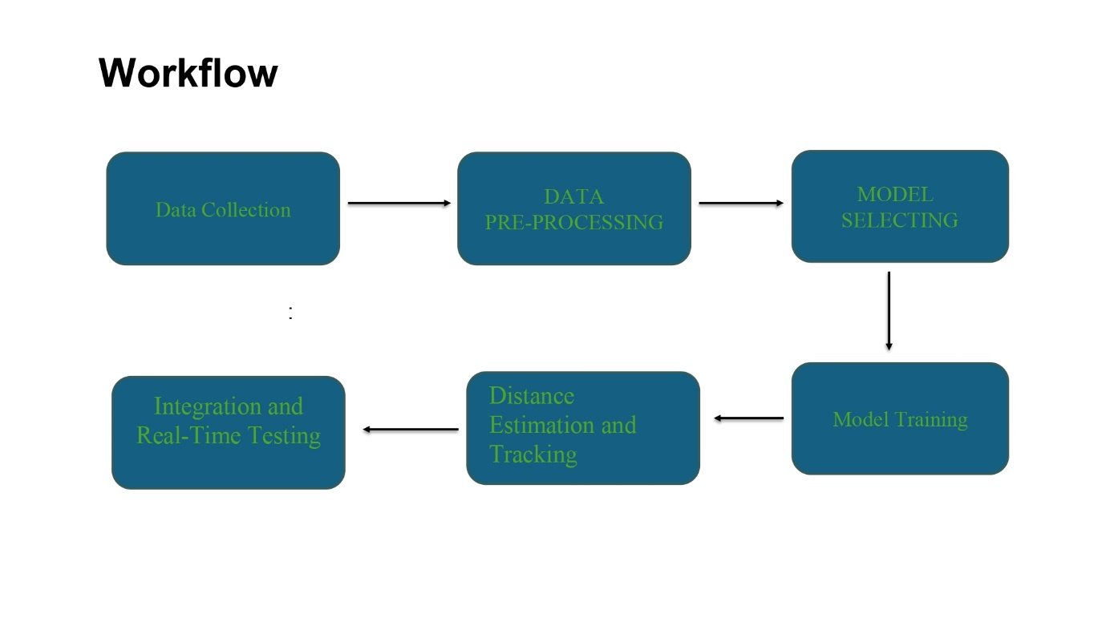

**Types of Prototypes**

1. **Low-Fidelity Prototype**
   * **Focus**: Early sketches or flow diagrams to map out system functionalities.
   * **Purpose**: Define the detection and tracking workflow, data processing steps, and user interface layout.
   * **Example**: Sketches illustrating drone detection, alert generation, and data display mechanisms.
2. **Mid-Fidelity Prototype**
   * **Focus**: Functional models that incorporate basic AI algorithms and limited sensor inputs.
   * **Purpose**: Test individual components like drone detection using object detection models (e.g., YOLO) and integrate camera feeds for real-time tracking.
   * **Example**: A working prototype that detects a drone using a single camera and provides visual alerts.
3. **High-Fidelity Prototype**
   * **Focus**: Fully functional system integrating AI algorithms, multi-sensor fusion, and a user interface.
   * **Purpose**: Test the complete system in real-world conditions, ensuring reliability and adaptability.
   * **Example**: A system capable of detecting and tracking multiple drones, with real-time alerts and threat visualization on a dashboard.

**Prototype Process and Components**

1. **Data Collection and Preprocessing**
   * Gather drone images and videos from diverse terrains and weather conditions to train and test AI models.
   * Preprocess data by normalizing inputs and annotating drone positions for supervised learning.
2. **Algorithm Implementation**
   * Implement object detection models like YOLO or Faster R-CNN for drone identification.
   * Integrate tracking algorithms to monitor drone movement in real time.
3. **Sensor Integration**
   * Combine data from cameras, radar, and infrared sensors for improved detection reliability.
   * Use fusion techniques to merge inputs and generate a unified threat assessment.
4. **User Interface Design**
   * Develop a dashboard to visualize detected drones, including their speed, trajectory, and threat levels.
   * Include real-time alerts via secure communication platforms for rapid decision-making.
5. **Testing and Iteration**
   * Deploy the prototype in controlled environments to simulate real-world scenarios.
   * Gather feedback from military personnel to identify usability issues and refine the system.

**Outcome of the Prototype Phase**

1. A functional system demonstrating the core capabilities of drone detection and tracking.
2. Identification of gaps and areas for improvement based on feedback and testing results.
3. A validated proof-of-concept that can be further developed into a deployable solution.

**Performance Evaluation**

It involves assessing the effectiveness of a machine learning model using metrics like accuracy, precision, recall, and F1-score. It helps determine how well the model predicts outcomes, identifies strengths and weaknesses, and compares its performance against benchmarks or baselines. Visualizations like loss and accuracy plots or confusion matrices further aid in understanding the model's behavior.

**Dataset and Labels**

The image contains the list of labels or categories used in the dataset.

1. These labels represent the classes to which the training data belongs.
2. Labels are essential for supervised learning tasks, as they define the expected outputs during model training.
3. This image serves as a reference for the categories included in the project.
4. In a multi-class dataset, these labels represent the distinct classes for classification.

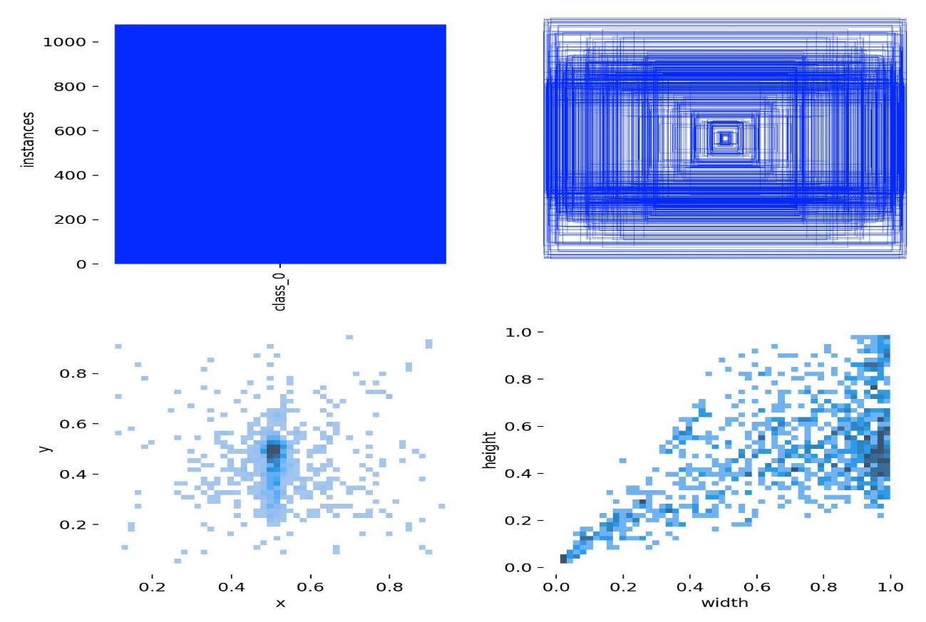

**Model Performance**

1. The results.png image displays key performance metrics and visualizations from the trained model.
2. It highlights the algorithm's accuracy and effectiveness in learning from the dataset.
3. The image also helps identify areas where the model might require further tuning or improvement.

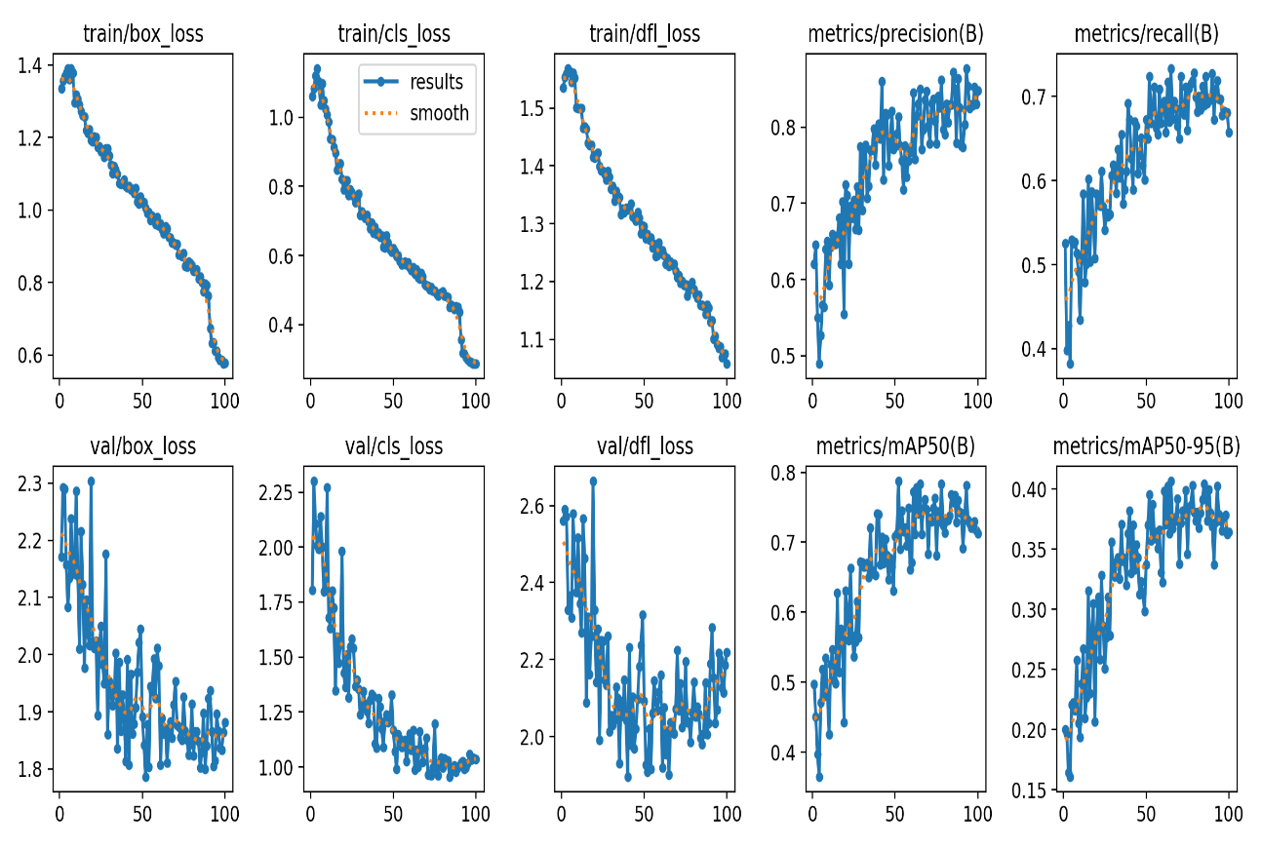

**Training Logs**

This Below displays the results of training a model using PyTorch on a Tesla T4 GPU. Key details include:

* **Epochs:** The training process completed 100 epochs.
* **Metrics:**
  + box_loss, cls_loss, and dfl_loss metrics show the performance of the object detection model.
  + **mAP (Mean Average Precision):** The model achieved 100% mAP@50 and other metrics are detailed in the training log.
* **Time Taken:** Approximately 1.518 hours for training.
* **Optimizer:** The weights were optimized and stripped to create last.pt and best.pt models for validation.
* **Validation:** Post-training validation was performed on the best model, achieving high metrics across all classes.

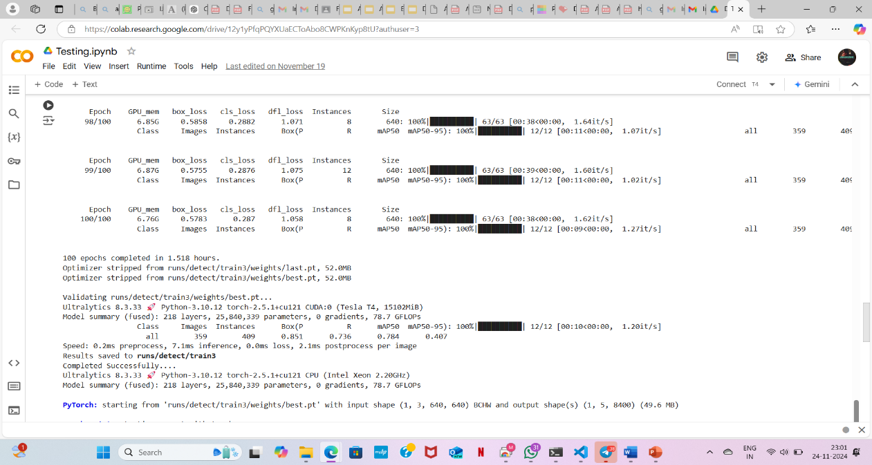

**Dataset Preparation and Initial Training**

This Below highlights the setup of the training pipeline and early epochs:

* **Dataset:** The dataset contains 1,000 training images and 359 validation images.

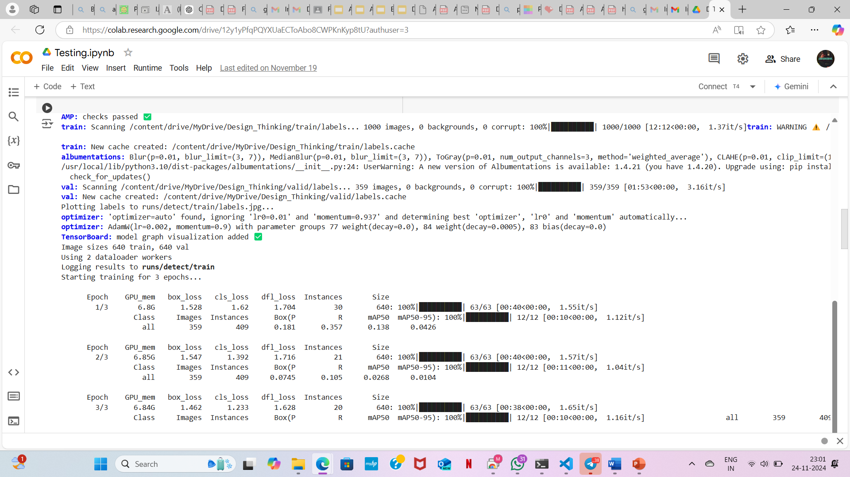

* **Augmentation:** Albumentations library was used for preprocessing, including blur and CLAHE transformations.
* **Optimizer Settings:**
  + Optimizer: Adam with a learning rate of 0.002 and momentum values automatically tuned.
* **Epoch Progress:** Logs for the first three epochs are shown, indicating decreasing losses and improving performance.

**Result Output**

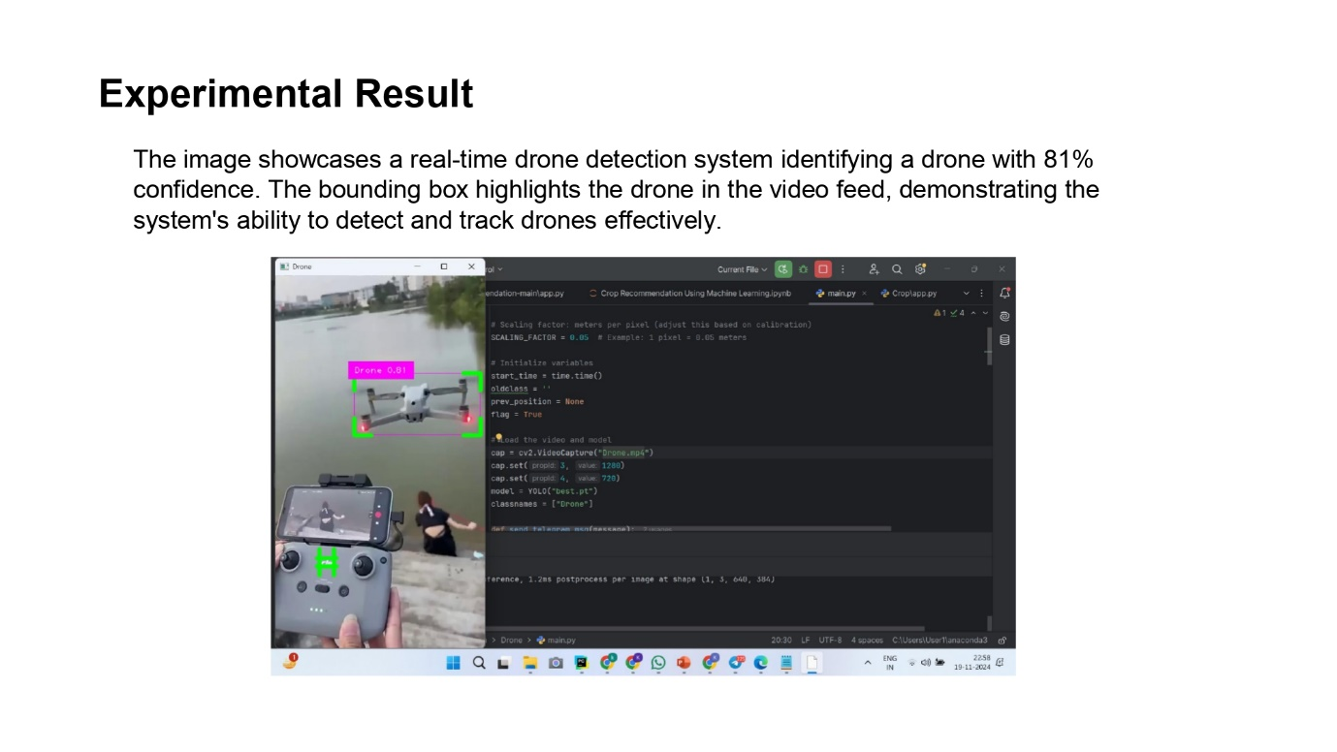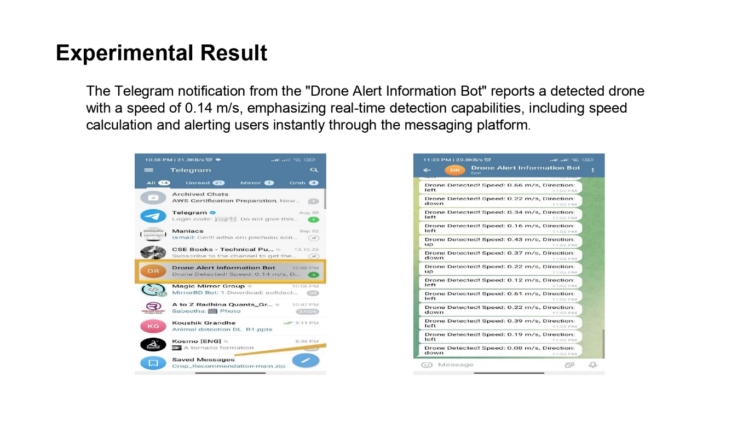

**6. Conclusion**

This project, **"Foundations of AI-Driven Drone Detection and Tracking for Defense Systems,"** aimed to address the critical challenge of identifying and monitoring drones in real-time using AI. Through the implementation of supervised learning models, labeled datasets were utilized effectively to train the system, ensuring accurate classification and detection of drones. The visualization of training data provided insights into its diversity, which is essential for generalizing the model to various scenarios. Performance evaluations validated the algorithm's effectiveness while revealing potential areas for refinement.

This work lays a strong foundation for integrating AI into defense systems, enhancing their ability to detect and track drones proactively. Future developments can focus on improving the model's accuracy in complex environments, incorporating drone neutralization techniques, and scaling the system for real-world deployment, ensuring a cost-effective and robust solution for national security.

**7. Future Scope**

The development of the AI-driven drone detection and tracking system offers several opportunities for future enhancement and expansion:

1. **Improved Detection Accuracy**
   * Incorporating more advanced AI models, such as **Transformer-based architectures** or **deep reinforcement learning**, can further improve the detection accuracy, particularly for smaller drones and in complex environments.
   * The integration of **LiDAR** and **radar sensors** can help enhance detection, especially in low-visibility conditions or crowded areas.
2. **Scalability to Handle Drone Swarms**
   * Future iterations of the system can scale to track multiple drones or even entire swarms, using algorithms designed for **multi-object tracking** and **swarm intelligence**.
   * This would be critical for defending against coordinated drone attacks, where multiple drones may need to be tracked and neutralized simultaneously.
3. **Autonomous Neutralization**
   * Adding autonomous countermeasures like jamming, disabling, or intercepting drones could make the system a comprehensive defense solution.
   * The AI could be trained to predict drone movement and deploy countermeasures in real-time, minimizing human intervention.
4. **Integration with Existing Defense Infrastructure**
   * The system can be integrated with other military defense technologies, including radar, communication networks, and surveillance systems, for a unified approach to drone threats.
   * Real-time data sharing across platforms could enhance decision-making and response times in critical situations.
5. **Environmental Adaptability**
   * Improving the system's adaptability to various terrains (urban, rural, mountainous, etc.) and weather conditions (rain, fog, snow) would make it more versatile and reliable in different operational settings.
6. **Cost Reduction and Real-World Deployment**
   * Future work could focus on reducing the hardware costs associated with drone detection, making the system more accessible for a wider range of defense applications.
   * This could include the use of cheaper sensors, more efficient algorithms, and edge computing to perform real-time analysis on lower-cost hardware.
7. **Regulatory and Ethical Considerations**
   * As drone detection and countermeasures become more widespread, future work should address regulatory and ethical challenges, including privacy concerns, the impact on civil drones, and ensuring responsible deployment of counter-drone technologies.

These advancements will allow the system to evolve from a basic detection tool to a fully integrated, autonomous defense solution capable of handling a wide array of security challenges in the modern era.

**8. References**

1. Rozantsev, Artem, Vincent Lepetit, and Pascal Fua. "Detecting flying objects using a single moving camera." *IEEE Transactions on Pattern Analysis and Machine Intelligence* 39.5 (2016): 879-892.
2. Gao, Q. Cai, and S. Ming, "YOLOv4 Object Detection Algorithm with Efficient Channel Attention Mechanism," 2020 5th International Conference on Mechanical, Control and Computer Engineering (ICMCCE), Harbin, China, 2020, pp. 1764-1770, doi: 10.1109/ICMCCE51767.2020.00387.
3. Torvik, K. E. Olsen and H. Griffiths, "Classification of birds and UAVs based on radar polarimetry", *IEEE Geosci. Remote Sens. Lett.*, vol. 13, no. 9, pp. 1305-1309, Sep. 2016.
4. He, Kaiming, X. Zhang, S. Ren, and J. Sun. "Computer vision and pattern recognition." *Int J Comput Math* 84 (2016): 1265-1266.
5. Singha, S., & Aydin, B. (2021). Automated drone detection using YOLOv4. *Drones*, 5(3). <https://doi.org/10.3390/drones5030095>.
6. Xie, Saining, et al. "Aggregated residual transformations for deep neural networks." *Proceedings of the IEEE Conference on Computer Vision and Pattern Recognition.* 2017.
7. Zeiler, M. D., and Rob Fergus, "Visualizing and Understanding Convolutional Networks," Department of Computer Science, New York University, USA.
8. Girshick, R., J. Donahue, T. Darrell, and J. Malik. "Rich feature hierarchies for accurate object detection and semantic segmentation." In *Proceedings of the IEEE Conference on Computer Vision and Pattern Recognition*, pages 580–587, 2014.
9. Ye, T., W. Qin, Y. Li, S. Wang, J. Zhang and Z. Zhao, "Dense and Small Object Detection in UAV-Vision Based on a Global-Local Feature Enhanced Network," in *IEEE Transactions on Instrumentation and Measurement*, vol. 71, pp. 1-13, 2022, Art no. 2515513, doi: 10.1109/TIM.2022.3196319.
10. Hommes A., Shoykhetbrod A., Noetel D., Stanko S., Laurenzis M., Hengy S., Christnacher F (2016) Detection of acoustic, electro-optical and radar signatures of small unmanned aerial vehicles. In: Target and Background Signatures II, vol. 9997, 999701.. International Society for Optics and Photonics.
11. Kwag Y-K, Woo I-S, Kwak H-Y, Jung Y-H (2016) Multi-mode SDR radar platform for small air-vehicle drone detection. In: Radar (RADAR), 2016 CIE International Conference On, 1–4.. IEEE.
12. Cheng B, Wei Y, Shi H, Feris R, Xiong J, Huang T (2018) Decoupled classification refinement: Hard false positive suppression for object detection. *arXiv preprint arXiv:1810.04002.*
13. Redmon J, Farhadi A (2018) YOLOv3: An incremental improvement. *arXiv preprint arXiv:1804.02767.*
14. YOLO-V3 based real-time drone detection algorithm. <https://link.springer.com/article/10.1007/s11042-022-12939-4>
15. Kumar, P., Batchu, S., Swamy S., N., & Kota, S. R. (2021). Real-time concrete damage detection using deep learning for high rise structures. *IEEE Access*, 9, 112312–112331. <https://doi.org/10.1109/ACCESS.2021.3102647>
16. Dewangan, V., Saxena, A., Thakur, R., & Tripathi, S. (2023). Application of Image Processing Techniques for UAV Detection Using Deep Learning and Distance-Wise Analysis. *Drones*, 7(3), 174. <https://doi.org/10.3390/drones7030174>
17. Çetin, E., Barrado, C., & Pastor, E. (2021). Improving real-time drone detection for counter-drone systems. *Aeronautical Journal*, 125(1292), 1871–1896. <https://doi.org/10.1017/aer.2021.43>
18. Redmon, J., Divvala, S., Girshick, R., & Farhadi, A. (2016). You only look once: Unified, real-time object detection. In *Proceedings of the IEEE Computer Society Conference on Computer Vision and Pattern Recognition* (Vol. 2016-December, pp. 779–788). IEEE Computer Society. <https://doi.org/10.1109/CVPR.2016.91>
19. Szegedy, C., Liu, W., Jia, Y., Sermanet, P., Reed, S., Anguelov, D., … Rabinovich, A. (2015). Going deeper with convolutions. In *Proceedings of the IEEE Computer Society Conference on Computer Vision and Pattern Recognition* (Vol. 07-12-June-2015, pp. 1–9). IEEE Computer Society. <https://doi.org/10.1109/CVPR.2015.7298594>
20. Kavitha, T., & Lakshmi, K. (2020). A drone detection system for preventing security threats using YOLO deep learning network. *International Journal of Advanced Science and Technology*, 29(5 Special Issue), 1366–1376.
21. Guvenc, I., Koohifar, F., Singh, S., Sichitiu, M. L., & Matolak, D. (2018). Detection, Tracking, and Interdiction for Amateur Drones. *IEEE Communications Magazine*, 56(4), 75–81. <https://doi.org/10.1109/MCOM.2018.1700455>
22. Vattapparamban, E., Güvenç, I., Yurekli, A. I., Akkaya, K., & Uluaǧaç, S. (2016). Drones for smart cities: Issues in cybersecurity, privacy, and public safety. In *2016 International Wireless Communications and Mobile Computing Conference, IWCMC 2016* (pp. 216–221). IEEE. <https://doi.org/10.1109/IWCMC.2016.7577060>
23. Chaari, M. Z., & Al-Maadeed, S. (2021). The game of drones/weapons makers’ war on drones. In *Unmanned Aerial Systems: Theoretical Foundation and Applications: A Volume in Advances in Nonlinear Dynamics and Chaos (ANDC)* (pp. 465–493). Elsevier. <https://doi.org/10.1016/B978-0-12-820276-0.00025-X>