GADDALA LOKESH KUMAR

AWS DEVOPS ENGINEER

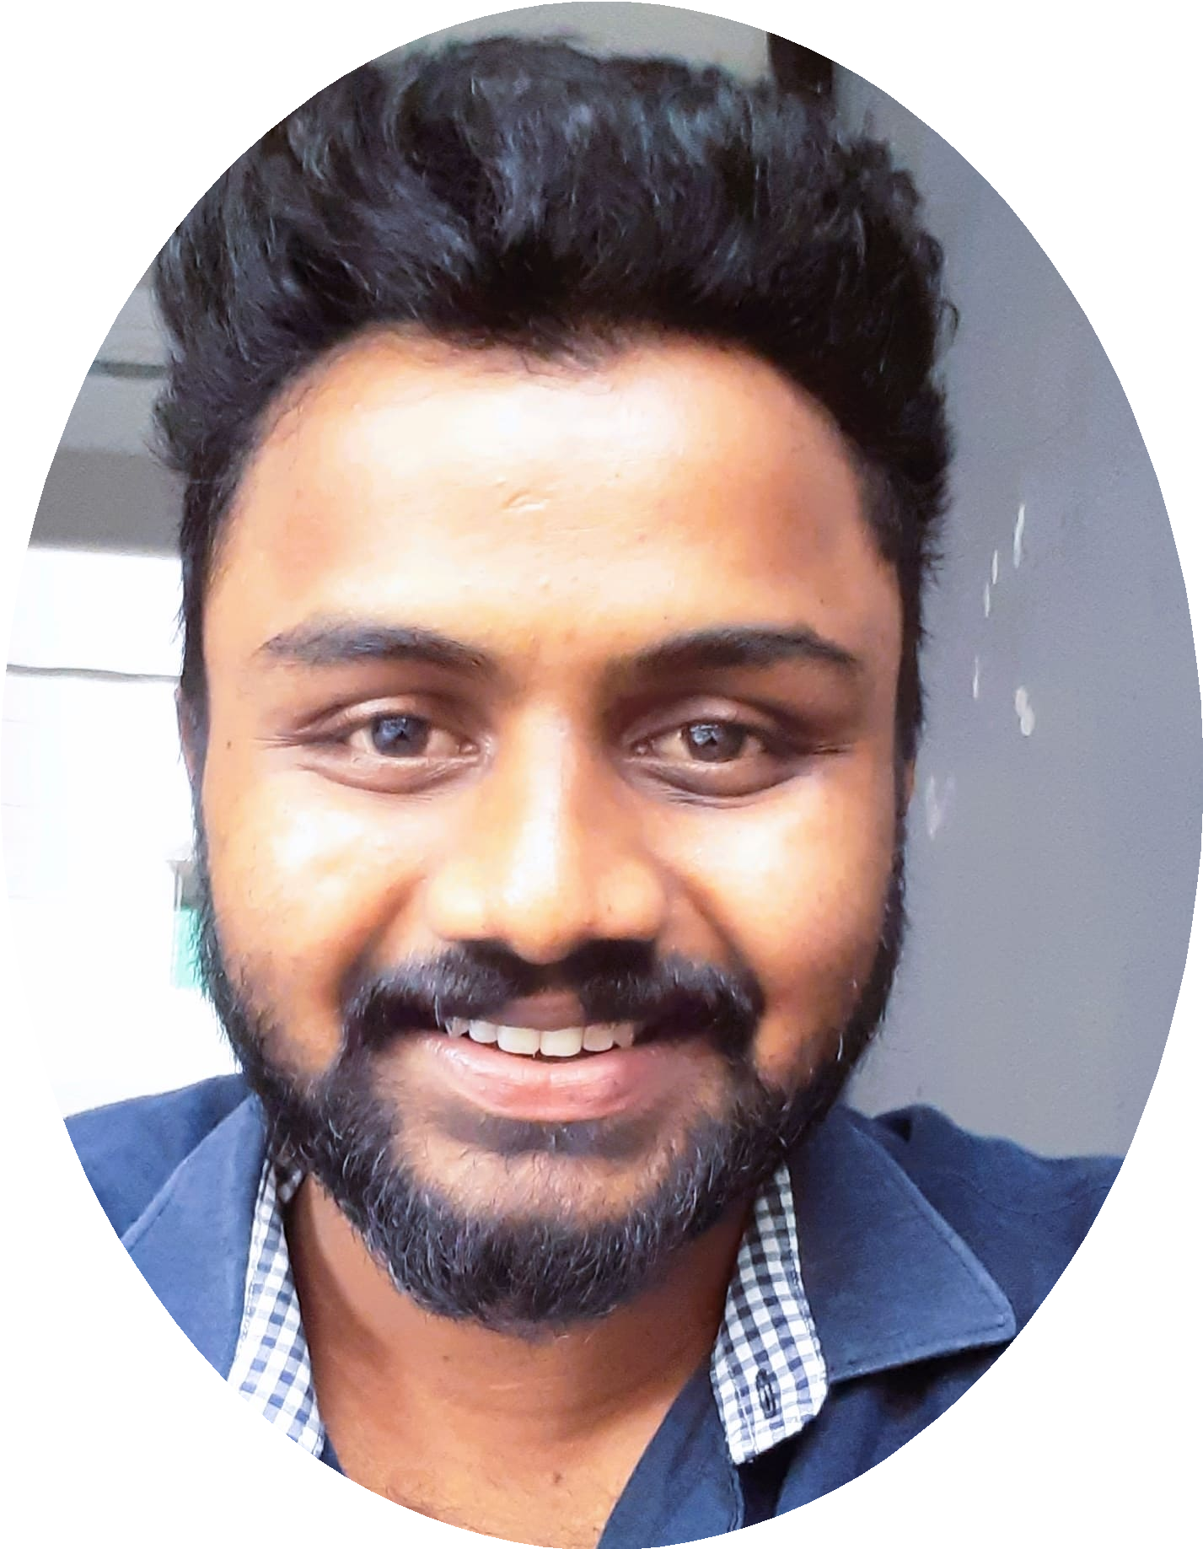

9502031550



[lokeshkumargaddala@gmail.com](mailto:lokeshkumargaddala@gmail.com)



SUMMARY

A DevOps and Cloud Engineer with over 4 years of experience working with Amazon Web Services (AWS) Services and DevOps tools. Good exposure to web application servers, infrastructure and platform automation and CI-CD. A Strong team player with deep understanding of development operations, great attention to detail and work ethic.

I have created and maintained continuous integration (CI) and continuous Delivery (CD) pipelines to facilitate an agile and scrum

development process, managed Docker installation, files and images, automated infrastructure and platforms using Terraform, Ansible, and Jenkins and created immutable infrastructure in different environments using Terraform.

KEY SKILLS

Cloud Services: Amazon Web Services (AWS)

Version Control: Git, GitHub, Bitbucket,Gitlab

Ticketing Tools: ServiceNow, Jira, Rally

Infrastructure Tools: Terraform, CloudFormation

CI CD Tools: Jenkins, AWS code pipeline

programming languages: Terraform, PowerShell,shell, SQL

Monitoring Tools: CloudWatch and splunk

PROFESSIONAL EXPERIENCE

Marella soft labs private limited Feb '18 - Oct '22 AWS DevOps Engineer

Project Name: General Dynamics.

General Dynamics Corporation is an American publicly traded, aerospace and defense corporation. As of 2020, it was the fifth-largest defense contractor in the world.

Created CI/CD pipelines to Build and release applications in AWS

Configured Docker environment, creating and managing docker images including custom images; running applications on Docker Images

Wrote Ansible Playbooks for configuration of applications and patching activity Built and managed AWS Infrastructure and worked on AWS (Public) Cloud to provide IaaS support

Provided an AWS cloud solution architecture to a client as per their requirement to set up an environment on AWS.

Used Git version control for pushing code to a Centralized repository. Created and

merged source code repositories including branching and merging for multiple concurrent code branches.

Created and tested Power-Shell script to deploy the VM, Storage, Network, and Affinity.

Provided a Multi-Site VPN solution to connect multiple networks in AWS. Configured the VMs in Availability Set to provide higher Availability for VMs. Migrated VMs from one cloud Service to another

Created new jobs using VSTS and managed build-related issues; coordinated with the development team to fix build-related issues

Provided Storage solutions to the Client.

Build & Release Engineer

Project Name: Citizens Financial Group

Citizens Financial Group, Inc. is an American bank headquartered in Providence, Rhode Island, USA.

Compiled source code using MS-Build/make and packaged it in its distributable

format, such as an ISO.

Handled multiple builds from the Development team, create build jobs in VSTS and perform

Automated the building Process Using AWS DevOps jobs.

Converted and automated builds; scheduled automated nightly builds using Subversion

Monitored daily builds using continuous integration tool AWS DevOps Maintained Continuous integration effort with Subversion along with scheduled builds

Worked on AWS virtual networks and web apps and Configured Webapps with AWS SQL DB

Deployed and managed AWS and storage accounts and Services like Virtual Machines, Web Apps, Storage, AWS Active Directory and Virtual Networks

Configured AWS public, internal load balancers, storage account access,

diagnostics, and monitoring

Resolved issues related to application deployment and operations

Artifactory Repos: JFrog Artifactory

Containerization Tools: Docker, ECS and ECR

Configuration Management: Ansible

Scripting Languages: Shell script,PowerShell, YAML, and JSON

Build Tools: Ant, Apache Maven

Web Application servers:active directory, HTTP Server, Websphere 6.x, 7.0, 8.x JBOSS and Apache- Tomcat

Server Operating Systems: RedHat, Ubuntu, Centos

Experienced in Remote Infrastructure management created CI/CD pipelines to Build and release applications in AWS

Configured Docker environment, creating and managing docker images including custom images; running applications on Docker Images

Wrote Ansible Playbooks for the configuration of applications and patching activity Built and managed AWS Infrastructure and worked on AWS (Public) Cloud to provide IaaS support

Provided an AWS cloud solution architecture to a client as per their requirement to set up an environment on AWS.

Used Git version control for pushing code to a Centralized repository. Created and

merged source code repositories including branching and merging for multiple concurrent code branches.

Created and tested Power-Shell script to deploy the VM, Storage, Network, and Affinity.

Provided a Multi-Site VPN solution to connect multiple networks in AWS. Configured the VMs in Availability Set to provide higher Availability for VMs. Migrated VMs from one cloud Service to another

Created new jobs using VSTS and managed build-related issues; coordinated with the development team to fix build-related issues

Provided Storage solutions to the Client.

Systems Engineer

Project Name: ABInBev (Carlton & United Breweries)

ABInBev is a multinational beverage and brewing company with global headquarters in Belgium. It is the world’s largest brewer. CUB is an Australian brewing company that operates as a subsidiary of Fosters Group. It is based in Melbourne, Victoria.

Scheduled Build, created project pipelines in Jenkins, and ensured running of CI-CD Created and developed the build process environment and Wrote cloud formation templates to setup and updated the infrastructure and platform

Created builds using Maven and integrated Maven with Jenkins

Worked on Amazon EC2 cloud deployments using DevOps tools like Jenkins and Ansible

Wrote playbooks using Ansible and Integrating Ansible playbooks with Jenkins Setup DEV, QA, and UAT environments for each sprint using Ansible

Set up/Managed VPC, and Subnets; made connections between different zones; blocked suspicious IP/subnet via ACL.

Created/Managed AMI/Snapshots/Volumes, Upgraded/downgraded AWS resources (CPU, Memory, EBS). Setup/Managed Databases on Amazon RDS. Monitoring servers through Amazon Cloud Watch, SNS.

EDUCATION

Bachelor of Arts [Economics] May '15 - Jun '17 Osmania University

*Percentage: 75.2%*