# Simulation: Recursive Modulation of Angular Power Spectrum

This simulation illustrates the recursive amplification of CMB angular power spectrum coefficients (C_ℓ) using a time-dependent memory kernel. We apply the model to low-ℓ modes (ℓ = 2 to 6) where observational anomalies are most prominent. The recursive structure is given by:  
  
 C_ℓ(τ) = C_ℓ(0) + ∫₀^τ K(τ - τ′) · C_ℓ(τ′) dτ′  
  
where K(τ - τ′) is a decaying exponential memory kernel representing field feedback. Under isochoric constraints, this causes recursive amplification of low-ℓ modes, as shown in the figure below. Lower multipoles grow more rapidly, mimicking the volatile behavior observed in the Planck spectrum anomalies.

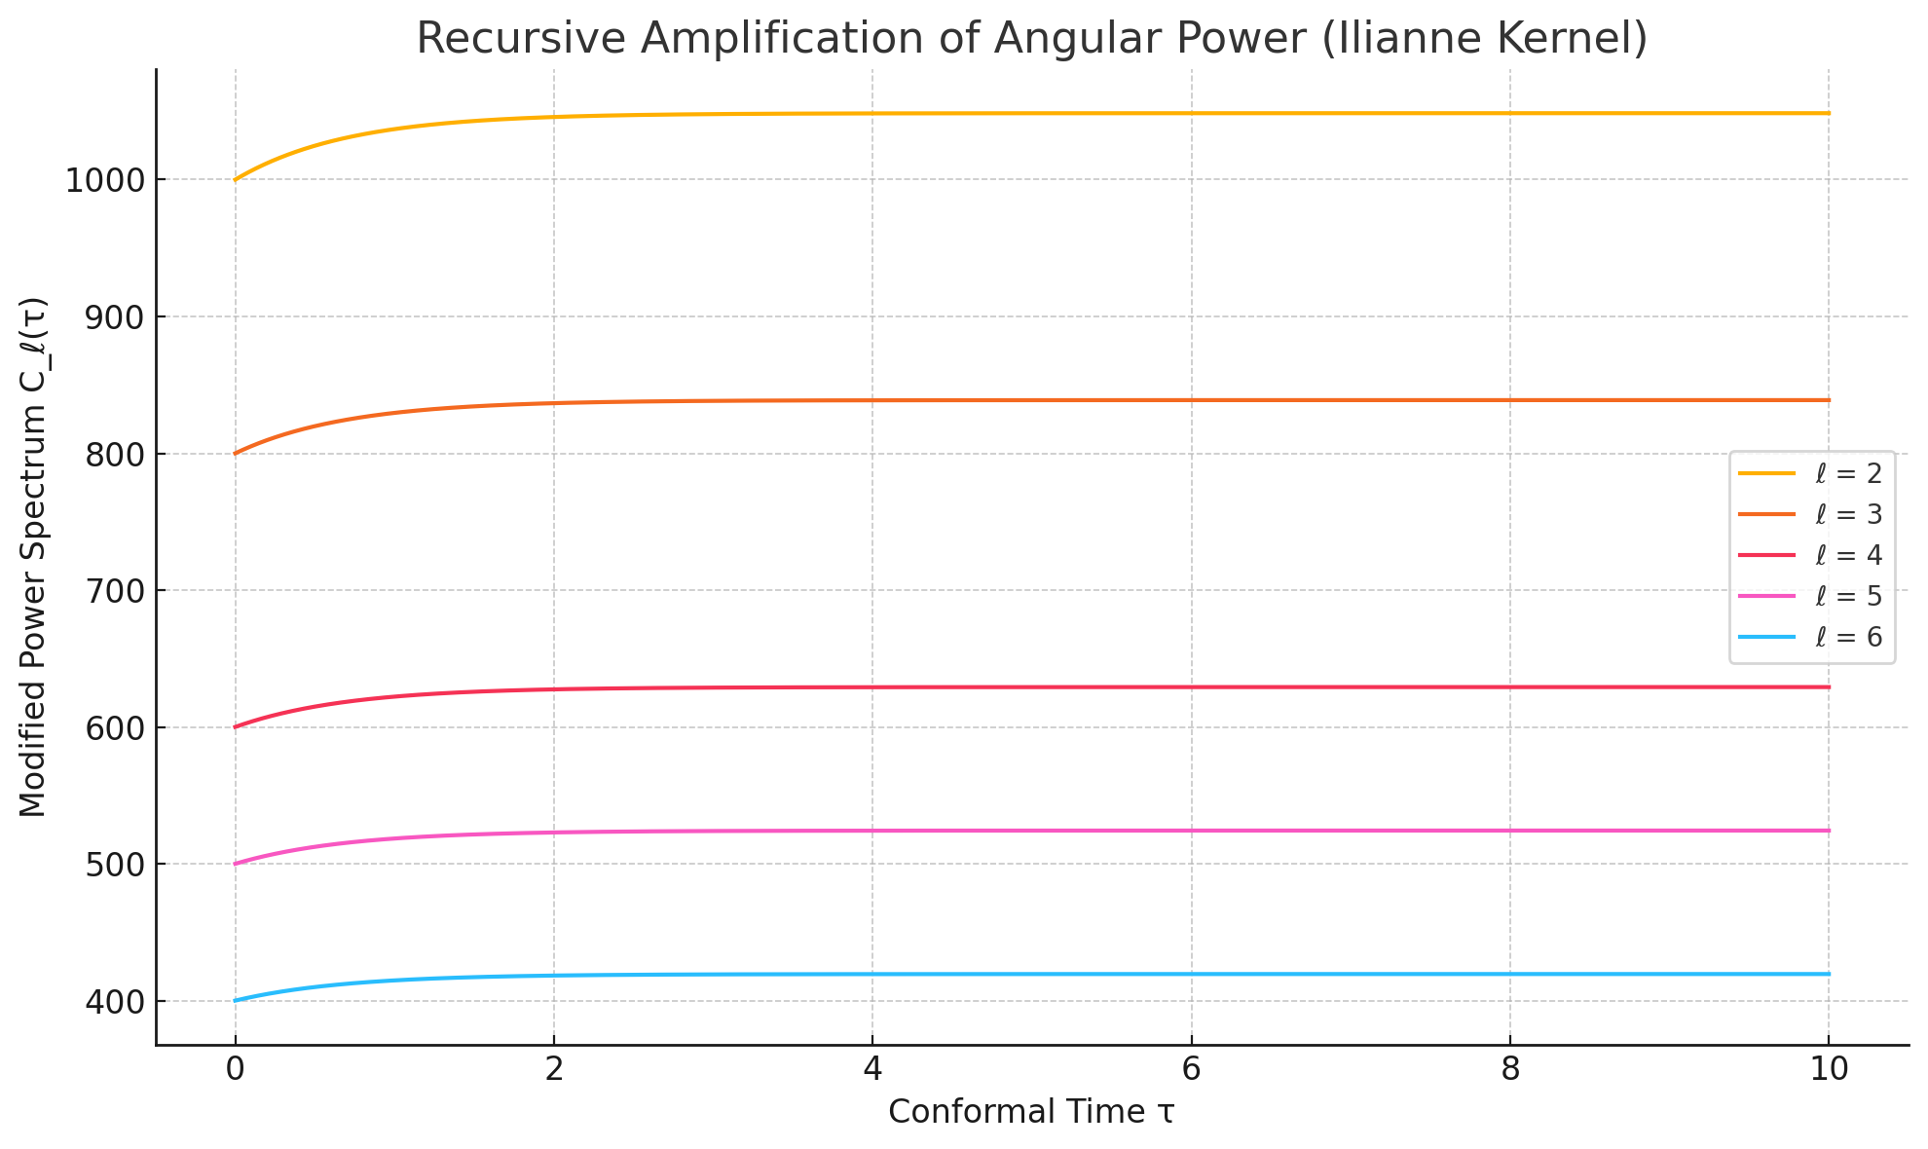

Figure: Recursive evolution of the power spectrum C_ℓ(τ) for multipoles ℓ = 2 to 6 using an exponential memory kernel.