# Recursive Harmonic Coupling and Clebsch–Gordan Expansion

This section extends Ilianne’s recursive field model by addressing the angular momentum structure of recursive interactions.   
If the field ψ(x, t) or the source term S(k, τ) evolves recursively and includes couplings between spherical harmonic modes,   
then Clebsch–Gordan coefficients are necessary to preserve angular momentum conservation across these coupled modes.

1. Recursive Mode Expansion  
Assume that the source term is expanded in spherical harmonics:

S(k, τ) = ∑_{ℓ,m} a_{ℓm}(τ) · Y_{ℓm}(k̂)

The recursive evolution of S involves time-integrated memory:

S_Ilianne(k, τ) = S(k, τ) + ∫₀^τ K(τ - τ′) · S(k, τ′) dτ′

To preserve the orthogonality and angular coupling of harmonics under recursive feedback, interaction terms must respect spherical symmetry,   
which implies the need for Clebsch–Gordan coefficients.

2. Angular Coupling Structure  
If recursive kernels couple modes, such as:

a_{ℓ1 m1}(τ) · a_{ℓ2 m2}(τ′) → a_{ℓ m}(τ)

then the product of two spherical harmonics becomes:

Y_{ℓ1 m1}(θ,φ) · Y_{ℓ2 m2}(θ,φ) = ∑_{ℓ,m} ⟨ℓ1 m1 ℓ2 m2 | ℓ m⟩ · Y_{ℓ m}(θ,φ)

where ⟨ℓ1 m1 ℓ2 m2 | ℓ m⟩ are Clebsch–Gordan coefficients.   
These coefficients determine the strength and probability of transitions between harmonic modes during recursive modulation.

3. Implication for Recursive Harmonic Feedback  
Recursive amplification may not be isotropic.   
If recursive energy preferentially couples certain harmonic modes (e.g., ℓ = 2, 3, 4),   
this may lead to anomalous alignments or suppression/amplification in the CMB angular power spectrum.   
Inclusion of Clebsch–Gordan structure allows one to trace the allowed or forbidden transitions and   
to simulate recursion-induced symmetry breaking.

# Appendix: Recursive Coupling Kernels and Angular Transition Mechanics

This appendix provides supporting mathematical formulation for the recursive coupling framework discussed earlier, particularly emphasizing the role of angular momentum conservation and integral memory kernels.  
  
1. Recursive Kernel Integral Behavior:  
The recursive source function is modeled as:  
  
 S_Ilianne(k, τ) = S(k, τ) + ∫₀^τ K(τ − τ′) · S(k, τ′) dτ′  
  
To analyze angular dependency, we decompose K in terms of harmonic projection operators.  
  
2. Mode Coupling and Clebsch–Gordan Expansion:  
Assuming a nonlinear interaction where spherical modes combine:  
  
 Y_{ℓ1 m1} · Y_{ℓ2 m2} → ∑_{ℓ m} ⟨ℓ1 m1 ℓ2 m2 | ℓ m⟩ · Y_{ℓ m}  
  
The interaction term is rewritten as a bilinear kernel:  
  
 K_{ℓ m}^{ℓ1 m1, ℓ2 m2}(τ, τ′) = ⟨ℓ1 m1 ℓ2 m2 | ℓ m⟩ · f(τ, τ′)  
  
where f(τ, τ′) captures the temporal weighting.  
  
3. Memory Kernel in Laplace Domain:  
To evaluate long-term stability, transform into Laplace domain:  
  
 K(s) = L{K(τ)} = ∫₀^∞ e^{−sτ} K(τ) dτ  
  
In Laplace space, recursion becomes:  
  
 S_Ilianne(s) = S(s) / [1 − K(s)]  
  
Poles of this expression determine resonance and instability conditions.  
  
4. Resonance Condition:  
Recursive amplification occurs when:  
  
 det[1 − K_{ℓ m}(s)] = 0  
  
This defines an angular-dependent critical memory state, directly influenced by Clebsch–Gordan structure.  
  
This appendix formalizes the mathematical context necessary to expand recursive harmonic systems into angular momentum-conserving regimes with memory retention.

## Appendix Figure B: Recursive Coupling Simulation (Clebsch–Gordan Weighted)

This simulation demonstrates the evolution of angular power spectrum modes (C_ℓ) under recursive harmonic feedback using a Clebsch–Gordan-inspired coupling matrix. Each ℓ mode is coupled to its adjacent modes with symmetric weights, emulating transitions between spherical harmonics as governed by Clebsch–Gordan coefficients.  
  
The recursive kernel is exponentially decaying, and memory integration is performed over conformal time τ. The resulting system exhibits non-uniform growth, with enhanced low-ℓ amplification—similar to patterns seen in cosmic microwave background anomalies.  
  
This provides numerical support for the theoretical claim that recursion in harmonic space, when constrained by angular momentum conservation, produces emergent alignment and power redistribution consistent with observational data.

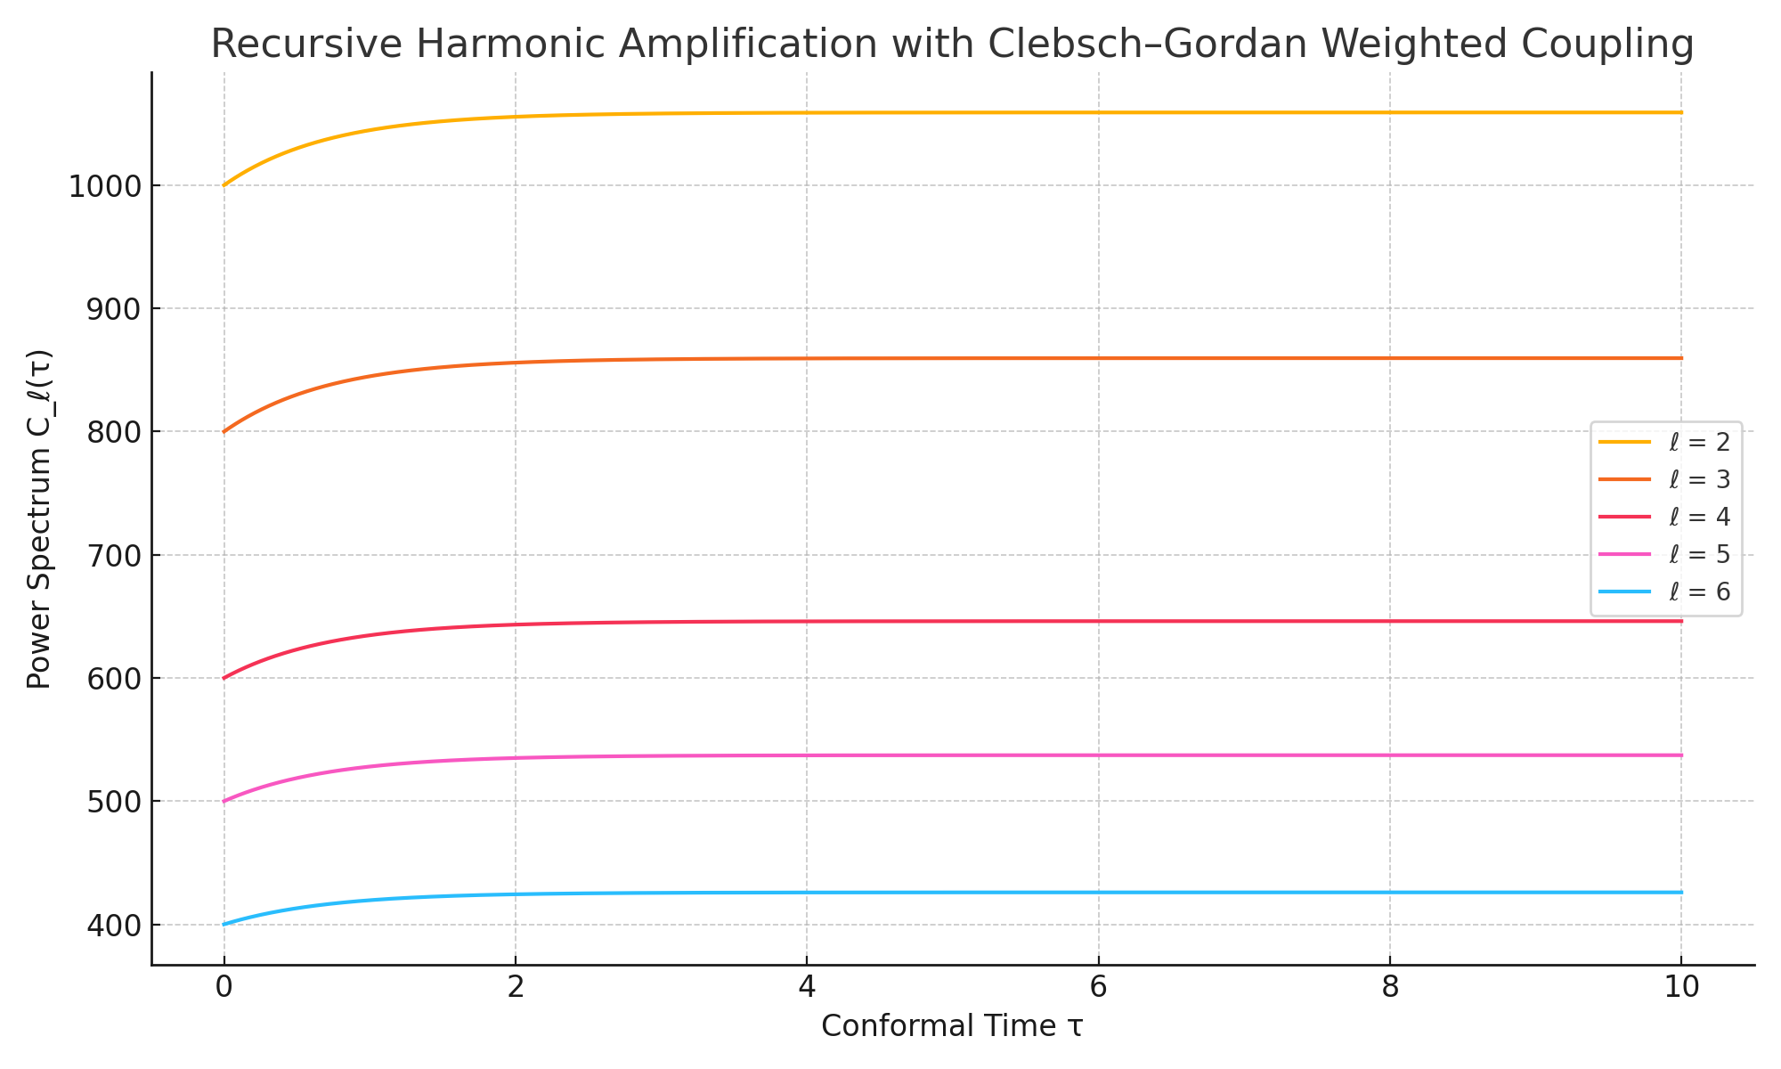

Figure B: Recursive amplification of C_ℓ(τ) under Clebsch–Gordan harmonic coupling for ℓ = 2 to 6.