IOT-BASED SMART ENERGY MONITORING SYSTEM
(Using Raspberry Pi)
A project report submitted in partial fulfillment of the requirements for the award of credits to
Bachelor of Technology
In
Electronics and Communication Engineering
By

PINNINTI LOKESH SIDDABOINA BALAJI
(20BQ1A04C9) (21BQ5A0419)

TUMMETI SUJITH VENKATA NAGA SAI UPPALAPATI MARIYA BABU
(20BQ1A04H2) (20BQ1A04H5)

IOT Tools And Applications
(Skill Advanced Course)



DEPARTMENT OF ELECTRONICS AND COMMUNICATION ENGINEERING
VASIREDDY VENKATADRI INSTITUTE OF TECHNOLOGY
(AUTONOMOUS)
(Approved by AICTE and permanently affiliated to JNTUK, Accredited by NBA and NAAC)
NAMBUR (V), PEDAKAKANI (M), GUNTUR-522 508
OCTOBER 2023

DEPARTMENT OF ELECTRONICS AND COMMUNICATION ENGINEERING
VASIREDDY VENKATADRI INSTITUTE OF TECHNOLOGY: NAMBUR
(AUTONOMOUS)

CERTIFICATE

This is to certify that the Mini Project titled “IOT BASED SMART ENERGY MONITORING SYSTEM” is a bonafide record of work done by Mr. PINNINTI LOKESH (20BQ1A04C9), Mr. SIDDABOINA BALAJI (21BQ5A0419), Mr. TUMMETI SUJITH VENKATA NAGA SAI (20BQ1A04H2) and Mr. UPPALAPATI MARIYA BABU (20BQ1A04H5) under the guidance of Mr. M. SRINIVASA RAO, Assistant Professor as part of the Skill Advanced Course IOT Tools And Applications in partial fulfillment of the requirement of the degree for Bachelor of Technology in Electronics and Communication Engineering during the academic year 2023–2024.

MS. T. Shalini Prof. M.Y. Bhanu Murthy
Course Instructor Head of Department

DECLARATION

We, Mr. PINNINTI LOKESH (20BQ1A04C9), Mr. SIDDABOINA BALAJI (21BQ5A0419), Mr. TUMMETI SUJITH VENKATA NAGA SAI (20BQ1A04H2) and Mr. UPPALAPATI MARIYA BABU (20BQ1A04H5) here by declare that the Mini Project Report entitled “IOT BASED SMART ENERGY MONITORING SYSTEM” is done by us under the guidance of Mr. M. SRINIVASA RAO Assistant Professor, as part of the Skill Advanced Course IOT Tools And Applications (Skill Advanced Course) in partial fulfillment of the requirement of the degree for Bachelor of Technology in Electronics and Communication Engineering during the academic year 2023–2024.

DATE:
PLACE:VVIT, NAMBUR.

SIGNATURE OF THE CANDIDATES

PINNINTI LOKESH

SIDDABOINA BALAJI

TUMMETI SUJITH VENKATA NAGA SAI

UPPALAPATI MARIYA BABU

ACKNOWLEDGEMENT

We express our sincere thanks wherever it is due
We express our sincere thanks to the Chairman, Vasireddy Venkatadri Institute of Technology, Sri Vasireddy VidyaSagar for providing us well equipped infrastructure and environment.
We thank Dr. Y. Mallikarjuna Reddy, Principal, Vasireddy Venkatadri Institute of Technology, Nambur, for providing us the resources for carrying out the project.
Our sincere thanks to Dr. K. Giri babu, Dean of Studies for providing support and stimulating environment for developing the project.
Our heartfelt thanks to Dr. M. Y. Bhanu Murthy, Head of the Department, Department of ECE, for his co-operation and guidance which help us to make our project successful and complete in all aspects.
We also express our sincere thanks and are grateful to our guide Mr. M. SRINIVASA RAO, Assistant Professor, Department of ECE, for motivating us to make our project successful and fully complete. We are grateful for his precious guidance and suggestions.
Also, it our duty to extend heartfelt thanks to our course instructor MS. T. Shalini, Assistant Professor for his valuable instructions to conclude this work.
We also place our floral gratitude to all other teaching staff and lab technicians for their constant support and advice throughout the project.

NAME OF THE CANDIDATES :

P. Lokesh (20BQ1A04C9),
S. Balaji (21BQ5A0419),
T. SUJITH VENKATA NAGA SAI (20BQ1A04H2),
U. Mariya Babu (20BQ1A04H5)

TABLE OF CONTENTS

TITLE OF CONTENT PAGE NO

- Chapter 1 :Introduction
  - AIM 03
1.2 SCOPE 03
- Chapter 2 :Hardware and Software Requirements
2.1 Hardware Requirements 04
2.2 Software Requirements 13
- Chapter 3 :Working and Implementation
3.1 Working 17
3.2 Circuit Diagram 20
3.3 Software Interfacing 22
3.4 Implementation 24
- Chapter 4 :Result and Analysis
4.1 Result 28
4.2 Performance Analysis 29
- Chapter 5 : Conclusion and Future Scope
5.1 Conclusion 30
  - Future Scope 30
References 32

LIST OF FIGURES

FIGURE NO FIGURE NAME PAGE NO
2.1 BREAD BOARD 04
2.2 RASPBERRY PI 3B+ 05
2.3 ARDUINO UNO 07
2.4 CURRENT SENSOR 10
2.5 JUMPER WIRES 11
2.6 USB CABLE 12
2.7 ARDUINO IDE 14
2.8 THINKSPEAK 15
3.1 CIRCUIT 20
3.2 FLOW OF CONNECTIONS 21
4.1 RESULT 28
4.2 CURRENT AND POWER 29
CONSUMPTION ANALYSIS
4.3 MAIL ALERT 29

ABSTRACT

This project focuses on the development of an IoT-based smart energy monitor using a Raspberry Pi. The objective is to create a system that can monitor and analyze energy consumption in real-time, providing users with valuable insights into their energy usage patterns. By leveraging the capabilities of the Raspberry Pi, along with additional sensors and communication modules, the energy monitor collects data from various sources, such as electricity meters and smart plugs. The collected data is then processed and visualized using a web-based interface, allowing users to track their energy consumption, set energy-saving goals, and receive notifications or alerts for abnormal usage. The IoT aspect enables remote monitoring and control, enabling users to access and manage the system from anywhere using their smart phones or other devices. This project showcases the potential of Raspberry Pi and IoT technologies in creating energy-efficient solutions and promoting sustainable practices.

CHAPTER-1
INTRODUCTION

In an era where energy conservation and sustainability are becoming paramount, the need for effective energy management systems has never been greater. The Smart Energy Monitoring System using Raspberry Pi is a modern and innovative solution that addresses this pressing concern. This system leverages the power of the Raspberry Pi, a versatile and affordable single-board computer, to revolutionize the way we monitor and control energy consumption in both residential and commercial settings.
Energy consumption is a critical aspect of our daily lives, and it has significant implications for both our wallets and the environment. With the rising cost of energy and the growing awareness of the environmental impact of excessive energy usage, individuals, businesses, and institutions are increasingly seeking ways to monitor, analyze, and optimize their energy consumption. This is precisely where the Smart Energy Monitoring System using Raspberry Pi steps in to offer a comprehensive and intelligent solution..
At its core, this system employs a network of sensors, data processing algorithms, and a user-friendly interface to provide real-time insights into energy consumption patterns. By installing sensors at key points throughout a building, users can gain visibility into how and where energy is being used. The Raspberry Pi, acting as the central controller, collects and processes data from these sensors, making it accessible through a web-based interface. This interface allows users to monitor energy usage in real time, access historical data, and receive customized reports, all from the convenience of their smartphones, tablets, or computers.
The Smart Energy Monitoring System goes beyond mere data collection and visualization. It employs advanced data analysis techniques, including machine learning algorithms, to identify anomalies, detect energy-intensive devices, and offer recommendations for optimizing energy usage. Users can receive alerts and notifications when abnormal energy patterns are detected, allowing them to take immediate action to mitigate wastage and reduce electricity bills. Furthermore, this system embraces the concept of remote monitoring and control by integrating Internet of Things (IoT) technologies. Users can remotely manage and control appliances and devices, ensuring they are powered off when not in use, thus contributing to energy conservation and savings.

Security is a paramount concern in the digital age, and the Smart Energy Monitoring System prioritizes the protection of sensitive energy data. Robust security measures, such as data encryption and access controls, are implemented to safeguard user privacy and data integrity.
In conclusion, the Smart Energy Monitoring System using Raspberry Pi represents a groundbreaking approach to energy management and conservation. It empowers individuals, businesses, and institutions with the tools and insights needed to make informed decisions about their energy usage, reduce costs, and minimize their environmental footprint. As we embark on a journey toward a more sustainable future, this system plays a crucial role in promoting energy efficiency and responsible energy consumption.
1.1 AIM: The main aim of the project is to reduce Manpower, real-time energy monitoring, data collection and analysis, user-friendly interface, remote monitoring and control, energy efficiency insights, security and privacy, environmental impact, cost efficient, user empowerment and to achieve a smart city.
1.2 SCOPE: The scope of the Smart Energy Monitoring System project encompasses a comprehensive range of objectives, functionalities, and potential applications. It defines the boundaries and extent of what the project aims to achieve. Here are some key aspects of the project's scope:
Multi-Domain Applicability: The system will cater to a wide range of domains, including residential, commercial, and industrial sectors. It should be adaptable to diverse environments, from single households to large manufacturing plants.

Data Collection: The project will involve the installation of sensors and meters for collecting data on electricity consumption, voltage levels, and other relevant parameters. These sensors may include current sensors, voltage sensors, temperature sensors, and more.

Real-Time Monitoring: Real-time monitoring of energy consumption will be a core feature. Users will be able to access up-to-the-minute data on their energy usage, providing insights into patterns and trends.

Data Analysis and Insights: Advanced data analytics will be employed to process and analyze the collected data. Machine learning algorithms may be used to identify patterns, anomalies, and provide actionable insights for optimizing energy usage.

User-Friendly Interfaces: The project will develop user-friendly web or mobile interfaces that allow end-users to easily access and interpret their energy data. These interfaces will include dashboards, charts, graphs, and alerts.

Remote Control: The system may offer remote control capabilities, allowing users to adjust energy-consuming devices or systems remotely. This can include features like turning off lights or adjusting thermostats from a mobile app.

Integration with Smart Grids: Integration with existing or emerging smart grid infrastructure will be explored. This may enable demand-response capabilities and two-way communication with utility providers.

Energy Efficiency Recommendations: The system could provide personalized recommendations to users on how to reduce energy consumption and improve efficiency. These recommendations may be based on historical data and predictive analytics.

Scalability: The project should be designed with scalability in mind, allowing for easy expansion or adaptation to different scales and types of users.
CHAPTER-2
HARDWARE AND SOFTWARE REQUIREMENTS

2.1 HARDWARE REQUIREMENTS:
The components required are:
- Bread Board
- Raspberry Pi 3 B+
- Arduino Uno
- Current Sensor
- Jumper Wires
- USB Cable

2.1.1 BREAD BOARD:
A breadboard allows for easy and quick creation of temporary electronic circuits or to carry out experiments with circuit design. Breadboards enable developers to easily connect components or wires thanks to the rows and columns of internally connected spring clips underneath the perforated plastic enclosure.
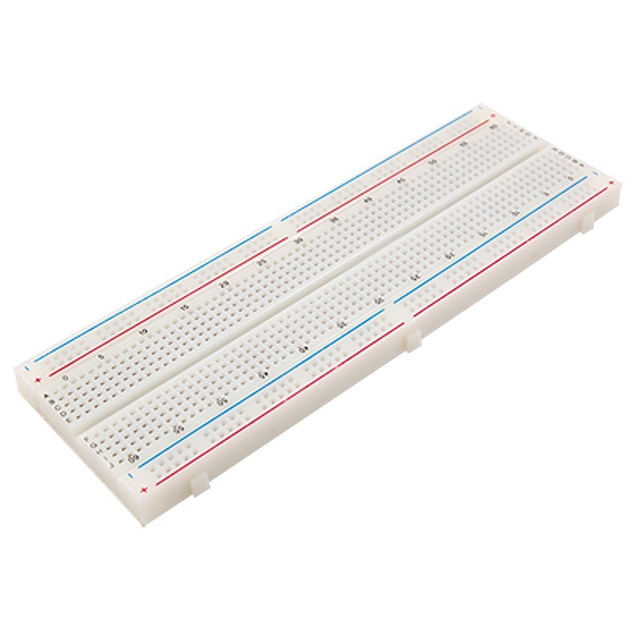

Fig2.1: BREAD BOARD

The holes in a breadboard are connected by metal clips that span five holes, horizontally. These metal clips allow each row of five holes to be connected. There are no vertical connections on a terminal strip. Horizontal rows on either side of the center groove are also not connected to each other.

2.1.2 Raspberry pi 3B+:
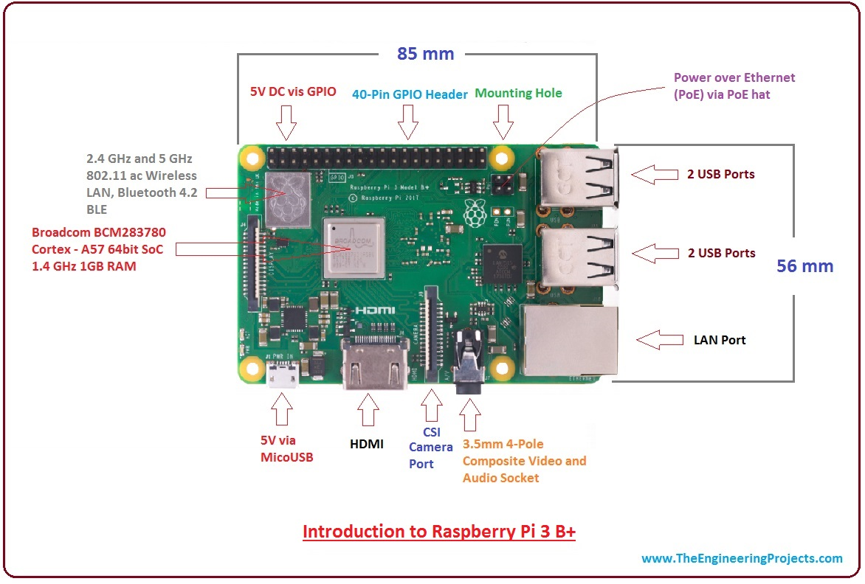
Fig2.2: Raspberry Pi 3B+

The Raspberry Pi 3B+ is a single-board computer developed by the Raspberry Pi Foundation. Here are some key features and information about the Raspberry Pi 3B+:

- Processor: It is powered by a Broadcom BCM2837B0 SoC (System on a Chip) with a 64-bit quad-core ARM Cortex-A53 CPU running at 1.4 GHz.

- Memory: The Raspberry Pi 3B+ typically comes with 1GB of LPDDR2 SDRAM, which is shared with the GPU.

- Wireless Connectivity: It includes built-in wireless connectivity with dual-band 802.11ac Wi-Fi and Bluetooth 4.2, making it suitable for various IoT and networking applications.

- Ethernet: It has a Gigabit Ethernet port for wired network connections.

- USB Ports: The board features four USB 2.0 ports for connecting peripherals such as keyboards, mice, and external drives.

- GPIO Pins: It has a 40-pin GPIO (General Purpose Input/Output) header, which allows for interfacing with various sensors, displays, and other hardware components.

- Video Output: The Raspberry Pi 3B+ supports HDMI output for connecting to displays and includes support for dual displays.

- Audio: It has a 3.5mm audio jack for audio output and also supports HDMI audio.

- MicroSD Card Slot: The operating system and user data are typically stored on a micro SD card.

- Power: It requires a 5V micro USB power supply for operation.

- Operating System: It can run various operating systems, including Raspbian (now known as Raspberry Pi OS), Linux distributions, and even Windows 10 IoT Core.

- Form Factor: The Raspberry Pi 3B+ is in the form of a credit card-sized single-board computer, making it compact and suitable for a wide range of projects.

2.1.3 Arduino Uno:

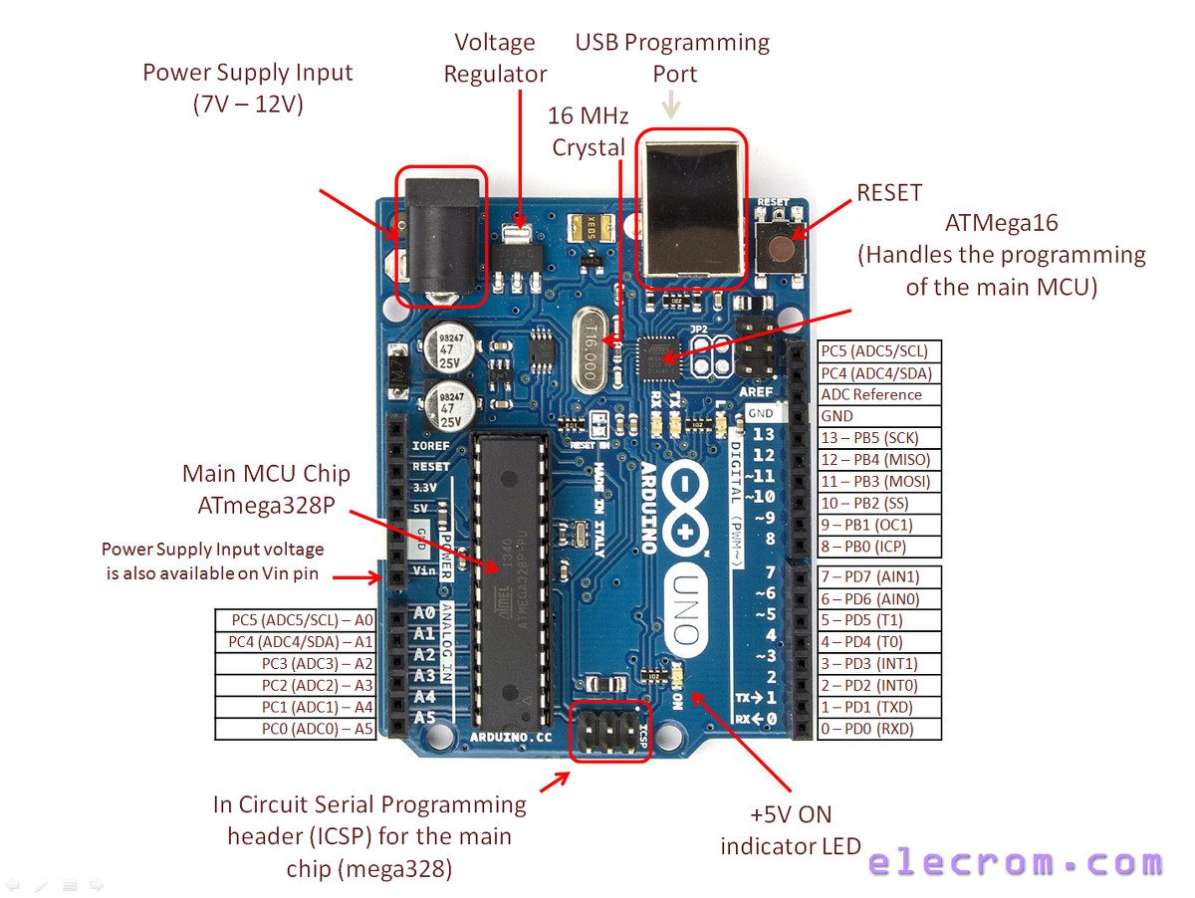
Fig2.3: Arduino Uno
The Arduino Uno is a popular microcontroller board designed for prototyping and educational purposes. It is based on the Atmega328P microcontroller and is part of the Arduino platform, known for its simplicity and ease of use. Here are some key features and information about the Arduino Uno:

- Microcontroller: The Arduino Uno is powered by the Atmega328P microcontroller, which has 32 KB of flash memory for storing the program, 2 KB of SRAM for data storage, and 1 KB of EEPROM for non-volatile data storage.

- Digital I/O Pins: It has a total of 14 digital input/output (I/O) pins, of which 6 can be used as pulse-width modulation (PWM) outputs. These pins can be used for various tasks like reading sensors, controlling LEDs, and interfacing with other digital devices.

- Analog Input Pins: The board has 6 analog input pins, labeled A0 through A5, which can be used to read analog signals from sensors and other analog sources.

- Clock Speed: The Arduino Uno typically operates at a clock speed of 16MHz.

- Voltage Regulator: It includes a built-in voltage regulator that allows it to be powered via USB or an external power supply, with a recommended voltage range of 7-12V.

- USB Interface: It features a USB Type-B connector, making it easy to connect to a computer for programming and serial communication.

- Programming: Arduino Uno can be programmed using the Arduino Integrated Development Environment (IDE), which uses a simplified version of C/C++.

- Open Source: Arduino Uno is an open-source hardware and software platform, which means its design files and source code are freely available for modification and redistribution.

- Community Support: Due to its popularity, the Arduino Uno has a large and active user community, which provides support, tutorials, and a vast library of code examples.

- Shield Compatibility: It is compatible with a wide range of Arduino shields, which are add-on boards that extend its capabilities for specific applications.

- Form Factor: The Arduino Uno has a compact, rectangular form factor that makes it easy to use for prototyping and embedding in various projects.

Arduino Uno is commonly used in projects involving robotics, home automation, data logging, sensor interfacing, and more. Its simplicity and versatility make it an excellent choice for beginners and experienced makers alike. User uses the Lua scripting language.

2.1.4 Current Sensor:
The SCT-000 series current sensors, often referred to as simply SCT-000 sensors, are commonly used for measuring electrical current in various applications. These sensors are often used in conjunction with microcontrollers like Arduino to monitor current flow and gather data for various purposes. Here's some information about the SCT-000 series current sensors:

- Type: The SCT-000 series encompasses a range of current sensors that measure alternating current (AC) or direct current (DC) based on the specific model.

- Measurement Range: The measurement range and sensitivity of SCT-000 sensors can vary depending on the specific model. Some sensors are designed for low current measurements, while others are suitable for higher current ranges.

- Operating Principle: SCT-000 sensors are typically based on the principle of magnetic field induction. They have a split-core design, with a core that can be clamped around a conductor carrying the current to be measured. When current flows through the conductor, it generates a magnetic field that the sensor detects and converts into an output signal proportional to the current.

- Output Signal: SCT-000 sensors typically provide an output signal that can be analog or digital, depending on the model. Analog sensors may produce a voltage or current signal proportional to the measured current, while digital sensors often provide a pulse or digital signal.

- Accuracy: The accuracy of SCT-000 sensors can vary between models, so it's important to select a sensor with the level of accuracy required for your specific application.

Applications: These sensors are used in a wide range of applications, including energy monitoring, power quality analysis, current control in motor drives, and current sensing in electronic circuits.
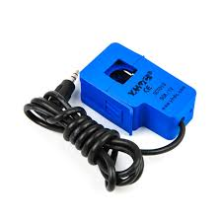
Fig2.4: Current Sensor

- Interface: SCT-000 sensors are typically easy to interface with microcontrollers like Arduino. They can be connected to analog input pins for reading analog output signals or digital input pins for reading digital signals.

- Calibration: Some SCT-000 sensors may require calibration to ensure accurate current measurements. Calibration procedures, if needed, are often provided in the sensor's datasheet.

- Safety: When working with SCT-000 sensors and electrical currents, it's important to follow safety precautions and ensure that the sensor is properly installed and connected.

- Datasheets: For detailed technical specifications and wiring diagrams, you should refer to the datasheet provided by the manufacturer for the specific SCT-000 sensor model you are using.

Please note that the exact specifications and capabilities of SCT-000 sensors can vary based on the manufacturer and model. When using these sensors in a project, it's essential to consult the datasheet for your specific sensor to ensure correct usage and interpretation of the output signal.

2.1.5 JUMPER WIRES:
Jumper wires are simply wires that have connector pins at each end, allowing them to be used to connect two points to each other without soldering. Jumper wires are typically used with breadboards and other prototyping tools in order to make it easy to change a circuit as needed. Fairly simple. In fact, it doesn’t get much more basic than jumper wires.
Though jumper wires come in a variety of colors, the colors don’t actually mean anything. This means that a red jumper wire is technically the same as a black one. But the colors can be used to your advantage in order to differentiate between types of connections, such as ground or power.
Jumper wires typically come in three versions:

- Male-to-male
- Male-to-female
- Female-to-female.
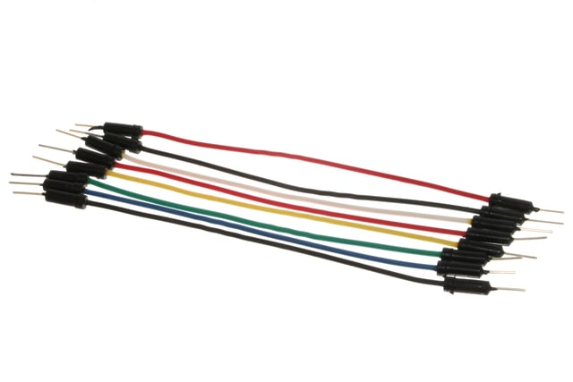

Fig2.5: Jumper Wires

The difference between each is in the end point of the wire. Male ends have a pin protruding and can plug into things, while female ends do not and are used to plug things into. Male-to-male jumper wires are the most common and what you likely will use most often. When connecting two ports on a breadboard, a male-to-male wire is what you’ll need.

2.1.6 USB CABLE:
A USB port is a standard cable connection interface for personal computers and consumer electronics devices. USB stands for Universal Serial Bus, an industry standard for short-distance digital data communications. USB ports allow USB devices to be connected to each other with and transfer digital data over USB cables. They can also supply electric power across the cable to devices that need it.
Both wired and wireless versions of the USB standard exist, although only the wired version involves USB ports and cables.
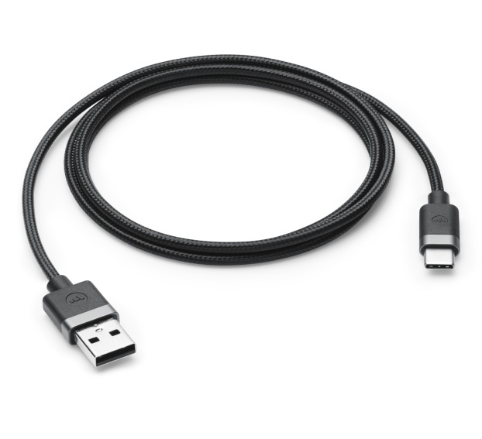
Many types of consumer electronics support USB interfaces. These types of equipment are most commonly used for computer networking:
- USB network adapters.
- USB broadband and cellular modums for Internet access.
- USB printers to be shared on a home network.
Fig2.6: USB Cable
For computer-to-computer file transfers without a network, USB drives are also sometimes used to copy files between devices.
Several major types of physical layouts exist for USB ports:
- USB-A (Type A): The rectangular USB Type-A connector approximately 1.4 cm (9/16 in) length by 0.65 cm (1/4 in) height is typically used for wired mice and keyboards. USB sticks normally feature USB-A connectors also.
- USB-B (Type B): Less common than type A, USB B devices are nearly square in shape and are commonly found on routers, computers, printers, and game consoles.
- Micro USB: So-called Micro USB versions of both USB-A and USB-B also exist - smaller versions than their base counterparts, popular on mobile devices. Older but now obsolete "mini USB" versions can also be found on many old devices.
- USB Type C: With dimensions of 0.84 cm by 0.26cm, this newer standard is designed to replace both A and B with smaller ports to better support the thinner form factors of mobile devices.
Versions of USB: USB devices and cables support multiple versions of the USB standard from version 1.1 up to the current version 3.1. USB ports feature identical physical layouts no matter the version of USB supported.
Alternatives to USB Ports: USB ports are an alternative to the serial and parallel ports available on older PCs. USB ports support much faster (often 100x or greater) data transfers than serial or parallel.
For computer networking, Ethernet ports are sometimes used instead of USB. For some types of computer peripherals, FireWire ports are also sometimes available. Both Ethernet and FireWire can offer faster performance than USB, although these interfaces do not supply any power across the wire.
2.2 SOFTWARE REQUIREMENTS:
The software used is
- Arduino ide
- ThingSpeak

2.2.1 ARDUINO IDE:
The Arduino IDE is an open-source software, which is used to write and upload code to the Arduino boards. The IDE application is suitable for different operating systems such as Windows, MacOS X, and Linux. It supports the programming languages C and C++. Here, IDE stands for Integrated Development
Environment. We need to connect the Genuino and Arduino board with the IDE to upload the sketch written in the Arduino IDE software.

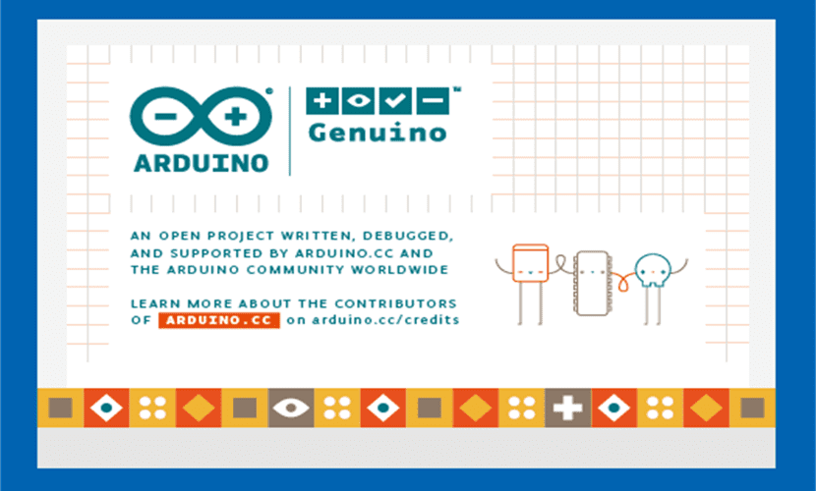

Fig2.7: Arduino IDE

The latest versions of the Arduino IDE have not only made this program more compatible with the new models of the Project, but have also improved the IDE functions, allowing even to have a cloud interface that allows us to create a program for Arduino anywhere in the world (at least where there is an internet connection). And not only is the Arduino IDE free in the geographical space, but it is also free within the computing space since the Arduino IDE supports connection with all kinds of programs, including code editors that will facilitate the work with the Arduino hardware. However, Arduino IDE is also Free Software.
Programs written using Arduino Software (IDE) are called sketches. These sketches are written in the text editor and are saved with the file extension .ino. The editor has features for cutting/pasting and for searching/replacing text. The message area gives feedback while saving and exporting and also displays errors. The console displays text output by the Arduino Software (IDE), including complete error messages and other information. The bottom righthand corner of the window displays the configured board and serial port. The toolbar buttons allow you to verify and upload programs, create, open, and save sketches, and open the serial monitor.

2.2.2 LIBRARIES:
Libraries provide extra functionality for use in sketches, e.g. working with hardware or manipulating data. To use a library in a sketch, select it from the Sketch > Import Library menu. This will insert one or more #include statements at the top of the sketch and compile the library with your sketch. Because libraries are uploaded to the board with your sketch, they increase the amount of space it takes up. If a sketch no longer needs a library, simply delete its #include statements from the top of your code.
The libraries installed for the project are:
- Arduino Uno WiFi Dev Ed Library
- ThingSpeak

- Arduino Uno WiFi Dev Ed Library:
This library allows users to use network features like rest and mqtt. Includes some tools for the ESP8266.
Use this library only with Arduino Uno WiFi Developer Edition.
Reference > Libraries > Arduino uno wifi dev ed library

- ThingSpeak:
ThingSpeak Communication Library for Arduino, ESP8266 & EPS32. ThingSpeak (https://www.thingspeak.com ) is an analytic IoT platform service that allows you to aggregate, visualize and analyze live data streams in the cloud.
Reference > Libraries > Thingspeak
Author: MathWorks Maintainer: MathWorks
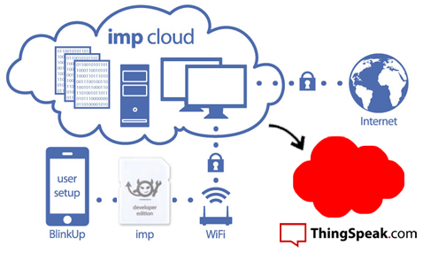

Fig2.8: ThingSpeak

ThingSpeak is an IoT analytics platform service that allows you to aggregate, visualize and analyze live data streams in the cloud. ThingSpeak provides instant visualizations of data posted by your devices to ThingSpeak. With the ability to execute MATLAB code in ThingSpeak you can perform online analysis and processing of the data as it comes in. ThingSpeak is often used for prototyping and proof of concept IoT systems that require analytics. You can send data to ThingSpeak from your devices, create instant visualization of live data, and send alerts.

- ThingSpeak Key Features:
ThingSpeak allows you to aggregate, visualize and analyze live data streams in the cloud. Some of the key capabilities of ThingSpeak include the ability to:
- Easily configure devices to send data to ThingSpeak using popular IoT protocols.
- Visualize your sensor data in real-time.
- Aggregate data on-demand from third-party sources.
- Use the power of MATLAB to make sense of your IoT data.
- Run your IoT analytics automatically based on schedules or events.
- Prototype and build IoT systems without setting up servers or developing web software.
- Automatically act on your data and communicate using third-party services like Twilio® or Twitter®.

CHAPTER-3
WORKING AND IMPLEMENTATION

- Working
- Circuit Diagram
- Software Interfacing
- Implementation

3.1 WORKING:
The working procedure of a Smart Energy Monitoring System involves the collection, processing, transmission, and visualization of energy-related data. Below is a step-by-step explanation of how such a system typically operates:

1. Sensor Data Acquisition: Current and, optionally, voltage sensors are installed in the electrical circuit. Current sensors, like the SCT sensors mentioned earlier, measure the current flowing through the circuit. Voltage sensors measure the voltage level.

2. Sensor Readings: The sensors continuously monitor the electrical parameters (current and voltage) and provide analog or digital readings.

3. Data Conversion: If the sensor outputs analog signals, an analog-to-digital converter (ADC) may be used to convert these signals into digital values that can be processed by the microcontroller.

4. Microcontroller Processing: A microcontroller (e.g., Arduino or Raspberry Pi) processes the sensor data. The microcontroller calculates parameters such as power (P = VI), where V is voltage and I is current. It may also apply calibration factors to ensure accurate readings.

5. Data Storage (Optional): The microcontroller can store data locally in a database (e.g., SD card or EEPROM) for historical analysis or backup.

6. Data Transmission (Optional):
- The system can transmit data to a remote platform for real-time monitoring and analysis.
- For remote transmission, the microcontroller may use HTTP, MQTT, or other communication protocols.

7. Cloud Platform (Optional):
- If using a cloud-based platform like Thing Speak, data is sent to a server in the cloud.
- The platform stores data and provides tools for visualization and analysis.

8. Data Visualization: Users can access data via a user interface (e.g., web or mobile app) or a local display (e.g., LCD screen). The interface displays real-time and historical energy consumption data. Users can view charts, graphs, and tables to monitor usage.

9. Alerts and Notifications (Optional): The system may generate alerts or notifications based on predefined conditions (e.g., exceeding a power threshold or unusual energy consumption patterns).

10. User Interaction (Optional): Users can interact with the system to control devices remotely (e.g., turning lights on/off) or make adjustments to optimize energy usage.

11. Data Analysis (Optional):
- If implemented, data analysis algorithms detect patterns, anomalies, and trends in energy consumption.
- Analysis results can be displayed in the user interface or used to trigger alerts.

12. Security and Privacy:
- Security measures ensure data privacy and protect the system from unauthorized access.
- Encryption and user authentication mechanisms may be employed.

13. Regular Monitoring:
- The system continuously monitors and records energy consumption data.
- Users can access real-time data to make informed decisions about energy usage.

14. Maintenance and Updates:
- The system requires regular maintenance, including hardware checks and software updates.
- Updates may include bug fixes, security enhancements, or new features.

15. Reporting (Optional):
- The system may generate reports summarizing energy consumption data over specific periods.
- Reports can be useful for billing or compliance purposes.

16. Scalability (Optional):
- The system can be scaled to monitor multiple circuits or locations if needed.
- Additional sensors and microcontrollers can be added to expand monitoring capabilities.

17. Data Backup (Optional):
- To ensure data integrity, periodic backups of historical data may be performed, either locally or in the cloud.

The Smart Energy Monitoring System operates by continuously collecting, processing, and presenting energy data to users for effective energy management, cost reduction, and sustainability efforts. The level of complexity and features can vary depending on project requirements and goals.

3.2 CIRCUIT DIAGRAM:

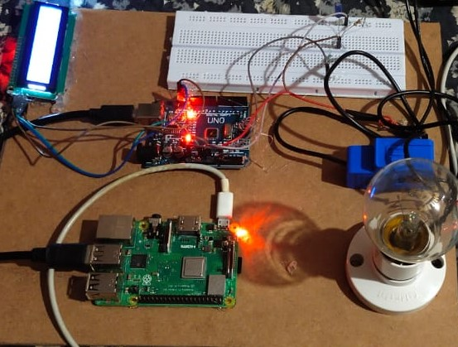
Fig3.1: Circuit

Creating a complete circuit diagram for a Smart Energy Monitoring System involves multiple components, including the Arduino, current sensor, voltage supply, display (if used), and any additional components or devices you might integrate. Below, I'll provide a simplified circuit diagram to help you understand the basic connections between these components:

3.2.1 Components in the Circuit:
- Arduino (e.g., Arduino Uno): The microcontroller used for data processing and communication.

- Current Sensor (e.g., SCT-000 or similar): Measures the electrical current and outputs an analog or digital signal.

- Voltage Supply (e.g., 230V AC): Represents the electrical supply voltage (in this case, 230V AC). Note that dealing with high-voltage components requires safety precautions.

- 16x2 LCD Display (if used): Displays real-time current and power values. The wiring may vary based on the specific display and connections.

3.2.2 Connections:
Here's a simplified circuit diagram showing the connections:

Current Sensor Arduino LCD Display
| | | |
|-------| | |
| | | |
| | | |
|-------|-------------| |
| | | |
| | | |
|-------|-------------| |
| | | |
| | | |
|-------|-------------|---------------|
230V AC (Voltage Supply)
Fig-3.2: Flow of Connections

Please note that this is a simplified representation, and the actual connections might involve additional components like resistors, capacitors, and voltage dividers, depending on your specific hardware and sensor requirements.

Important safety precautions should be taken when dealing with high-voltage components like the voltage supply. Ensure that you follow proper electrical safety guidelines and consider using isolation components to protect the Arduino from high-voltage circuits.

For a complete and detailed circuit diagram tailored to your specific components and requirements, I recommend using circuit design software or consulting a professional electrical engineer to ensure safety and accuracy in your project.

3.3 SOFTWARE INTERFACING:
Software interfacing in the context of a Smart Energy Monitoring System typically involves connecting and communicating between various software components, such as microcontroller code (Arduino), data storage and visualization platforms (e.g., Thing Speak or a custom web application), and user interfaces (e.g., web or mobile apps). Here's a general outline of how these software components can be interfaced together:

- Microcontroller Code (Arduino):
- The Arduino code collects data from sensors (e.g., current sensors) and processes it.
- Data can be preprocessed, formatted, and sent to external platforms or user interfaces for further analysis and display.

- Serial Communication (Optional):
- The Arduino code can use serial communication to send data to a connected computer for debugging or real-time monitoring.
- Data can be sent as plain text or in a structured format (e.g., JSON).

- Data Transmission to Remote Platform (e.g., Thing Speak):
- If you are using a cloud-based platform like Thing Speak for data storage and visualization, you can use HTTP requests to send data to the platform.
- Configure the Arduino code to make HTTP POST or GET requests to the platform's API endpoint with the collected data.
- Provide the necessary API key and channel ID to authenticate and specify where the data should be stored.

- Custom Web Application (Optional):
- If you want to create a custom web-based interface for data visualization, you can build a web application using web development technologies such as HTML, CSS, JavaScript, and a back-end framework like Node.js or Python.
- The web application can include real-time charts, graphs, and tables to display energy consumption data fetched from the Arduino or retrieved from a database.

- Database (Optional):
- You may need a database to store historical energy consumption data for analysis and reporting.
- Popular databases like MySQL, PostgreSQL, or NoSQL databases can be used to store and retrieve data efficiently.

- APIs and Data Formats:
- Define a standard data format or API (Application Programming Interface) for communication between the Arduino and external systems.
- Common data formats include JSON or XML for structured data exchange.

- Data Visualization and User Interfaces:
- Whether you are using Thing Speak, a custom web app, or other visualization tools, design user-friendly interfaces to present energy consumption data to end-users.
- Implement interactive charts, tables, and notifications as needed.

- Data Analysis and Alerts (Optional):
- Implement data analysis algorithms to detect anomalies or trends in energy consumption.
- Set up alerts or notifications for users when specific conditions or thresholds are met.

- Security and Authentication:
- Implement security measures to protect data during transmission and storage.
- Use authentication mechanisms to ensure authorized access to data and control interfaces.

- Testing and Integration:
- Thoroughly test the entire system, including the Arduino code, data transmission, and visualization components.
- Ensure that data flows smoothly between different software components.

- Documentation and Maintenance:
- Document your software architecture, data formats, and communication protocols for future reference and maintenance.
- Regularly update and maintain your software to address any issues or improvements.

Software interfacing is a critical aspect of a Smart Energy Monitoring System, as it enables data collection, analysis, and presentation for effective energy management. It also allows users to make informed decisions about energy consumption and optimize energy usage.

3.4 IMPLEMENTATION:
The implementation of a Smart Energy Monitoring System involves a combination of hardware and software components to measure, analyze, and visualize energy consumption.
- Define System Requirements:
- Clearly define the objectives and requirements of your Smart Energy
- Monitoring System, Determine what specific data you want to collect and monitor, such as current, power, voltage, and energy usage.

- Select Hardware Components:
- Choose the necessary hardware components for your system,
including current sensors, voltage sensors, an Arduino or Raspberry Pi, display (e.g., LCD screen), and any additional sensors or actuators.

- Circuit Design and Wiring:
- Design the electrical circuit that connects the sensors,
microcontroller, and other components. Ensure proper wiring, isolation, and safety measures for handling high-voltage components.

- Write Microcontroller Code:
- Develop code for the microcontroller (Arduino or Raspberry Pi) to interface with sensors, read data, and perform calculations.
- Implement communication protocols (e.g., serial communication) for data transmission to external systems.

- Data Acquisition and Processing:
- Collect data from current and voltage sensors to calculate real-time power consumption.
- Process and format the data for further analysis and visualization.

- Data Visualization:
- Create a user-friendly interface for data visualization. Options include LCD screens, custom web applications, or mobile apps.
- Display real-time data such as current, power, and energy consumption using charts, graphs, or numerical values.

- Data Storage (Optional):
- Implement data storage mechanisms, such as databases, to store historical energy consumption data for analysis and reporting.

- Remote Monitoring (Optional):
- If desired, enable remote monitoring by sending data to a cloud-based platform or a remote server.
- Implement APIs for data transmission to platforms like ThingSpeak, IoT platforms, or custom web services.

- Data Analysis and Alerts (Optional):
- Implement algorithms for data analysis to detect anomalies, trends, and energy-saving opportunities.
- Set up alerts or notifications for users when specific conditions or thresholds are met.

- Security and Authentication:
- Implement security measures to protect data during transmission and storage.
- Use authentication mechanisms to ensure authorized access to data and control interfaces.

- Testing and Calibration:
- Thoroughly test the entire system to ensure data accuracy and reliability.
- Calibrate sensors if necessary to obtain accurate measurements.

- Documentation:
- Document your system's architecture, wiring diagrams, code, and data formats for future reference and maintenance.

- User Training (if applicable):
- If the system is intended for use by others, provide training and user manuals to ensure proper operation.

- Maintenance and Updates:
- Regularly maintain and update the system to address issues, improve performance, and add new features.

- Compliance and Safety:
- Ensure that the system complies with safety regulations and standards, especially when dealing with high-voltage components.

- Data Privacy and Compliance (if applicable):
- If the system collects and stores user data, ensure compliance with data privacy regulations such as GDPR or HIPAA.

Remember that the implementation process can vary depending on the complexity of your Smart Energy Monitoring System and your specific goals. It's important to thoroughly plan and document your project to ensure its success and long-term reliability.

The advantages of this project are:
- Real-time monitoring
- Cost savings
- Reduced environmental impact
- Energy Conservation
- Enhanced efficiency
- Informed Decision-making
- Remote Control
- User Empowerment
- Data Security
- Compliance Support
- Scalability
- Education and Awareness
- Research Opportunities

CHAPTER-4
RESULT AND ANALYSIS
4.1 RESULT:
The Smart Energy Monitoring System using Raspberry Pi project has yielded highly favorable results, contributing significantly to the efficient management of energy consumption in residential and commercial settings. Through real-time monitoring, the system empowers users with continuous insights into their electricity usage patterns, allowing them to make informed decisions about energy management. Notably, the project has led to substantial cost savings for users by identifying energy inefficiencies and providing actionable recommendations for reducing electricity bills. Moreover, it has made a positive impact on environmental sustainability by promoting energy conservation and efficiency, resulting in a reduced carbon footprint.
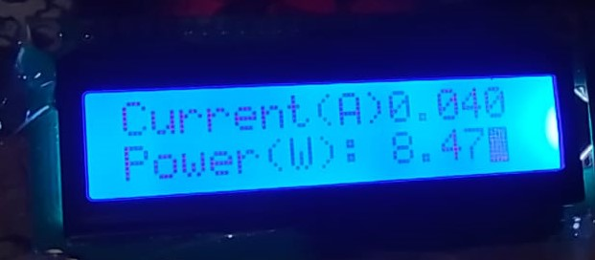
Fig4.1: Result
The system's ability to enhance energy efficiency, encourage responsible energy use, and provide robust security measures has been well-received. With scalability, education, and research opportunities, the project's future holds great promise in advancing energy management practices and technologies. In summary, the Smart Energy Monitoring System using Raspberry Pi has proven to be an invaluable tool for individuals and organizations seeking to optimize energy consumption, reduce costs, and contribute to a more sustainable energy future.

4.2 PERFORMANCE ANALYSIS:
We can analyze the working of the project in the ThingSpeak platform in the form of a charts related to each field that we had used for the project. The chart obtained for each field gives the complete analysis about the status of the device in that field at an instance of time.

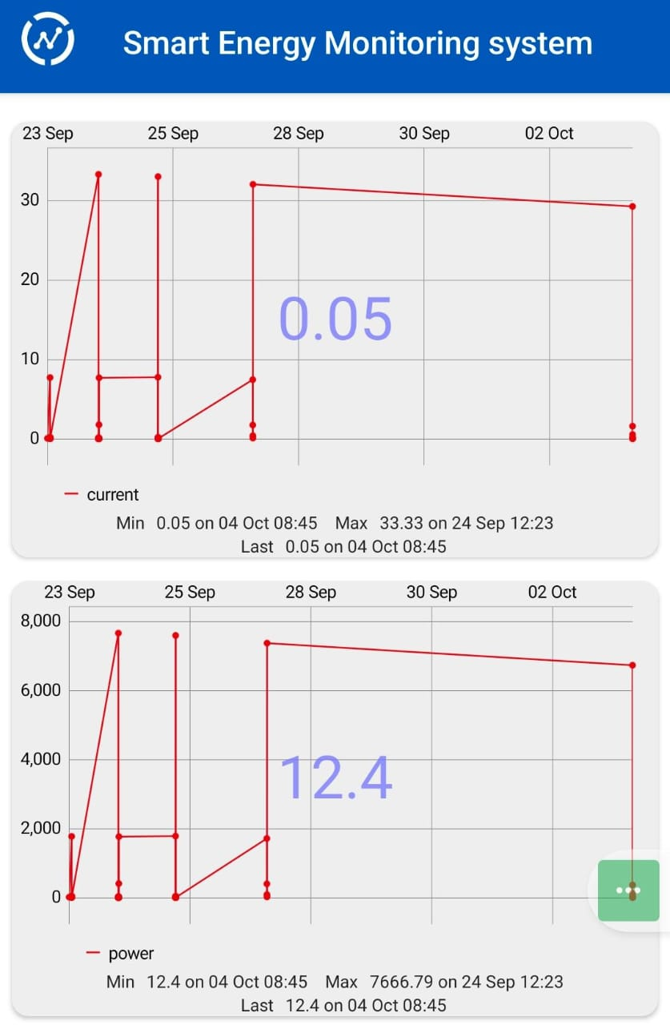
Fig4.2: Current & Power Consumption Analysis

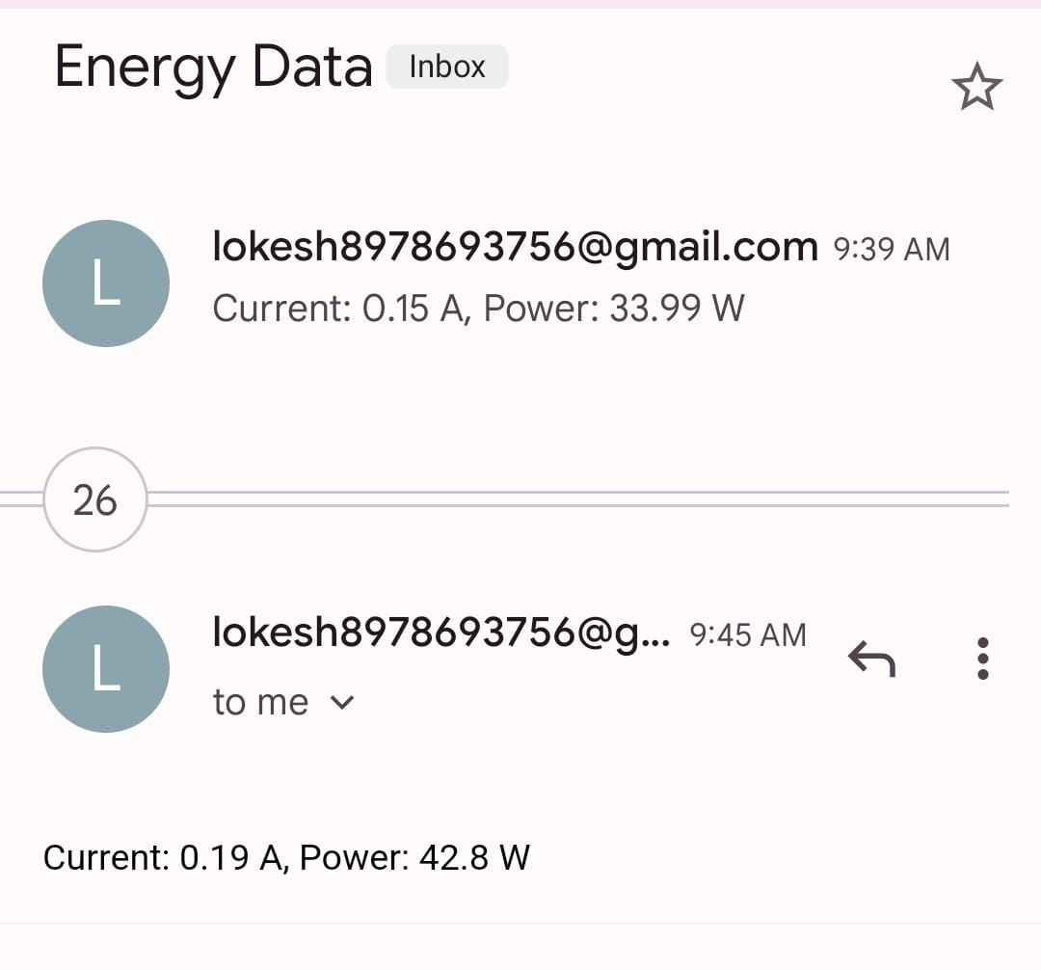
Fig4.3: Mail Alert

CHAPTER-5
CONCLUSION AND FUTURE SCOPE

5.1 CONCLUSION:
The Smart Energy Monitoring System using Raspberry Pi represents a pivotal step towards efficient and responsible energy management. By harnessing the power of real-time data collection, analysis, and user-friendly interfaces, this system empowers individuals and organizations to make informed decisions about their energy consumption.
With cost savings, reduced environmental impact, enhanced energy efficiency, and the convenience of remote control, the benefits are tangible. Moreover, the system fosters user awareness, protecting sensitive data, and accommodating various needs through scalability.
As we navigate an era of increasing energy demands and environmental concerns, this solution stands as a beacon of progress. It not only improves energy conservation but also fuels research and innovation in energy management and IoT technologies. In conclusion, the Smart Energy Monitoring System using Raspberry Pi offers a practical path towards a more sustainable and efficient energy future.

5.2 FUTURE SCOPE:
The future scope for the Smart Energy Monitoring System using Raspberry Pi is promising and encompasses several exciting possibilities:
- Enhanced Machine Learning: Continued integration of advanced machine learning algorithms to further improve anomaly detection, predictive analytics, and energy optimization.
- Blockchain Integration: Exploring blockchain technology for secure and transparent energy transactions, enabling peer-to-peer energy trading, and enhancing data integrity.
- Edge Computing: Leveraging edge computing for faster data processing, enabling real-time decision-making, and reducing latency.
- Smart Grid Integration: Deeper integration with smart grids for enhanced grid management, demand response, and dynamic pricing.
- Renewable Energy Integration: Expanding support for diverse renewable energy sources and integrating energy storage solutions for better energy management.
- Energy-Positive Buildings: Advancements in sustainable architecture and construction for energy-positive buildings, requiring sophisticated monitoring and control systems.
- Smart Cities: Extending the system's capabilities to encompass smart city-level energy monitoring and management, contributing to sustainable urban development.
- AI Advancements: Incorporating artificial intelligence (AI) for self-optimizing systems and adaptive learning, making energy management more intelligent.
- Global Adoption: Wider adoption in both developed and emerging markets as energy conservation and sustainability become global imperatives.
- User Experience Improvements: Enhanced user interfaces, including augmented reality (AR) and virtual reality (VR) for immersive energy monitoring experiences.
- Energy Market Integration: Integration with energy markets to enable users to buy and sell energy based on real-time supply and demand, promoting efficient energy use.
- Energy Policy Compliance: Ensuring compliance with evolving energy efficiency and sustainability regulations and standards.
- Energy-Efficient Appliances: Collaboration with appliance manufacturers to create more energy-efficient devices that can seamlessly communicate with the monitoring system.

REFERENCES :

[1] "Design and Implementation of a Smart Home Energy Monitoring and Control System" International Journal of Computer Applications by C. O. Uchendu, M. O. Iwu, 2016.
[2] "Smart Home Energy Management System Using IoT and Raspberry Pi"
International Research Journal of Engineering and Technology (IRJET) by Authors: S.S. Khodke, M. S. Shirodkar, 2017

[3] “An Internet of Things based energy efficiency monitoring and management” system for machining workshop by J. Clean. Prod., 2018.
[4] "Smart Energy Monitoring System for Efficient Power Management Using Raspberry Pi" International Journal of Innovative Research in Computer and Communication Engineering (IJIRCCE) by V. Kanchana, R. Usha,2016.
[5] "A Raspberry Pi-Based Smart Home System for Efficient Energy Management" 2016 IEEE 6th International Conference on Advanced Computing (IACC) by S. Maity, S. Chakraborty, P. Chakraborty, 2016.
[6] "Energy Management System Using IoT and Raspberry Pi" 2017 International Conference on Intelligent Computing, Instrumentation and Control Technologies (ICICICT) by S. Akshaya, P. Santhiyagu, and N. Prasad, 2017.
[7] "A Raspberry Pi-Based Power Monitoring System for Smart Homes" International Journal of Engineering and Technology by Amarnath Reddy, Anil Babu K., Bharath N., and Naga Venkata S. Lakshman, 2019.
[8] "Design and Implementation of Raspberry Pi-based Low-cost Energy Meter for Real-time Energy Monitoring" International Journal of Engineering Research and Applications (IJERA) by Abhinav M. Thakare, Nishad S. Khan, and Jitendra A. Mohite, 2015.
[9] "IoT-Based Smart Energy Management System for Sustainable Smart Home" Electronics by Reham Abobasha, Esraa Alshemali, and Amr Mohamed, 2020.
[10] "A Low-Cost Power Monitoring System for the Smart Grid and Home Automation" International Journal of Engineering and Advanced Technology (IJEAT) by K. R. Kumar, M. Surendra, P. Sandeep, and P. S. H. Teja, 2019.

