Open sln file

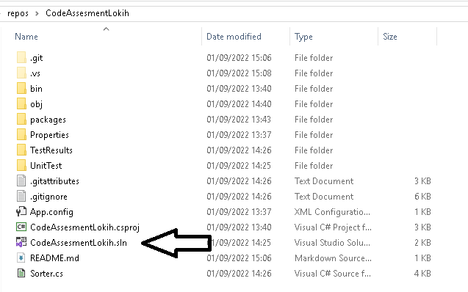

There will be 2 projects inside the solution

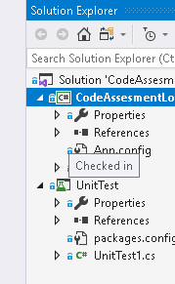

Click Start to run the application

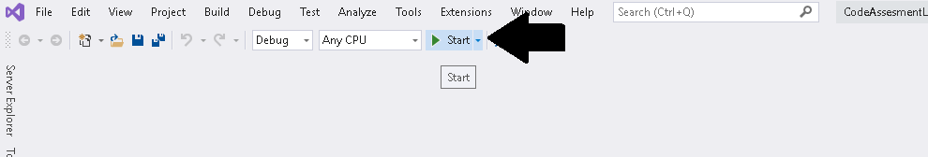

The application only know **name-sorter** as the valid command, after that the name of the file separated with space, where the file itself located in the same level with the EXE application

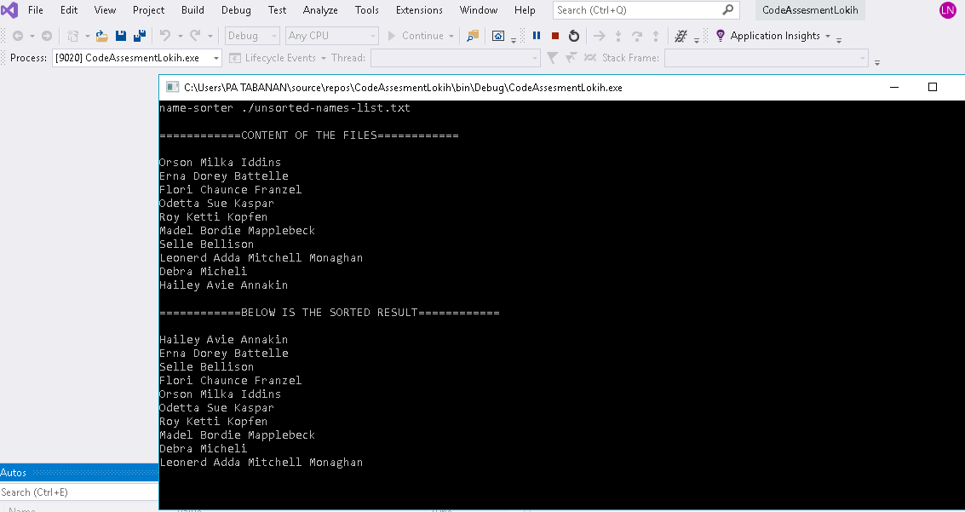

The program will generate / overwrite the txt file in **Debug** folder

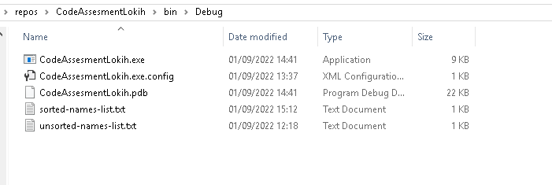

Right click here to run the Unit Test

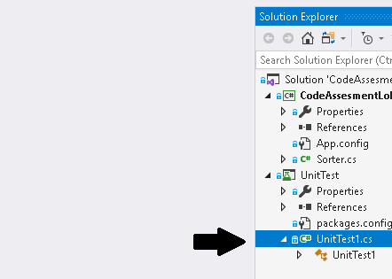

Click **Run Test**

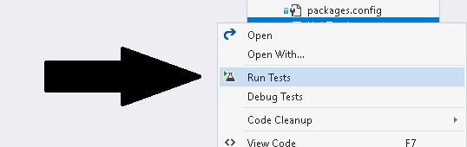

The Unit Test will run

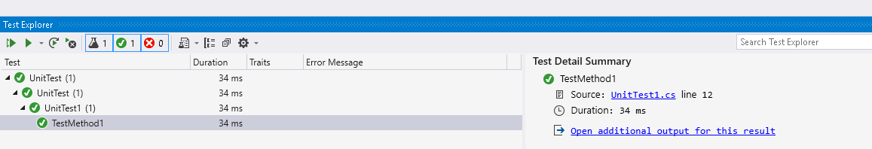

Click this area to show more details of the output

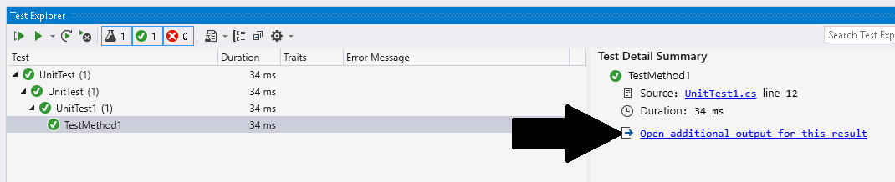

The Output is as follow :

