LAB 8 Report

130050032- Amit Malav
130050047- Lokit Kumar Paras

1)
Experiment time: 120
Concurrent users: 20
Queue Size: 0 (Unbounded Queue)

Worker threads | Responce time | Throughput
1 | 66748.66 | 299.00
2 | 48090.89 | 412.00
3 | 43648.20 | 407.00
4 | 44076.82 | 390.00
5 | 43456.24 | 395.00
6 | 44088.43 | 382.00
7 | 41510.05 | 381.00
8 | 40063.85 | 370.00
9 | 37249.79 | 370.00
10 | 36638.59 | 360.00

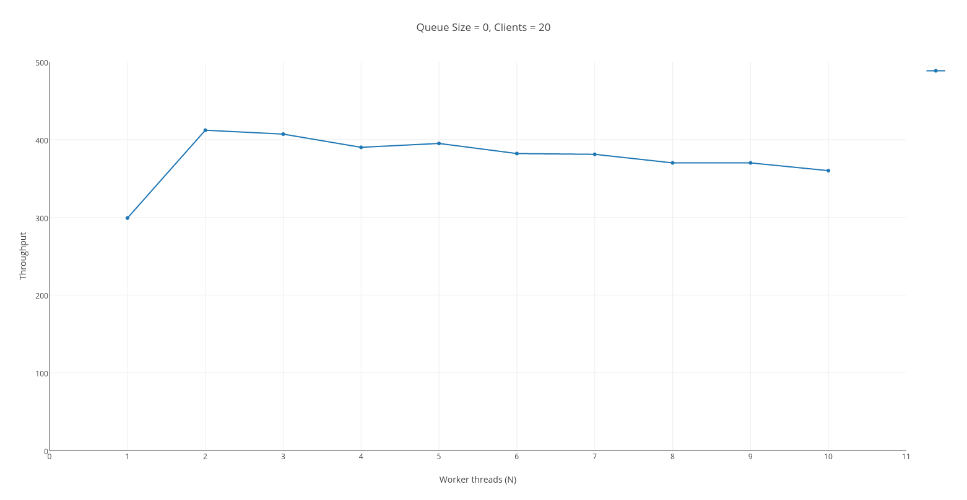
Value of N for saturation = 2

2)
Experiment time: 120
Concurrent users: 1000
Queue Size: 1 (Unbounded Queue)

Worker threads | Responce time | Throughput
1 | 212611.62 | 102.00
2 | 290003.17 | 331.00
3 | 272148.62 | 277.00
4 | 256864.02 | 274.00
5 | 277941.19 | 345.00
6 | 268088.41 | 285.00
7 | 288327.38 | 339.00
8 | 324907.44 | 291.00
9 | 253404.08 | 300.00
10 | 278254.29 | 308.00

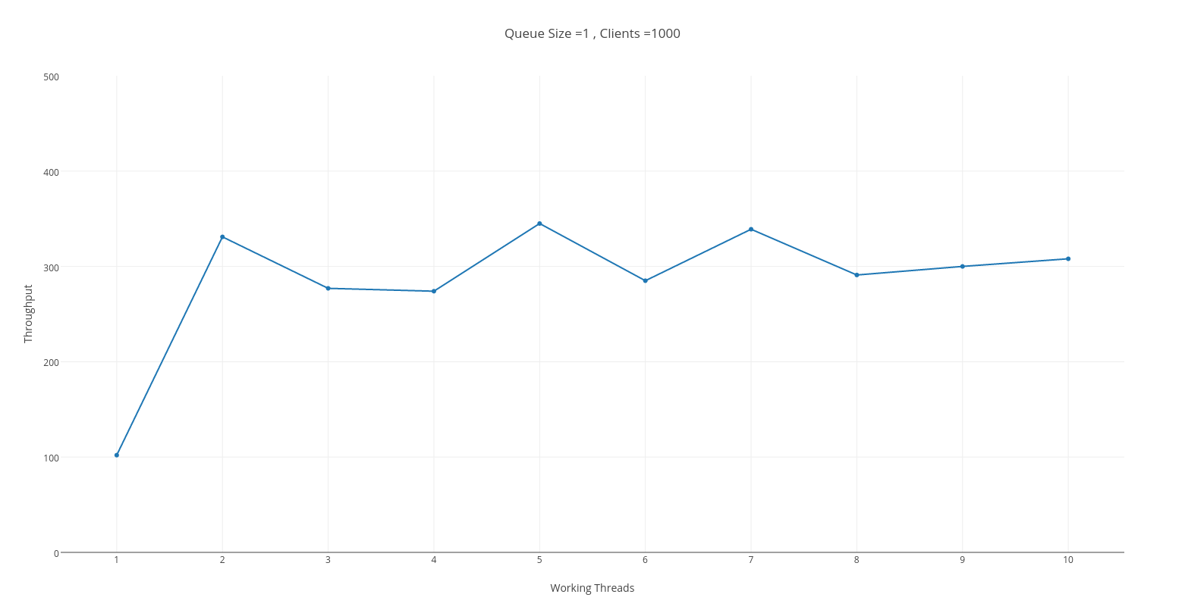

Value of N for saturation = 2

No , in this case we do not see all the requests being served successfully. The TCP socket sends RST packets i.e. connection is reset by the server leading to failure in reading from the socket by client thread. This can be explained, due to huge traffic on server which causes server to close the socket leading to reset , and any further requests to that socket are denied giving connection reset error.

