Report

Amit Malav - 130050032

Lokit Kumar Paras - 130050047

**Question 1**

Setup – Two laptops connected using Ethernet cable

    (i)

Maximum disk read bandwidth in server -   43.160 MBps

File Size - 2MB

Approximate no of requests per sec that can be served - 21.58 req /sec

Commands used – Ran the *‘disk.c’* program from Lab1 and measured the bandwidth using *iostat –x 1*

    (ii)

Maximum network bandwidth between the devices – 11.8 MBps

File Size – 2MB

Approximate no of requests per sec that can be served– 5.9 req/sec

Justification- We are using 100Mbps Ethernet link that offers nearly 94.4 Mbps maximum network

bandwidth

Commands used – *iperf –s on server*

*iperf –c < I.P. of server >  -i 2*

**Question 2**

**Parameters**-

* Read mode - “random”
* sleep time - 0
* Experiment duration - 120 sec

**Observations**-

|  |  |  |  |  |  |  |  |  |  |
| --- | --- | --- | --- | --- | --- | --- | --- | --- | --- |
| N | 1 | 2 | 5 | 10 | 15 | 20 | 25 | 30 | 35 |
| Throughput(req/s) | 5.21 | 5.69 | 5.74 | 5.76 | 5.75 | 5.83 | 5.82 | 5.87 | 5.85 |
| Response time(s) | 0.18 | 0.35 | 0.87 | 1.74 | 2.61 | 3.47 | 4.32 | 5.17 | 6.05 |

**Graphs**-

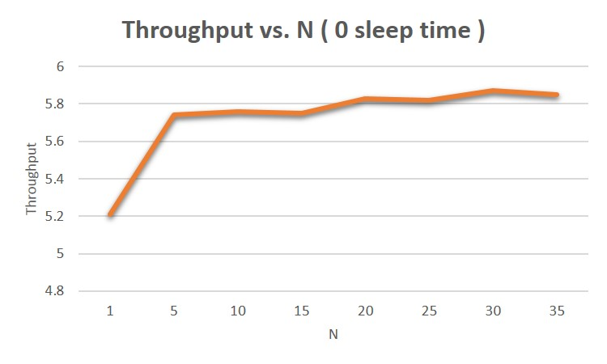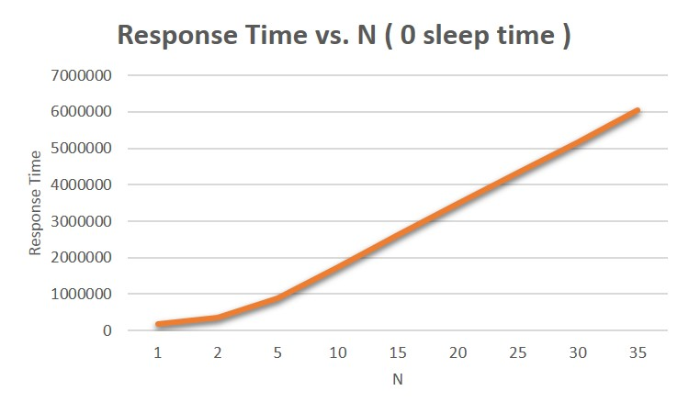

1. Optimal value of N at saturation – 5
2. For the values lower than N the throughput rapidly increases and response time also increases almost linearly. For the values higher than N, throughput is almost constant or increases at very low rate and response time linearly increases.
3. Network is the bottleneck resource at the saturation. We used *nload* tool to measure network usages. For the optimal value of N, average network usage were constant and almost equal to the maximum network bandwidth. Whereas the Disk reading was still much below its maximum bandwidth.
4. Server throughput at saturation- 5.74

Justification - As the network becomes the bottleneck, for the optimal value of N (= 5)

throughput is approximately equal to the maximum network bandwidth. Also as we saw earlier at maximum network bandwidth the no. of requests that can be served per sec was 5.9, which is almost achieved at N=5.

**Question 3**

**Parameters**-

* Read mode - “random”
* sleep time - 1
* Experiment duration - 120 sec

**Observations**-

|  |  |  |  |  |  |  |  |
| --- | --- | --- | --- | --- | --- | --- | --- |
| N | 1 | 5 | 10 | 15 | 20 | 25 | 30 |
| Throughput(req/s) | 0.84 | 3.78 | 5.64 | 5.77 | 5.78 | 5.80 | 5.81 |
| Response time(s) | 0.19 | 0.33 | 0.78 | 1.62 | 2.49 | 3.35 | 4.23 |

**Graphs**-

|  |  |
| --- | --- |
| 3.jpg | 4.jpg |

1. Optimal value of N at saturation – 15.

We see that number of clients required to reach saturation of

throughput has increased. This can be explained by the fact that, now the client threads sleep in between requests, so this allows the server to relax and hence it can serve more requests now in that sleep time.

1. For the values lower than N the throughput rapidly increases and response time also increases

almost linearly. For the values higher than N, throughput is almost constant or increases at very

low rate and response time linearly increases.

(c)

    Network is the bottleneck resource at the saturation. We used *nload* tool to measure network

usages. For the optimal value of N, average network usage were constant and almost equal to the

maximum network bandwidth.

(d)

    Server throughput at saturation- 5.77

Justification - As the network becomes the bottleneck, for the optimal value of N (= 15)

throughput is approximately equal to the maximum network bandwidth. Also as we saw earlier at maximum network bandwidth the no. of requests that can be served per sec was 5.9, which is almost achieved at N=15.

**Question 4**

**Parameters**-

* Read mode - “fixed”
* sleep time - 0
* Experiment duration - 120 sec

**Observations**-

|  |  |  |  |  |  |
| --- | --- | --- | --- | --- | --- |
| N | 1 | 2 | 5 | 10 | 15 |
| Throughput(req/s) | 5.39 | 5.75 | 5.77 | 5.79 | 5.79 |
| Response time(s) | 0.17 | 0.34 | 0.86 | 1.73 | 2.60 |

**Graphs**-

|  |  |
| --- | --- |
| 5.jpg | 6.jpg |

(a)

        Optimal value of N at saturation – 2

Here we see that the saturation is achieved at less number of clients as we are fetching the same

file again and again, so it is present in the cache. Hence the server can complete the request at

lesser response time, which leads to earlier saturation of the server.

(b)

For the values lower than N the throughput rapidly increases and response time also increases

almost linearly. For the values higher than N, throughput is almost constant or increases at

very low rate and response time linearly increases.

(c)

Network is the bottleneck resource at the saturation. We used *nload* tool to measure network usages.For the optimal value of N, average network usage were constant and almost equal to the maximum network bandwidth.

(d)

    Server throughput at saturation- 5.75

Justification - As the network becomes the bottleneck, for the optimal value of N (= 2)

throughput is approximately equal to the maximum network bandwidth. Also as we saw earlier at maximum network bandwidth the no. of requests that can be served per sec was 5.9, which is almost achieved at N=2.