1. Register with <https://www.expedia.com/>
2. 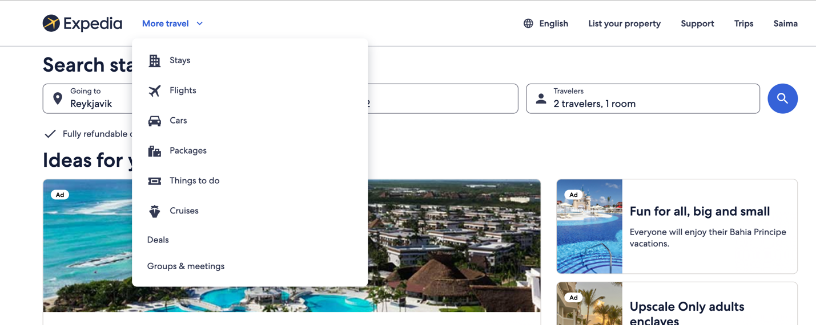select stays
3. 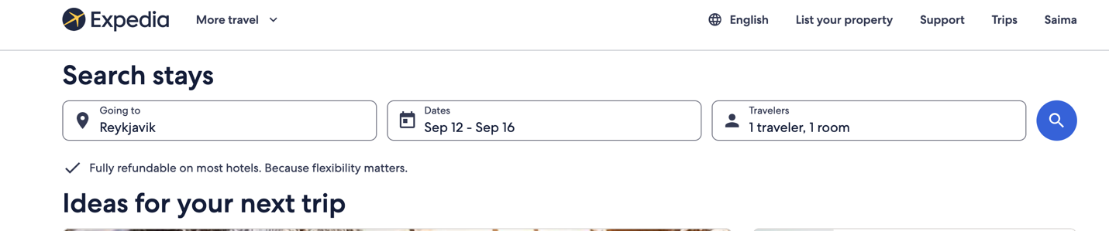
4. 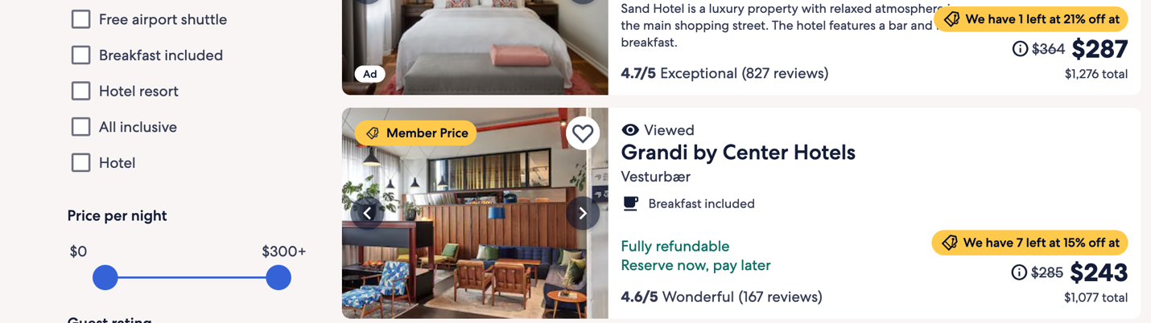
5. 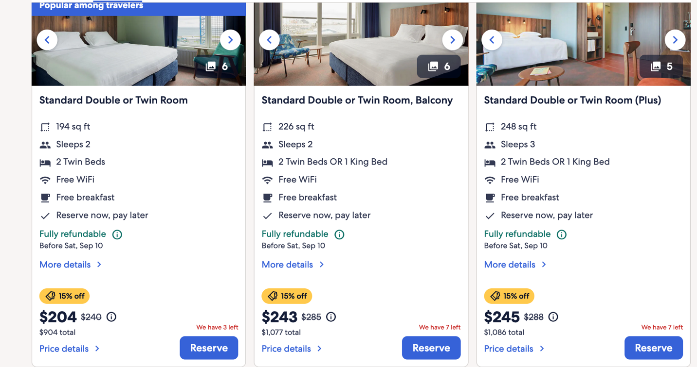
6. 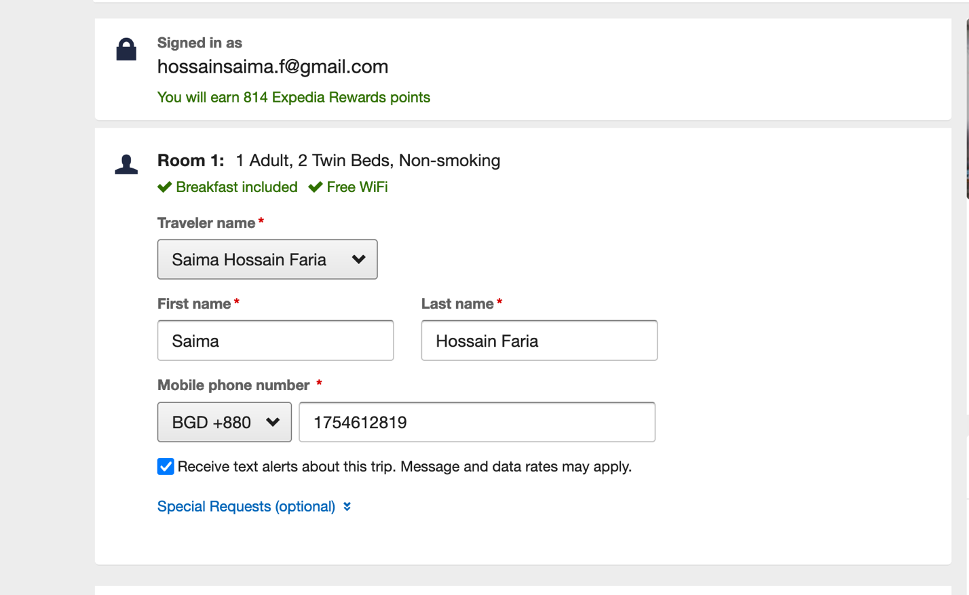
7. 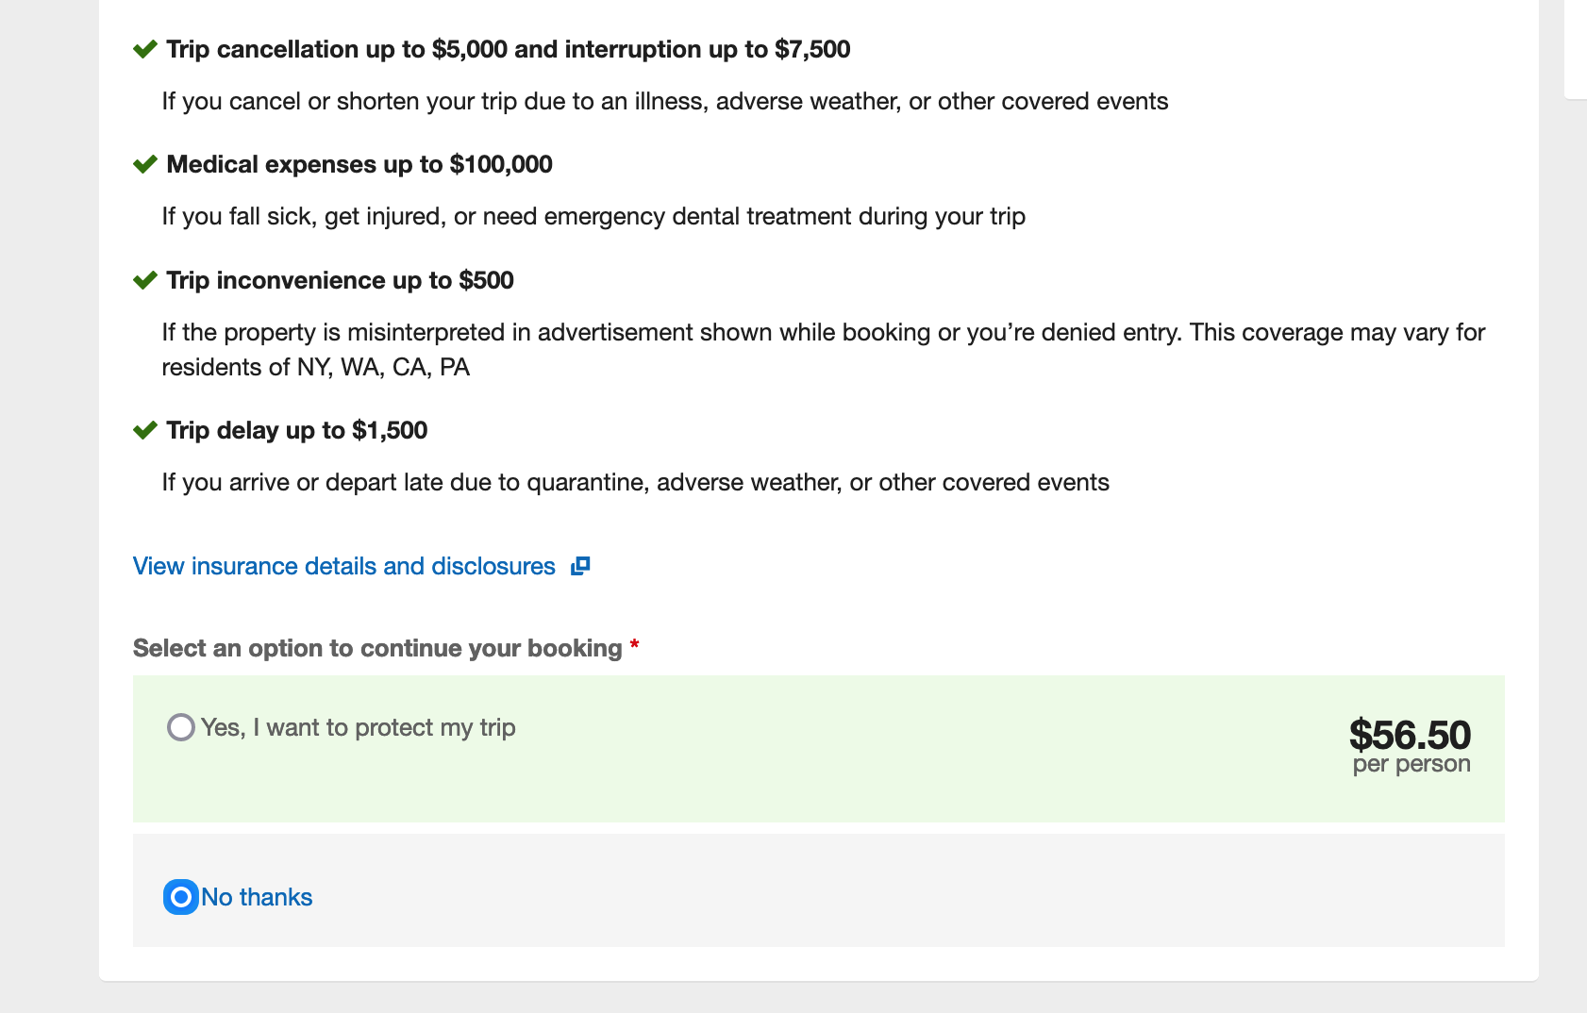
8. 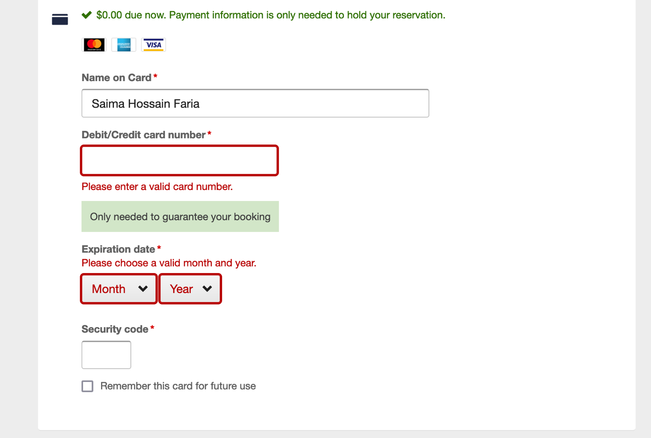
9. Confirm booking
10. Check mail
11. Check itinerary
12. 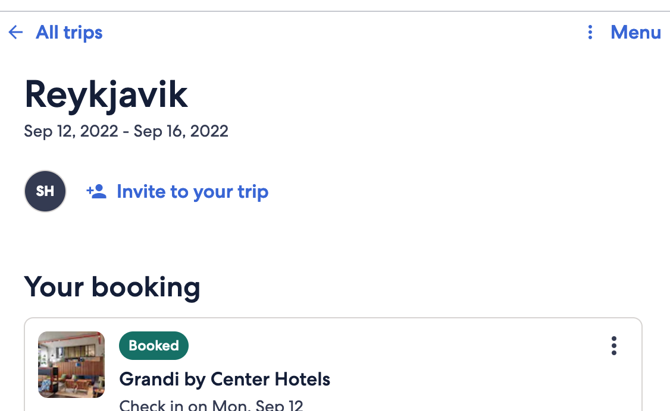
13. 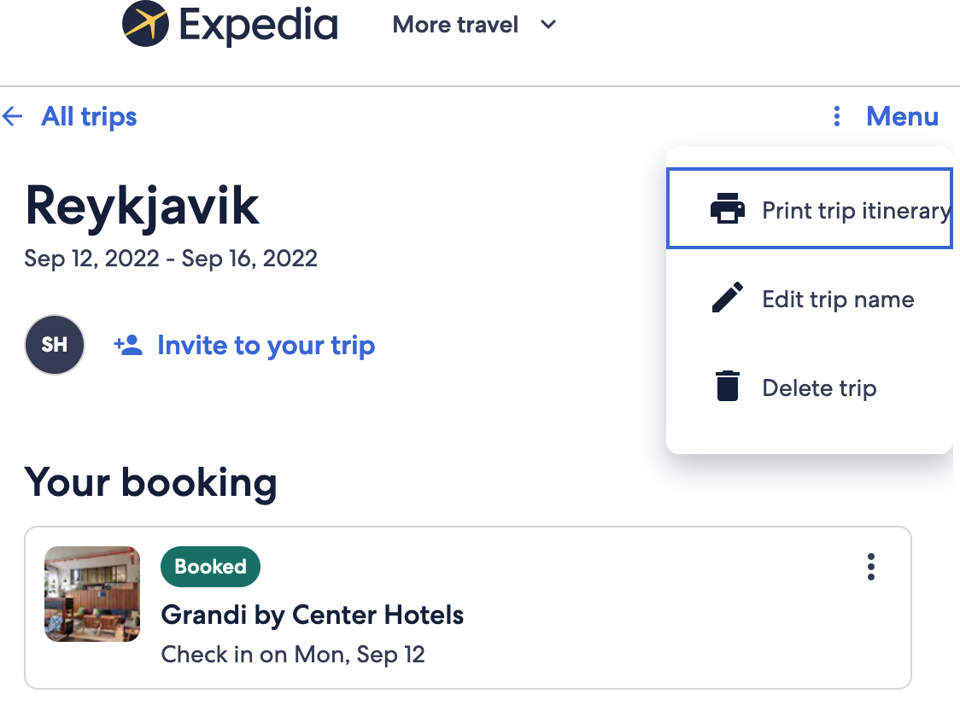

And you are done.

No fee will be charged until you stay. You can also use debit card.