Experiment - 15
Career Pathways and Future of Low-Code Development
Lokranjan
241401048 CSBS
1. AIM
To study the career pathways in low-code development, identify the skills required for different roles, and understand the future growth and evolution of low-code platforms using the Patient Appointment & Scheduling Management application as a practical context.
2. INTRODUCTION TO LOW-CODE DEVELOPMENT
Low-code development is an approach to building software applications mainly through visual tools, configuration, reusable components, and limited traditional programming. Applications can be created using forms, reports, dashboards, workflows, automation rules, and integrations.
The Patient Appointment & Scheduling Management application demonstrates how low-code development can be used to build a complete business application, with appointment forms, field validation, status management, notifications, reports, dashboards, access control, and integration with external systems.
Low-code development reduces repetitive programming effort and allows applications to be developed more quickly. It also enables business users and professional developers to participate in application development.
However, low-code does not eliminate the need for technical knowledge. Database concepts, workflow logic, APIs, programming, security, and business-process understanding remain important as applications become more complex.
3. CAREER PATHWAYS IN LOW-CODE DEVELOPMENT
The roles differ according to technical depth, business responsibility, and the complexity of applications handled.
Role | Focus | Typical Responsibilities
Low-Code Application Developer | Application development | Creating forms, reports, workflows, and application logic.
Business Application Developer | Business processes | Converting business requirements into working applications.
Automation Developer | Process automation | Designing workflows, triggers, and automated processes.
Integration Developer | System connectivity | Working with APIs, connections, and external services.
Low-Code Consultant | Solution guidance | Recommending suitable low-code solutions.
Solution Developer / Platform Specialist | Advanced applications | Handling customization and complex workflows.
Solution Architect | Application architecture | Designing solutions, integrations, and scalability.
Technical Lead / Enterprise Application Architect | Enterprise solutions | Guiding technical decisions, governance, and long-term strategy.

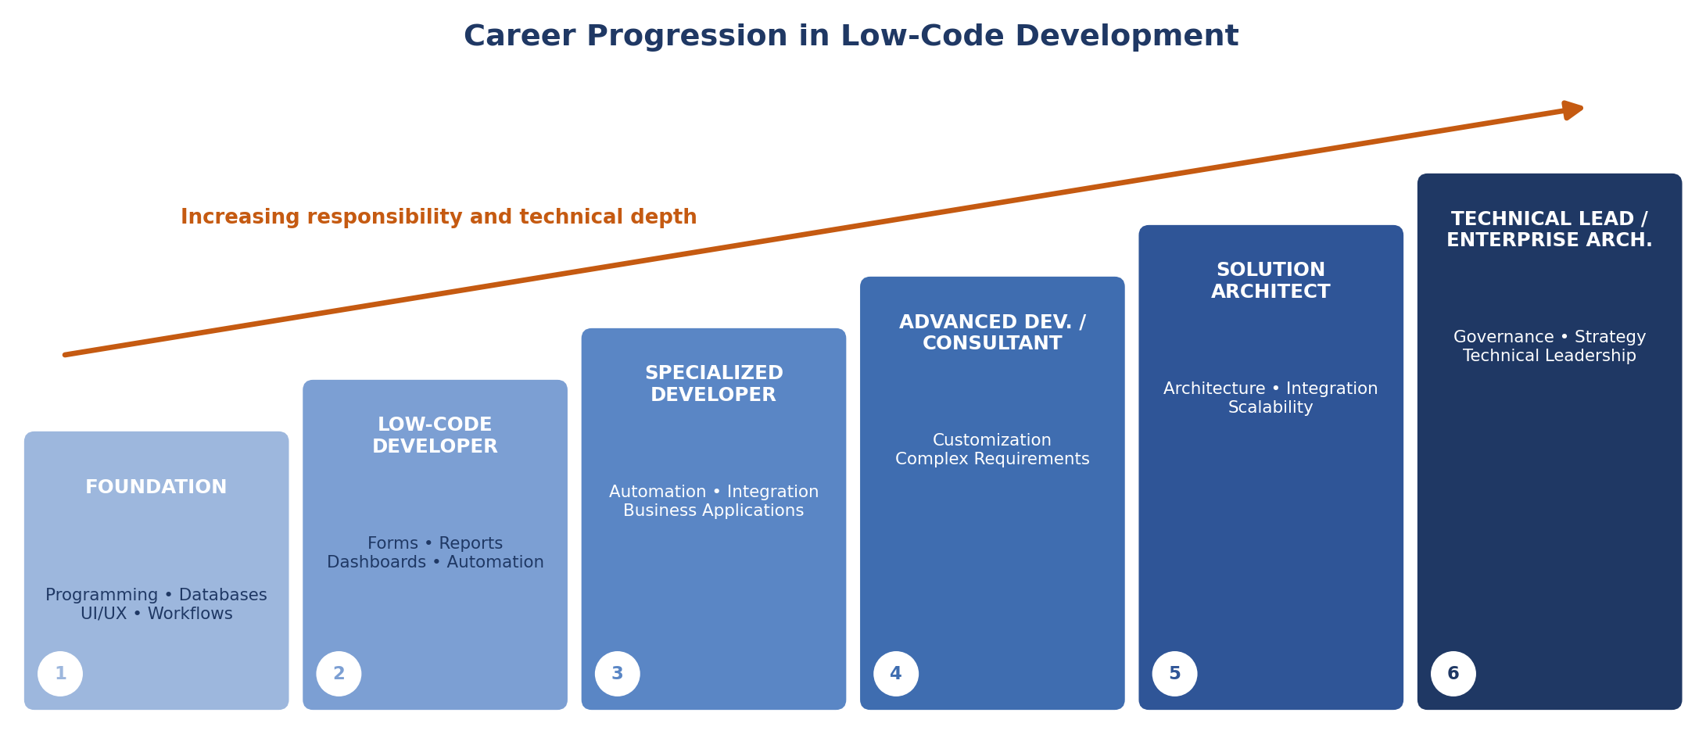
Figure 1: Career Progression in Low-Code Development
The progression moves from developing individual application components to designing complete solutions and guiding technical decisions.
4. SKILLS REQUIRED FOR LOW-CODE CAREERS
Skill | Relevance to Patient Appointment Application
Low-Code Platform Knowledge | Forms, reports, workflows, permissions, and platform limitations.
Database Concepts | Managing patient and appointment data efficiently.
Workflow and Automation | Automating validation, status updates, and notifications.
APIs and Integration | Connecting the system with CRM and other services.
Basic Programming | Writing Deluge scripts for custom logic.
UI/UX Fundamentals | Designing forms and dashboards that are easy to use.
Problem Solving | Identifying workflow, data, and integration issues.
Business Process Understanding | Understanding how appointment booking and healthcare administration operate.
Data Handling | Validating, processing, searching, and reporting appointment information.
AI-Assisted Development | Using AI tools for design, coding, testing, and analysis.
Communication and Requirement Analysis | Understanding requirements from patients, receptionists, doctors, and administrators.

Low-code professionals benefit from combining platform expertise with programming, databases, APIs, automation, and business knowledge.
5. CAREER PROGRESSION USING THE PATIENT APPOINTMENT APPLICATION
The Patient Appointment & Scheduling Management application can be used as an example of how responsibilities grow throughout a low-code career. Responsibilities and technical depth generally increase at each stage.

Foundation Stage
The developer learns basic databases and fields, forms, basic workflows, data validation, and platform concepts. For the appointment application, this includes creating patient fields, appointment-date fields, department selection, and mandatory fields.
Low-Code Developer Stage
The developer progresses to building complete applications. For the appointment application, responsibilities include:
- Creating appointment forms, reports, and dashboards.
- Configuring appointment workflows and validation rules.
- Automating confirmation notifications.
Specialized Developer Stage
The developer begins working with specialized areas such as automation and integration. Examples include:
- Appointment notification automation and CRM integration.
- Advanced workflow processing and data retrieval optimization.
- Access-control configuration.
Advanced Developer / Consultant Stage
The professional handles complex requirements and advises organizations. For example, a large hospital may require:
- Multiple departments and locations, and complex doctor availability.
- Advanced appointment scheduling and reporting.
- Integration with several external systems.
Solution Architect and Technical Lead Stages
The professional moves from individual features to complete solution architecture: planning application structure, designing integrations, considering scalability, planning security and governance, and deciding when low-code, pro-code, or hybrid development should be used. At the highest level, professionals guide enterprise development, governance, and technical decisions.
6. FUTURE OF LOW-CODE DEVELOPMENT
Low-code development is expected to become increasingly connected with AI, automation, cloud services, APIs, and enterprise applications. The major trends include:
- AI-Assisted Development: AI tools can help generate logic, explain code, identify problems, prepare documentation, and improve applications.
- Intelligent Workflow Automation: automation combined with intelligent decision-making, such as appointment recommendations and cancellation analysis. These are potential future applications, not current features.
- Natural-Language Application Building: describing requirements in plain language, for example “Create a report showing pending appointments by department.”
- API and Cloud Integration: closer interaction with cloud services, CRM, and other authorized healthcare applications.
- Citizen Development: receptionists and administrators contributing to simple changes while developers handle complex logic.
- Enterprise Low-Code: wider use for larger organizational applications, increasing the importance of scalability, security, governance, integration, and architecture.
- Low-Code and Pro-Code Collaboration: combining visual development with traditional programming.
- AI-Powered Testing and Optimization: AI support for testing workflows and suggesting improvements.
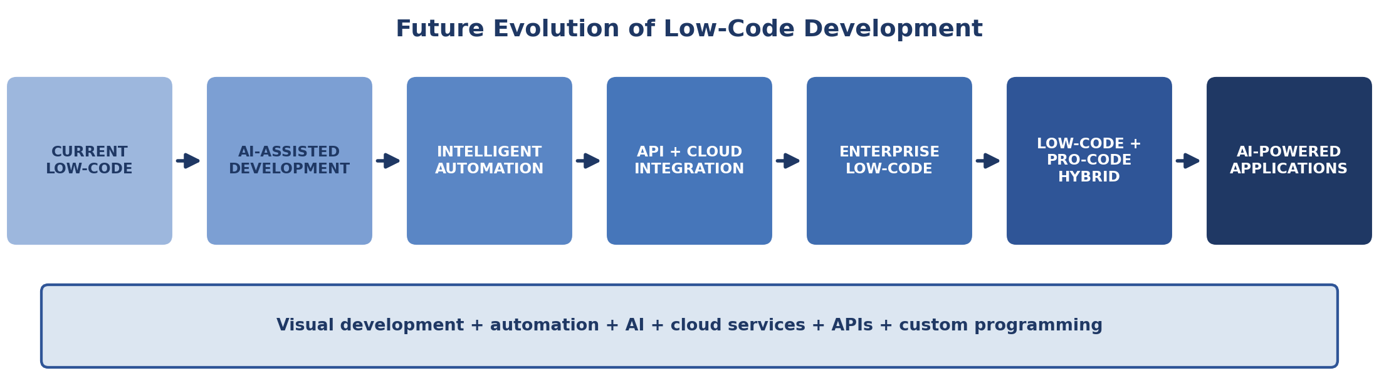
Figure 2: Future Evolution of Low-Code Development
7. LOW-CODE + AI + PRO-CODE
Low-code, AI, and pro-code should be viewed as complementary approaches.
Low-Code | AI | Pro-Code
Faster development | Intelligent assistance | Custom business logic
Visual development | Natural-language interaction | Advanced processing
Pre-built components | Data analysis and insights | APIs and integrations
Workflow automation | Testing assistance | Specialized functionality
Easier accessibility | Optimization support | Greater technical control

For the Patient Appointment & Scheduling Management application:
- Low-code provides the application foundation.
- AI can assist with development, analysis, testing, and intelligent automation.
- Pro-code can provide specialized logic and integrations when requirements become more complex.
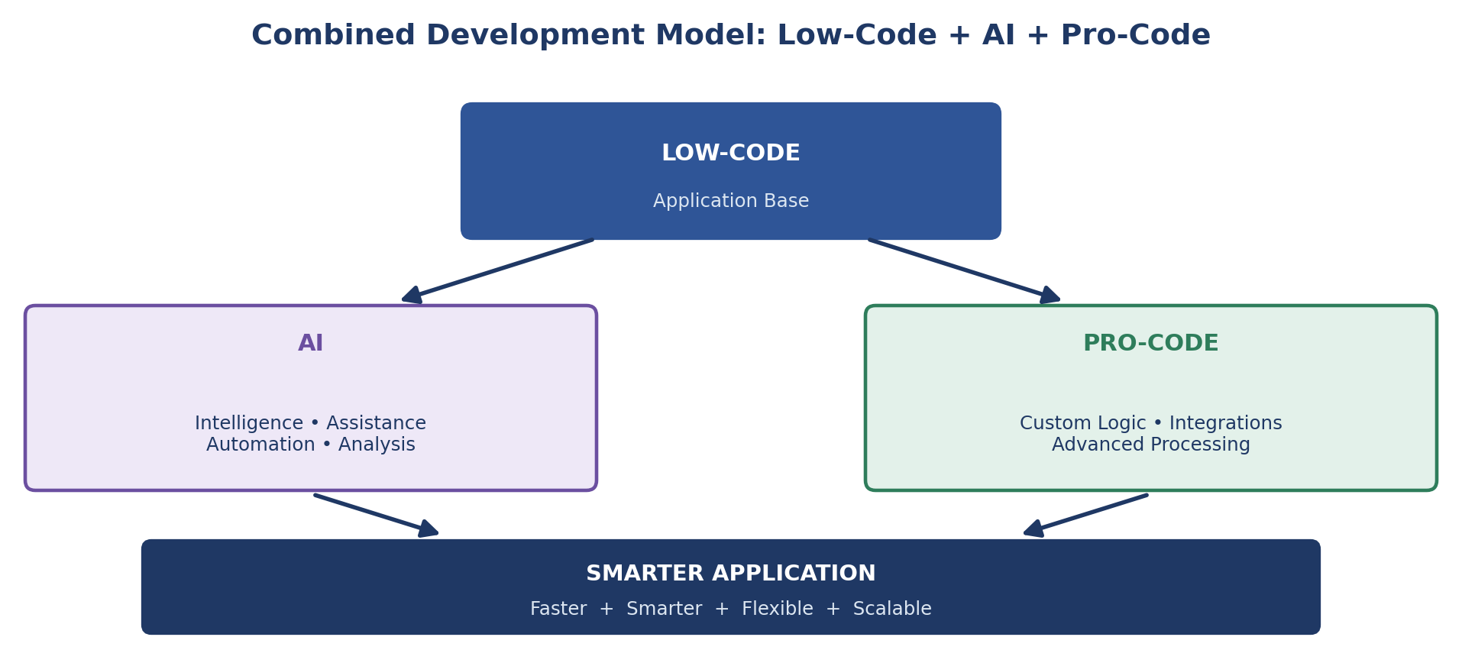
Figure 3: Combined Development Model
8. FUTURE DEVELOPER SKILL SET
The future low-code developer will require a broader combination of skills: low-code platforms, programming fundamentals, APIs and integration, databases, AI tools, and business understanding.
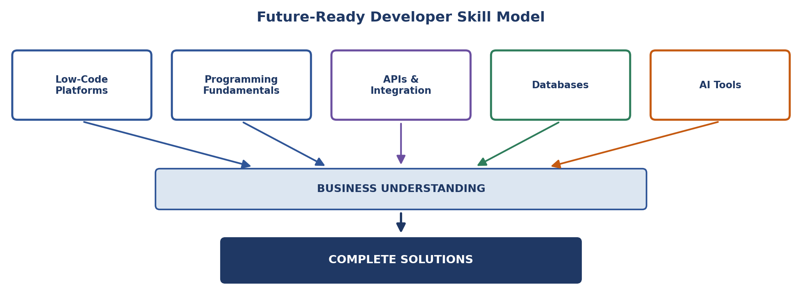
Figure 4: Future-Ready Developer Skill Model
Component | Role
Low-Code Platforms | Building applications quickly using visual tools, components, and workflows.
Programming Fundamentals | Writing custom logic, understanding how applications work, and troubleshooting.
APIs & Integration | Connecting applications with other systems and services.
Databases | Organizing and managing application data.
AI Tools | Assisting with development, automation, testing, and data analysis.
Business Understanding | Ensuring that applications solve real business needs.

A future-ready professional should also understand application architecture, security, and governance. Low-code platforms can reduce repetitive development effort, while programming knowledge remains valuable for customization, troubleshooting, and integration.
9. ADVANTAGES OF LOW-CODE DEVELOPMENT
The Patient Appointment & Scheduling Management application demonstrates several advantages of low-code development.
- Faster Development: forms, reports, workflows, and dashboards can be created using visual tools.
- Reduced Repetitive Coding: routine functionality uses configuration and reusable platform features.
- Faster Prototyping: a working application can be developed and improved incrementally.
- Workflow Automation: validation, status updates, and notifications can be automated.
- Easier Maintenance: visual workflows are easier to understand and modify.
- Improved Collaboration: business users and developers can work on the same application.
- Wider Access to Development: users with limited programming experience can contribute.
- Faster Response to Requirements: changes can be implemented more quickly.
10. CHALLENGES OF LOW-CODE DEVELOPMENT
Despite its advantages, low-code development also presents challenges.
- Platform Limitations: the platform may not support every specialized requirement.
- Vendor Dependency: applications depend on the capabilities and restrictions of the selected platform.
- Complex Customization: highly specialized requirements may need custom development.
- Integration Challenges: external or legacy systems may require additional expertise.
- Scalability Considerations: large data volumes and user numbers require careful planning.
- Security and Governance: enterprise applications need appropriate access control and administration.
- Need for Technical Knowledge: complex applications still require programming and architectural understanding.
These challenges do not make low-code unsuitable; the approach should be selected according to application requirements.
11. CAREER OPPORTUNITIES AND FUTURE OUTLOOK
Low-code professionals can work across many areas, including:
- Enterprise application development and business process automation.
- Digital transformation and IT consulting.
- Workflow automation and system integration.
- Cloud application development, internal business applications, and data-driven applications.
For a healthcare application such as this one, opportunities include developing administrative systems, automating appointment processes, integrating healthcare applications, and designing data-driven operational solutions.
Low-code development is likely to evolve rather than simply replace traditional software development. Future professionals are expected to work increasingly with AI-assisted development, hybrid low-code and pro-code solutions, APIs, cloud technologies, data management, and solution architecture.
12. RESULT
The study examined career pathways and the future of low-code development using the Patient Appointment & Scheduling Management application. The major career progression identified was:
Foundation → Low-Code Developer → Specialized Developer → Advanced Developer/Consultant → Solution Architect → Technical Lead/Enterprise Architect
Important skills identified include low-code platform knowledge, databases, workflow automation, APIs, programming, UI/UX, data handling, AI tools, problem solving, and business understanding.
Future low-code development is expected to be strongly influenced by AI, automation, cloud services, APIs, and low-code/pro-code collaboration. It is not expected to eliminate development careers but to shift them toward architecture, integration, problem solving, and business understanding.

