Experiment - 11
Deploying a Zoho Creator Application from Development to Production Environment
Lokranjan
241401048 CSBS
AIM
To demonstrate the development-to-production deployment workflow of the Patient Appointment & Scheduling Management application using environments.
INTRODUCTION
Zoho Creator provides an Environments feature that allows an application to be developed, tested, and published through separate environments without directly affecting the live application.
An application passes through three environments:
Environment | Purpose
Development | The environment in which the application is built, configured, and modified.
Stage | An intermediate testing environment where the application is deployed and tested before release.
Production | The live environment where the tested application is published and used by end users.

Separating these environments allows changes to be tested in Stage before they are released to Production, reducing the risk of affecting the live application with incomplete or untested changes.
APPLICATION USED
Patient Appointment & Scheduling Management – an application used to manage patient appointment bookings, appointment details, departments, appointment status, and confirmation notifications.
PROCEDURE
The deployment follows the flow:
Development Environment → Stage Environment → Production Environment
1. Sign in to Zoho Creator and open the Patient Appointment & Scheduling Management application.
2. Navigate to DEPLOY → Environments. The Environments page displays the Stage and Production environments separately.
3. The Development environment contains the Patient Appointment & Scheduling Management application, where the application configuration and changes are maintained.
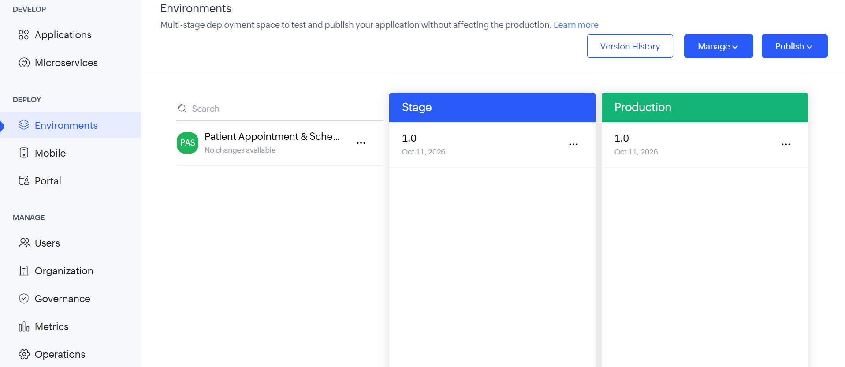
Figure 1: Development environment of the Patient Appointment & Scheduling Management application

4. The application is available in the Stage environment with version 1.0. Stage is used to test the deployed application before making it available to end users.
5. The Stage application was tested by opening the appointment booking form and submitting a test appointment.
6. The test appointment was successfully created, confirming that the deployed application was functioning correctly in the environment.
7. After successful testing, the application was available in the Production environment with version 1.0.
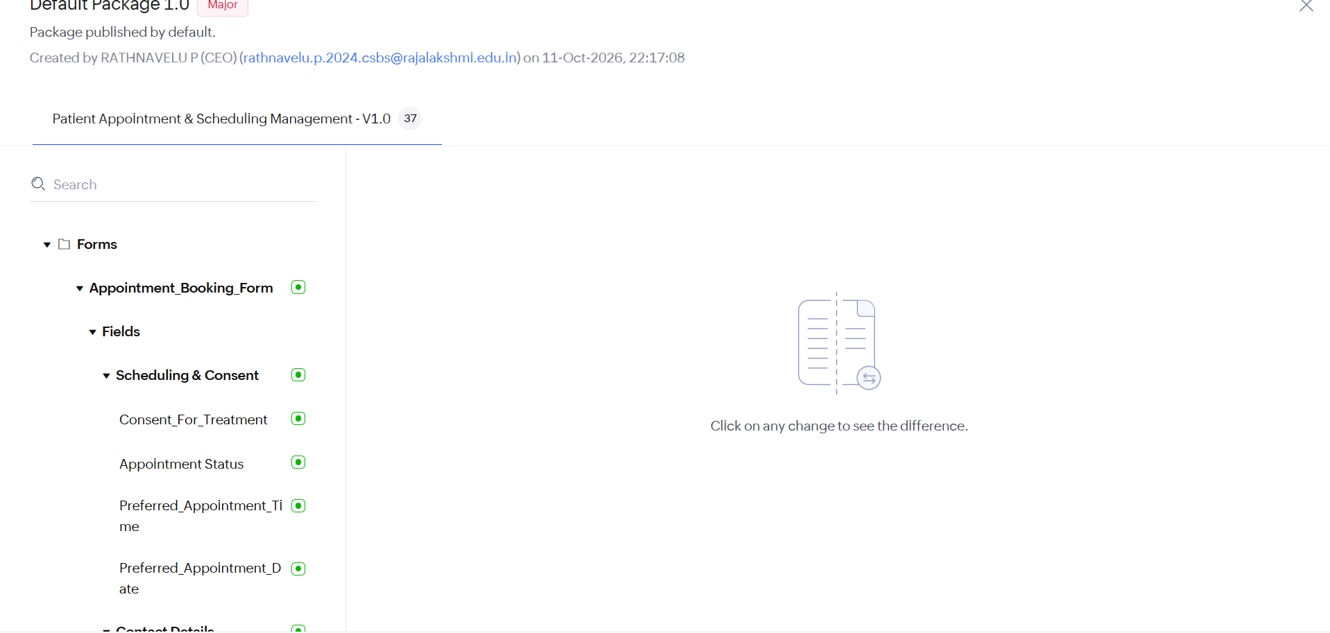
Figure 2: Production environment – Application deployed and live

8. The Production application was tested by submitting an appointment through the appointment booking form.
9. The appointment was successfully created in Production, confirming that the application was available for end-user use.

DEPLOYMENT FLOW
The stages and deployment status of the application are summarized below:
Environment | Version / Status | Description
Development | Development | Application configured and maintained during development.
Stage | Version 1.0 | Application deployed and tested before production release.
Production | Version 1.0 | Application deployed and available for end-user use.

The completed deployment flow is:
Development
↓
Stage
↓
Testing
↓
Production
↓
Live
RESULT
The Patient Appointment & Scheduling Management application was successfully deployed through the Development, Stage, and Production environments. Version 1.0 was available in both Stage and Production, and an appointment was successfully created during testing, demonstrating that the deployed application was functioning correctly.

