Experiment - 13
Case Study on Limitations of Low-Code Platforms for a Complex Enterprise Use Case
Lokranjan
241401048 CSBS
1. AIM
To study the limitations of low-code platforms when developing complex enterprise-level applications using the Patient Appointment & Scheduling Management system as a case study, and to understand when pro-code extensions or hybrid development approaches may become necessary.
2. INTRODUCTION
Low-code development platforms enable applications to be developed using visual interfaces, drag-and-drop components, forms, reports, dashboards, workflows, and limited scripting. These platforms reduce development time and simplify the implementation of common business processes.
The Patient Appointment & Scheduling Management application is developed using Zoho Creator. It supports appointment booking, validation, department-wise reports, status management, email notifications, dashboards, and integration with Zoho CRM. These capabilities suit routine appointment management, but a large hospital network with many departments, high appointment volumes, and external healthcare systems may raise additional technical challenges.
This case study examines the limitations that could arise when extending the application into a complex enterprise healthcare solution. These limitations are potential challenges to evaluate, rather than failures demonstrated by the current application.
3. CASE STUDY: ENTERPRISE PATIENT APPOINTMENT & SCHEDULING MANAGEMENT SYSTEM
The Patient Appointment & Scheduling Management application is considered as the foundation for a larger enterprise healthcare system. In a small clinic it may manage patient details, appointment requests, departments, appointment status, and confirmation notifications. As the organization expands, it may need to coordinate multiple departments, branches, healthcare professionals, and external information systems.
The proposed enterprise system may include patients, receptionists, doctors and specialists, and hospital administrators as users, together with appointment management, a scheduling engine, patient data management, a notification system, external integrations, and analytics and reporting.
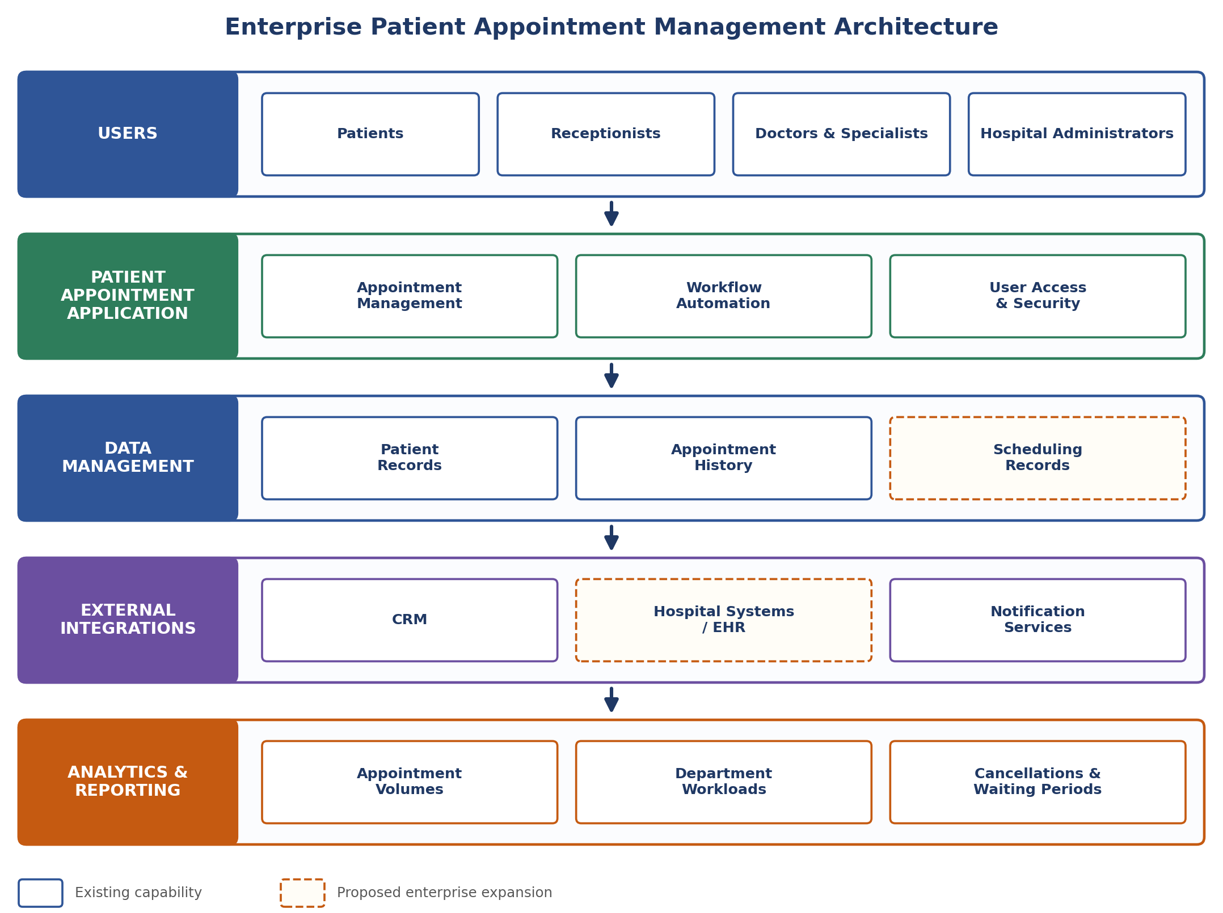
Figure 1: Enterprise Patient Appointment Management Architecture
The architecture illustrates a proposed enterprise expansion of the existing application. It does not imply that all these components have already been implemented.
4. HOW LOW-CODE PLATFORMS SUPPORT THE APPLICATION
Zoho Creator provides capabilities that support the existing appointment-management application:
- Form Development: forms collect patient information, preferred dates, and departments, with mandatory fields and validation rules.
- Workflow Automation: workflows validate appointment details, set the initial status, and send confirmation notifications.
- Reports and Dashboards: appointments can be presented by department, date, and status.
- Integration Capabilities: connections, integration tasks, and APIs are supported; the application integrates with Zoho CRM to create leads.
- Access Control: user permissions and roles restrict access according to responsibilities.
These capabilities make low-code development useful for creating business applications quickly. However, suitability must be re-evaluated as scale, complexity, and integration requirements grow.
5. LIMITATIONS OF LOW-CODE PLATFORMS AT ENTERPRISE SCALE
5.1 Performance and Scalability
As patients, appointment records, departments, and concurrent users increase, a large hospital network may receive thousands of appointment requests and frequent searches across doctors, departments, dates, and statuses. Zoho Creator documents limits on API request frequency, concurrent requests, and records processed per request, which must be considered when designing high-volume integrations.
Potential challenges include:
- Slower reports when large datasets must be processed.
- Increased processing for complex scheduling rules.
- Delays when multiple workflows run on appointment submission.
- API rate limits when external services are accessed frequently.
Possible solution: Use criteria-based record retrieval, optimize workflow execution, reduce unnecessary API calls, and evaluate whether high-volume processing requires a separate service.
5.2 Complex Business Logic
A basic appointment form can validate a preferred date and initialize the status, but enterprise scheduling involves more complicated rules. As these rules increase, workflows become difficult to maintain and test.
For example, an appointment system may need to handle:
- Preventing overlapping appointments and conflicting bookings for the same doctor or time slot.
- Checking doctor availability across multiple locations, appointment duration, and consultation type.
- Handling emergency appointments, rescheduling, cancellations, and waiting lists.
Possible solution: Separate complex scheduling logic into reusable functions or dedicated services, implement systematic validation, and test interactions between workflows.
5.3 System Integration
An enterprise healthcare organization may use hospital information systems, electronic health records, billing applications, and notification providers. The current application connects with Zoho CRM, but additional healthcare systems may require different data formats, authentication mechanisms, and field mappings.
Potential challenges include:
- Differences in patient identifiers and inconsistent provider or appointment data between systems.
- Failed or delayed synchronization and duplicate records from repeated requests.
- Changes to external APIs.
Possible solution: Use documented APIs, standardized healthcare data formats where appropriate, explicit field mappings, reliable error handling, and reconciliation procedures.
5.4 Customization
Low-code platforms provide predefined interface components that suit routine appointment management but may not satisfy every specialized requirement. A large healthcare organization may require specialized calendar views, real-time availability updates, advanced search across facilities, and custom interfaces for existing hospital systems. When these cannot be achieved efficiently with built-in components and supported scripting, custom development may become necessary.
Possible solution: Extend the low-code application using supported custom components, APIs, or pro-code services where the required functionality exceeds the available configuration options.
5.5 Security and Governance
Patient appointment systems handle personal information, contact details, and potentially sensitive healthcare-related data, so enterprise deployment requires careful access control and administrative governance. Zoho Creator provides permission management and API access controls, but these must be configured appropriately for the intended use.
Potential challenges include:
- Ensuring users access only the records necessary for their responsibilities.
- Managing permissions consistently across departments and locations.
- Monitoring administrative changes and maintaining retention, backup, and recovery procedures.
Possible solution: Apply least-privilege access, review permissions regularly, protect external connections, monitor available audit information, and establish data-governance procedures.
5.6 AI and Advanced Technology
An enterprise appointment system may eventually require demand forecasting, predicted waiting times, intelligent appointment recommendations, and analysis of cancellation patterns. Basic workflows and reports may not be sufficient; such capabilities may require specialized datasets, external AI services, or more complex processing pipelines.
Possible solution: Integrate suitable analytical or AI services through supported APIs and evaluate their accuracy, cost, and privacy implications before deployment.
Possible solution: Use modular application design, document business rules, maintain controlled data exports and backups, and avoid unnecessary dependence on platform-specific features when portability is important.
6. RELEVANCE OF LIMITATIONS TO THE CASE STUDY
Limitation | Enterprise Requirement | Potential Challenge
Performance and Scalability | Handle large appointment volumes and concurrent users. | Slow reports, processing delays, or API throttling.
Complex Business Logic | Coordinate doctor availability, rescheduling, and conflicting bookings. | Increasing workflow complexity and difficult maintenance.
System Integration | Exchange information with hospital and healthcare systems. | Data mapping, synchronization, and API compatibility issues.
Customization | Provide specialized scheduling interfaces and operational tools. | Built-in components may not meet every requirement.
Security and Governance | Protect patient information across multiple departments. | Complex permission management and monitoring requirements.
AI and Advanced Technology | Forecast demand and optimize appointment allocation. | Additional analytical infrastructure or services may be required.
Vendor Dependency | Maintain flexibility for future technology changes. | Migration may require redevelopment of platform-specific logic.
Data Management | Maintain consistent patient and appointment records. | Data duplication, complex queries, and growing maintenance needs.

These are potential risks to assess during enterprise planning. Their actual impact depends on workload, design, configuration, subscription limits, and organizational requirements.
7. LOW-CODE VS PRO-CODE REQUIREMENTS
Requirement | Low-Code Approach | Pro-Code Approach
Appointment Booking | Form workflows and status management. | Advanced scheduling engines for complex availability and conflict resolution.
Notifications | Built-in notification actions and templates. | Custom notification services for specialized routing or delivery.
Reports and Dashboards | Built-in reports and visualizations. | Dedicated analytics pipelines for large-scale processing.
External Integration | Supported connectors, connections, and APIs. | Custom middleware for complex transformations and synchronization.
Security | Configurable permissions and access controls. | Specialized identity or authorization services when required.
Data Processing | Platform records, workflows, and supported APIs. | Dedicated services or databases when workload justifies them.

Pro-code development is not automatically superior. It introduces additional responsibilities for development, testing, deployment, monitoring, and maintenance, so the appropriate approach depends on the complexity and criticality of each requirement.
8. HYBRID DEVELOPMENT APPROACH
A hybrid approach combines the rapid development of low-code platforms with custom software components for requirements that exceed the platform's practical capabilities. Zoho Creator can continue to manage appointment forms, routine validation, statuses, reports, dashboards, and notifications, while specialized services are introduced when enterprise requirements justify them.
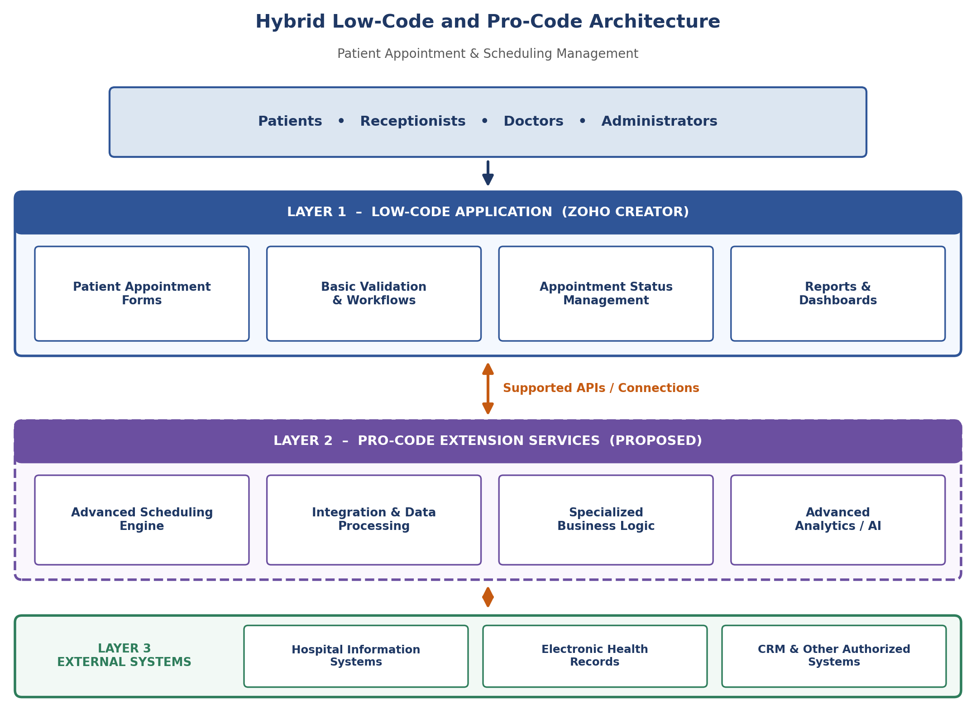
Figure 2: Hybrid Low-Code and Pro-Code Architecture
The diagram represents a proposed architecture, not an implemented extension of the current application. Pro-code services are introduced selectively, which reduces unnecessary redevelopment while preserving flexibility as organizational needs grow.
9. WHEN PRO-CODE EXTENSIONS MAY BECOME NECESSARY
Pro-code extensions may be considered when one or more of the following conditions arise:
1. Advanced Scheduling Requirements: complex constraints, real-time coordination, or sophisticated conflict resolution.
2. High-Volume Processing: large workloads cannot be handled efficiently within platform limits.
3. Specialized Integrations: external systems need custom transformations, complex authentication, or specialized protocols.
4. Advanced Analytics: predictive models or demand forecasting go beyond built-in capabilities.
5. Specialized User Interfaces: required interfaces cannot be built with the available components.
These conditions should be evaluated using actual requirements and testing. Their presence does not automatically mean that the entire application must be rewritten.
10. CASE STUDY ANALYSIS
The Patient Appointment & Scheduling Management application demonstrates how a low-code platform can support a practical business application with relatively limited development effort. It currently includes appointment booking, age and date validation, confirmation notifications, status initialization, reports, dashboards, role-based access arrangements, and a Zoho CRM integration.
An enterprise healthcare environment may introduce requirements not demonstrated by the current implementation, such as centralized availability across branches, standardized exchange with electronic health records, workload testing for many concurrent users, and more extensive security and governance. Platform limits must be evaluated against the actual subscription, API usage, data volumes, and design.
11. RESULT
The case study examined the limitations that may arise when the Patient Appointment & Scheduling Management application is expanded into a complex enterprise healthcare solution. It identified eight major areas for evaluation: performance and scalability, complex business logic, system integration, customization, security and governance, AI and advanced technology, vendor dependency, and data management.
It also showed how a hybrid approach could combine the existing low-code application with specialized services when enterprise requirements exceed the platform's practical capabilities. Thus, low-code platforms suit many business applications, but complex enterprise systems require careful evaluation of performance, integration, security, maintainability, and long-term technical requirements.

