Experiment - 06
Automating Business Processes Using Deluge Scripting and Workflows, with Application Testing and Debugging
Lokranjan
241401048 CSBS
AIM
To design and implement automated business processes within the Patient Appointment & Scheduling Management application using Zoho Creator workflows and Deluge scripting, and to perform application testing and debugging to verify that the workflows execute correctly during appointment submission.
PROCEDURE
Step 1: Opening the Workflow Configuration
1. Open the Patient Appointment & Scheduling Management application in Edit mode.
2. Select Workflows from the left-hand navigation panel.
3. Open the Form Workflows section.
4. The workflows associated with Appointment_Booking_Form are displayed.
The workflow configuration provides the automation layer for validating appointment information and performing actions after successful form submission.
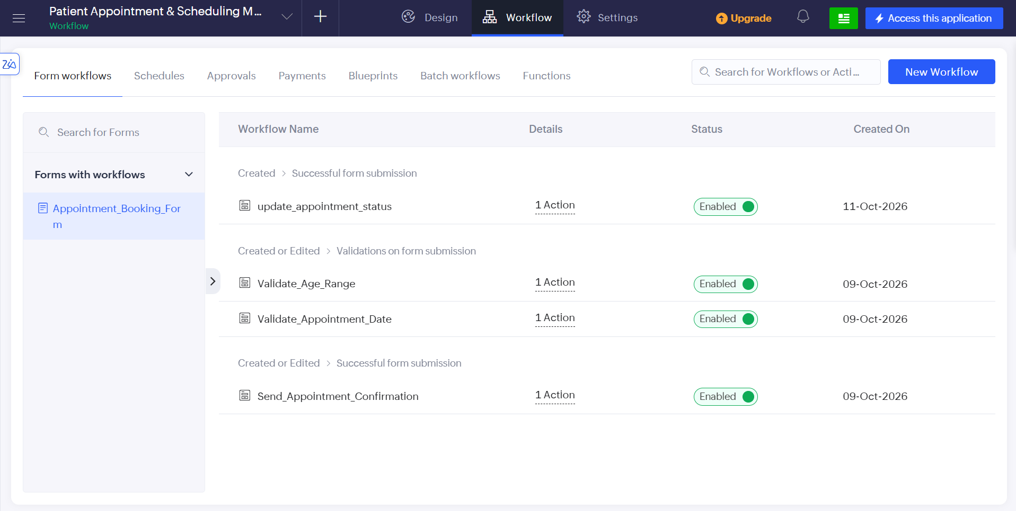
Screenshot 1 — Four workflows listed under Form Workflows

Step 2: Configuring Age Validation
A workflow named validate_age_range was configured to validate the patient's age before the appointment record is submitted. The Deluge script used is:
if(input.Age < 0 || input.Age > 120)
{
alert "Age must be between 0 and 120.";
cancel submit;
}

Explanation: The script checks whether the entered age is outside the permitted range of 0 to 120. If the value is invalid, an alert message is displayed and the form submission is cancelled.
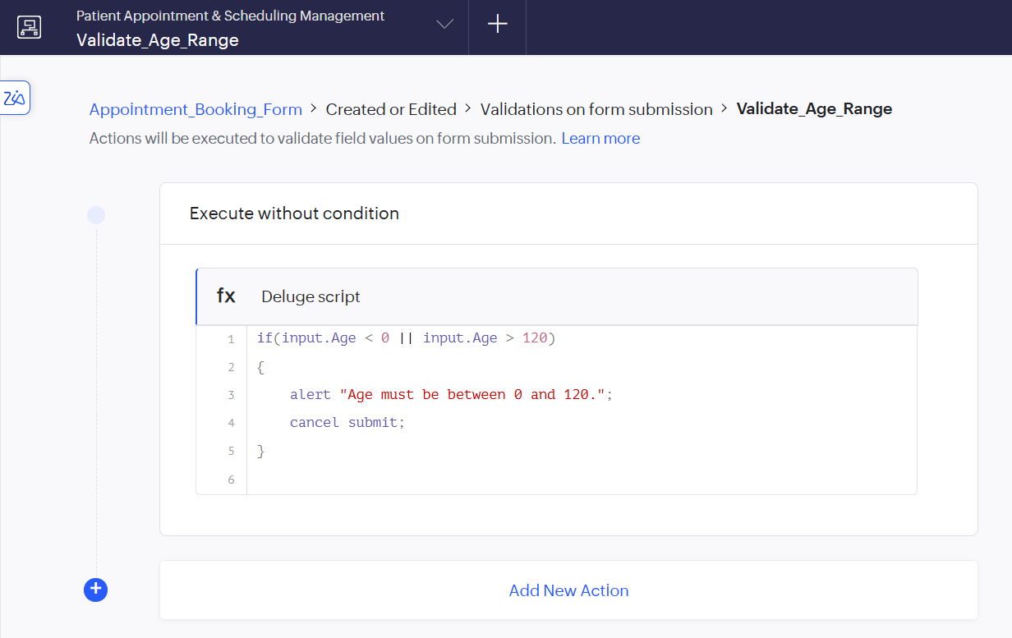
Screenshot 2 — validate_age_range Deluge script in the Deluge editor

Step 3: Configuring Appointment Date Validation
A second workflow named validate_appointment_date was configured to ensure that patients cannot select an appointment date in the past. The Deluge script used is:
if(input.Preferred_Appointment_Date < zoho.currentdate)
{
alert "Preferred Appointment Date cannot be a past date.";
cancel submit;
}

Explanation: The workflow compares the selected appointment date with the current date. If the selected date is earlier than the current date, the submission is cancelled and an appropriate validation message is displayed.
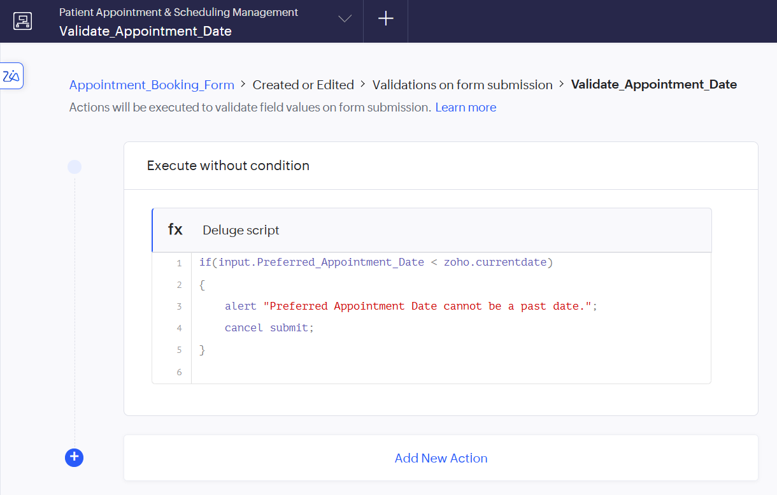
Screenshot 3 — validate_appointment_date Deluge script in the Deluge editor

Step 4: Automatically Updating Appointment Status
A workflow named update_appointment_status was created for newly submitted appointment records. The Deluge script used is:
input.Appointment_Status = "Pending";

Explanation: When a new appointment is successfully submitted, the workflow automatically assigns the appointment status as Pending. This prevents newly created appointments from having a blank status and establishes the initial state of the appointment lifecycle.
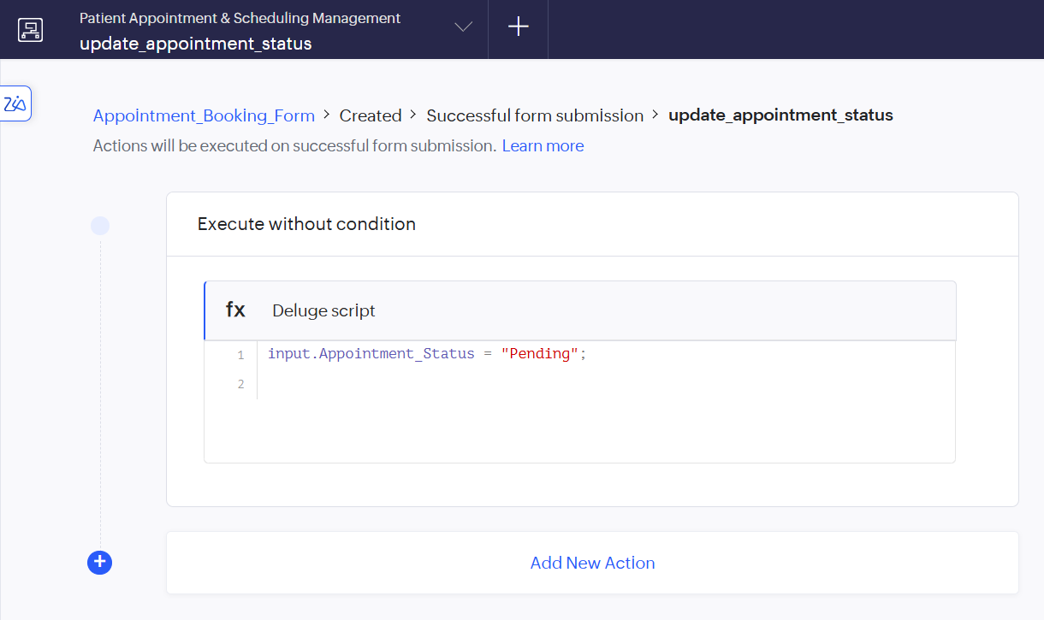
Screenshot 4 — update_appointment_status workflow trigger and Deluge script

Step 5: Sending Appointment Confirmation
The send_appointment_confirmation workflow was configured to send an acknowledgement email after a successful appointment submission, with the trigger Record Event = Created and Form Event = Successful form submission. The workflow uses the patient's Email Address field as the recipient.
Explanation: This workflow provides immediate feedback to the patient after submitting the appointment form and eliminates the need for the front desk to manually send an acknowledgement email.
WORKFLOWS IMPLEMENTED
Workflow Name | Purpose
validate_age_range | Validates that the patient's age is between 0 and 120
validate_appointment_date | Prevents the selection of a past appointment date
update_appointment_status | Automatically sets a newly submitted appointment to Pending
send_appointment_confirmation | Sends an acknowledgement email to the patient after successful submission
TESTING AND DEBUGGING RESULTS
Test Result 1 — Appointment Status
A newly submitted record initially had no status entered manually. After submission, the update_appointment_status workflow automatically assigned Appointment Status → Pending. This confirmed that the Deluge script executed successfully, as shown in Screenshot 6.
Test Result 2 — Appointment Record
The submitted appointment appeared successfully in Appointment_Booking_Report. The record contained the patient information, appointment date, appointment time, department, and automatically assigned status.
Test Result 3 — Confirmation Email
The patient confirmation email was successfully received after the appointment was submitted. This verified that the send_appointment_confirmation workflow was executed successfully, as shown in Screenshot 7.
Test Result 4 — Validation Workflows
The application also contains the following validation logic, which ensures that invalid appointment information does not enter the application database:
- Invalid age values are rejected.
- Past appointment dates are rejected.
OUTPUT
The completed workflow automation produced the following results:
1. Appointment form submission was successfully processed.
2. Age validation prevented invalid age values.
3. Appointment-date validation prevented past appointment dates.
4. New appointments were automatically assigned Pending status.
5. Appointment records were stored successfully in the application.
6. An automated acknowledgement email was delivered to the patient's email address.
7. The appointment could be viewed through Appointment_Booking_Report.
8. The resulting appointment status was also reflected in the application's appointment management and dashboard functionality.
The final results of the experiment are shown below.
1. Appointment_Booking_Report
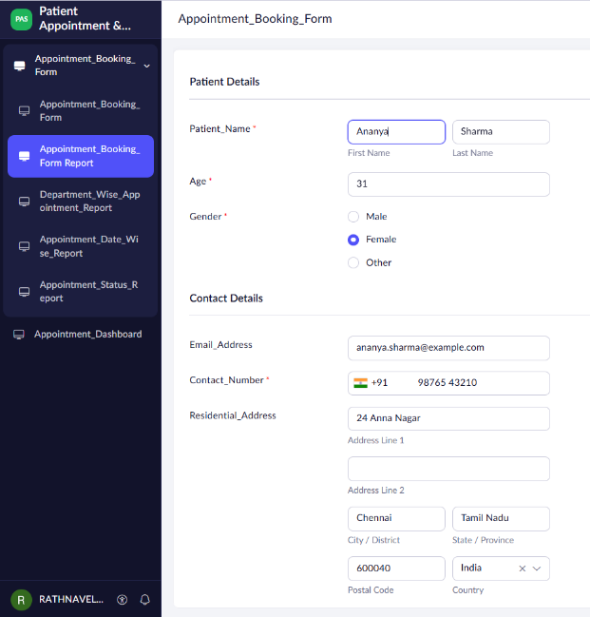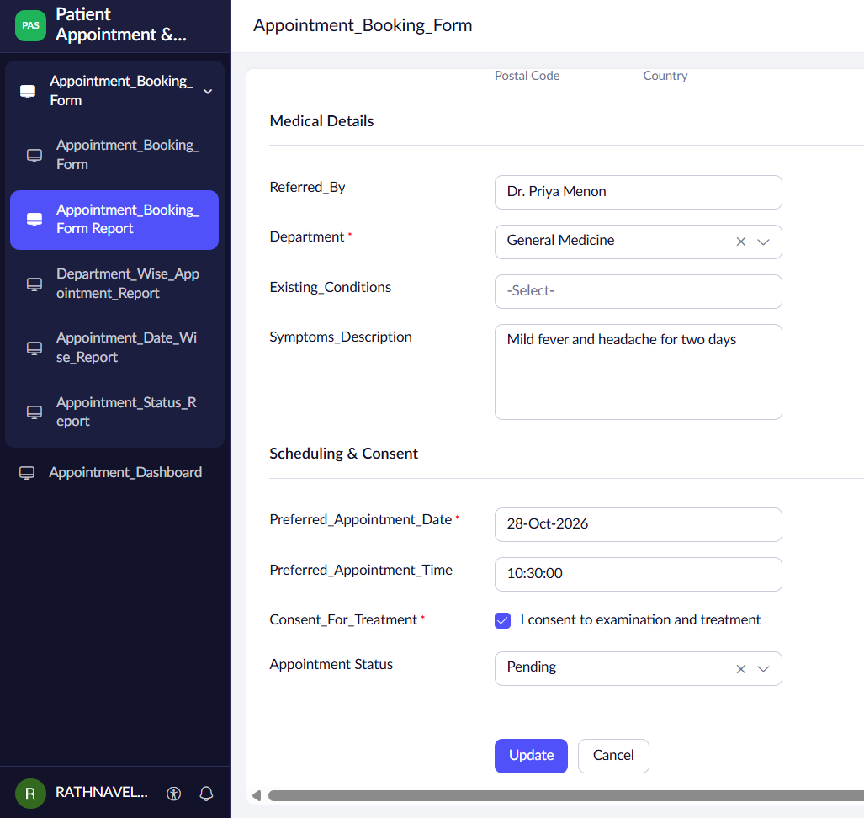
Screenshot 5 — Newly submitted appointment with Appointment Status = Pending

2. Confirmation Email Received
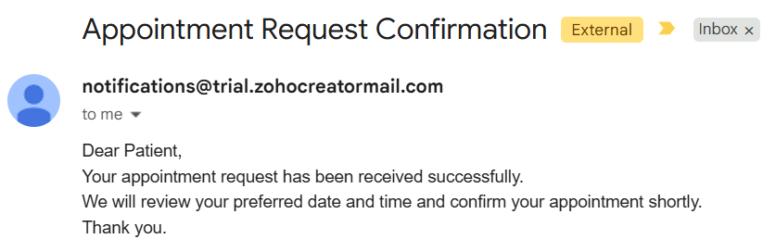
Screenshot 6 — Appointment Request Confirmation email in the patient's inbox
RESULT
The Patient Appointment & Scheduling Management application was successfully enhanced with automated business processes using Zoho Creator workflows and Deluge scripting.

