ServiceNow Tutorial

ServiceNow Tutorial for Beginners Introduction to ServiceNow

**What is ServiceNow?**

It is a cloud-based platform which was mainly developed for workflow and process automation as per ITIL principles. It is highly customizable.

ServiceNow is a no-code platform, which means that organizations can create and customize their own applications without having to write any code.

**Services of ServiceNow:**

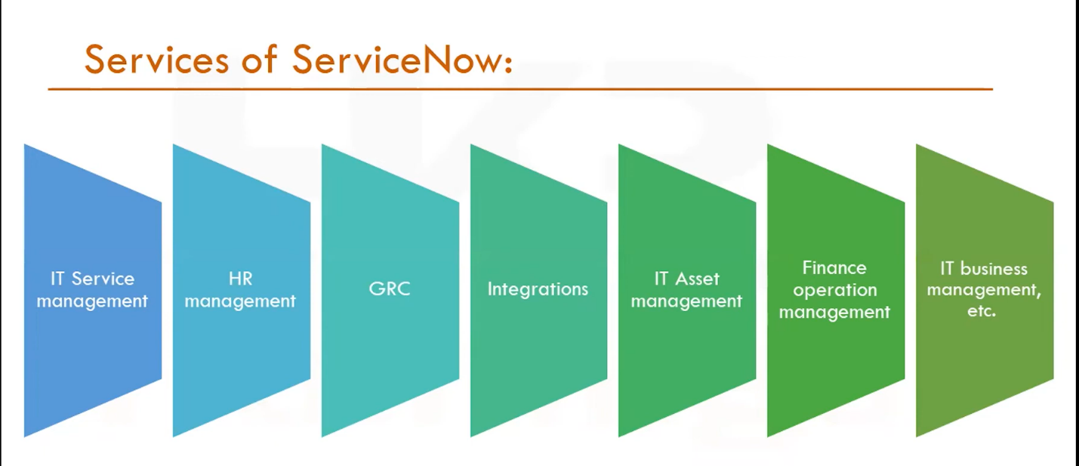

ServiceNow offers a variety of modules, including IT Service Management (ITSM), Human Resources (HR), and Governance, Risk, and Compliance (GRC) ,etc.

**How to get free SNOW instance?**

Follow these steps to det your SNOW instance:

Step 1 – Signup from <https://developer.servicenow.com/app.do#!/home>

Step 2 – Fill the registration form.

Step 3 – Verify your Account.

Step 4 - Now login to your ServiceNow Developer Platform.

Step 5 – Request/create an Instance.

Step 6 – Choose the ServiceNow Developer Instance Version (currently Vancouver).

**NOTE:**

* + **If the instance is inactive for 10 days, then the instance is released.**
  + **If your instance in inactive for more than 24 hours, then your instance may go in hibernation state.**

**How to become a SNOW Developer?**

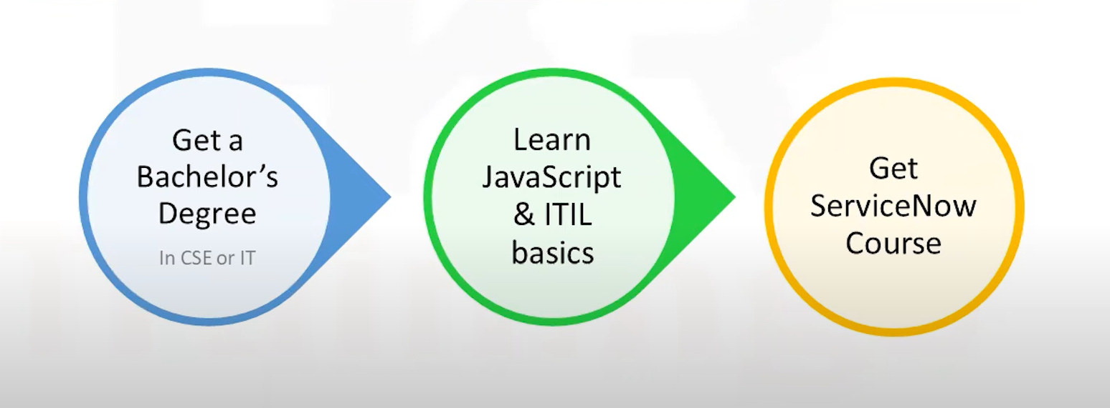

**Career and Growth in ServiceNow**

* ServiceNow is expected to continue to grow even in future.
* Nowadays, Cloud platform is Very popular.
* In the cloud platform, ServiceNow is the best tool to use because of its simplicity and ease of use.

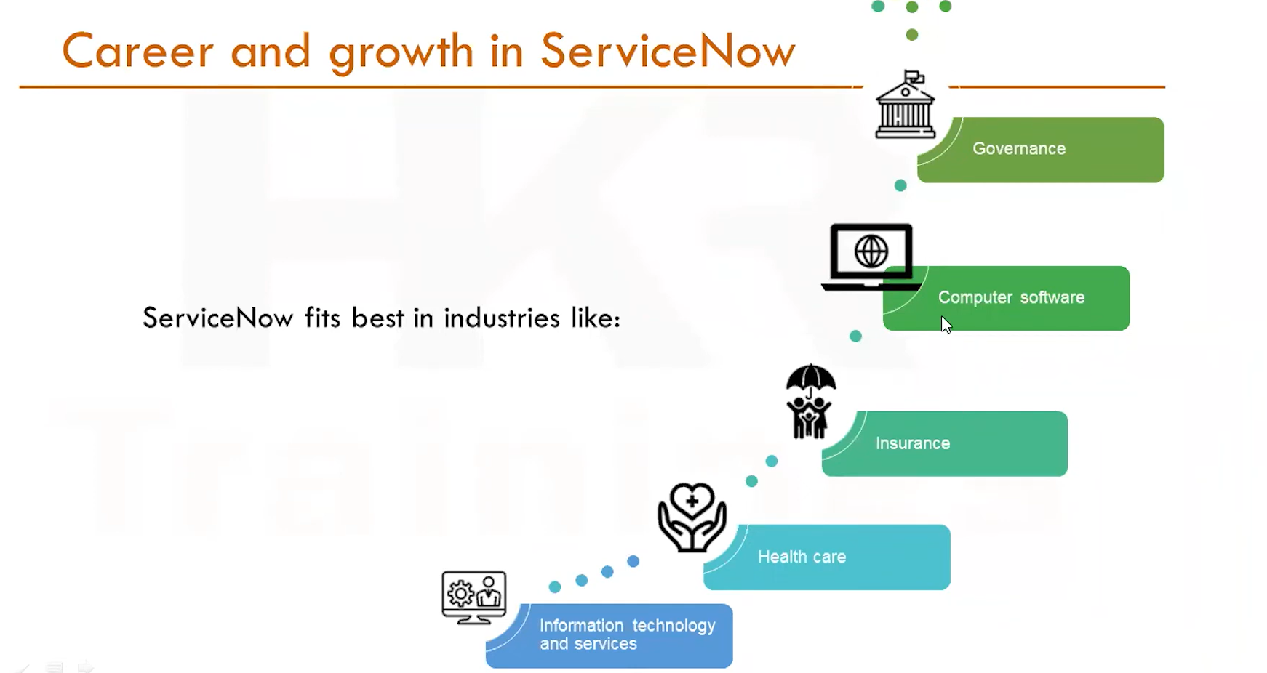

**ServiceNow UI Overview**

We interact with the application and modules of the ServiceNow platform through the user interface using s web browser.

Currently ServiceNow is Using Next UI from San Diego Release. Before it used to be UI 16.

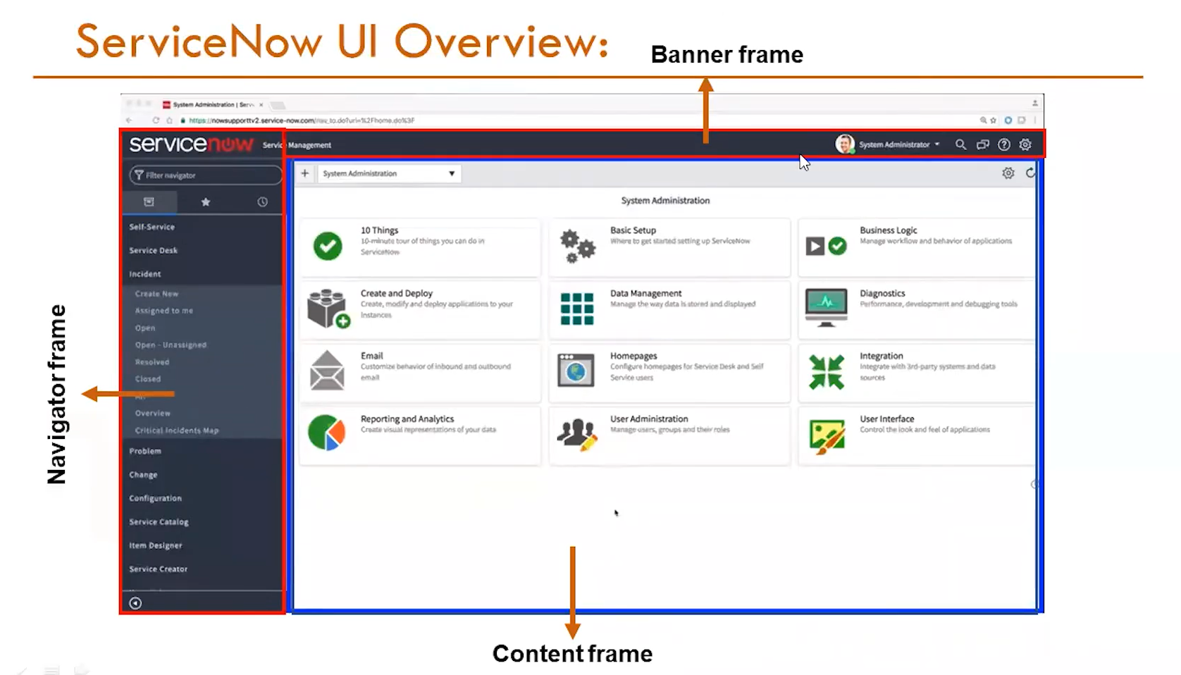

*Banner frame:* The banner frame is the topmost section of the ServiceNow interface. It houses essential navigation elements, such as the ServiceNow logo, search bar, navigation menu, and user profile information.

*Content Frame:* The content frame occupies the main central area of the ServiceNow interface. It displays the primary content or data relevant to the user's current action or view.

*Navigator Frame:* The navigator frame, often located on the left side of the content frame, provides a secondary navigation menu. It can be used to display related lists, shortcuts, or frequently accessed items.

**ServiceNow Components**

* These are the basic elements of the page.
* It ranges from the basic elements like labels, and buttons to more complex experience components like lists and forms.
* It can be added to the pages to create or personalize the workspace or portal.

*Modules*: these are the elements that make up the ServiceNow application navigator.

Some of the modules in ServiceNow are-

* Incident Management
* Problem Management
* Change and Release Management
* Request Management
* Asset and Cost Management
* Walk-Up Experience
* Agent Workspace
* Now Mobile, etc.

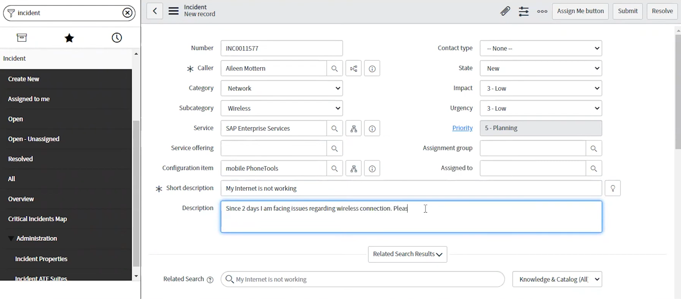

Incident Module:

It is a situation where normal service operations are interrupted, disrupted or degraded. An open incident indicates that the customer is strongly affected or it represents a business risk. The process of managing the incident lifecycle is called as an incident management.

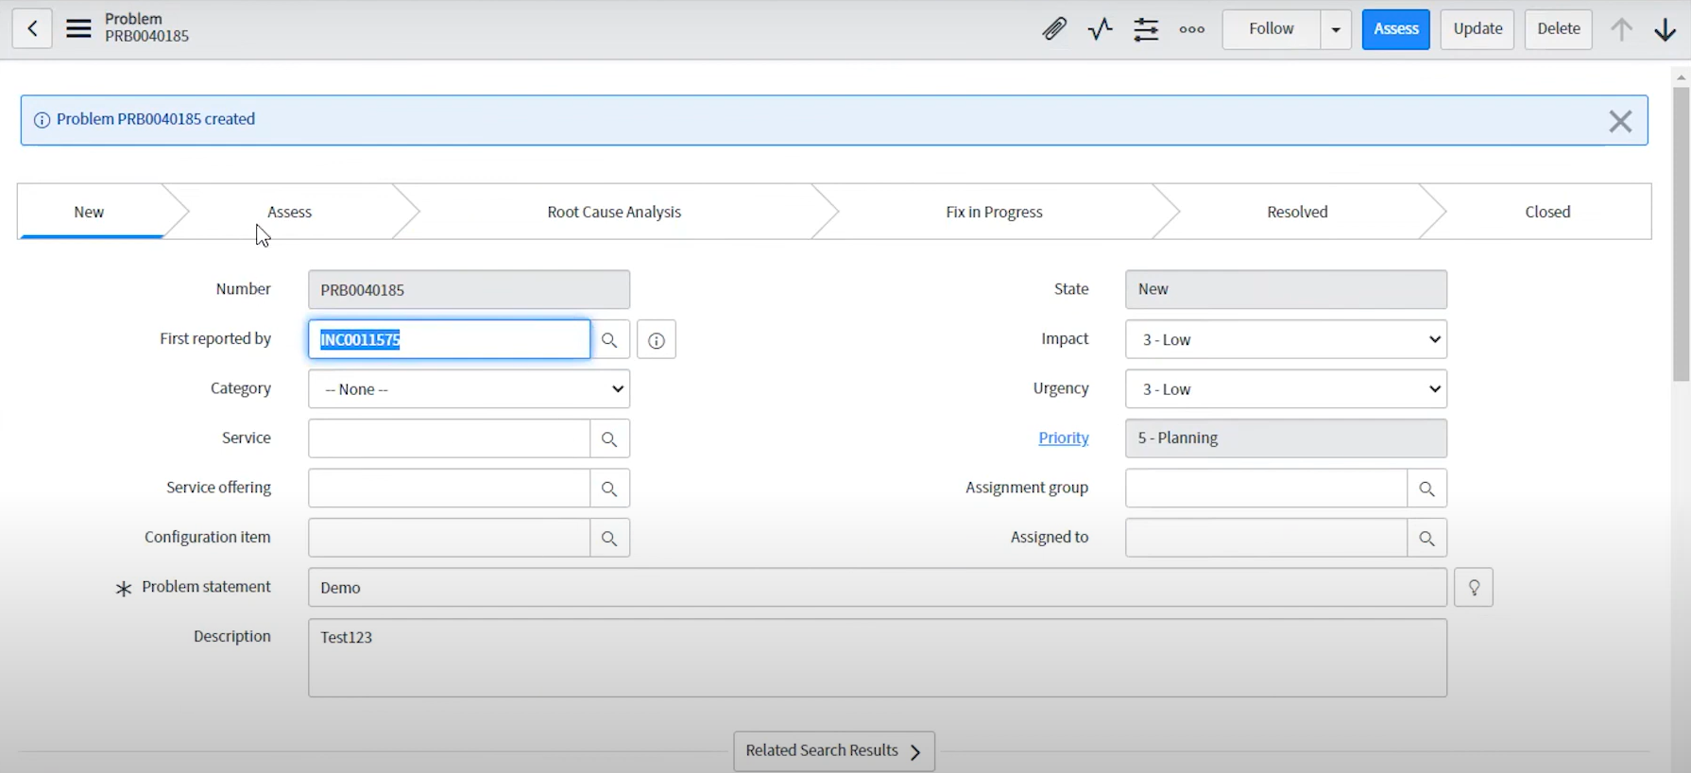

Problem Module:

It is a case of one or more incidents. The process of managing the lifecycle of all the problems that arises or could arise in an IT service Is called as problem management.

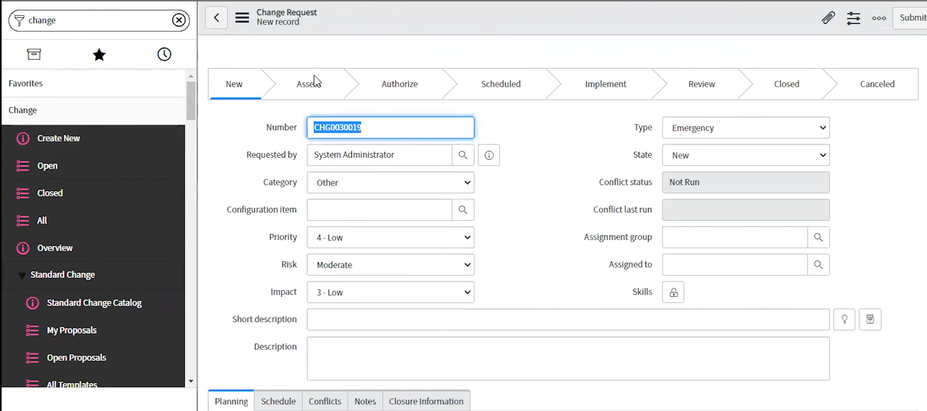

Change module:

It contains the detailed information regarding the change like the reason for the change, the risk, the priority, the change type, and the change category. A systematic approach for controlling the life cycle of all changes making it easier to make beneficial changes with the less disputation to the IT services is called ServiceNow Change management.

Lists in ServiceNow are tabular representations of data that allow users to view, filter, search, and interact with records efficiently. They serve as the primary interface for many common tasks within the platform.

Forms in ServiceNow are essentially digital documents that capture and store data about specific entities or processes. They serve as the primary interface for creating, editing, and viewing records within the platform. 