JAYPEE UNIVERSITY OF ENGINEERING & TECHNOLOGY, GUNA (MP)

Lab -7

ALGORITHM LAB (10B17CI472)

Implement the given algorithm in C/C++/Java. Try to find the running time of the given algorithm. You have to perform a comparative analysis for the given n element.

Objective: - Implement an algorithm of Max-Priority-Queue for any array of elements having INSERT, EXTRACT-MAX, INCREASE-KEY operations. Analyze its operations in terms of running time and find the time complexity of the algorithm.
Instruction:-
HEAP-MAXIMUM (A)
return A[1]
Example:-
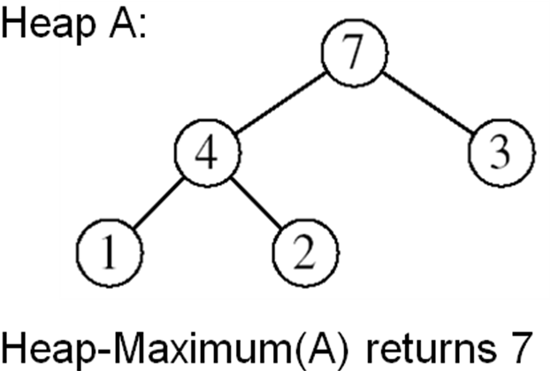

HEAP-EXTRACT-MAX (A, n)
- if n < 1
- then error “heap underflow”
- max ← A[1]
- A[1] ← A[n]
- MAX-HEAPIFY(A, 1, n-1)
- return max

Example: HEAP-EXTRACT-MAX
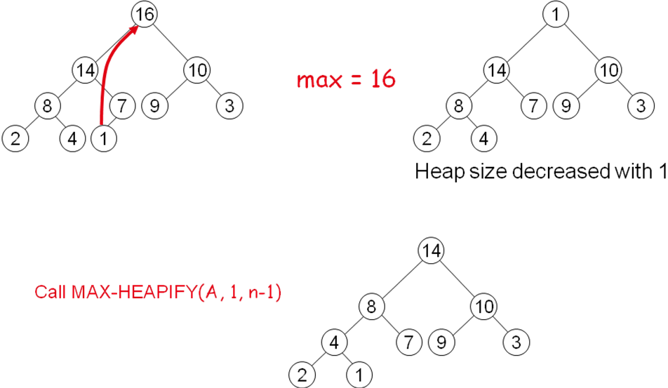
HEAP-INCREASE-KEY (A, i, key)
- if key < A[i]
- then error “new key is smaller than current key”
- A[i] ← key
- while i > 1 and A[PARENT(i)] < A[i]
- do exchange A[i] ↔ A[PARENT(i)]
- i ← PARENT(i)
Example:-
