JAYPEE UNIVERSITY OF ENGINEERING & TECHNOLOGY, GUNA (MP)

Lab - 12

ALGORITHM LAB (10B17CI472)

Implement the given algorithm in C/C++/Java. Try to find the running time of the given algorithm. You have to perform a comparative analysis for the given n element.

Objective: - Design and implement algorithm for B-Tree with t (minimum degree of tree) =3 for following operations:
- B-Tree Search
- B-Tree Create
- B-Tree Insert
Analyze its time complexities on the basis of CPU utilization and justify it.
Instruction:-
Algorithm for B-Tree-Search ():-
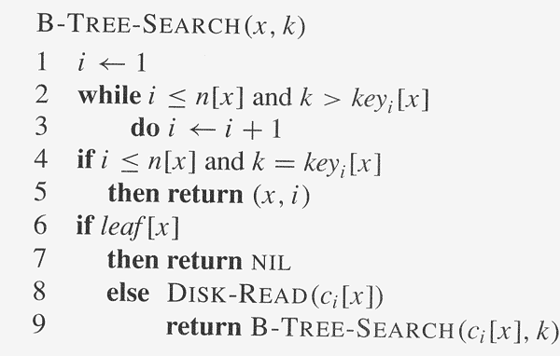

Algorithm for B-Tree-Create () and B-Tree-Insertion ():-

