JAYPEE UNIVERSITY OF ENGINEERING & TECHNOLOGY, GUNA (MP)

Lab - 9

ALGORITHM LAB (10B17CI472)

Implement the given algorithm in C/C++/Java. Try to find the running time of the given algorithm. You have to perform a comparative analysis for the given n element.

Objective: - Design and implement an algorithm to perform LEFT-ROTATE (RIGHT-ROTATE) operation on a binary search tree.
Instruction:-
LEFT-ROTATE (T, x)
- y ← right[x] ✄ Set y.
- right[x] ← left[y] ✄ Turn y’s left subtree into x’s right subtree.
- if left[y] _= nil[T ]
- then p[left[y]] ← x
- p[y] ← p[x] ✄ Link x’s parent to y.
- if p[x] = nil[T ]
- then root[T ]← y
- else if x = left[p[x]]
- then left[p[x]] ← y
- else right[p[x]] ← y
- left[y] ← x ✄ Put x on y’s left.
- p[x] ← y
The pseudocode for LEFT-ROTATE assumes that
• right[x] _= nil[T ], and
• root’s parent is nil[T ].
*Pseudocode for RIGHT-ROTATE is symmetric: exchange left and right everywhere.
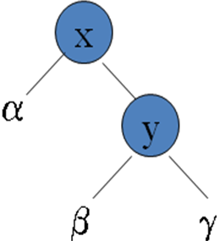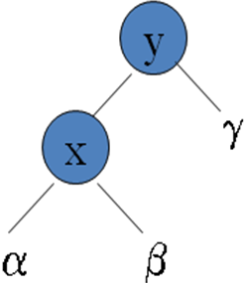
LR(T,x)

RR(T,y)

