STAR
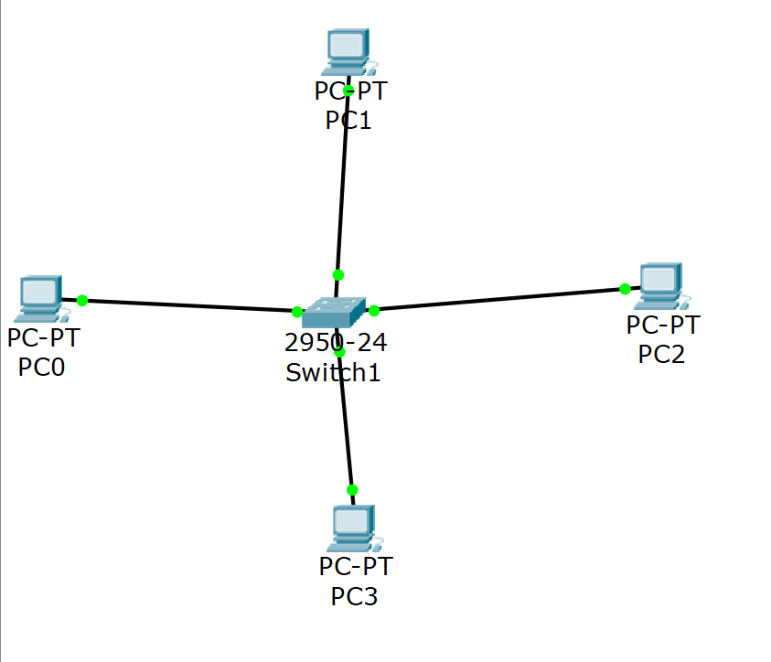
How to build this in Packet Tracer
1
Open Cisco Packet Tracer → click New (blank workspace)
2
From the bottom panel, select End Devices → drag 4 PC-PT icons onto the workspace (PC0, PC1, PC2, PC4)
3Select Network Devices → Switches → drag 1 2950-24 switch to the center
4Select Connections (lightning bolt icon) → choose Copper Straight-Through cable
5Click each PC → select port FastEthernet0 → click Switch → select any free FastEthernet port. Repeat for all 4 PCs
6
Assign IPs: double-click each PC → Desktop tab → IP Configuration → set:
PC0: 192.168.1.1 / PC1: 192.168.1.2 / PC2: 192.168.1.3 / PC4: 192.168.1.4
Subnet mask: 255.255.255.0 for all
7
Test: PC0 → Desktop → Command Prompt → type ping 192.168.1.3 → should say Successful

RING
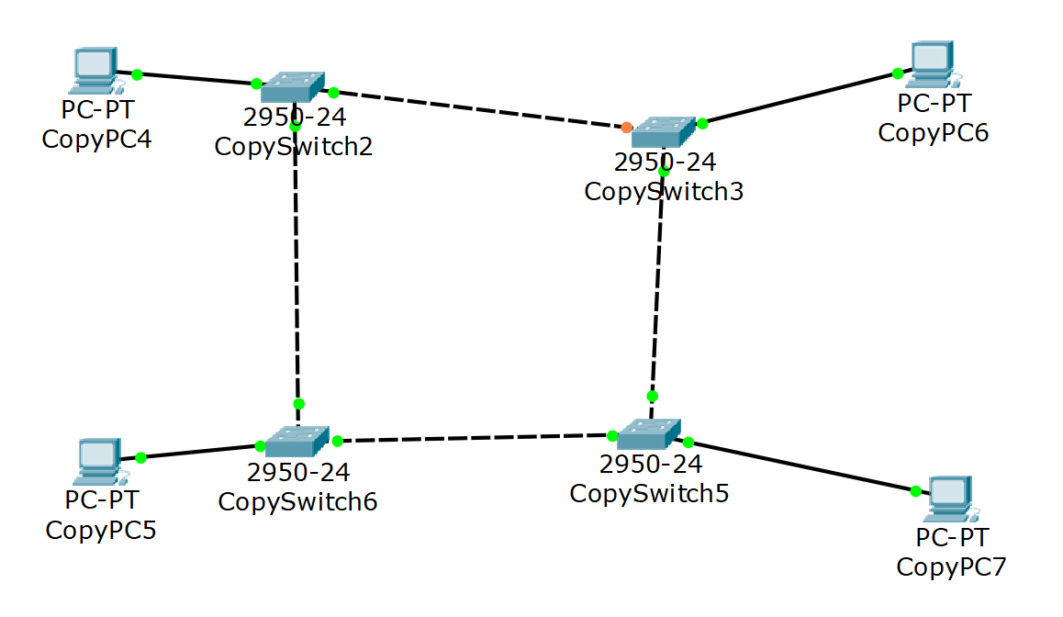

How to build this in Packet Tracer
1
Add 4 switches (2950-24) and 4 PCs to the workspace
2
Connect each PC to its nearest switch using Copper Straight-Through cable (PC0 → Switch2, PC1 → Switch0, PC2 → Switch3, PC3 → Switch1)
3
Connect switches in a ring using Copper Cross-Over cable:
Switch0 ↔ Switch1 ↔ Switch3 ↔ Switch2 ↔ Switch0
4
Assign IPs to all 4 PCs (192.168.1.1 through .4, subnet 255.255.255.0)
5
Test with ping between PCs — data travels around the ring through the switches

MESH
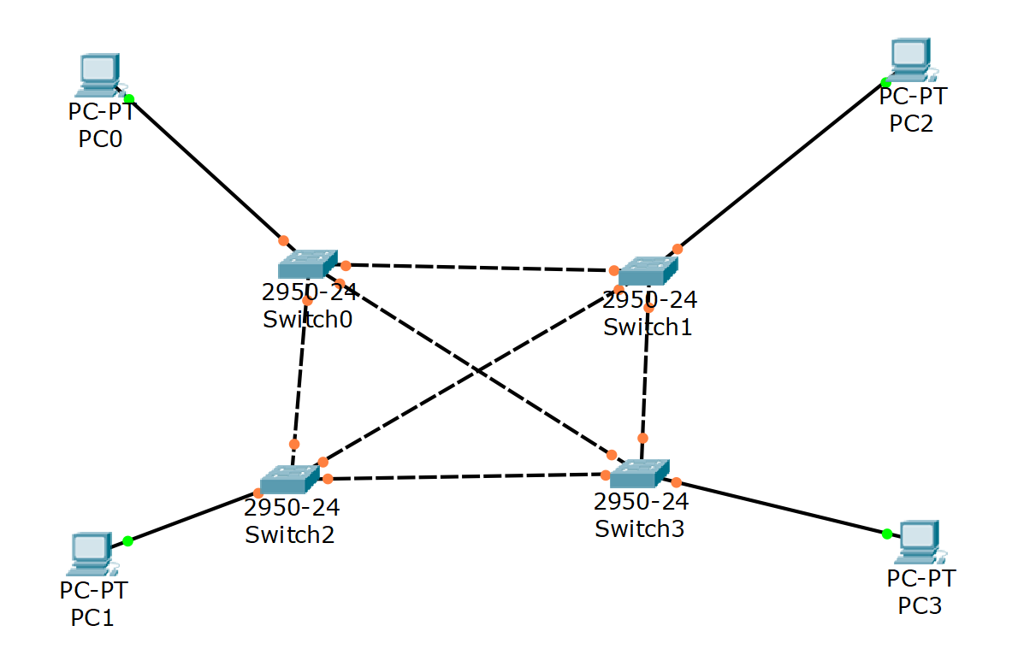
How to build this in Packet Tracer
1
Add 4 switches (2950-24) and 4 PCs to the workspace
2
Connect each PC to its switch using Copper Straight-Through
3
Connect every switch to every other switch using Crossover cables — that's 6 switch-to-switch links total:
SW0↔SW1, SW0↔SW2, SW0↔SW3, SW1↔SW2, SW1↔SW3, SW2↔SW3
4
Assign IPs (192.168.1.1–.4) and test with ping
💡 Mesh has multiple paths — if one link fails, data finds another route

BUS
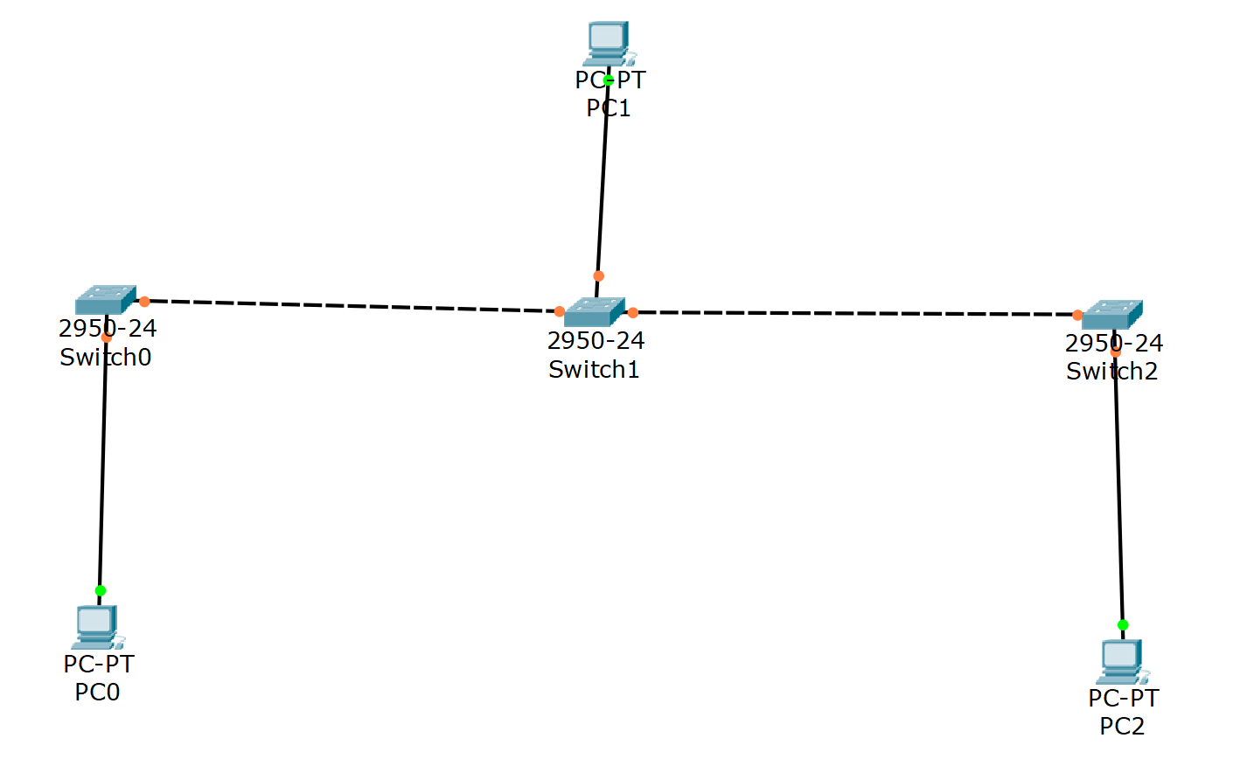
How to build this in Packet Tracer
1
Add 3 switches and 3 PCs to the workspace — arrange them in a straight line
2
Connect each PC to its switch: PC0 → Switch0, PC1 → Switch1, PC2 → Switch2 using Straight-Through cable
3
Connect switches in a line: Switch0 ↔ Switch1 ↔ Switch2 using Crossover cables
4
Assign IPs: PC0=192.168.1.1, PC1=192.168.1.2, PC2=192.168.1.3 (subnet 255.255.255.0)
5
Test connectivity: open Command Prompt on PC0 → ping 192.168.1.3

EXP3: LAN – BUILD ANY NW BTWN(STAR,RING MESH) AND USE COMMANDS
ping ip_address
ipconfig
ipconfig /all
netstat
tracert ip_address
nslookup www.hello.com
arp -a

FOR WAN WITH ROUTER – IN ROUTER CLI
enable
conf t
configure terminal
interface portname
ip adddress ip subnet
hostname name
show ip route

EXP3- WAN
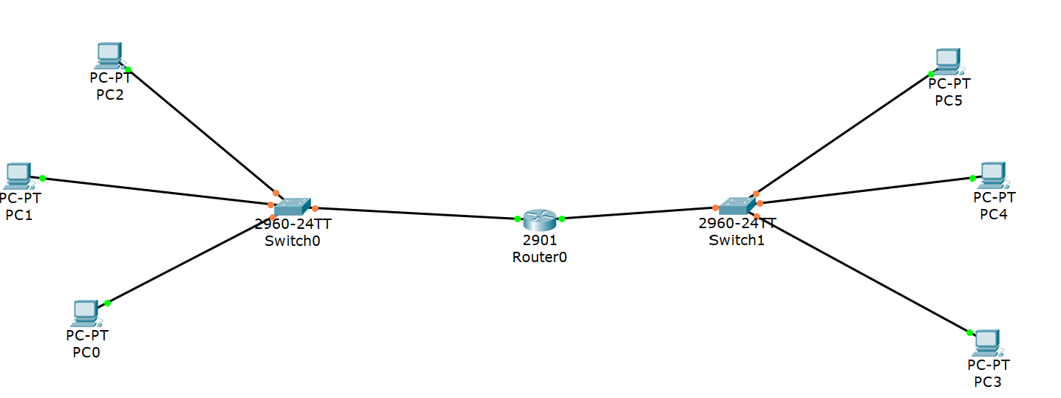

PC0,PC2 -10.10.0.0 – 10.10.0.2 -- LEFT ROUTER CABLE—10.10.0.0
PC3 – PC5 – 20.20.0.1 – 20.20.0.2 – RIGHT ROUTER CABLE 20.20.0.0

EXP – SUBNETING
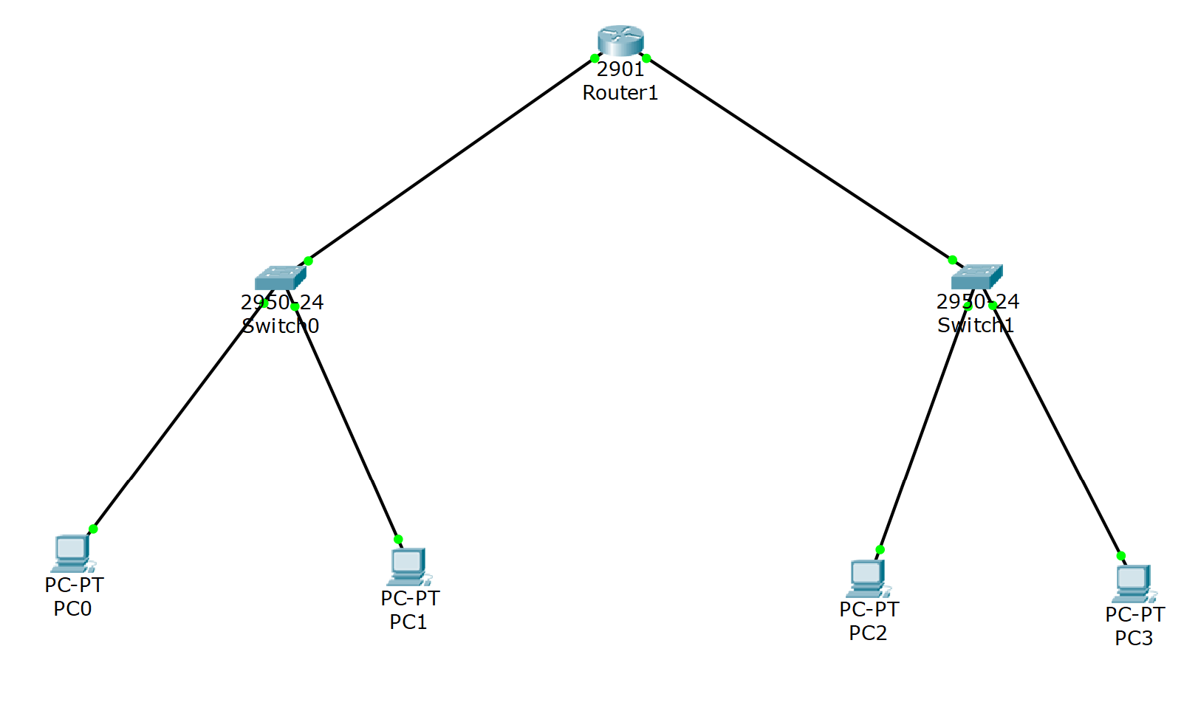

From your output PDF the setup is:
Subnet 1 — 192.168.0.0/25
- PC0 → 192.168.0.1 / 255.255.255.128 / Gateway 192.168.0.3
- PC1 → 192.168.0.2 / 255.255.255.128 / Gateway 192.168.0.3
- Router Fa0/0 → 192.168.0.3 / 255.255.255.128
Subnet 2 — 192.168.0.128/25
- PC2 → 192.168.0.129 / 255.255.255.128 / Gateway 192.168.0.131
- PC3 → 192.168.0.130 / 255.255.255.128 / Gateway 192.168.0.131
- Router Fa0/1 → 192.168.0.131 / 255.255.255.128
OP :
ALL PCS – IP CONFIG SCREENSHOT, ROUTER IP CONFIG, CND PING

EXPT5: SWITCH
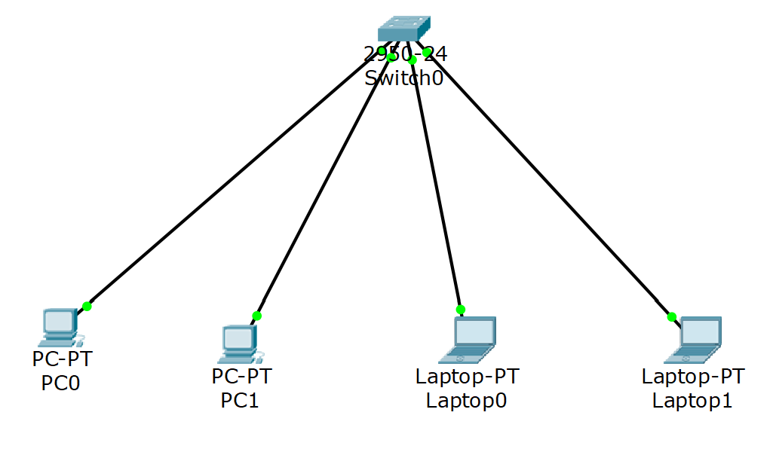
PCO – LAST, -- 192.168.1.1 TO 192.168.1.4
HUB –
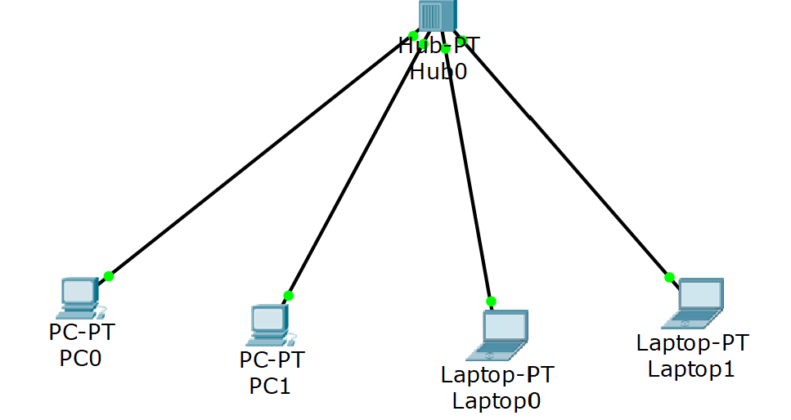
SAME

EXP5 – ROUTER SWITCH – SAME AS SUBNETTING

From your output PDF the setup is:
Subnet 1 — 192.168.0.0/25
- PC0 → 192.168.0.1 / 255.255.255.128 / Gateway 192.168.0.3
- PC1 → 192.168.0.2 / 255.255.255.128 / Gateway 192.168.0.3
- Router Fa0/0 → 192.168.0.3 / 255.255.255.128
Subnet 2 — 192.168.0.128/25
- PC2 → 192.168.0.129 / 255.255.255.128 / Gateway 192.168.0.131
- PC3 → 192.168.0.130 / 255.255.255.128 / Gateway 192.168.0.131
- Router Fa0/1 → 192.168.0.131 / 255.255.255.128
OP – SIMULATION PANEL

EXP6:
DHCP WIRED:
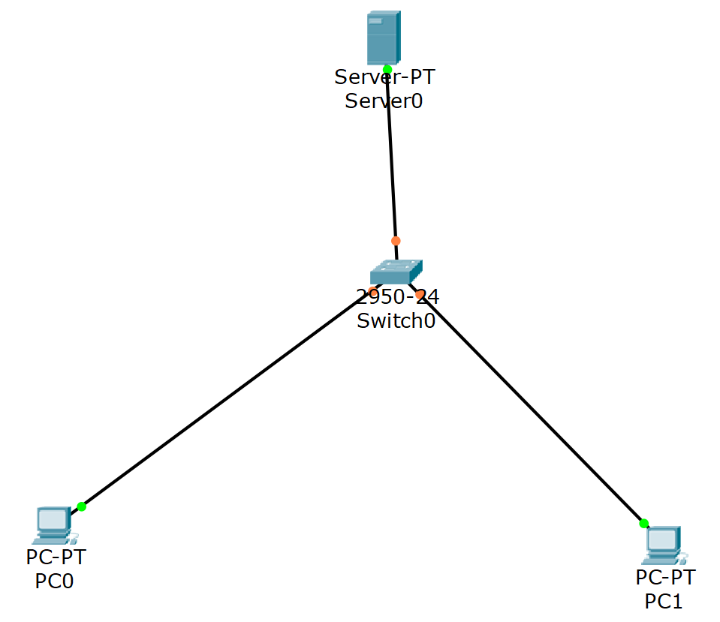
SERVER – IP : 10.0.0.1,, DEFAULT,DNS -0.0.0.0
SERVICESS – DHCP -- > DEFAULT : 10.0.0.1 --- SAVE AND SERVICE ON
CHECK IP – ADDRESS OF ALL DEVICES AND TAKE SS AND OF SERVER

EXP 6 – WIRELESS
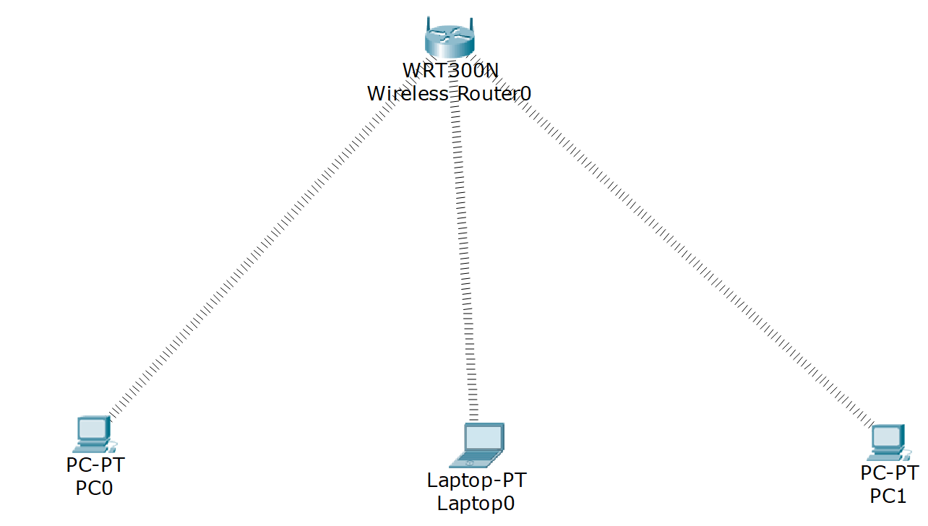

ROUTER – GUI AUTOMATIC – SAVE SETTINGS
PC, LAPTOP --- PHYSICAL OFF PC – REMOVE THEN ADD W300 ON PC FOR ALL
PC PC WIRELESS – CONNECT DEFAULT CONNECT
PING, TAKE SS OF ROUTER , LAPTOP,PC , DHCP IP

EXP 7—WEB SERVER CONFIG, AND 9.1- HTTP CONFIG :
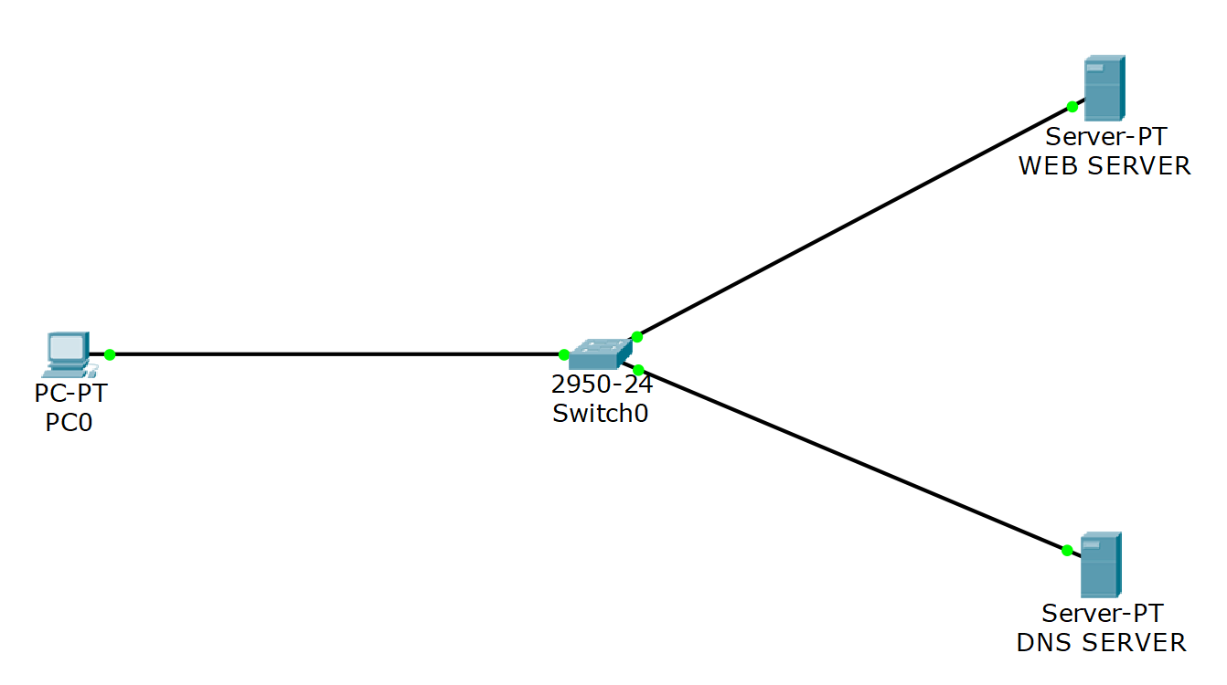

WEB SERVER : IP – 192.168.1.2, DNS - 192.168.1.1 – SERVICES – INDEX HTML -EDIT - SAVE
DNS : IP – 192.168.1.1, IP – 192.168.1.1, SERVICES DNS NAME AND ADDRESS - 192.168.1.2, SAVE AND
PC – GIVE IP 192.168.1.3, - WEB BROWSER – URL/IP

OP -SC – IP OF PCS , SERVER DNS – HTTP, HTML , WEBPAGE

EXP 10:
Given by sir:
import math
def gcd(a, h):
temp = 0
while(1):
temp = a % h
if (temp == 0):
return h

a = h
h = temp

p = 3
q = 7
n = p * q
e = 2
phi = (p - 1) * (q - 1)

while (e < phi):

# e must be co-prime to phi and
# smaller than phi.
if (gcd(e, phi) == 1):
break
else:
e = e + 1

# Private key (d stands for decrypt)
# choosing d such that it satisfies
# d*e = 1 + k * totient

k = 2
d = (1 + (k * phi)) / e

# Message to be encrypted
msg = 12.0

print("Message data = ", msg)

# Encryption c = (msg ^ e) % n
c = pow(msg, e)
c = math.fmod(c, n)
print("Encrypted data = ", c)

# Decryption m = (c ^ d) % n
m = pow(c, d)
m = math.fmod(m, n)
print("Original Message Sent = ", m)

COMPRESSED :
def gcd(a,b):

while b: a,b=b,a%b

return a

p,q=3,7

n=p*q

phi=(p-1)*(q-1)

e=2

while gcd(e,phi)!=1: e+=1

d=pow(e,-1,phi)

msg=12

c=pow(msg,e,n)

m=pow(c,d,n)

print(msg,c,m)

RIP , OSPF, BGP – NETWORK – IP, CLOCK IS ALSO SAME
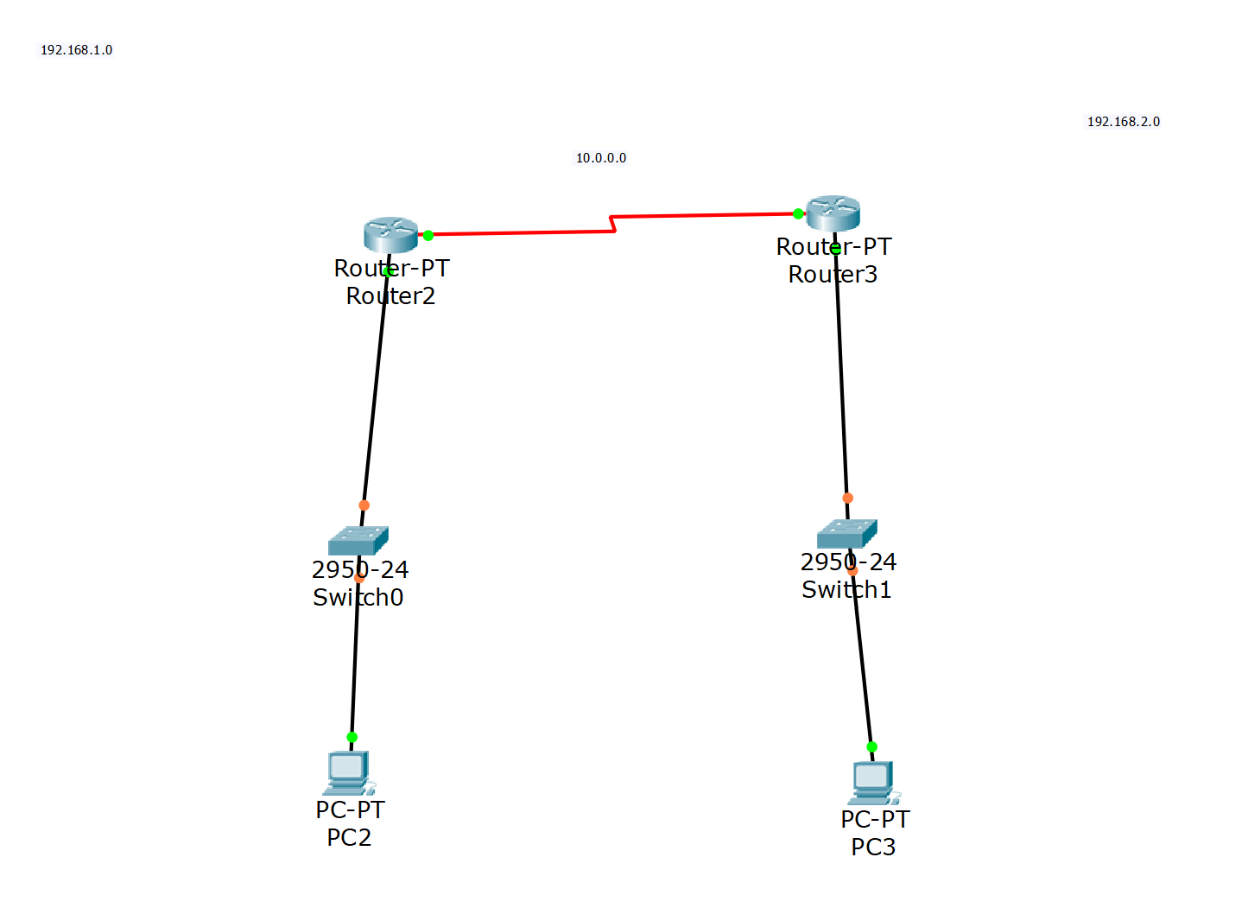

SERIAL2/0 PORTS ARE HORIZONTAL – IP – 10.0.0.2 AND FROM RIGHT – 10.0.0.03, LEFT CLOCK 64, RIGHT NOT SET
GO INTO RIP IN EACH – AD 10.0.0.0 AND 192.168.1.0 AND RIGHT ONES DIFF

OSPF Router 1
enable
conf t

router ospf 1
network 192.168.2.0 0.0.0.255 area 0
network 10.0.0.0 0.0.0.255 area 0
OSPF both Routers
conf t
no ip route 192.168.2.0 255.255.255.0 10.0.0.2
no ip route 192.168.0.0 255.255.255.0 10.0.0.1
end

BGP Router 0
enable
conf t
interface fastEthernet0/0
ip address 192.168.0.1 255.255.255.0
no shutdown
exit
interface fastEthernet1/0
ip address 10.0.0.1 255.255.255.0
no shutdown
exit
ip route 192.168.2.0 255.255.255.0 10.0.0.2
BGP Router 1
enable
conf t
interface fastEthernet0/0
ip address 192.168.2.1 255.255.255.0
no shutdown
exit
interface fastEthernet1/0
ip address 10.0.0.2 255.255.255.0
no shutdown
exit

ip route 192.168.0.0 255.255.255.0 10.0.0.1

FTP:
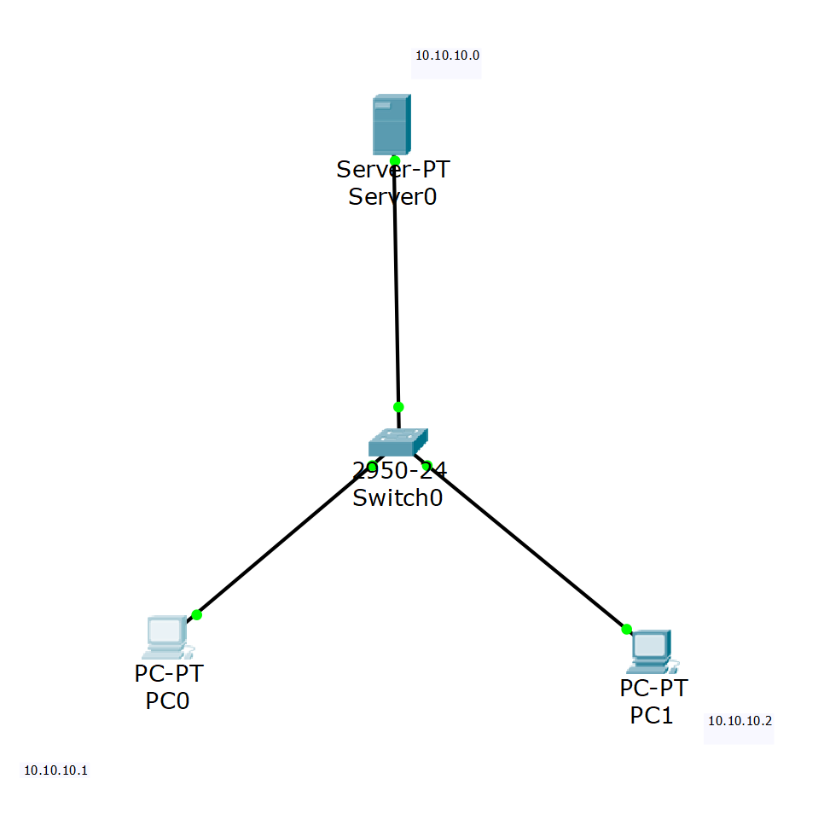
GO TO SERVER:
TURN ALL OFF EXCEPT FTP – ADD USERNAME AND PASSWORD
PC – ipconfig
ftp serverip
add id and password
dir
make text file – add and save in .html
go back to pc
put filename.html
dir
FTP
Take server0
PC 0
Switch
Server ip
192.168.0.1
Defaul Gateway
0.0.0.0
PC IP
192.168.0.2
PC Gateway
192.168.0.1
Go on server
Services and turn off
all services
PC0 Cmd code
ipconfig
ftp 192.168.0.1
pass 123
ftp>dir
help
Go to Text editor
Save file .html
PC0 Cmd code
put ___.html
dir

telnet and ssh have same structure:
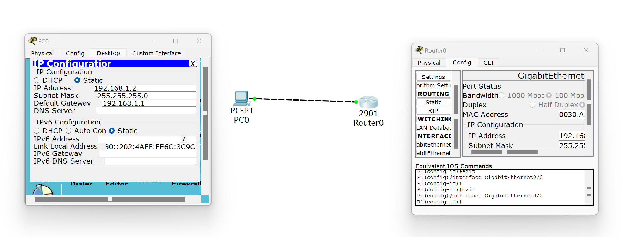
TELNET Router 0
conf t
interface fastEthernet0/0
ip address 192.168.1.1 255.255.255.0
no shutdown
exit
hostname R1
enable secret rp
line vty 0 5
password tp
login
exit
TELNET PC 0
ping 192.168.0.1
ipconfig

SSH CLI code
Router 0
PC 0
Switch 0
! R1 Configuration:
en
config t
hostname R1
int f0/0
ip add 192.168.1.1 255.255.255.0
no sh
enable password abc
ip domain-name abc
username abc password abc
crypto key generate rsa
ans--2048
ip ssh version 2
line vty 0 4
transport input ssh
login local
press ctrl z
PC0 Cmd
Ssh –l abc 192.168.1.1
Password:abc
En
Sh ip int br

