# 

Sprint report one

# **Team 3**

Sam Halali

Johan Andersson

Nandha Gopal Elangovan

David Fogelberg

Gunnar Gunnarsson

Jonathan Granstrom

Miguel Angel Sanchez Cifo

# 

# 

# 

# **Project Description**

**Project Title : H4U ( search for doctor) App**

**Platform :** Android studio

**Minimum and target SDK :** 5.0

**Programming language :** Java

The “H4U” app helps a user search for hospitals, pharmacies and doctors including; doctor details, doctor availability and doctor reputation. It will also show the directions to each hospital by showing the route map. The route map will be set from a user’s current location and will show both a visual and descriptive way of the route, which will make it easy for a user to find the hospital location.

**Sprint Log**

**First Day of Sprint 1 : 2017/03/23.**

**Last Day of Sprint 1 : 2017/04/05.**

**User Stories :**

|  |  |
| --- | --- |
| **Id** | **User stories** |
| #2 | As a user i want to be able to search for doctors |
| #3 | As a user, I want to be able to search for hospitals |
| #4 | As a user I want to be able to make an emergency call |
| #5 | As a user i want to be able to search for pharmacy |
| #7 | As a user i want to be able to create my own profile |
| #8 | As a user, I want to be able get directions to hospitals |
| #9 | As a user i want to be able to schedule appointments |
| #10 | As a user I want to be able to get directions to a pharmacy |
| #11 | As a user i want to be able to consult with a doctor |
| #12 | As a user, I want to able to see all the nearest hospitals in my area |
| #13 | As a user i want to be able to update my profile |
| #14 | As a user I want to be able to set medicine reminders |

## **Commitment**

**Sprint 1**

|  |  |  |
| --- | --- | --- |
| ID | User stories | Tasks |
|  |  |  |
|  |  |  |
|  |  |  |
|  |  |  |
|  |  |  |
|  |  |  |
|  |  |  |
|  |  |  |
|  |  |  |

## **Work done**

|  |  |  |  |  |
| --- | --- | --- | --- | --- |
| **Feature** | **Commits** | **Group members** | **Effort** | **Practices** |
| Name and ID of each feature | Sha1 for the commit(s) that make up the feature | Names of the group members who developed the feature | The development effort expended, in story points or other unit of choice | The agile practices practiced when developing the feature |

## **Reflections**

Sprint one started with project proposal , where we have panel discussion with some brainstorming sessions to initiate the ideas, later we came up with the project proposal. Once after the approval from the owner side, we started with eliciting the user stories and tasks ,with reference to the agile principles we prioritize the user stories and task, created abstract reference for each task.

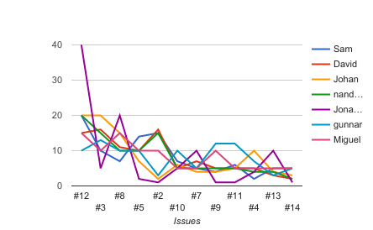

***Figure 1: Prioritized user stories and tasks***

***Github url :*** [***https://github.com/lol2kpe/EDA397_Team3***](https://github.com/lol2kpe/EDA397_Team3) ***.***