sex_comparison

Nick Fox

Friday, March 27, 2015

## The following are the analyses from my Masters progress report, looking at how treatment affects performance within sex.

### Females: latency to find platform

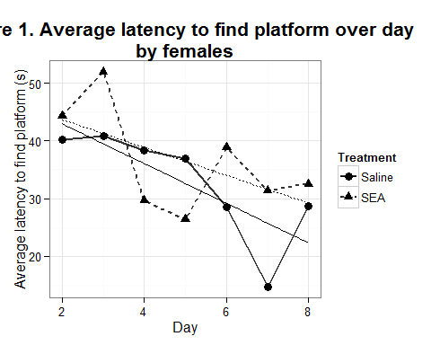

##   
## Error: Animal  
## Df Sum Sq Mean Sq  
## Treatment 1 70.38 70.38  
##   
## Error: Within  
## Df Sum Sq Mean Sq F value Pr(>F)   
## Treatment 1 1481 1481.5 6.564 0.012213 *   
## Day 1 2880 2879.5 12.758 0.000593 ***  
## Treatment:Day 1 238 238.4 1.056 0.307028   
## Residuals 83 18733 225.7   
## ---  
## Signif. codes: 0 '***' 0.001 '**' 0.01 '*' 0.05 '.' 0.1 ' ' 1

### Females: distance traveled

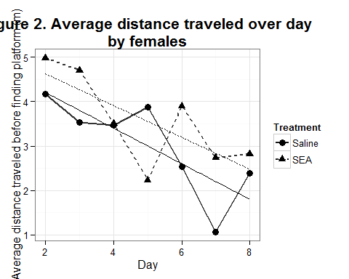

##   
## Error: Animal  
## Df Sum Sq Mean Sq  
## Treatment 1 0.3626 0.3626  
##   
## Error: Within  
## Df Sum Sq Mean Sq F value Pr(>F)   
## Treatment 1 4.65 4.652 3.689 0.05820 .   
## Day 1 9.29 9.293 7.370 0.00806 **  
## Treatment:Day 1 0.02 0.015 0.012 0.91276   
## Residuals 83 104.65 1.261   
## ---  
## Signif. codes: 0 '***' 0.001 '**' 0.01 '*' 0.05 '.' 0.1 ' ' 1

### Females: average speed

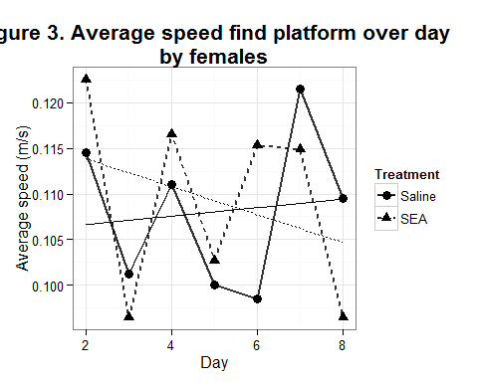

##   
## Error: Animal  
## Df Sum Sq Mean Sq  
## Treatment 1 0.004217 0.004217  
##   
## Error: Within  
## Df Sum Sq Mean Sq F value Pr(>F)  
## Treatment 1 0.00001 0.0000067 0.004 0.948  
## Day 1 0.00020 0.0001997 0.129 0.721  
## Treatment:Day 1 0.00028 0.0002836 0.183 0.670  
## Residuals 72 0.11153 0.0015490

### Males: Latency to find platform

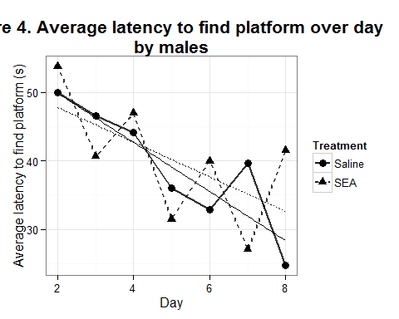

##   
## Error: Animal  
## Df Sum Sq Mean Sq  
## Treatment 1 841.1 841.1  
##   
## Error: Within  
## Df Sum Sq Mean Sq F value Pr(>F)   
## Treatment 1 480 480 1.491 0.224050   
## Day 1 3966 3966 12.319 0.000593 ***  
## Treatment:Day 1 168 168 0.523 0.470827   
## Residuals 149 47965 322   
## ---  
## Signif. codes: 0 '***' 0.001 '**' 0.01 '*' 0.05 '.' 0.1 ' ' 1

### Males: distance traveled

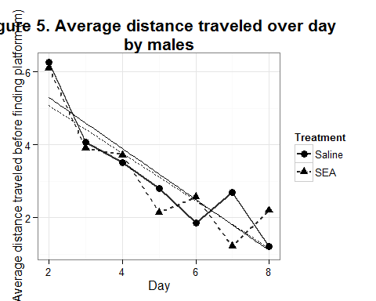

##   
## Error: Animal  
## Df Sum Sq Mean Sq  
## Treatment 1 2.326 2.326  
##   
## Error: Within  
## Df Sum Sq Mean Sq F value Pr(>F)   
## Treatment 1 3.27 3.27 2.091 0.150   
## Day 1 110.07 110.07 70.322 3.53e-14 ***  
## Treatment:Day 1 0.98 0.98 0.628 0.429   
## Residuals 149 233.23 1.57   
## ---  
## Signif. codes: 0 '***' 0.001 '**' 0.01 '*' 0.05 '.' 0.1 ' ' 1

### Males: average speed

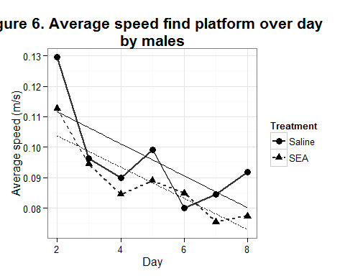

##   
## Error: Animal  
## Df Sum Sq Mean Sq  
## Treatment 1 0.007629 0.007629  
##   
## Error: Within  
## Df Sum Sq Mean Sq F value Pr(>F)   
## Treatment 1 0.01152 0.011523 6.171 0.0141 *   
## Day 1 0.01655 0.016551 8.863 0.0034 **  
## Treatment:Day 1 0.00000 0.000003 0.001 0.9707   
## Residuals 149 0.27824 0.001867   
## ---  
## Signif. codes: 0 '***' 0.001 '**' 0.01 '*' 0.05 '.' 0.1 ' ' 1

## The following is a new analysis, looking to see how sex affects performance, within treatment condition.

### Saline treated: Latency to find platform

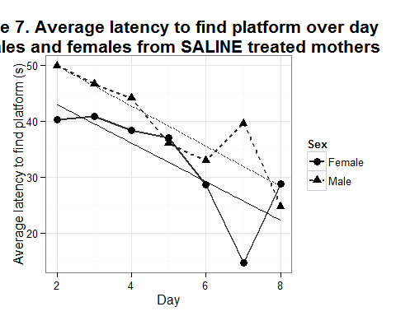

##   
## Error: Animal  
## Df Sum Sq Mean Sq  
## Sex 1 1425 1425  
##   
## Error: Within  
## Df Sum Sq Mean Sq F value Pr(>F)   
## Sex 1 671 670.8 2.277 0.13460   
## Day 1 2853 2852.8 9.682 0.00244 **  
## Sex:Day 1 257 256.7 0.871 0.35292   
## Residuals 97 28580 294.6   
## ---  
## Signif. codes: 0 '***' 0.001 '**' 0.01 '*' 0.05 '.' 0.1 ' ' 1

### Saline treated: Distance traveled

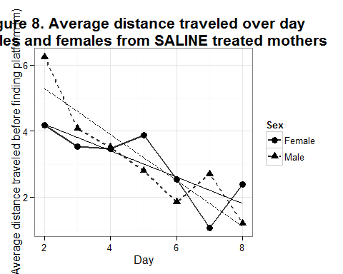

##   
## Error: Animal  
## Df Sum Sq Mean Sq  
## Sex 1 0.9278 0.9278  
##   
## Error: Within  
## Df Sum Sq Mean Sq F value Pr(>F)   
## Sex 1 2.26 2.26 1.844 0.17759   
## Day 1 54.12 54.12 44.150 1.78e-09 ***  
## Sex:Day 1 10.55 10.55 8.610 0.00417 **   
## Residuals 97 118.91 1.23   
## ---  
## Signif. codes: 0 '***' 0.001 '**' 0.01 '*' 0.05 '.' 0.1 ' ' 1

### Saline treated: Average speed

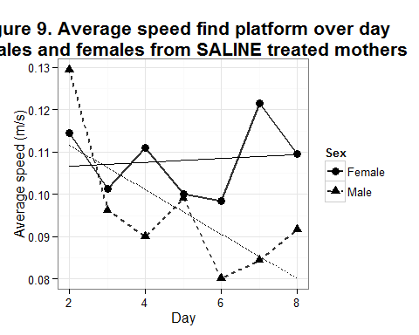

##   
## Error: Animal  
## Df Sum Sq Mean Sq  
## Sex 1 0.0006405 0.0006405  
##   
## Error: Within  
## Df Sum Sq Mean Sq F value Pr(>F)   
## Sex 1 0.04659 0.04659 30.059 2.15e-07 ***  
## Day 1 0.00769 0.00769 4.958 0.0277 *   
## Sex:Day 1 0.00160 0.00160 1.032 0.3116   
## Residuals 128 0.19839 0.00155   
## ---  
## Signif. codes: 0 '***' 0.001 '**' 0.01 '*' 0.05 '.' 0.1 ' ' 1

### SEA treated: Latency to find platform

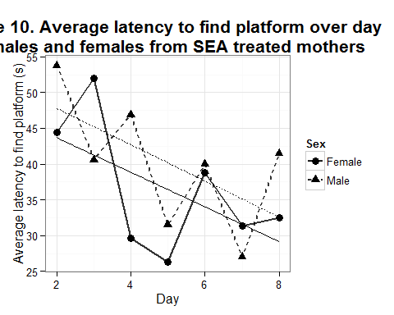

##   
## Error: Animal  
## Df Sum Sq Mean Sq  
## Sex 1 145.7 145.7  
##   
## Error: Within  
## Df Sum Sq Mean Sq F value Pr(>F)   
## Sex 1 2343 2343 8.544 0.004066 **   
## Day 1 3992 3992 14.556 0.000206 ***  
## Sex:Day 1 150 150 0.548 0.460248   
## Residuals 135 37023 274   
## ---  
## Signif. codes: 0 '***' 0.001 '**' 0.01 '*' 0.05 '.' 0.1 ' ' 1

### SEA treated: Distance traveled

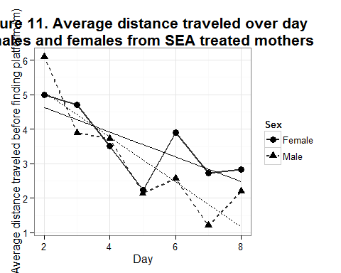

##   
## Error: Animal  
## Df Sum Sq Mean Sq  
## Sex 1 0.01151 0.01151  
##   
## Error: Within  
## Df Sum Sq Mean Sq F value Pr(>F)   
## Sex 1 10.40 10.40 6.511 0.0118 *   
## Day 1 45.98 45.98 28.790 3.41e-07 ***  
## Sex:Day 1 9.70 9.70 6.076 0.0150 *   
## Residuals 135 215.62 1.60   
## ---  
## Signif. codes: 0 '***' 0.001 '**' 0.01 '*' 0.05 '.' 0.1 ' ' 1

### SEA treated: Average speed

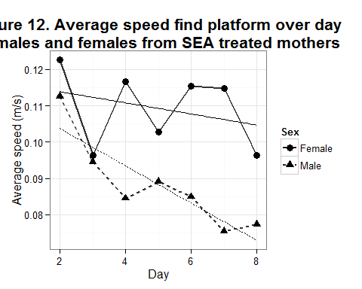

##   
## Error: Animal  
## Df Sum Sq Mean Sq  
## Sex 1 0.0006405 0.0006405  
##   
## Error: Within  
## Df Sum Sq Mean Sq F value Pr(>F)   
## Sex 1 0.04659 0.04659 30.059 2.15e-07 ***  
## Day 1 0.00769 0.00769 4.958 0.0277 *   
## Sex:Day 1 0.00160 0.00160 1.032 0.3116   
## Residuals 128 0.19839 0.00155   
## ---  
## Signif. codes: 0 '***' 0.001 '**' 0.01 '*' 0.05 '.' 0.1 ' ' 1