Understanding the Role of T cell Activity in Generating the Neurodevelopmental Consequences Associated with Maternal Infection

A Four Month Update

Nick Fox

Tuesday, March 03, 2015

##   
## Attaching package: 'dplyr'  
##   
## The following object is masked from 'package:stats':  
##   
## filter  
##   
## The following objects are masked from 'package:base':  
##   
## intersect, setdiff, setequal, union

# **Summary**

The following is a 4-month update on my Masters project. As of March 5th, 2015, I have completed Aim 1 of my proposal and am preparing to start Aim 2.

## *Research Aim 1*

Assess the effect the effect of T cell-specific maternal immune activation on the generation of schizophrenic-associated behavioral deficits in adult progeny.

### **Methods**

#### Animals

Experiments for Aim 1 were conducted using C57BL/6 mice bred in our vivarium (Psychology Building, Busch Campus, Rutgers University New Jersey). Animals were housed 3-4 per cage with siblings of the same sex under a 12:12h light:dark cycle (lights on at 5:30a). Food and water was available ad libitum. All experiments were conducted in accordance with the Guide for the Care and Use of Laboratory Animals as adopted by the National Institutes of Health, and approved by the Rutgers Institutional Animal Care and Use Committee.

#### Animal Breeding

Pregnant females were generated by housing two females with one male. Females were checked daily for the presence of a sperm plug, which was evidence of copulaltion. The day a sperm plug was identified was considered embryonic day 0.5 (E0.5). Females observed with a sperm plug were removed from the breeding cage and singly housed. Regardless of sperm plug, body weight was measured twice a week for evidence of developing pregnancy. Females with progressively increasing body weight were singly housed before birth. Pregnant females gave birth between E20 and E21. Pups were weaned from their mother on postnatal day 21 (PN21), with weekly cage changes. On PN21, pups will be sexed and housed with same sex siblings in new cages.

#### Staphylococcal Enterotoxin A Administration

Three pregnant females were injected intraperitoneally (IP) with 200ug/kg of staphylococcal enterotoxin A (SEA) in 200ul on day E12.5. Another three pregnant females were IP injected with 200ul physiological saline and acted as control animals.

#### Behavioral Measures

##### Four Platform Water Radial Arm Maze

I replaced the proposed Morris Water Maze (MWM) task with the four platform water radial arm maze (4wRAM) after a recent publication by Vorhees and Williams (2014) suggested the wRAM was a more sensitive tool for investigating teratogenic effects. This maze consists of eight arms radiating from a central hub. The entire maze is filled with 22C water and made opaque with white tempera paint. The maze exists in an environment rich in spatial cues. Four platforms are submerged 1-2cm below the surface of the water in four different arms. No more than two adjcent arms may contain platforms. Animals are run for four trials per day for a total of 12 days. Animals start at the end of one arm and are allowed to explore the maze for 120 seconds. When they find a platform, the trial is ended, the animal is taken out of the maze, as is the platform they found. After a 45 second inter-trial interval, the animal is returned to the maze (now with only three platforms), and again allowed to explore for 120 seconds. Trials 3 and 4 follow, with only one platform existing in the maze in the last trial.

The outcome from this task is measured by two types of errors: Working Memory Correct (WMC) errors, and Reference Memory (RM) errors. A WMC error is an entry into an arm that had been previously used to escape the maze. A RM error is an entry into an arm that had never had a platform.

##### Single Platform Radial Arm Maze

I also used a single platform radial arm maze (1wRAM) to more directly test spatial learning as in the traditional MWM. This maze uses the same apparatus as the 4wRAM, though only has one platform. This platform remains in the same arm for all trials. Animals are run for four trials per day for a total of 8 days. On each trial, the animal starts in a randomized arm and is allowed to explore the maze for 60 seconds. When the animal finds the platform, the trial ends and the animal is removed from the maze.

The outcomes from this task are distance traveled, measured in meters, and latency to find the platform, measured in seconds.

##### Prepulse Inhibition

A behavioral model of prepulse inhibition designed for mice was utilized. Each animal was placed into a Colburn Instruments acoustic startle chamber. The chamber includes an acrylic tube (to contain the animal) which is mounted on an acrylic plate, under which is attached an accelerometer. The accelerometer measures the inflection of the animal/tube in response to acoustic stimulation. White noise was transmitted to the box via a speaker in the top of the chamber. Pulses of white noise was 120db. This pulse is intended to cause a starte. We had three levels of our prepulse, either 62db, 65db, or 68db (+2db, +5db, and +8db above background). Each pulse lasted for 40ms.

For "pulse alone" trials (S), only 40ms of the 120db white noise was provided. Inflection from this trial served as a positive control for startle. "Prepulse alone" trials (p) only consisted of 40ms of one of the three prepulse conditions and served as a negative control (prepulse tones should not be inherently startling, and we saw that they were not). Test trials (PPI-S) had both prepulse and pulse, separated by an inter-pulse interval of 100ms. Animals were exposed to 30 PPI-S trials, 15 S trials, and 15 p trials, randomly ordered. Each session began and ended with five S trials.

Percent scores for amount prepulse inhibition were calculated as %PPI = 100 * (S - PPI-S) / S. Scores closer to 0% were considered evidence of less prepulse inhibition.

### **Results**

##### Four Platform Working Memory

The learning curve, measured by WMC errors is shown in Figure 1, and the learning curve measured by RM errors is shown in Figure 2.

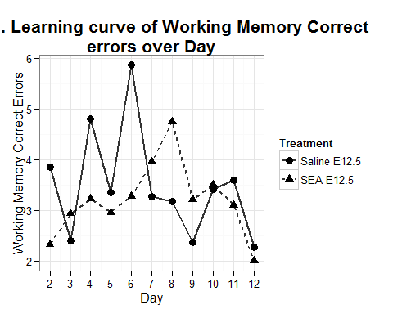

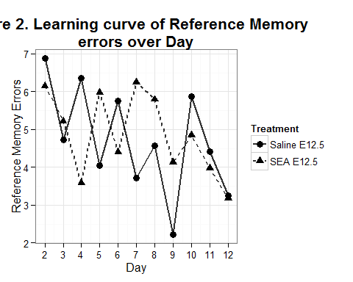

One-between (treatment) and one-within (Day) repeated measures ANOVAs revealed a main effect of Treatment for Working Memory Correct errors (F(1, 257) = 5057, p < 0.05), but not for Reference Memory errors (F(1, 257) = 0.98, p > 0.05). We found a significant main effect of Day for Reference Memory errors (F(1, 257) = 16.36, P < 0.001), but not for Working Memory Correct errors (F(1, 257) = 0.06, p > 0.05). We did not detect an interaction between Treatment and Day in our collected data.

To further investigate the learning curves, we analyzed the data trial-by-trial. Figure 3 shows the mean number of WMC errors by trial across days, and figure 4 shows the mean number of RM errors.

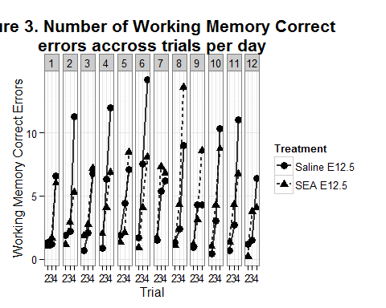

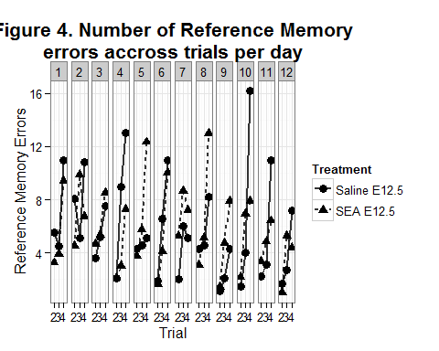

Animals make significantly more WMC errors (F(1, 92) = 265.78, p < 0.001) and RM errors (F(1, 92) = 121.51, p < 0.001) on trial 4 of a test day.

##### Single Platform Spatial Navigation

To investigate if our animals from treated mothers were able to learn to spatially navigate the wRAM using extramaze cues, we tested a 33 animals (22 males, 11 females) in the single platform water radial arm maze. Males and females were run in two separate experiments and are reported separately.

**Males**. The average distance traveled by males before finding the escape platform is shown in Figure 5.

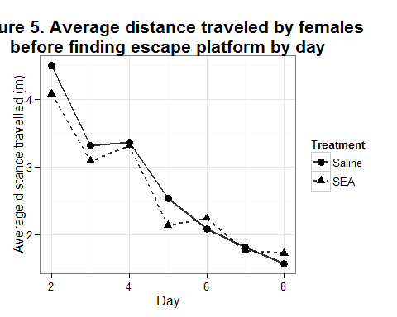

We found a main effect of Day (F(1, 149) = 70.32, p < 0.001), but not for Treatment (F(1, 149) = 2.09, p > 0.05) on the distance traveled before finding the escape platform.

The average latency for males to find the escape platform is shown in Figure 6.

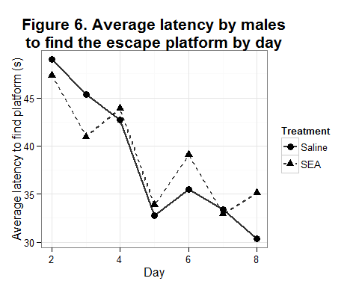

We found a main effect of Day (F(1, 149) = 12.32, p < 0.001), but not for Treatment (F(1, 149) = 1.49, p > 0.05) on the latency to find the escape platform.

**Females**. The average distance traveled by females before finding the escape platform is shown in Figure 7.

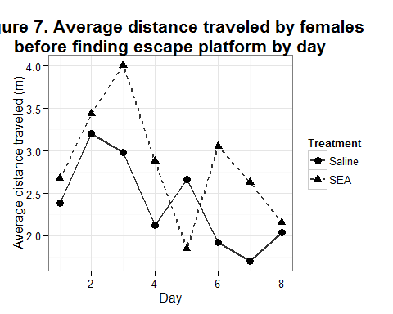

We found a main effect of Day (F(1, 83) = 7.37, p < 0.01), and a marginally significant main effect of Treatment (F(1, 83) = 3.69, p = 0.058) on the distance traveled before finding the escape platform.

The average latency for females to find the escape platform is shown in Figure 8.

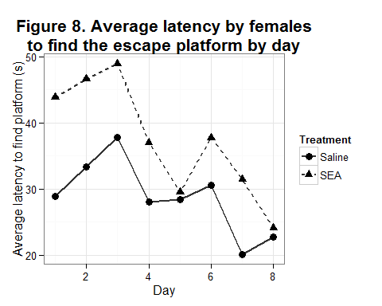

We found a main effect of Day (F(1, 83) = 12.76, p < 0.001), and a main effect of Treatment (F(1, 83) = 6.5, P < 0.05) on the latency to find the escape platform.

### Aim 1 Conclusions

After performing the 4wRAM, we decided that we had taken a few two many steps at once. Instead of testing spatial learning and working memory and reference memory, we decided to roll back to a more simple design. From that, we found that female offspring from mothers treated with SEA performed significantly differently at at the 1wRAM compared to offspring from saline treated mothers, measured both by how long it took them and how far they traveled before finding the escape platform.

In collecting data for Aim 2, we will specifically test for differences between male and female offspring to confirm this initial analysis from Aim 1.

## ------

## Research Aim 2

Assess the ability of T cell-specific maternal immune activation to sensitize progeny to repeated psychological stress in adolescence.

### Additional Methods

Methods of animal care, breeding, and SEA administration will remain as stated under Research Aim 1. Additional methods unique to Research Aim 2 follow below.

#### Chronic Psychological Stress

Psychological stress will be administered starting postnatal day 28 (PN28), or one week after weaning. Randomized stressors will be administered daily for fifteen weekdays. Animals will not be stressed over weekends. Stressors included are as follows:

1. four hours of restraint
2. two hours of exposure to foot shock chamber

* 10 foot shocks are administered at unpredictible intervals over the two hour period

1. two hours of exposure to whote noise chamber

* 40 bursts of white noise at randomized frequency and duration are administered over the two hour period

1. social disruption

* individual animals are introduced to a new cage with two long-term cagemates

1. circadian cycle disruption

* individuals are singly housed in a bright room overnight, robbing them of a dark phase that day.

This stress protocol (Stress Protocol 2) is someone altered from the stressors outlined in my proposal (Stress Protocol 1) - reasons for the change are under preliminary results below.

#### Additional Behavioral Measures

##### Elevated Plus Maze

The elevated plus maze is a four-armed maze that all radiate from a center area. Two opposite arms have tall perimeter walls. The other two arms are open. The entire maze is elevated one meter off of the ground. Animals were allowed to explore the maze for one trial of five minutes.

The outcome of this test is measured as the ratio of time spent in the open arms to the time spent in the closed arms. Ratio scores closer to zero will be evidence of anxious-like behavior.

##### Open Field / Novel Object

The open field is a 1 meter by 1 meter square maze with four large walls on the perimeter. Animals will be allowed to explore the maze for one trial of five minutes. After this trial, a novel object will be placed in the center of the maze. The object used is a large, weighted metal cylinder. After the object is in the maze, the animal is allowed to explore the maze for an additional five minutes.

One outcome of this test is measured as the ratio of time spent against the perimeter to the time spent in the exposed center area. Another outcome of interest is number of contacts with the novel object. Fewer contacts with the novel object and a smaller

### **Preliminary Results**

#### Chronic Psychological Stress

We piloted our chronic psychological stress paradigm ahead of starting Aim 2 to ensure our stressors were adequately stressful. To test this, we tested two different stress protocols. For each protocol, we had three conditions: "chronic stress", which received the full stress protocol, "acute stress", which was only stressed on the final day of the stress protocol, and "home cage control", which received no stress.

Figure 9 shows the percent body weight change of animals in each of the three stress conditions. put in the weight change over time graph here

Chronically stressed animals did not gain weight over the 14 day protocol, while the acute stress and homecage control animals did.

Figure 10 shows the ratio of time spent in the open arms to the time spent in the closed arms for animals in Stress Protocol 1. put in the cohort 1/2 stress graph here

Animals administered chronic stress spent a similar amount of time in the open arms of the maze as the the home cage controls. Acutely stressed animals spent less time in the open arms compared to either the chronicly stressed or the control animals.

Figure 11 shows the percent time spent in the exposed area in the open field with and without the novel object. put in the open field/novel object graph here

All three stressor groups spent more time in the center when the novel object was present, though the increase was most modest in the acute stress group.

Theoretically, the 14 days of chronic stress should be a compounding insult to the animal. Since the results of the previous experiments seemed to suggest our chronic stress animals were developing resilience to the stress condition, we altered the original stress protocol. The experiments for Stress Protocol 2 have just been completed (elevated plus maze and open field finished the week of March 1st, 2015), and analysis is not yet complete.

### Future Plan for Research Aim 2

The schedule for the final experiment of Research Aim 2 is outlined in Appendex 1. The experiment is a 2x2 design with maternal immune activation (MIA) and pubescent stress as the two factors. There will be 3 litters per cell. MIA mothers will receive treatment on day E12.5 of pregnancy. Animals assigned to pubescent stress will start receiving stress at PN28. Behavioral testing will begin when the offspring animals are 8 weeks old. Experimental groups are staggered to avoid delays when running animals in the longitudinal spatial learning task. I plan to be finished by October 4th, 2015, on schedule to defend at the departmental Masters day.