wram_working_memory_analysis

Nick Fox

Tuesday, March 03, 2015

This is the first pass at analyzing the wRAM working memory protocol in R. Things to do: Methods: 1) Animals 2) Immune Activation 3) Chronic Stress 4) Single Platform wRAM 5) Four Platform wRAM 6) Elevated Plus Maze 7) Open Field / Novel Object 8) Pre-Pulse Inhibition

Results: - working memory 4 platform wRAM - spatial learning 1 platform wRAM - low-grade chronic stress: body weight, EPM, OF, PPI - severe chronic stress: body weight, EPM, OF, PPI Future plans

##   
## Attaching package: 'dplyr'  
##   
## The following object is masked from 'package:stats':  
##   
## filter  
##   
## The following objects are masked from 'package:base':  
##   
## intersect, setdiff, setequal, union

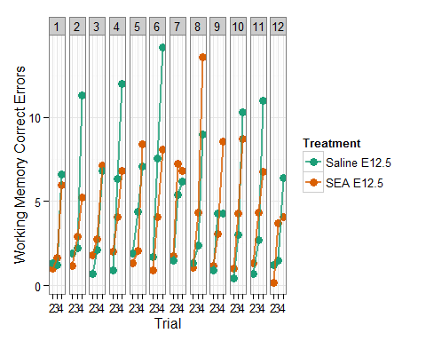

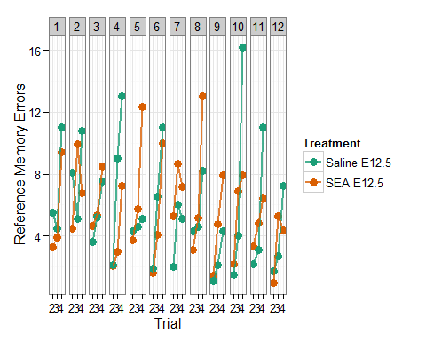

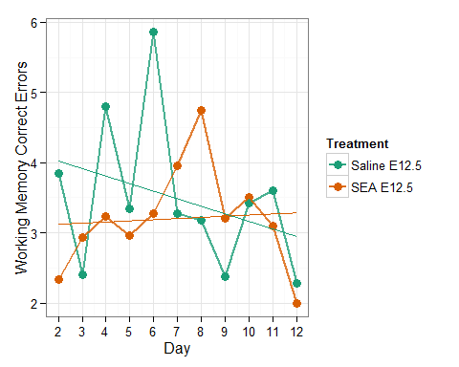

##   
## Error: Animal  
## Df Sum Sq Mean Sq  
## Treatment 1 0.4511 0.4511  
##   
## Error: Within  
## Df Sum Sq Mean Sq F value Pr(>F)  
## Day 1 0.459 0.4592 0.527 0.477  
## Treatment:Day 1 0.848 0.8482 0.974 0.337  
## Residuals 18 15.675 0.8708

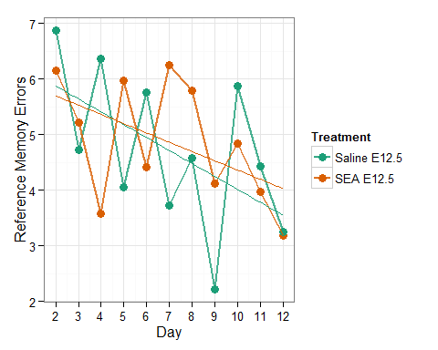

##   
## Error: Animal  
## Df Sum Sq Mean Sq  
## Treatment 1 0.1255 0.1255  
##   
## Error: Within  
## Df Sum Sq Mean Sq F value Pr(>F)   
## Day 1 8.793 8.793 7.044 0.0161 *  
## Treatment:Day 1 0.240 0.240 0.192 0.6664   
## Residuals 18 22.468 1.248   
## ---  
## Signif. codes: 0 '***' 0.001 '**' 0.01 '*' 0.05 '.' 0.1 ' ' 1

This next set of analyses comes from averaging the data by treatment per day. Each treatment (SEA or Saline) has 1 point per day. That point is the average of all of the measures made for the animals of that treatment that day.

# Females - Average Distance Traveled

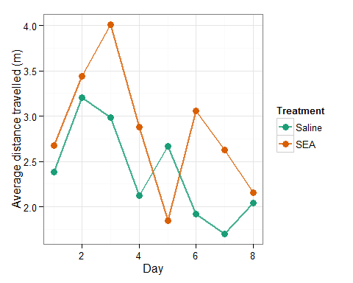

##   
## Error: Animal  
## Df Sum Sq Mean Sq  
## Treatment 1 0.3626 0.3626  
##   
## Error: Within  
## Df Sum Sq Mean Sq F value Pr(>F)   
## Treatment 1 4.65 4.652 3.689 0.05820 .   
## Day 1 9.29 9.293 7.370 0.00806 **  
## Treatment:Day 1 0.02 0.015 0.012 0.91276   
## Residuals 83 104.65 1.261   
## ---  
## Signif. codes: 0 '***' 0.001 '**' 0.01 '*' 0.05 '.' 0.1 ' ' 1

# Females - Average latency to find platform

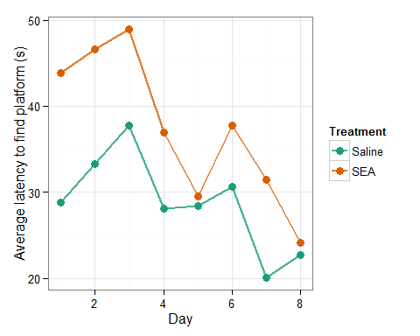

##   
## Error: Animal  
## Df Sum Sq Mean Sq  
## Treatment 1 70.38 70.38  
##   
## Error: Within  
## Df Sum Sq Mean Sq F value Pr(>F)   
## Treatment 1 1481 1481.5 6.564 0.012213 *   
## Day 1 2880 2879.5 12.758 0.000593 ***  
## Treatment:Day 1 238 238.4 1.056 0.307028   
## Residuals 83 18733 225.7   
## ---  
## Signif. codes: 0 '***' 0.001 '**' 0.01 '*' 0.05 '.' 0.1 ' ' 1

# Males - Average Distance Traveled

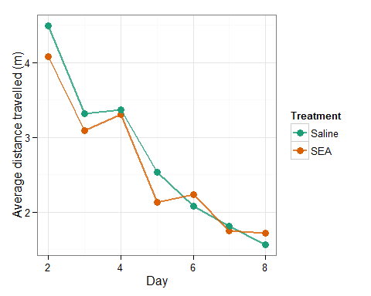

##   
## Error: Animal  
## Df Sum Sq Mean Sq  
## Treatment 1 2.326 2.326  
##   
## Error: Within  
## Df Sum Sq Mean Sq F value Pr(>F)   
## Treatment 1 3.27 3.27 2.091 0.150   
## Day 1 110.07 110.07 70.322 3.53e-14 ***  
## Treatment:Day 1 0.98 0.98 0.628 0.429   
## Residuals 149 233.23 1.57   
## ---  
## Signif. codes: 0 '***' 0.001 '**' 0.01 '*' 0.05 '.' 0.1 ' ' 1

# Males - Average latency to find platform

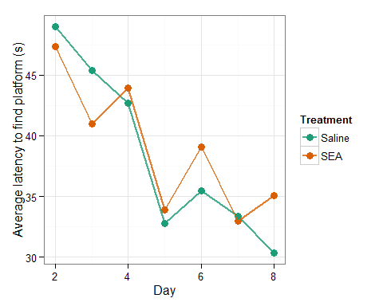

##   
## Error: Animal  
## Df Sum Sq Mean Sq  
## Treatment 1 841.1 841.1  
##   
## Error: Within  
## Df Sum Sq Mean Sq F value Pr(>F)   
## Treatment 1 480 480 1.491 0.224050   
## Day 1 3966 3966 12.319 0.000593 ***  
## Treatment:Day 1 168 168 0.523 0.470827   
## Residuals 149 47965 322   
## ---  
## Signif. codes: 0 '***' 0.001 '**' 0.01 '*' 0.05 '.' 0.1 ' ' 1

wram_raw_female3 <- wram_raw_female2 %>%  
 dplyr::group_by(Day, Treatment) %>%  
 dplyr::mutate(mean.latency = mean(avr.latency), sd.latency = sd(avr.latency), sem.latency = se(avr.latency), mean.distance = mean(avr.distance), sem.distance = se(avr.distance))