Test management tools

Accessing Testlink and Jenkins services

Accessing campus services (private network of the IT department) using SSH tunneling

This tutorial uses for example the Jenkins and Testlink services installed on machine 172.30.0.8 (private IP) and accessible (physically only connected to the network of the Campus Department) at the URLs:
http://172.30.0.8:8080
http://172.30.0.8/testlink
The SSH tunneling mechanism works similarly for any service or server hosted on a machine with a private IP address within the department's network. The necessary steps to access the two services from anywhere on the Internet, through SSH tunneling are:

Step 1. Connecting and authenticating
Students must log on to the server www.scs.ubbcluj.ro, the external SSH being open to students on port 8937. For students, the two putty commands look like this:

putty.exe -L 8080:172.30.0.8:8080 www.scs.ubbcluj.ro -P 8937
putty.exe -L 80:172.30.0.8:80 www.scs.ubbcluj.ro -P 8937

Step 2. Accessing the services
After successfully connecting and authenticating from step 1, keeping the putty connections open, the two services are available in your browser at the following addresses:
http://localhost:8080
http://localhost/testlink
Remarks:
- If only the individual use of Jenkins or Testlink is desired, only one of the putty commands from step 1 can be run individually.
- It is possible that ports 80 or 8080 on your local computer are occupied by other processes (other Web servers, various antivirus, Skype, etc.), other ports can be chosen, it is not mandatory that the local port be the same as the port on which run the service on the car you want to access.

putty.exe -L 8123:172.30.0.8:8080 www.scs.ubbcluj.ro -P 8937
with access then to
http://127.0.0.1:8123

start putty.exe -L 80:172.30.0.8:80 avescan@www.scs.ubbcluj.ro -P 8937
with access then to
http://127.0.0.1/testlink
Steps for using Testlink

Create new user

  - Create a new user using your scs email

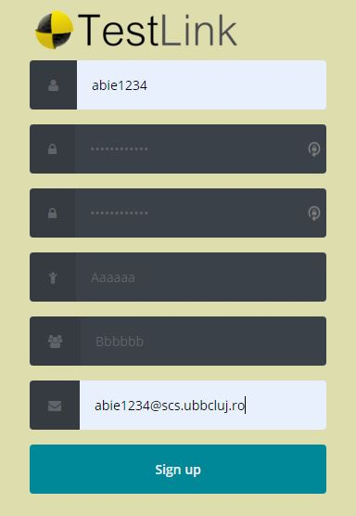

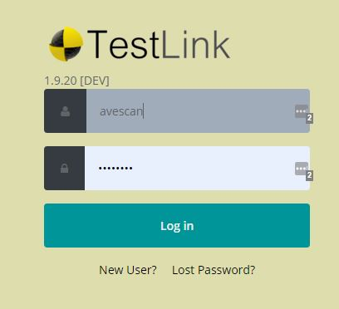

  - The account is created (the error should be ignored; the account is created)

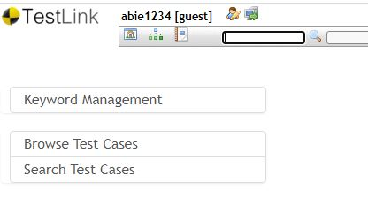

  - Your laboratory teacher will assign you to the group project Projects93X

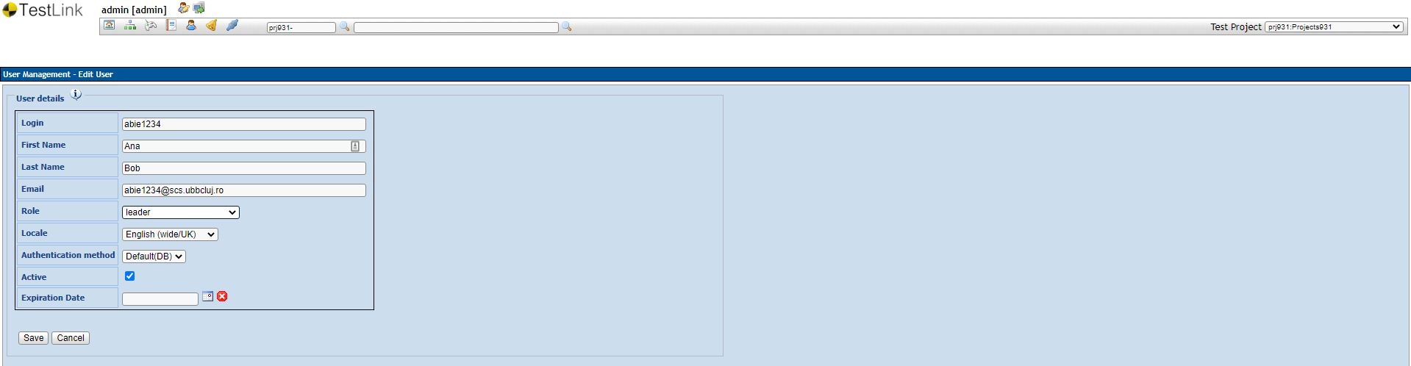

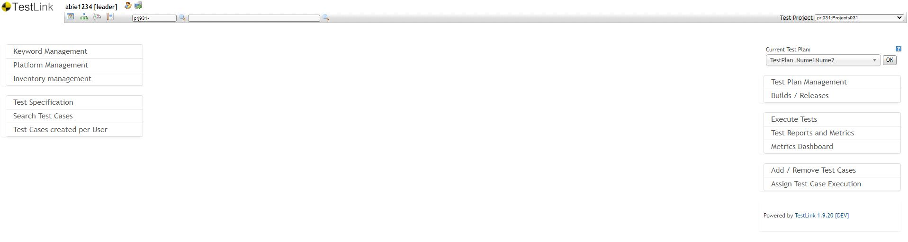
Important remark 1. Only admin user can create project. For each group we have created a project, thus each student will use the project name from his group.
The already created projects are:
- Projects931
- Projects932
- Projects933
- Projects934
- Projects935
- Projects936
- Projects937
- ProjectsOthers (for the students from other years of study or/and reenrolment)
Important remark 1. To each project there are two custom fields assigned:
- JavaClassName
- JavaTestMethodName

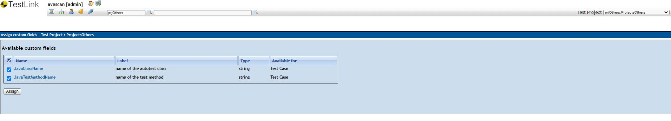

Select the project that you are assigned to
- Project Menu
- In the upper right corner select from the combo box your Test Project.

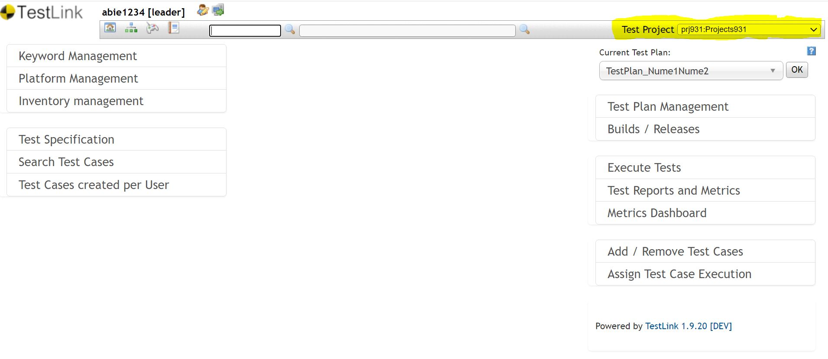

Create a Test Plan
Each team will create his/her own Test Plan, the name of the test plan will be composed by groupNumber followed by the names of the team members concatenated with TestPlan.
93X_Name01Name02_TestPlan

Select “Test Plan Management” and create the test plan using the naming convention above.

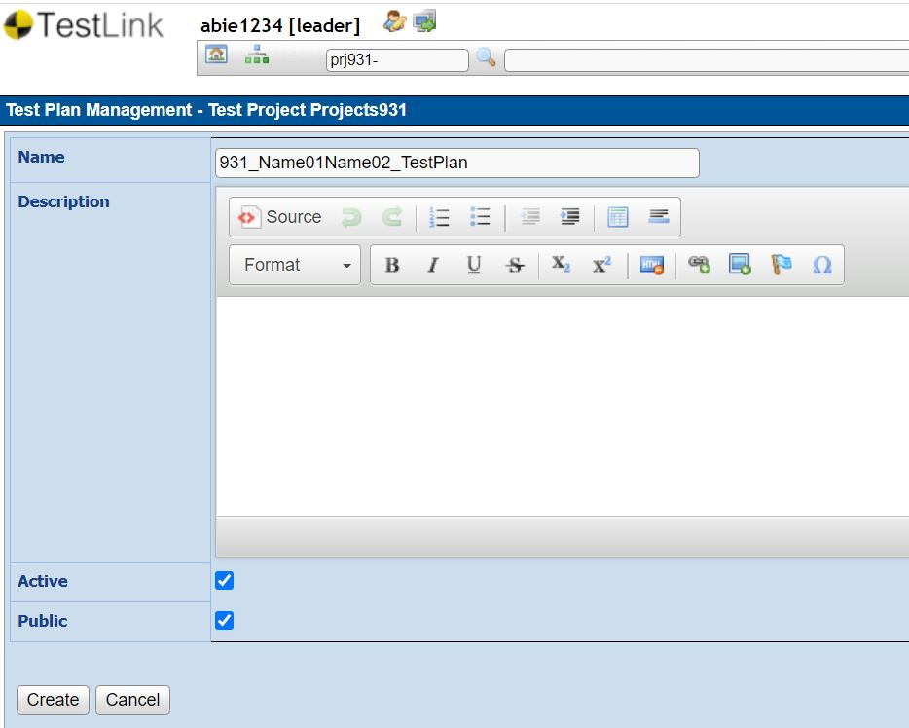

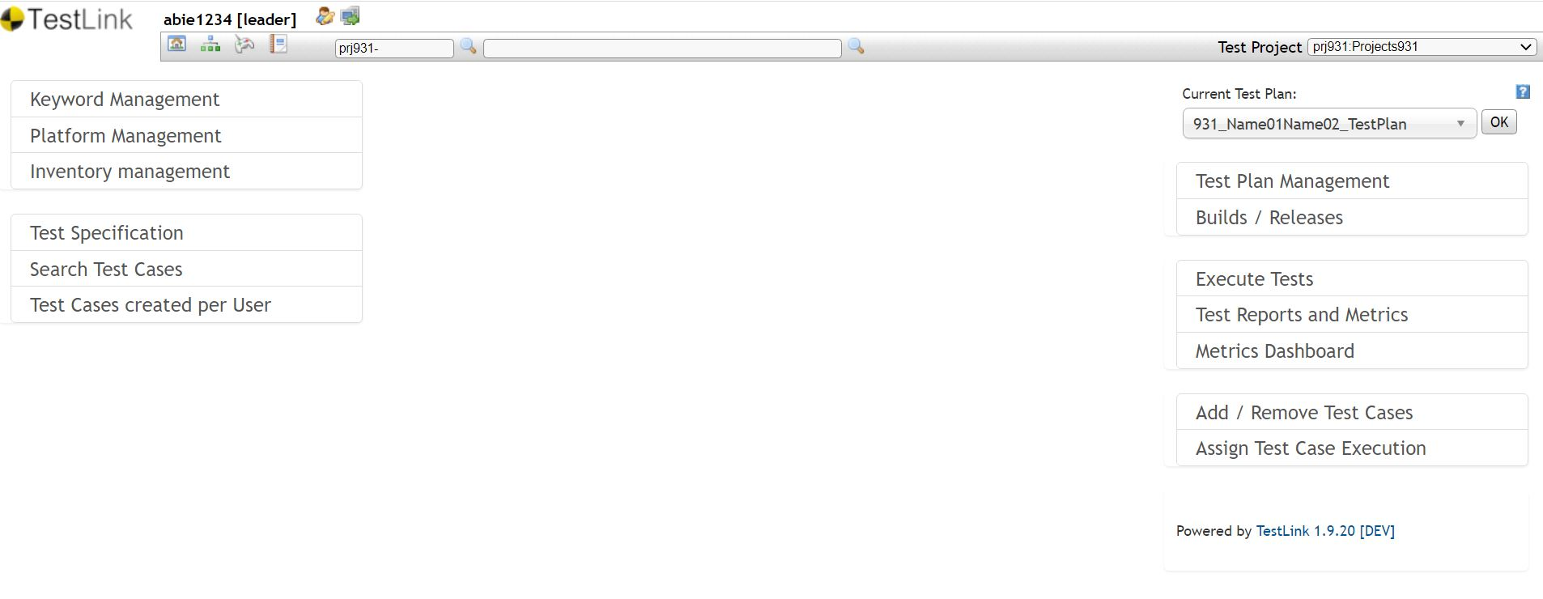

Create Test Suites/ Test Cases
Each student will create in total 3 test suites:
- 1 test suite from laboratory 2 - black-box testing
  - Test Suite Name = Name01Name02_BBT
- 1 test case from laboratory 3 - white-box testing
  - Test Suite Name = Name01Name02_WBT
- 1 test case from laboratory 4 - integration testing.
  - Test Suite Name Name01Name02_IntegrationT
Create Test Suites - STEPS
- Project/Desktop menu --> Test Specification section -->click on Test Specification
- Select your test project in navigation tree (left side screen)
- In the Test Suite Operations panel click on the Create button.
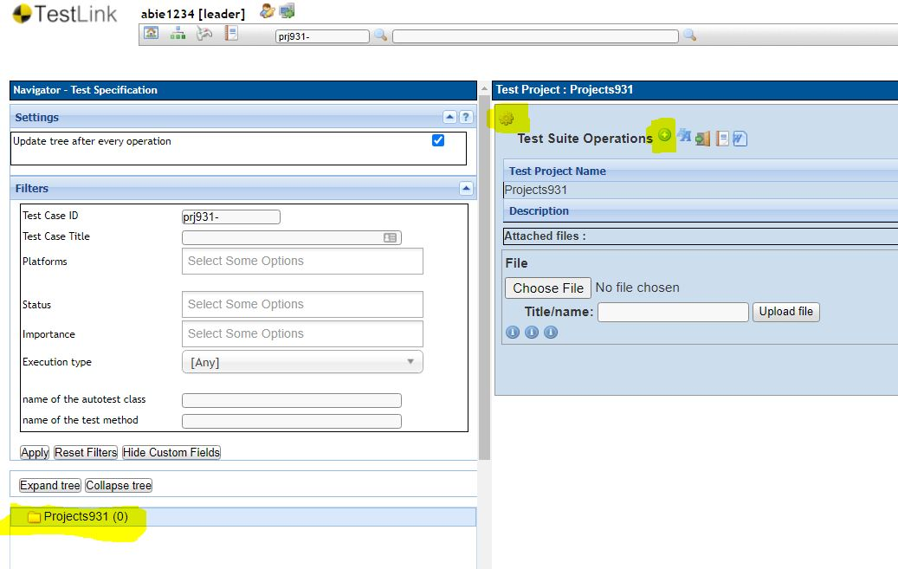

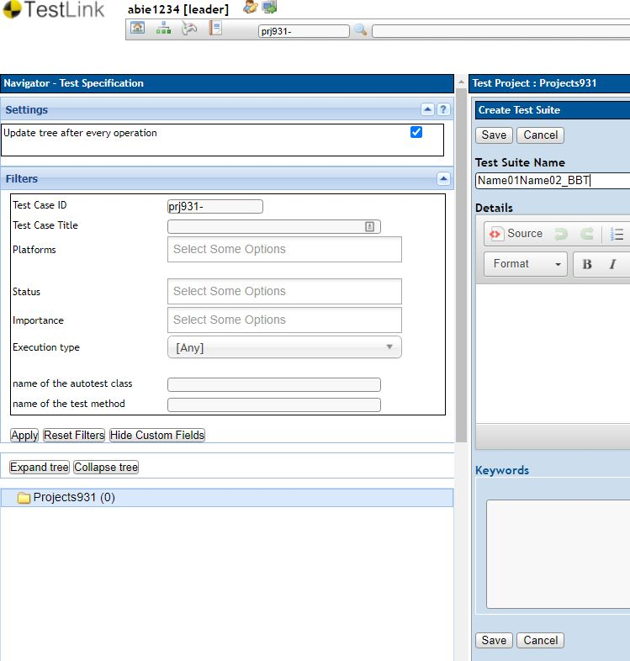

Create Test Cases - STEPS
- Select your test suite in navigation tree (left side screen)
- In the Test Suite Operations/ Test Case Operations panel click on the Create button (from Test Case Operation). Figure 6a and Figure 6b. Remember to modify Execution type to automated.
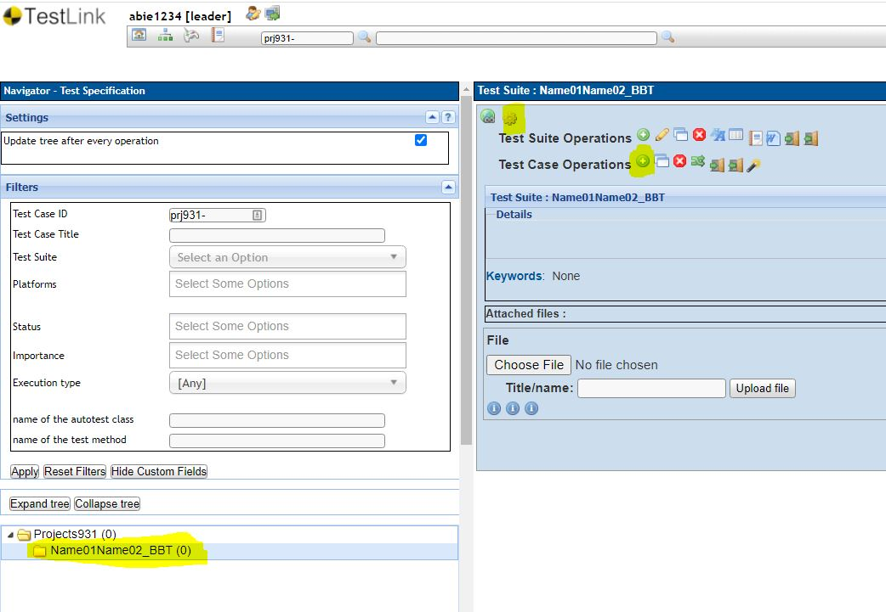

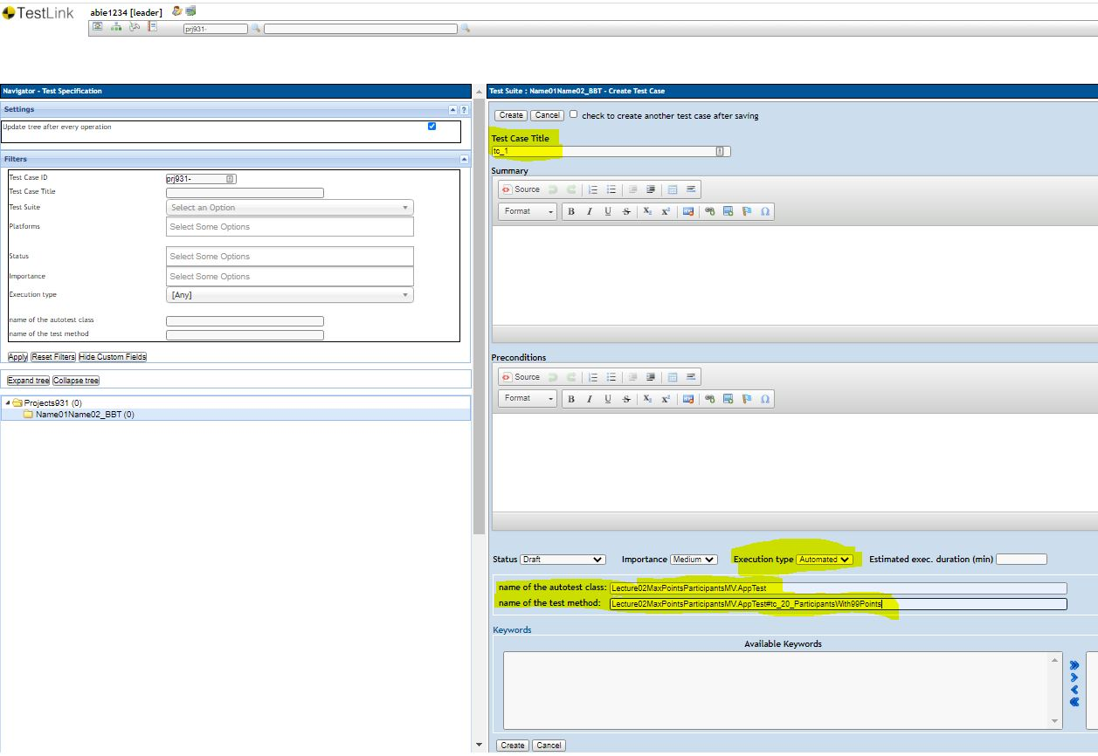

Add a Test Case to a Test Plan

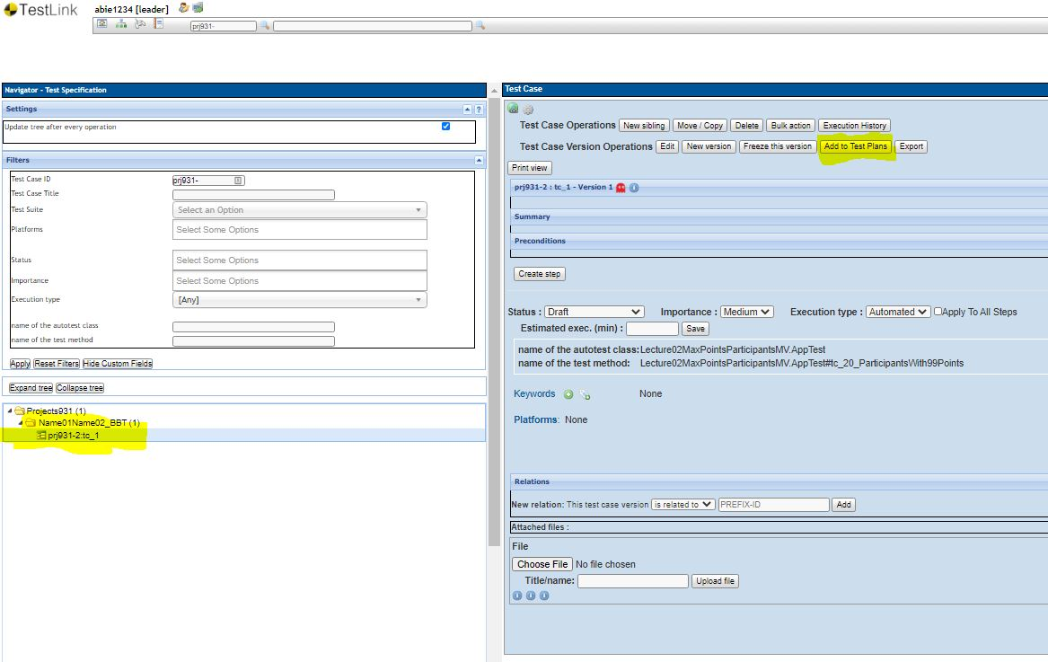

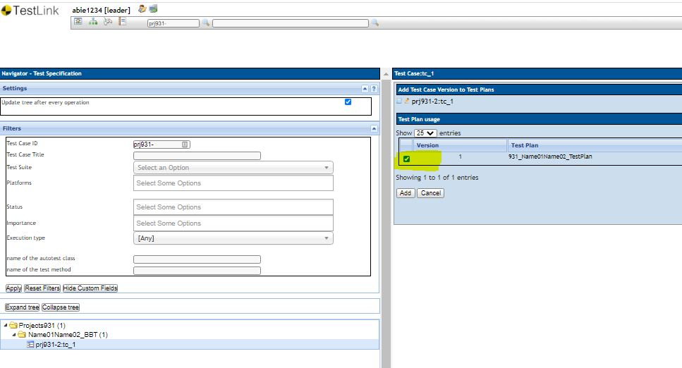

Steps for using Jenkins

Create new user

  - Select “create an account”

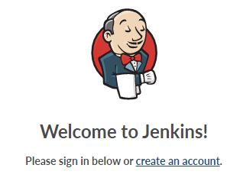

  - Create the new account using your scs email

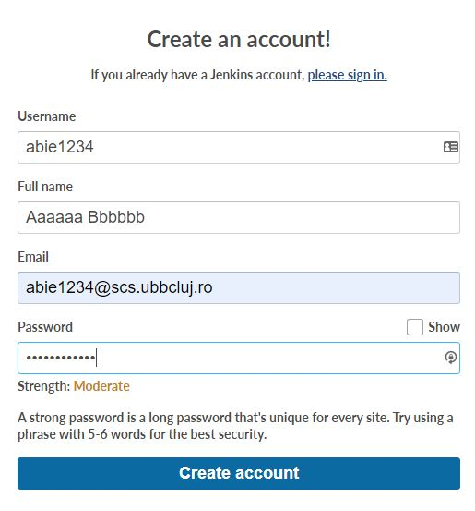
  - The account is created

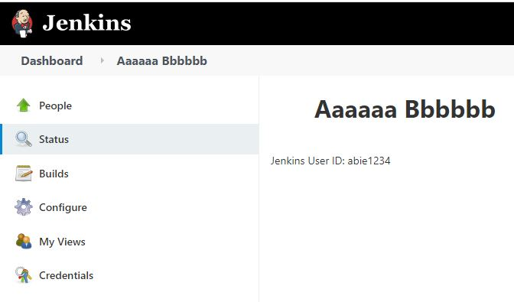

Create a new Job

Each team will create his/her own Job (for the TestPlan created in Testlink), the name of the job will be composed of: groupNumber followed by the names of the team members concatenated with the word Job. (93X_Name01Name02_Job)
- for example, for one of the team in group 931 Pop and Popescu the name of the job will be:
  - 931_PopPopescu_Job.

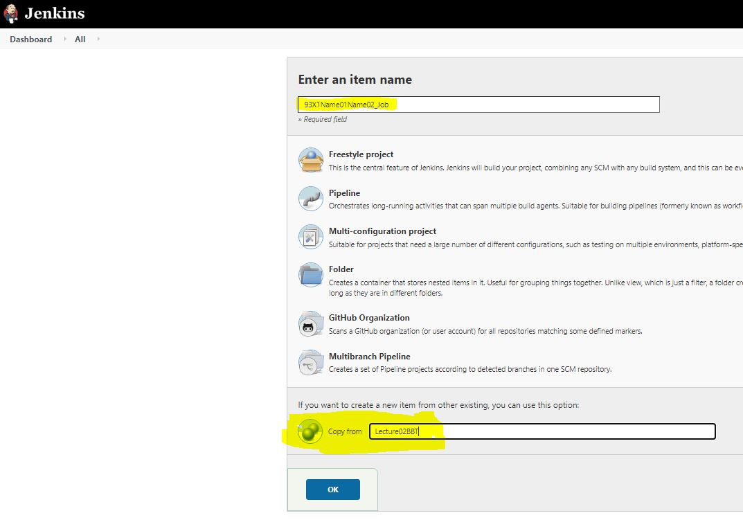

Create a new Job from other existing job
- Use “Copy from”: Lecture02BBT
- Modify in your Job the following elements
  - Github link with your Github link
  - Test Project and Test Plan with
  - Lecture02MaxPointsParticipantswith Projects93X
  - TestPlan_Lecture02MaxPointsParticipants with 93X_Name01Name02_TestPlan (created in Testlink).

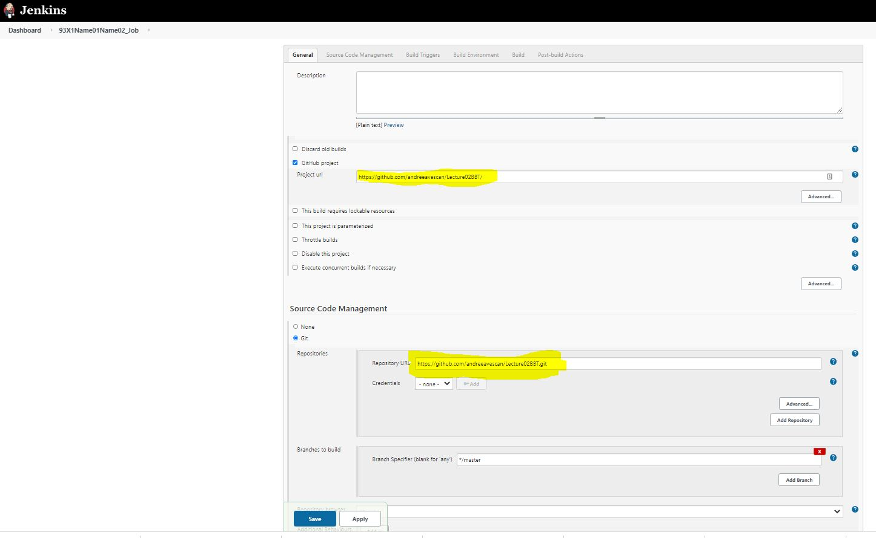

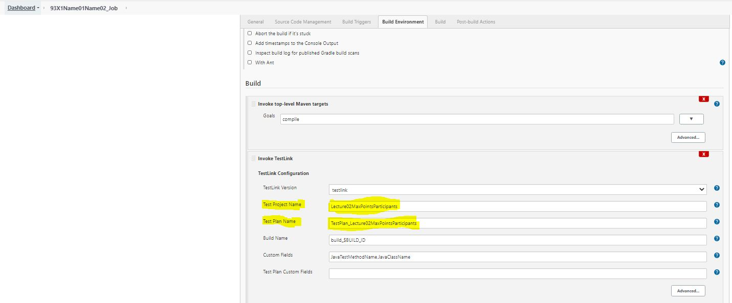

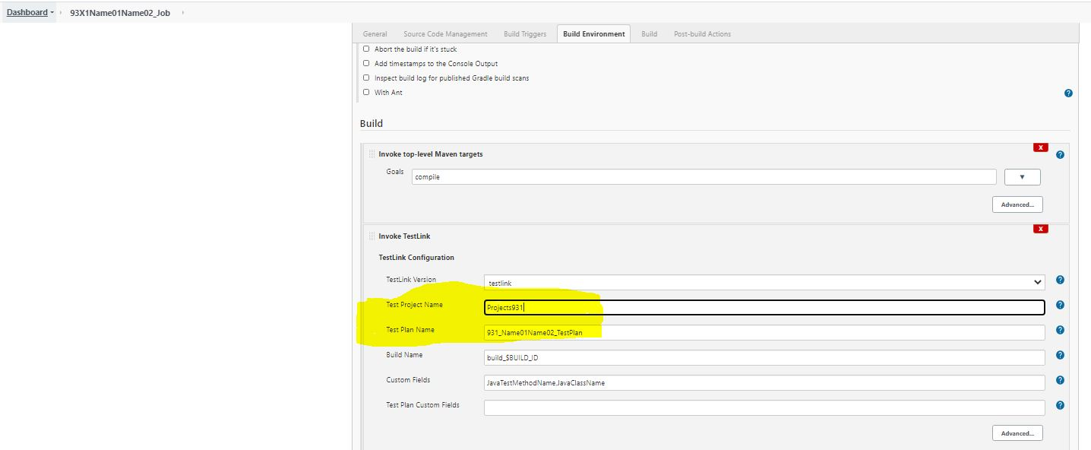

Build
  - Select the Job
  - Select Build Now

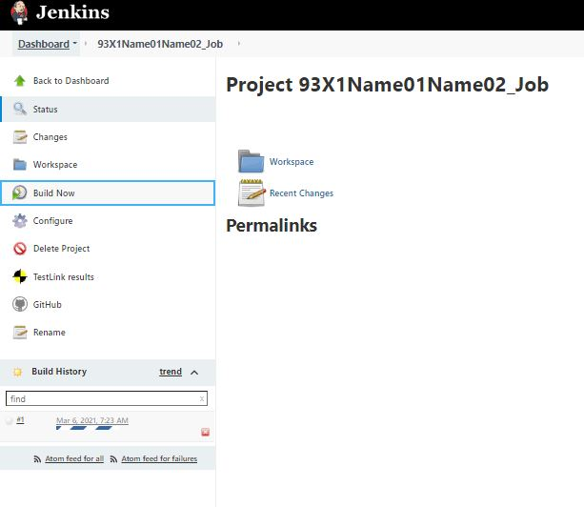

  - Console Output

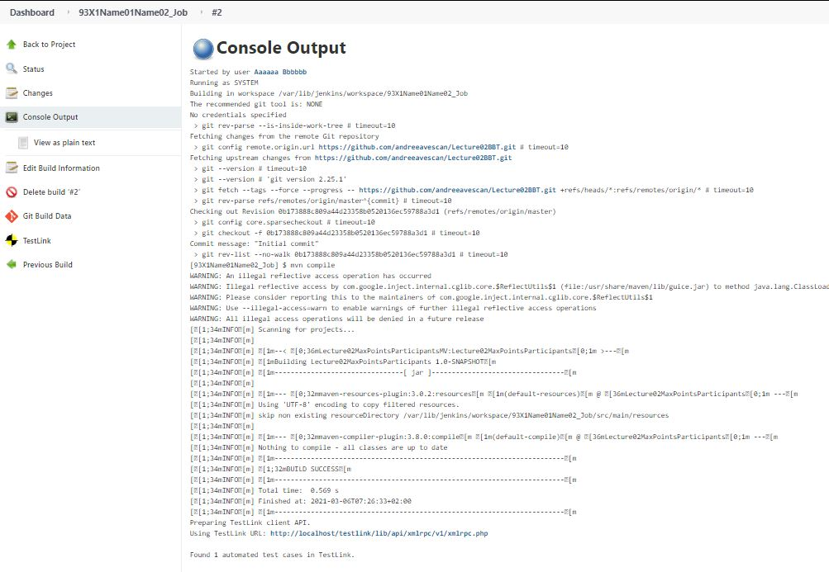

Sending results from Jenkins to Testlink
After successfully running the job, in Testlink it is updated automatically the status of the test cases in Not Run, Passed, Failed, or Blocked.

View the state of a Test case in Testlink
In the Test Specification menu, within the chosen project, eg Projects931, a desired Test Suite is selected, e.g., abie1234_BBT, and a test case.

