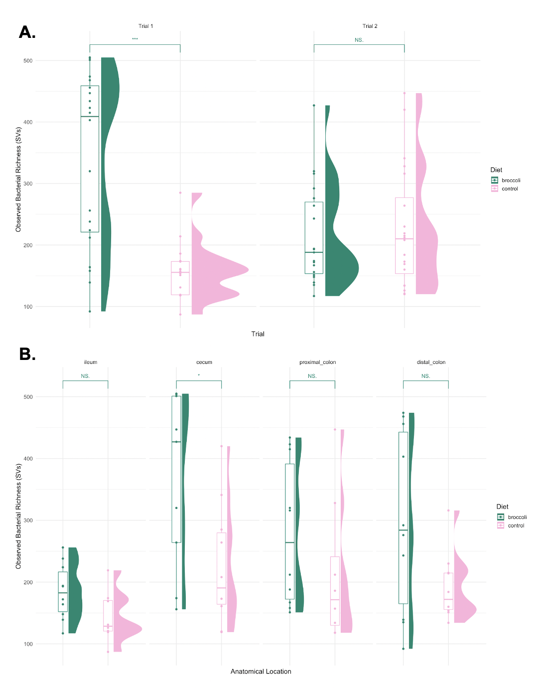

Figure 1. IL-10 KO mice that consumed a diet containing 10% broccoli sprouts seem to have greater observed bacterial richness compared to those that consumed a control diet. A. The trial 1 mice, aged 4-weeks old, showed significantly different observed bacterial richness between the two diet groups, with the broccoli-fed mice having significantly greater richness compared to the control group (***p<0.001); trial 2 mice, aged 7-weeks old, showed no significant differences in observed bacterial richness. Graphics made using phyloseq and ggplot2 packages in R. Significance added by Wilcox tests from ggsignif package in R.

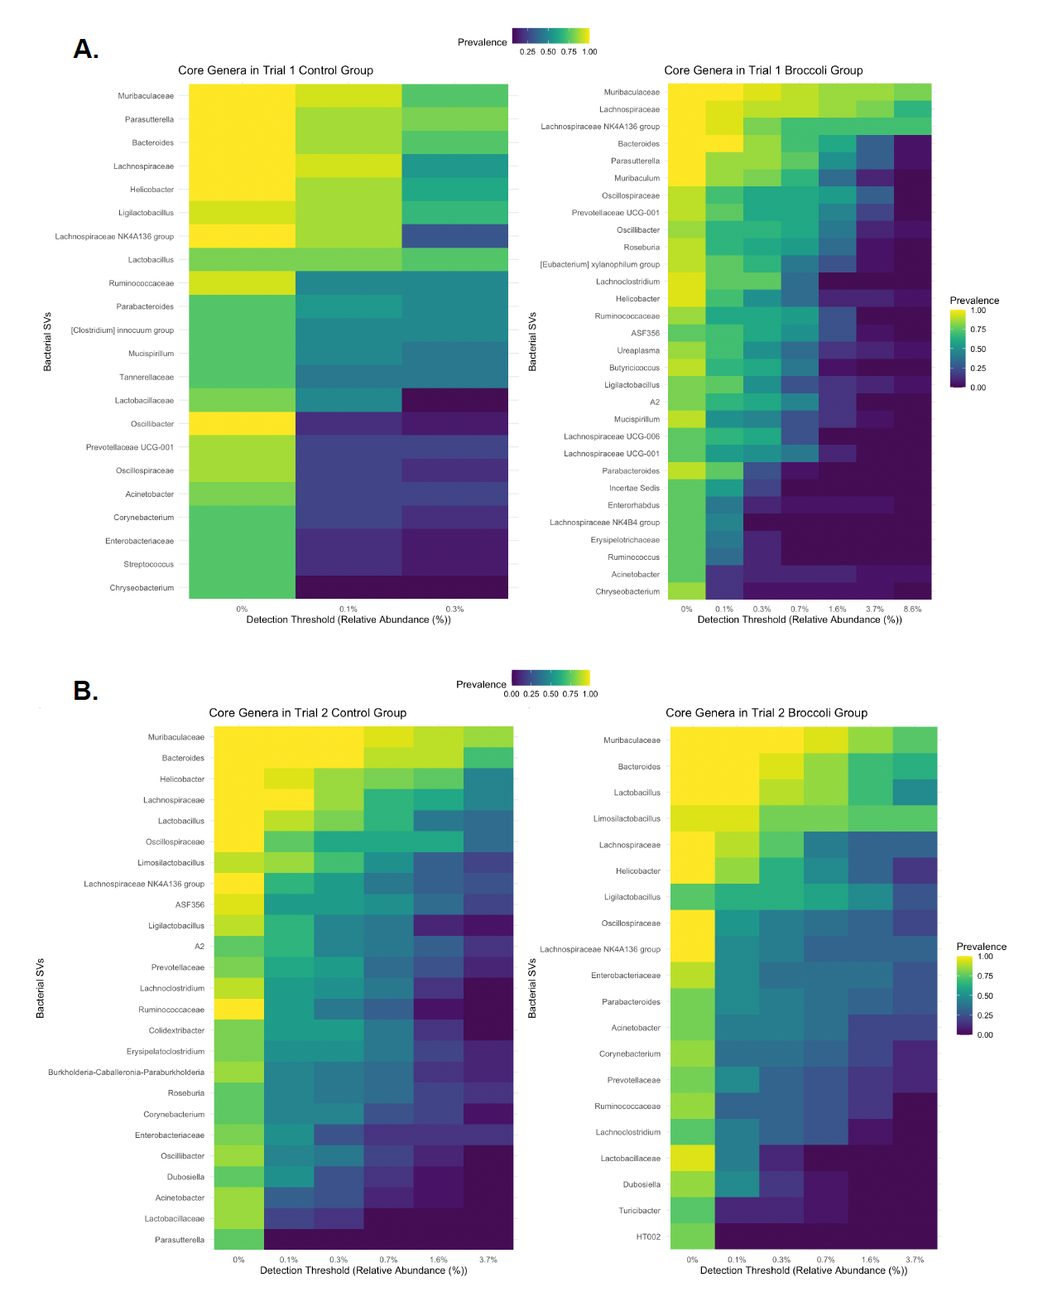

Figure 2. Younger (4-week-old) broccoli-fed mice have greater bacterial richness, and less abundance and prevalence of some inflammatory bacteria, for example, Helicobacter.  A. Control group trial 2 mice, aged 7 weeks, have a greater prevalence and abundance of the harmful Helicobacter species compared to the younger, 4-week-old trial 1 mice. B. The 4-week-old trial 1 mice have more microbial species that meet the core genera standard (detection = 1/1000, prevalence = 70/100) compared to the 7-week-old trial 2 mice.  Broccoli-fed trial 1 4-week-old mice also have less abundance and prevalence of Helicobcater compared to the older trial 2 mice. Graphics made using phyloseq, dplyr, and ggplot2 packages in R.

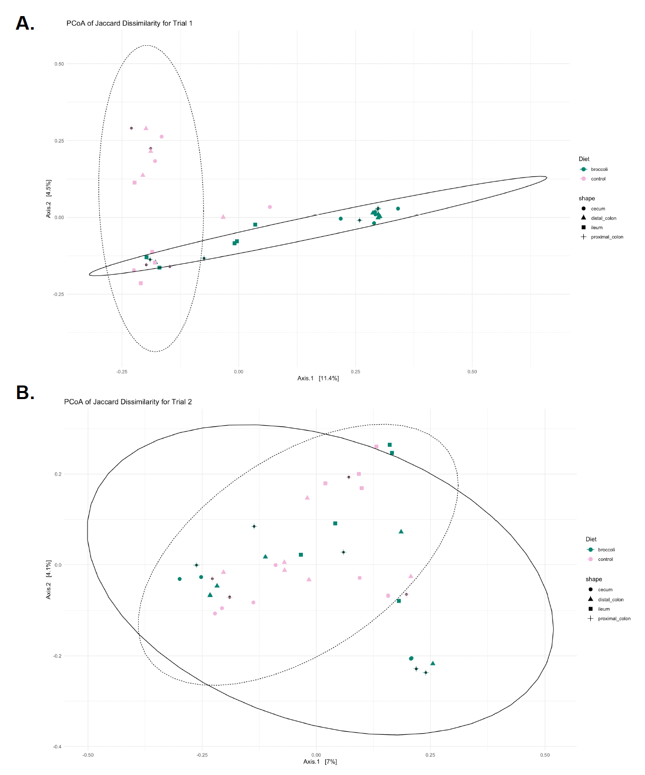

Figure 3. Principal coordinates analysis (PCoA) of all experimental factors. Ellipses show groupings by anatomical location of the sample. This PCoA shows that broccoli exerts a similar micro-biotic influence across all samples within the broccoli group. Graphic made using phyloseq, vegan, and viridis packages in R.