

Cloud Computing WS20/21

Setup of Nextcloud using Kubernetes

Michael Zodel 1234567

Andrej Korinth 1234567

Francisco Seipel-Soubrier 1123213213123

Nils Krug 1367470

Table of contents

Introduction to Nextcloud 3

Overview of Kubernetes 3

High availability cluster 3

Setup of Kubernetes 3

What have we learned 3

# Introduction to Nextcloud

The market for cloud solutions is dominated by American companies in the likes of Microsoft, Google and Amazon. Cloud solutions offer great scalability and fast deployment while also having lower running costs (Jansen, 2011). Big companies like Volkswagen and EON are using these services for their business processes (Handelsblatt, 2019).

The 2013 Edward Snowden leak showed, that American companies are tightly connected to government bodies and sharing user data for analysis (Landau, 2013). These practises are not supervised by the public and the damage for the privacy of its users is difficult to measure. Despite its initial impact, very little has changed regarding the protection of personal privacy. Therefore an alternative is needed for the data conscious user.

Nextcloud started as a fork of Owncloud in 2016 after some of team members including the founder left their previous company. While the enterprise part of Owncloud is closed source, all features of Nextcloud are open source. Since its launch the popularity of Nextcloud increased steadily making it one of the biggest alternatives to Amazon and co.

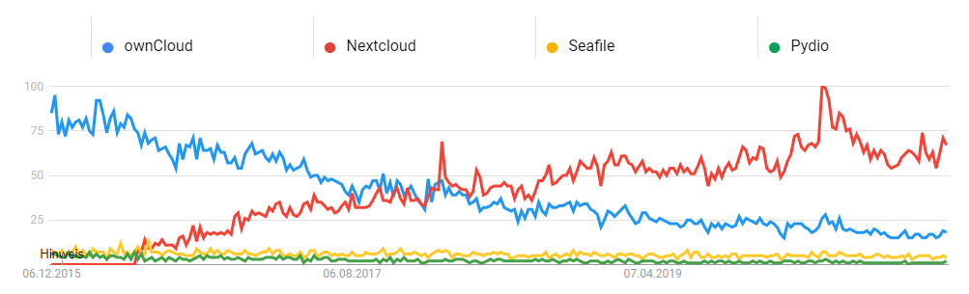

Picture 1 Google Trends for alternative cloud solutions

In 2019 Major contracts with Governments have been closed supplying cloud services for several hundred thousand government workers in France, Germany, Sweden and the Netherlands. (Handelsblatt, 2019). Due to its open source nature, implementing backdoors for surveillance is unlikely. (Source?)

Since 2016 the amount of functions increased steadily. While the core function is still sharing files, a text and video chat option has been added. Furthermore several groupware functions have been added, synchronizing calendars and task lists. With plugins for Microsoft Teams, Gitlab, Slack, Twitter and many more Nextcloud can be adapted to many different needs.

# Overview of Kubernetes

* Allgemeine Einleitung (Herkunft etc.)
* Wie ist es aufgebaut
* Was sind die Vorteile

Kubernetes -> Andrej

MinIO: Kubernetes, Docker,

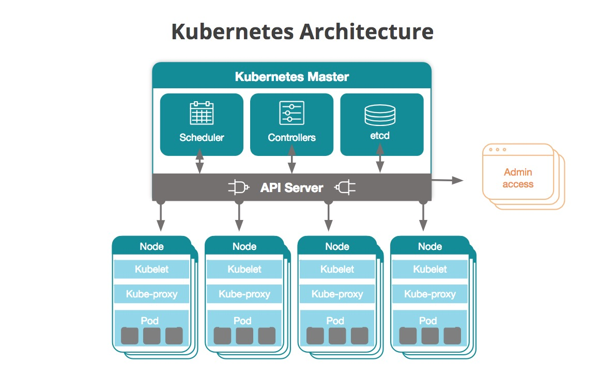

# High availability cluster

* Was ist ein high availability cluster
* Warum macht es in dem Fall Sinn

Michael -> Cluster

# Setup of Kubernetes

* Schritte beim Setup mit vielen Screenshots

# What have we learned