**Introduction/Business Problem**

City/Town planners always have difficulty to determine where to put stop sign, stop light, extra precautions such as pedestrian crossings with extra indications(flashing lights, road signs or signals) for automotives /cyclist/pedestrians etc. Since Police collect detailed data of the accident locations and other various accident data information, can we use that data to identify the locations of severe accidents. Additionally by predicting weather is a factor in such accidents and then give a predictive tool for road safety planning. This project is to identify such locations from the accident data and independently provide predictive model to 911 dispatchers to identify how much a weather is a contributing factor in the severity of the accident to mobilize additional resources.

1. Can we predict the severity of the accident based on weather condition?
2. Is there any specific region in Seattle where more accidents occur in last two years?

Severity prediction is a useful for 911 operators to mobilize and dispatch right resources ahead of time based on this predicted model.

Visual analysis is useful to town planners for additional infrastructure selection, to reduce number of incidents at high accident zones.

**Data Source**

We will use the sample Seattle data set provided in the course for this problem solving. Some key information is necessary for this kind of problem prediction is to have latitude/longitude information or accident location information, weather conditions etc. are important. The provided data set has the required basic data for solving the problem.

**https://s3.us.cloud-object-storage.appdomain.cloud/cf-courses-data/CognitiveClass/DP0701EN/version-2/Data-Collisions.csv**

The data set has the following features for data analysis, train and test the model.

|  |  |  |  |
| --- | --- | --- | --- |
| Feature | Data Type | Comment |  |
| SEVERITYCODE | Int | Target |  |
| (X)Longitude | Float | Keep | For Accident location clusters |
| (Y)Latitude | Float | Keep | For Accident location clusters |
| OBJECTID | Int | Unique ID | None |
| INCKEY | Int | Drop |  |
| COLDETKEY | Int | Drop |  |
| REPORTNO | Int | Drop |  |
| STATUS | Text | Drop |  |
| ADDRTYPE | Text | Keep | For Info and accident cluster |
| INTKEY | Int | Drop – Only reference number |  |
| LOCATION | Text | Keep, Evaluate | For Info and accident cluster |
| EXCEPTRSNCODE | Text | Drop |  |
| EXCEPTRSNDESC | Text | Drop |  |
| SEVERITYDESC | Text | Keep, evaluate |  |
| COLLISIONTYPE | Text | Keep, evaluate |  |
| PERSONCOUNT | Int | Keep, evaluate |  |
| PEDCOUNT | Int | Keep, evaluate |  |
| PEDCYLCOUNT | Int | Keep, Evaluate |  |
| VEHCOUNT | Int | Keep, evaluate |  |
| INCDATE | Text | Drop as the same is available in ‘INCDTTM’ |  |
| INCDTTM | Text | Keep, & Transform to DATE , Day and Time Ranges | For clustering on time/weekday/Weekend |
| JUNCTIONTYPE | text | Drop | Not using |
| SDOT_COLCODE | Int | Drop |  |
| SDOT_COLDESC | text | Drop |  |
| INATTENTIONIND | Text | Drop – Only one value |  |
| UNDERINFL | Text | Drop |  |
| WEATHER | Text | Keep | Vs Severity Code |
| ROADCOND | Text | Drop | Not analyzing |
| LIGHTCOND | Text | Drop | Not analyzing |
| PEDROWNOTGRNT | Text | Drop – only one value |  |
| SDOTCOLNUM | Int | Drop |  |
| SPEEDING | Text | Drop – Only one value |  |
| ST_COLCODE | Int | Drop |  |
| ST_COLDESC | Int | Drop |  |
| SEGLANEKEY | Int | Drop |  |
| CROSSWALKKEY | Int | Drop |  |
| HITPARKEDCAR | Text | Drop |  |

Since our intention is to identify the severity of the collision, we will use **“severitycode”** as our target feature.

**Dropping Features:**

Based on the Metadata given for the data set, some features can be dropped as they are mostly informational for the authorities for their tracking. Also the features which will not be used are dropped. These were indicated next to feature as **Drop** in the table.

**Dropping the records:**

Since this is a large data set, we will use only the most recent 2 years data for the analysis. That means we will use only 2020 & 2019 data, which gives sufficiently large data to work with.

**Dropping NaN records**

Since we do not want to make any assumptions on the blank values of a feature on **‘ SEVERITYCODE’** or any other features, any records have Blanks are dropped.

**Data Preprocessing and formatting**

INCDTTM is combined string and same is separated into Date, Time and ‘Day of the week’ and those additional features are added with intention to find any patterns for Severity prediction.

Since WEATHER is our main independent variable and it has list values, using **one hot encoding** method, the following additional features were created and added to the dataset.

**Blowing Sand/Dirt**

**Clear**

**Fog/Smog/Smoke**

**Other**

**Overcast**

**Partly Cloudy**

**Raining**

**Severe Crosswind**

**Sleet/Hail/Freezing Rain**

**Snowing**

**Feature Selection**

Target Feature is SEVERITYCODE (Dependent)

Weather Features (Independent)

Since only two codes are available in the data sets (**1-Property Damage only**, **2-Injury collision**), we will use **classifier methodology algorithms** for modeling.

**Correlation Heatmap:**

To eliminate any features highly correlated, correlation heatmap is plotted.

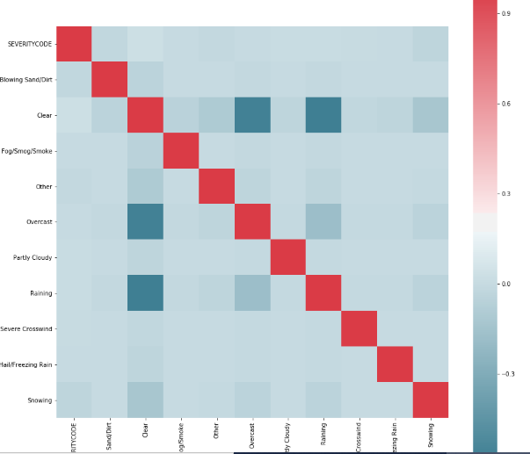

**Modeling**

The data set is randomly divided into training (75%) and testing (25%)

Train set: (7422, 11) (7422,)

Test set: (2474, 11) (2474,)

The predictive model building is done using train dataset with following algorithms:

**KNN**

Found the optimum K as 3

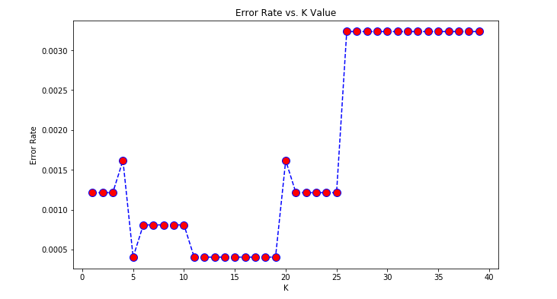

Using K = 3,

Build the model using train dataset and then predicted the values for Test Data set and predicted the KNN J-CARD Index & F1-Score for test data set.

KNN Jaccard index: 0.99879

KNN F1-score: 0.99879

The similar modeling is done with Decision Tree, Support Vector Machine and logistic regression.

**Decision Tree**  
DT Jaccard index: 1.00000

DT F1-score: 1.00000

Since the weather conditions are mutually exclusive, this is not useful.

**Support Vector Machine**

SVM Jaccard index: 0.99879

SVM F1-score: 0.99879

**Logistic Regression**

LR Jaccard index: 1.00

LR F1-score: 1.00000

LR LogLoss: 0.04323

**Summary:**

| Algorithm | Jaccard | F1-score | LogLoss |

|---------------------- ----|--------------|---------------|--------------|

| KNN | 0.99838 | 0.99838 | NA |

| Decision Tree | 1.00000 | 1.00000 | NA |

| SVM | 0.99797 | 0.99798 | NA |

| LogisticRegression | 1.00000 | 1.00000 | 0.04323 |

**Conclusion:**

We can use KNN, SVM and Logistic regression for the prediction.

The most significant weather conditions which are contributing to Accidents are: **Overcast**, **Raining** and **Snow**

**Identifying the high amount of accidents location**

For this analysis, Folium library is used and mapped the accidents on Seattle geography map.

Using Marker Cluster plugin, the map is made more interactive.

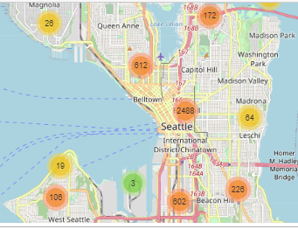

On zooming 2488 count cluster:

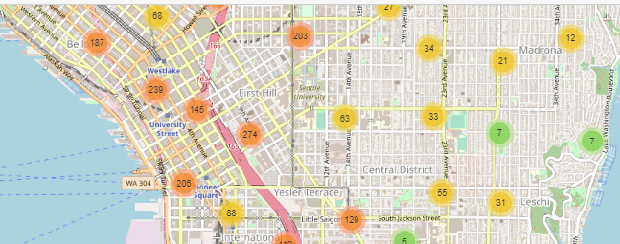

On further zooming on 274 cluster:

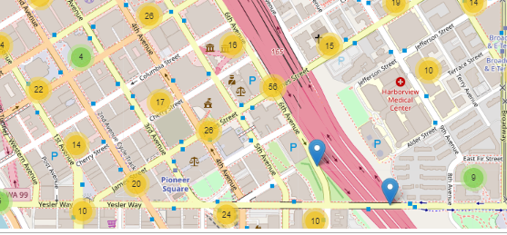

On zooming further on 56 Cluster:

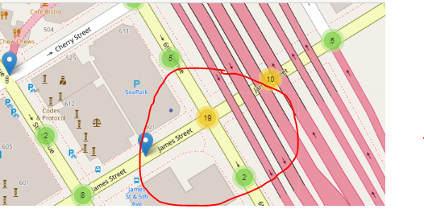

**Conclusion:**

One of the high accident incidents intersection is: James Street/6th Avenue.

Now a town planner can do further analysis to find what are the causes for the high incidents and make corrective measures.