**Html/css/bootstrap –Python – sql | flask**

**Javascript introduction**

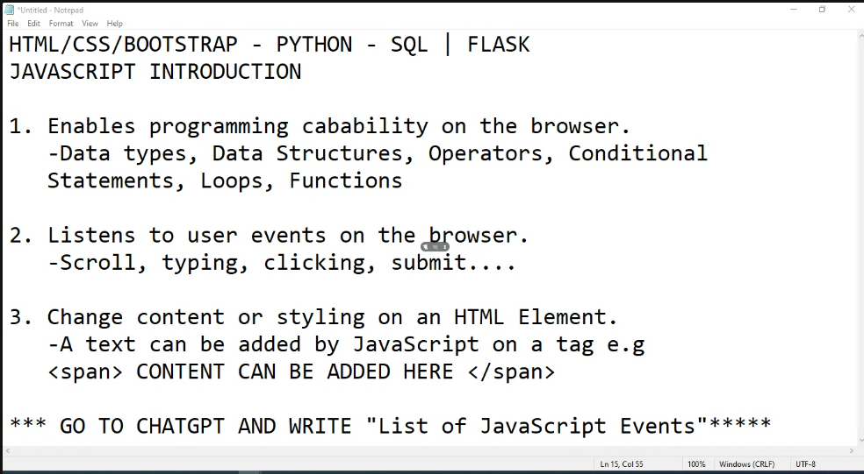

UI- User Interface (HTML/CSS)

UX- User Experience (JavaScript)

FrontEnd Developer – HTML/CSS/JAVASCRIPT – Vanilla JavaScript (raw javascript)

**Using javascript**

1. Javascript is written at the bottom always.

Defining a variable

// console.log is print

        console.log('Hello world');

        // creating a variable

        let num1 = 2;

        let num2 = 5;

        let sum =num1 + num2;

        console.log(sum)

1.introduces programming on the browser.

Data types-strings **methods****

,numbers(ints,floats) ***arithmentic operations**

, Booleans *** conditional operator***logical operators**

-Data structures –array(list) **methods**

- object (exactly like a dictionary)

--Operators –arithmetic - +, -

-conditional

-logical – and(&&), or (||) eg num1 >= 0 && num2 <= 100

-conditional statement – use if, else if, else to check a Boolean.

- loops – for for,while,. Accessing values inside an array.

- functions –block of code that does a specific task,take in some data and return a value.

