UTSEUS – US01 – Data meaning

Machine Learning

Basic concept:

Machine learning : teach something at a computer

Input space X, can be mono-label or multi-label
Output space (response we would like) Y
Target function f: X→Y (the function we trying to approximate)

Learning type: unsupervised learning, reinforcement learning, supervised learning

Data representation:

Qualitative variable (non-numeric): ordinal (for example months), nominal
Quantitative variable: discrete (finite, countable), continuous (non-countable)

Transformation in numbers: We use vector to do data meaning, so how manipulate qualitative variable? For example, how represent green, red, blue?
→ green = 100
red= 010
blue = 001
We don’t use 1,2,3 because it will introduce an order between the colours.

Scaling factor: be careful at the units, you need to normalize the feature. Often normalize all the variables to have a range in [0;1]
For example vector (weight, high): (68; 1,67), (80; 1,87) weight has most weight than high

Performance:

Risk minimization:
Binary decision
Prediction/ True | +1 | -1
+1  -1 | True positive TP  False negative FN | False positive FP  True negative TN

The cost can be different (example with autonomous vehicle)

Model is build on observed data and a good one can be use to generalize (classify new unseen data).
→ Ockham’s razor (simplicity): “Entities must not be multiplied beyond necessity”

Crossed-validation: used a part of the data to train and the rest to validate
Part 1
1: validate2: validate3: validate 4: validate
2,3,4: train1,3,4: train 1,2,4: train1,2,3: train
→ r1→ r2→ r3→ r4

R = ¼ (r1+r2+r3+r4)
Part 2
Part 3
Part 4

Supervised classification

Classification: finite number of value
Regression: real number

Algorithms:

Constant predictor: always predict the class that appears the more often, the one with the highest prior probability

k-NN: (prediction very slow, training fast) take x as an example, take his n closest neighbour and check the distance between them

Trees: (prediction fast, training slow) repeat binary classification problem → binary classification tree
Random forest

Support vector machine: (prediction fast, training slow)

Neural network: (prediction fast, training slow)

Boosting: (prediction fast, training slow)

SVN:

Mutliclass problem

OvO (one versus one)
3 class → 1-2, 2-3, 3-1
k-class → (k 2) separation → big cost
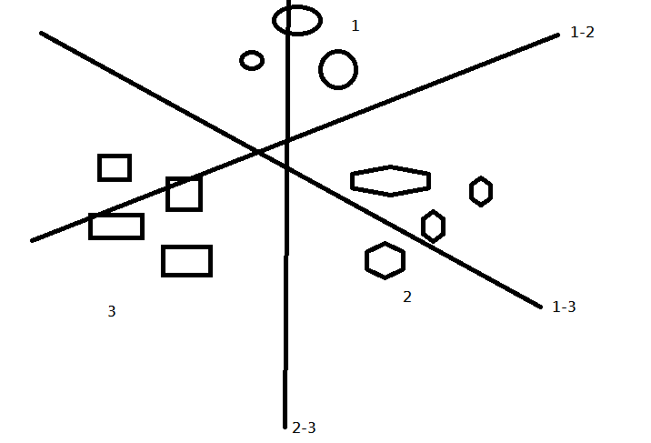

OvR (one versus rest)
3 class → 1-(2,3), 2-(1,3), 3-(1,2)
k-class → k separation
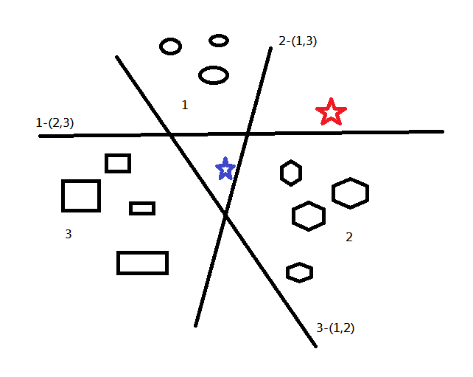
red: 2 use max(score)

blue: 2 use min(score)

(score is the distance between the star and the ligne 2-(1,3))

Unsupervised learning

There is no Y, no rules. All the data are in X

Algorithms:

k-Means: Take a number of group and make group according to condition. First the group’s center is random then it’s ajust.
X → expression in condition 1
Y → expression in condition 2

Hierarchical Clustering: Combine the dot with the closest (make a new dot in the middle of them) in order to make group. Make a tree of the pairs. You can choose the number of group you want thanks to the tree.

