**Use Case Diagram**

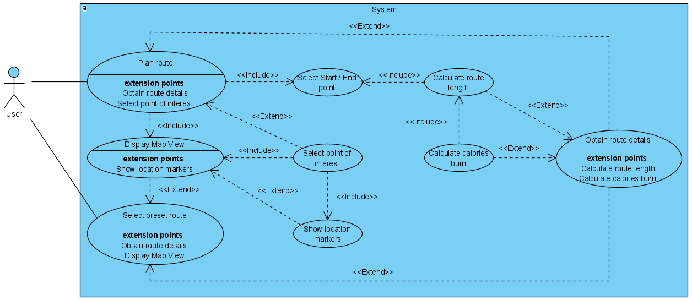

**Use Case Descriptions**

|  |  |
| --- | --- |
| Use Case: | Plan Route |
| Actor: | User |
| Preconditions: | User selects ‘Plan Route’ from the landing page. |
| Description: | User will select a start and end point for their route along with one or more stops along the way.  Based on the user inputs, the system will generate a route and its’ details.  System will navigate the user from the starting point to the first stop. |
| Postconditions: | - |
| Alternative Flow: | In the case where user selects a start and end point without any stops, the system will generate a route and its’ details and navigate the user from the starting point to the end point. |

|  |  |
| --- | --- |
| Use Case: | Select Preset Route |
| Actor: | User |
| Preconditions: | User selects ‘Select Preset Route’ from the landing page. |
| Description: | Based on user’s GPS determined/ user entered location, the system will generate a list of preset route.  User will select a route which appeals to them.  System will generate the route, its’ details and navigate the user. |
| Postconditions: | - |
| Alternative Flow: | User can view the route details (e.g. start/end point, route length) by expanding on a route from the list of preset routes. |

|  |  |
| --- | --- |
| Use Case: | Display Map View |
| Actor: | User |
| Preconditions: | User navigating to the map view after selecting a preset route, or from the ‘Plan Route’ page. |
| Description: | System displays the user-defined route on an interactive map. |
| Postconditions: | - |
| Alternative Flow: | - |

|  |  |
| --- | --- |
| Use Case: | Select Start/ End point |
| Actor: | User |
| Preconditions: | User selects ‘Plan Route’ from the landing page. |
| Description: | User will select a start and end point for their route.  System will generate a path in the map view accordingly. |
| Postconditions: | A path from the start to the end point must be generated in the map view. |
| Alternative Flow: | - |

|  |  |
| --- | --- |
| Use Case: | Select point of interest |
| Actor: | User |
| Preconditions: | A path from the start to the end point in map view. |
| Description: | User will select a point of interest along the path.  System will display location markers in a circumference around the point of interest.  User will select a location marker.  System will show the details of the selected location.  User will select ‘Add Stop’.  System will register the location as one of the stops for the route. |
| Postconditions: | One or more stops added to the user-defined route. |
| Alternative Flow: | - |

|  |  |
| --- | --- |
| Use Case: | Show location markers |
| Actor: | User |
| Preconditions: | User navigating to the map view with a preset route, or after the selection of a point of interest in map view. |
| Description: | If user navigated to the map view with a preset route, location markers of all stops defined in the route will be displayed.  If user selected a point of interest when planning their route, all possible stops around a circumference of the point of interest will be displayed as location markers. |
| Postconditions: | A least one location marker displayed on the map. Otherwise, prompt the user that no possible stops are found around the point of interest. |
| Alternative Flow: | - |

|  |  |
| --- | --- |
| Use Case: | Calculate route length |
| Actor: | - |
| Preconditions: | Start and End point determined. |
| Description: | System calculates route length based on the start and end point. |
| Postconditions: | Display route length on route details. |
| Alternative Flow: | - |

|  |  |
| --- | --- |
| Use Case: | Calculate calories burn |
| Actor: | - |
| Preconditions: | Route length calculated. |
| Description: | System estimates calories burn based on route length. |
| Postconditions: | Display estimated calories burn on route details. |
| Alternative Flow: | - |

|  |  |
| --- | --- |
| Use Case: | Obtain route details |
| Actor: | User |
| Preconditions: | User navigating to the route details on a selected preset route or when planning a route. |
| Description: | System displays any information pertaining to the route. |
| Postconditions: | Display route details. |
| Alternative Flow: | - |