OVERVIEW
Welcome to Ischemic Stroke Lesion Segmentation (ISLES) 2016, a medical image segmentation challenge at the International Conference on Medical Image Computing and Computer Assisted Intervention (MICCAI) 2016 (October 17-21st).
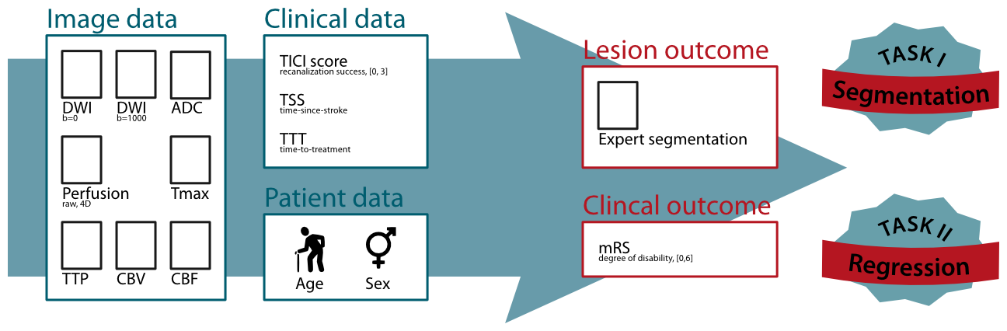
ISLES 2016 provides a segmentation and a regression task
Task I: Lesion outcome prediction
Task II: Clinical outcome prediction
A public dataset of diverse ischemic stroke cases and a suitable automatic evaluation procedure will be made available. The provided data allows the participating methods to combine image and clinical information in any combination to achieve the tasks' goals.
On this page, you can find details on how the challenge works in the about section, the clinical and research motivation behind it, the rules of how to participate, the data description and the evaluation scheme.

Stroke treatment time-line
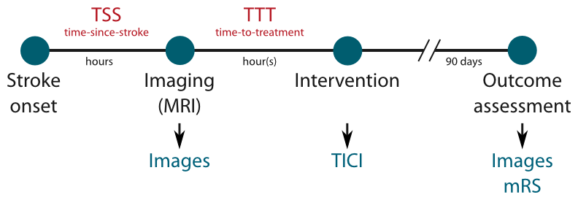
The typical stroke treatment procedure involves the acquisition of brain images at some time-since-stroke (TSS). Depending on the these and other factors a treatment decision is made and an intervention takes place after a time-to-treatment (TTT). The success of this intervention is assessed via the standardized TICI score. After the effects stabilized, the final clinical outcome is determined with the mRM and the final lesion outcome by brain imaging.

Thrombolysis in Cerebral Infarction (TICI) scale
The TICI scale, originally proposed by Higashida et al 2003 (http://stroke.ahajournals.org/content/34/8/e109), provides a standardized method to evaluate intracranial perfusion assessed in cerebral angiography. Here, it is used to assess the achieve re-perfusion after a flow-restoration intervention such as thrombectomy.

TABLE 2. Thrombolysis in Cerebral Infarction (TICI) Perfusion Categories [Higashida et al 2003 (http://stroke.ahajournals.org/content/34/8/e109)]
Grade 0:
No Perfusion. No antegrade flow beyond the point of occlusion.
Grade 1:
Penetration With Minimal Perfusion. The contrast material passes beyond the area of obstruction but fails to opacify the entire
cerebral bed distal to the obstruction for the duration of the angiographic run.
Grade 2: Partial Perfusion. The contrast material passes beyond the obstruction and opacifies the arterial bed distal to the obstruction.
However, the rate of entry of contrast into the vessel distal to the obstruction and/or its rate of clearance from the distal bed are
perceptibly slower than its entry into and/or clearance from comparable areas not perfused by the previously occluded vessel, eg,
the opposite cerebral artery or the arterial bed proximal to the obstruction.
Grade 2a: Only partial filling (2/3) of the entire vascular territory is visualized.
Grade 2b: Complete filling of all of the expected vascular territory is visualized, but the filling is slower than normal.
Grade 3: Complete Perfusion. Antegrade flow into the bed distal to the obstruction occurs as promptly as into the obstruction
and clearance of contrast material from the involved bed is as rapid as from an uninvolved other bed of the same vessel or the opposite cerebral artery.

Modified Rankin Scale (mRS)
The 90 days mRS is a standardized scale to assess the degree of disability 90 days after a stroke incidence and can be considered as the clinical outcome (van Swieten et al. [https://dx.doi.org/10.1161/01.str.19.5.604]). The mRS score serves as endpoint for Task II.

No Symptoms at all
0

No significant disability despite symptoms; able to carry out all usual duties and activities
+1

Slight disability; unable to carry out all previous activities, but able to look after own affairs without assistance
+2

Moderate disability; requiring some help, but able to walk without assistance
+3

Moderately severe disability; unable to walk without assistance and unable to attend to own bodily needs without assistance
+4

Severe disability; bedridden, incontinent and requiring constant nursing care and attention
+5

Dead
+6

Time-since-stroke (TSS)
TSS is an important factor as only a fast re-establishing of the cerebral perfusion can lead to benefits for the patient. The less time passed since stroke onset, the more likely a re-perfusion can salvage brain tissue.

Time-to-treatment (TTT)
TTT denotes the time passed between imaging the patient and the re-perfusion treatment. Similar to the TSS, its value determines the amount of salvageable brain tissue.

Acute stroke imaging
For this challenge, MRI sequences recorded at the time of admission are as detailed below. For more information on the sequences, see e.g. http://mriquestions.com/index.html.

DWI trace images at b=0 and b=1000
The perfusion restriction caused by stroke shows up early in DWI images as hyperintense areas.

ADC map
Constructed from the DWI images, the ADC map show the underperfused area as hypointense region. Compared to the DWI trace images, the ADC map does not suffer from confounding T2 shine-through effects.

Raw perfusion data
Perfusion imaging (here: dynamic susceptibility imaging) denotes the perfusion of brain tissue with blood over time. The raw perfusion data are multiple 3D scans performed at equal time-intervals combined into a 4D volume.

Perfusion maps (Tmax, TTP, CBV, CBF)
For clinical assessment various maps can be computed from the raw perfusion data, each of which denotes different aspects of the measured brain perfusion. For ISLES 2016, a number of maps computed via block decomposition using the Olea Sphere [http://www.olea-medical.com] software are provided.

Follow-up stroke imaging
To assess the final lesion outcome, an anatomical sequence is acquired when the stroke lesion stabilized. The manually segmented lesion in this scan constitutes the final lesion outcome and serves as end-point for Task I.

About

Why challenges?
Leave

Past challenges
[…] Last year, we organized with ISLES 2015 [link] and successful ischemic stoke lesion segmentation challenges with a similar task.

The ISLES 2016 challenge
The ISLES 2016 challenge treats the challenging problem of stroke lesion/clinical outcome prediction from acute MRI scans. To this end, we will provide acute MRI scans of a large number of acute stroke cases and associated clinical parameters. The associated ground truth is the final lesion volume (Task I) as manually segmented in 3 to 9 month follow-up scans, and the clinical mRM score (Task II) denoting the degree of disability.

How it works
[...]upload their segmentation results (in the form of binary images, Task I) / their score predictions (Task II) as well as a short paper describing their method […]

Motivation

Research motivation
Yet-to-come

Clinical motivation
Yet-to-come

Rules

What is required to participate?
Upload the test data results

Which methods are called for?
All types of automatic methods producing the desired end-points are welcome. We specifically do not restrict the participation to new, innovative and unpublished methods, but invite research groups from all over the world to enter their existing method in the competition. Semi-automatic methods are eligible for participation and will appear in the ranking, but out of competition, as it is impossible to rate the influence of the manual steps in a fair manner.

Usage of ISLES data for the Brain Lesion Segmentation (BrainLeS) workshop
Participants are free to use the training data from ISLES to evaluate methods submitted to BrainLeS, but are then encouraged to participate in the challenge too. […]

On-site method presentation
Presentation
scheme: X minutes presentation plus Y minutes discussion

Pre-processing
All MRI sequences are skull-stripped. No other pre-processing, such as re-sampling or co-registration is performed. This allows each participant to employ their favorite algorithms.

Data details
Roughly 40 training and 50 testing images. Training with 1GT, testing with 2GTs.

Data layout
Remove

Case characteristics
Remove

Evaluation

Task I: Lesion outcome
As for ISLES 2015 SISS (link#evaluation)

Task II: Clinical outcome
Yet-to-be-announced

About

