Design Tools Catalogue
Real-Time Cabin Condition Monitoring System — AIRE325

1. System Overview Diagram
The system overview diagram shows the complete pipeline of the Real-Time Cabin Condition Monitoring System. The pipeline is divided into three stages. Stage 1 covers the hardware sensor setup and data collection firmware on the Arduino Nano 33 BLE. Stage 2 covers the Python training pipeline in Google Colab including feature engineering, CNN model training, and TFLite export. Stage 3 covers real-time inference deployment back on the Arduino with results displayed on the LCD.

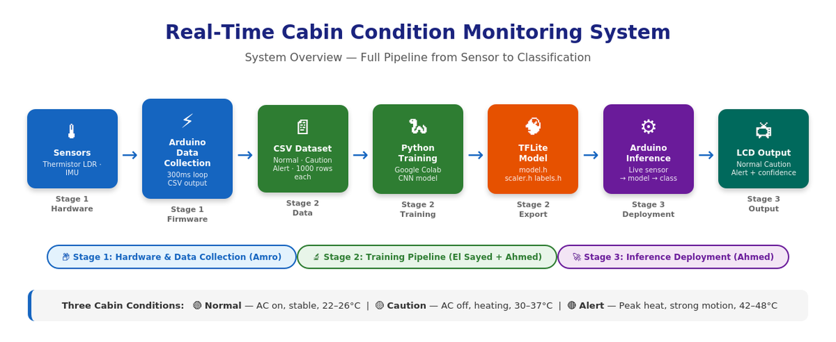
Figure 1: System Overview Diagram — Full Pipeline from Sensor to LCD Classification

2. Hardware Schematic
The hardware circuit was assembled on a breadboard using the Arduino Nano 33 BLE. The thermistor was connected in a voltage divider with a 22kΩ fixed resistor on analog pin A0. The LDR was connected to analog pin A1. The onboard LSM9DS1 IMU provides accelerometer data without additional wiring. An I2C LCD display is connected via SDA and SCL pins and shows the real-time classification result, confidence score, temperature, and LDR reading.
The data collection firmware reads all three sensors simultaneously every 300ms and outputs 7-column CSV rows (sampleNo, tempC, ldrRaw, accX, accY, accZ, label) to the Serial Monitor. CoolTerm captures and saves the output as CSV files named by class label.

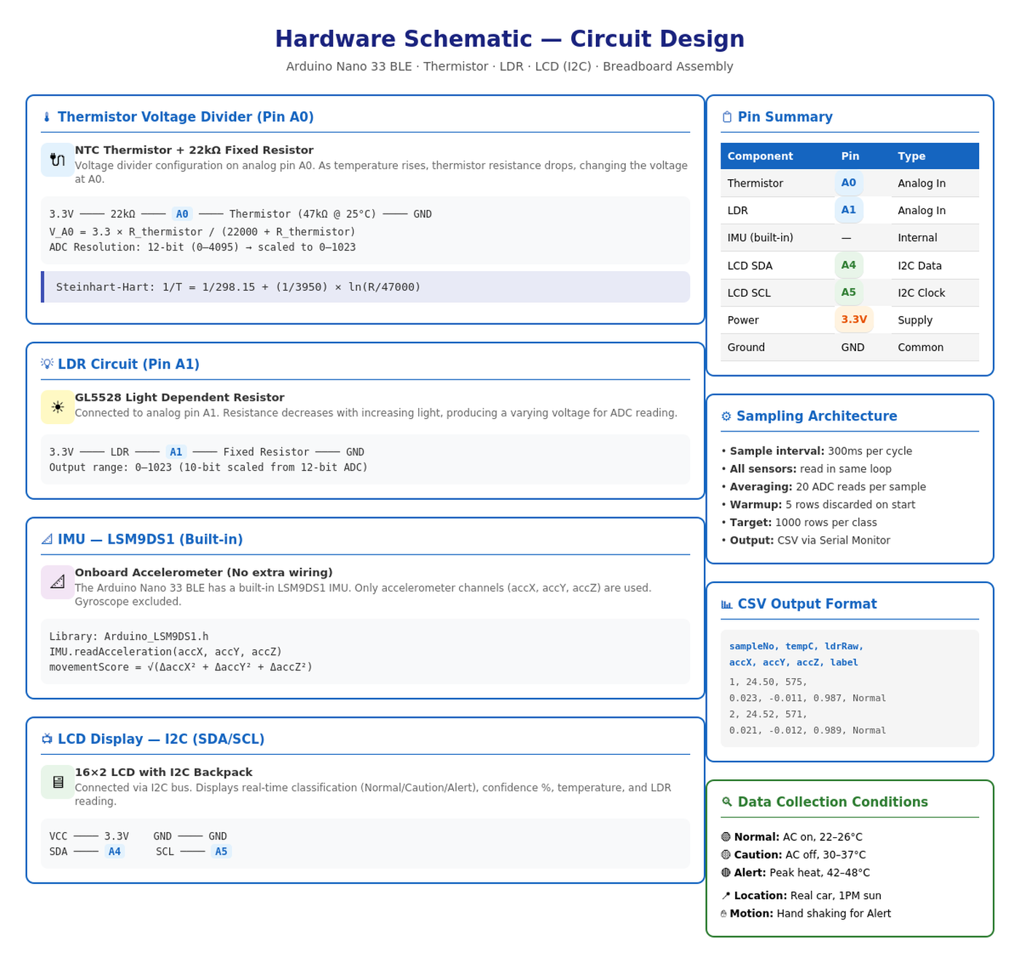
Figure 2: Hardware Circuit Schematic — Sensor Wiring, Pin Assignments, and CSV Output Format

3. Design Diagrams
The following four diagrams document the key design decisions and data processing steps in the system pipeline.

3.1 MovementScore Feature Engineering
The movementScore feature is computed from raw accelerometer readings. Instead of using raw accX, accY, accZ values directly (which are orientation-dependent), the change between consecutive samples is computed on each axis and the Euclidean magnitude is used as a single orientation-independent motion indicator. Normal cabin conditions produce scores near 0.017, Caution near 0.27, and Alert near 1.84.

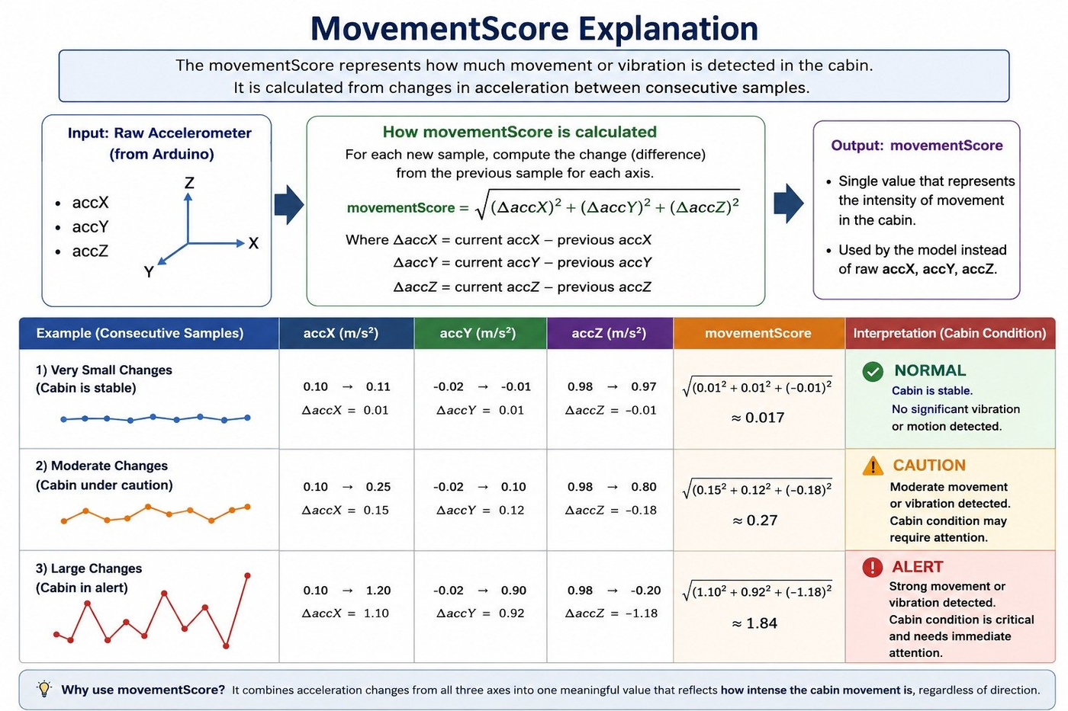
Figure 3: MovementScore Explanation — Formula and Examples for Normal, Caution, and Alert Conditions

3.2 TinyML Workflow
The TinyML workflow diagram shows the complete 10-step pipeline from raw CSV data collection to deployed Arduino inference. It highlights the team responsibilities across the three stages: Amro handled hardware and data collection, El Sayed handled dataset preparation and feature engineering, and Ahmed handled model training and deployment.

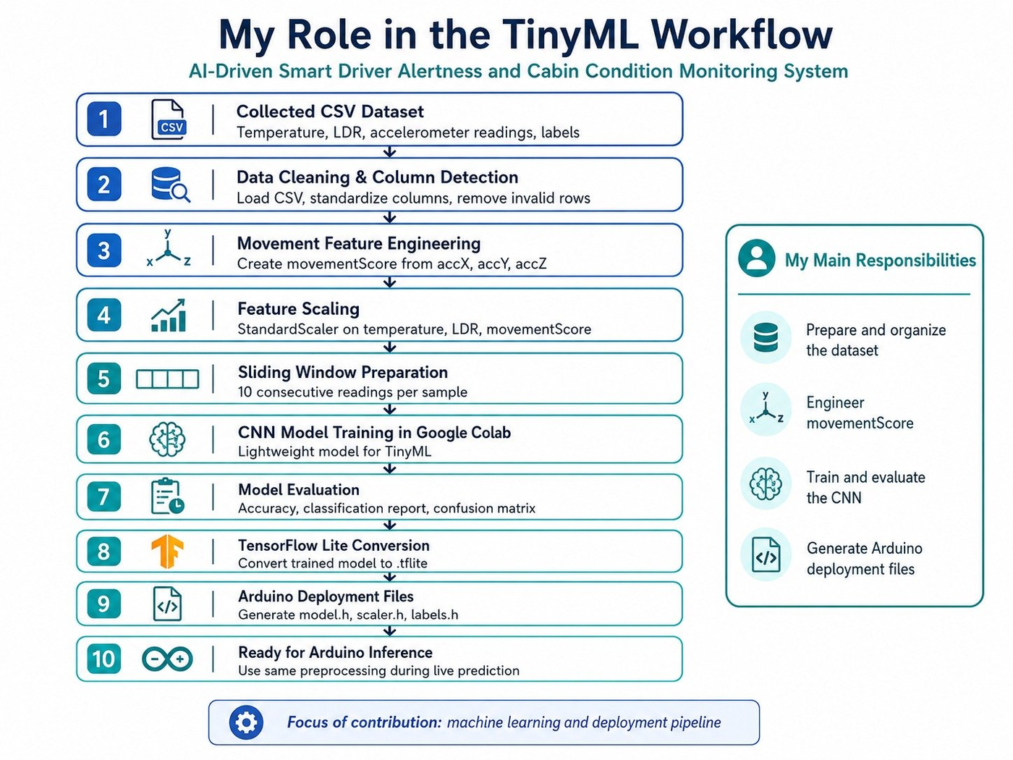
Figure 4: TinyML Workflow — 10-Step Pipeline from CSV Collection to Arduino Deployment

3.3 Sliding Window Preparation
The sliding window technique converts continuous sensor readings into fixed-size training samples. Each window contains 10 consecutive rows of normalized sensor data (temperature, LDR, movementScore). The window slides by 1 row at a time producing overlapping samples that capture temporal patterns in the data. Each window of shape (10, 3) is fed into the CNN as one training sample.

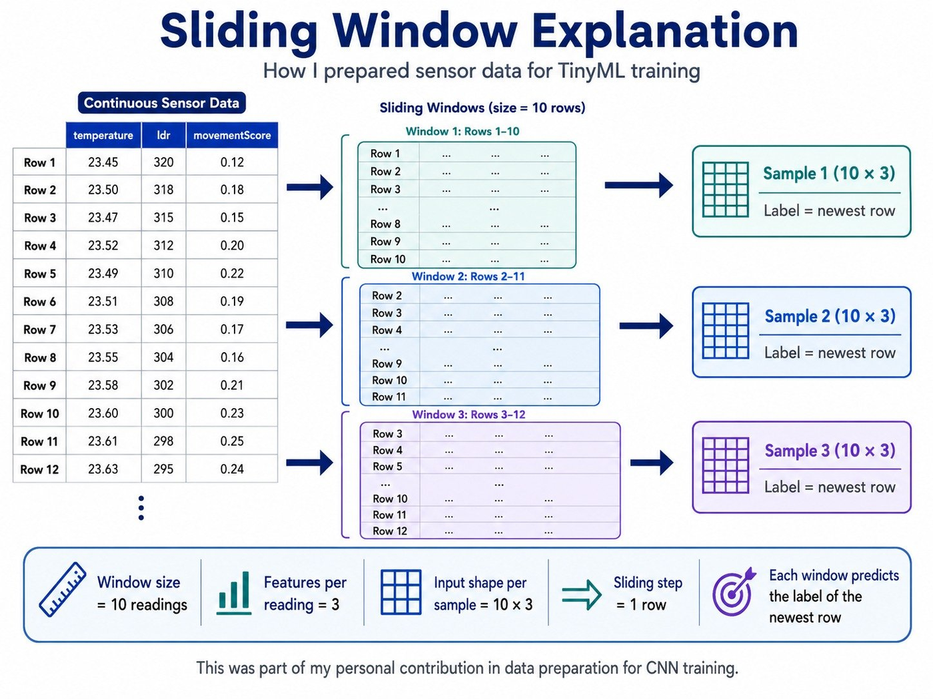
Figure 5: Sliding Window Explanation — How 10-Row Windows Form Training Samples for the CNN

3.4 CNN Architecture
The lightweight CNN model was designed for TinyML deployment on the Arduino Nano 33 BLE. The architecture avoids Squeeze and MaxPooling operations not supported by older TFLite Micro builds. It uses only Conv2D, Reshape, FullyConnected, ReLU, and Softmax operations. Total model size is approximately 2.6KB, well within the 256KB RAM of the Arduino.

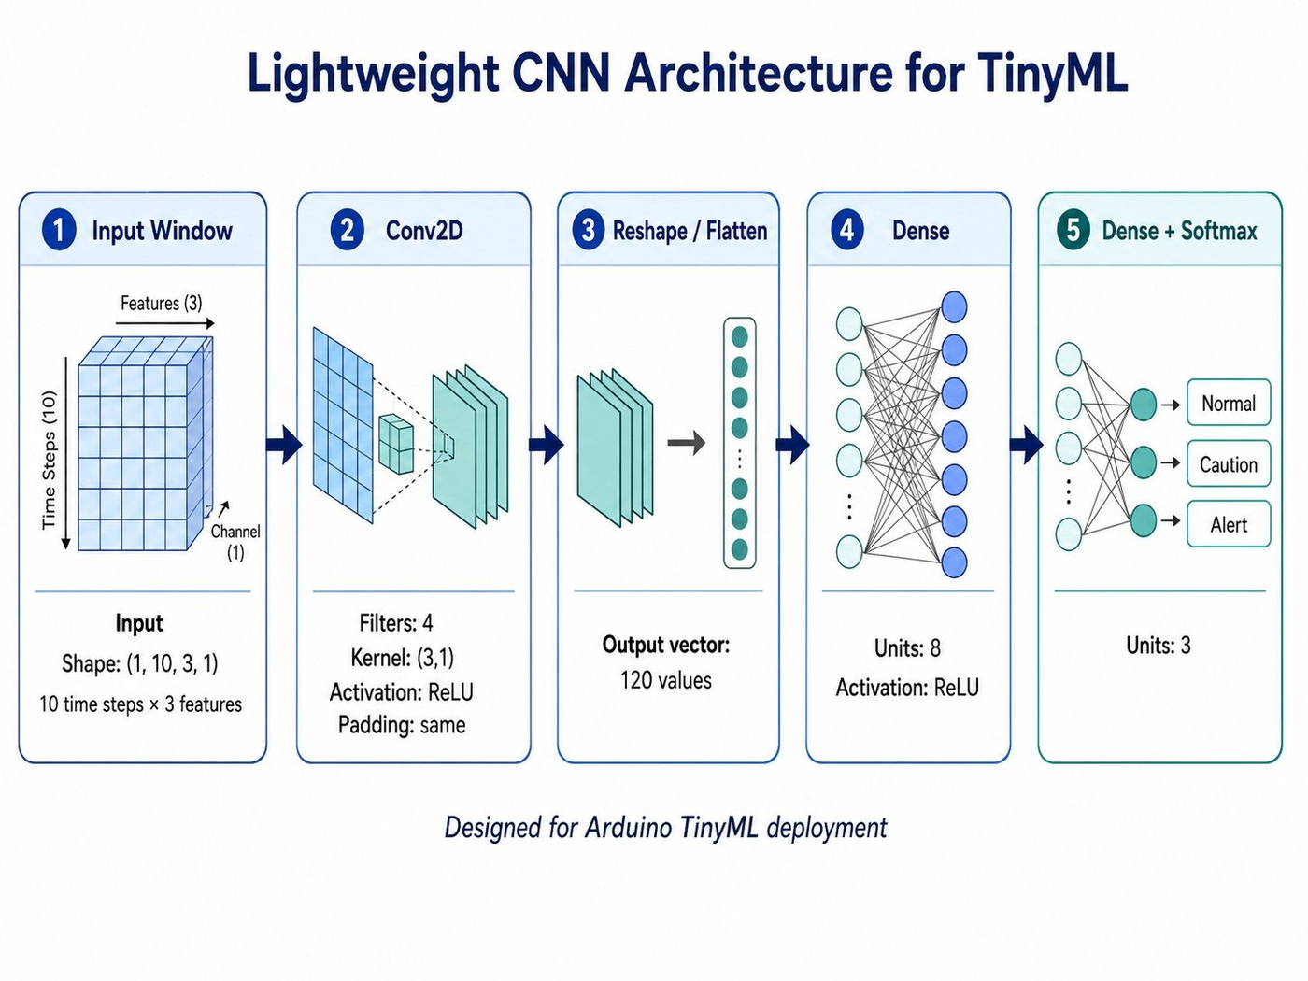
Figure 6: Lightweight CNN Architecture — Input (1,10,3,1) to 3-Class Softmax Output

4. Design Calculations
The main design calculations cover four areas: thermistor voltage divider and Steinhart-Hart temperature conversion, movementScore formula, feature normalization using StandardScaler values from scaler.h, and CNN model input dimensions and layer parameters.

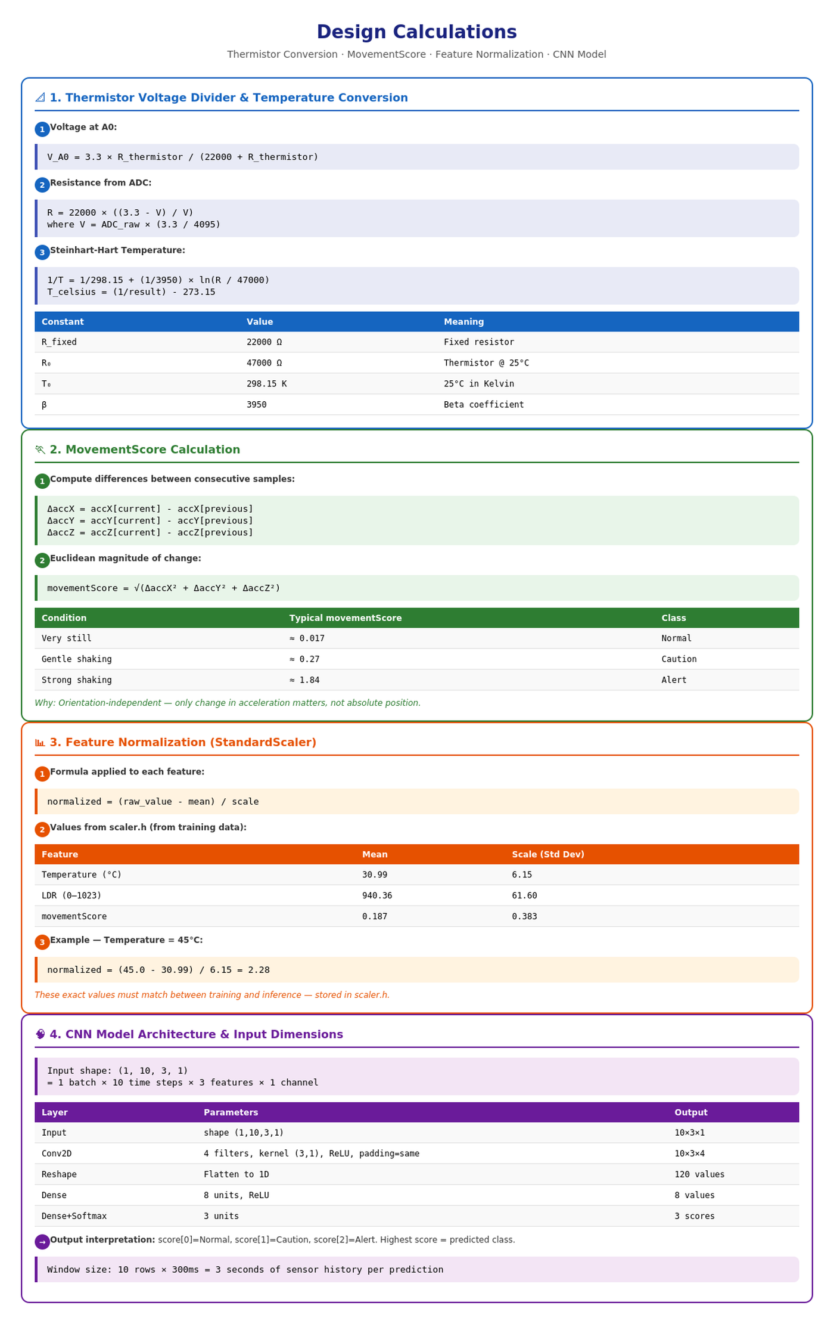
Figure 7: Design Calculations — Thermistor, MovementScore, Normalization, and CNN Dimensions

